Semester | T.E. Semester V– BIOM
Subject | Biomedical Digital Signal Processing
Subject Professor In-charge | Prof. Geetha Narayanan
Student Name | Rehan Raza Shaikh
Roll Number | 24105A0037
Grade and Subject Teacher’s Signature

Week 2 Submission
Project Title | Phonocardiogram(PCG)
Weekly Objective | Learning Convolution logically & deeply
Key concepts learned | FFT , IFFT , Noise Removal , Filtering
Work Completed | Filtering , FFT , IFFT , Noise Removal Before 20 HZ
Code | SIGNAL CONVOLUTION  import numpy as np  import matplotlib.pyplot as plt  # Define the signal segment 'signal_a'  # Assuming record, start_sample, and end_sample are already defined from previous cells  # If not, you would need to define them here, e.g.:  # import wfdb  # record_name = '100'  # record = wfdb.rdrecord(record_name)  # start_sample = 0  # end_sample = 200  signal_a = record.p_signal[start_sample:end_sample, 0]  # Define a simple kernel  kernel = np.array([0.2, 0.6, 0.2])  # Perform convolution  convolved_signal = np.convolve(signal_a, kernel, mode='full')  # Plot the original signal, the kernel, and the convolved signal  plt.figure(figsize=(18, 10))  plt.subplot(3, 1, 1)  plt.plot(signal_a)  plt.title(f'Original Signal Segment (Lead {record.sig_name[0]})')  plt.xlabel('Sample Index')  plt.ylabel('Amplitude')  plt.grid(True)  plt.subplot(3, 1, 2)  plt.plot(kernel)  plt.title('Convolution Kernel')  plt.xlabel('Kernel Index')  plt.ylabel('Value')  plt.grid(True)  plt.subplot(3, 1, 3)  plt.plot(convolved_signal)  plt.title(f'Convolved Signal (Original with Kernel)')  plt.xlabel('Output Sample Index')  plt.ylabel('Amplitude')  plt.grid(True)  plt.tight_layout()  plt.show()  FFT  from scipy.fft import fft, ifft, fftfreq  import matplotlib.pyplot as plt  import numpy as np  # Ensure yf (FFT of signal_a), xf (frequency bins) and kernel are available  # If they are not defined in previous cells, you would need to re-run the FFT cell (c834e7a8)  # and potentially the convolution kernel definition cell (0ad2c6c4 or similar).  # Convolve the FFT of the signal with the kernel  # Note: Convolution in the time domain is multiplication in the frequency domain,  # but if the user literally means 'convolve the FFT signal', we will do that.  # For frequency domain convolution, the signals should ideally be zero-padded to avoid circular convolution.  # For this demonstration, we will directly convolve the FFT values.  convolved_yf = np.convolve(yf, kernel, mode='full')  # Adjust xf to match the length of convolved_yf for plotting  # The length of the convolved signal will be N + len(kernel) - 1  # We need to re-calculate xf based on this new length.  N_convolved_yf = len(convolved_yf)  # Assuming fs is still the sampling frequency from the original signal  convolved_xf = fftfreq(N_convolved_yf, 1 / fs)  # Plot the magnitude spectrum of the convolved FFT  plt.figure(figsize=(15, 6))  plt.plot(convolved_xf, np.abs(convolved_yf))  plt.title(f'Magnitude Spectrum of Convolved FFT (Original FFT convolved with Kernel)')  plt.xlabel('Frequency (Hz)')  plt.ylabel('Magnitude')  plt.grid(True)  # Limit x-axis to positive frequencies up to Nyquist for better visualization  plt.xlim(0, fs / 2)  plt.show()  REMOVE NOISE BEFORE 20HZ  import numpy as np  import matplotlib.pyplot as plt  # Ensure convolved_yf, convolved_xf, and fs are available from previous cells.  # Create a copy to avoid modifying the original convolved_yf  filtered_convolved_yf = np.copy(convolved_yf)  # Get the Nyquist frequency  nyquist_frequency = fs / 2  # --- Apply filtering based on user request ---  # Remove all noise before 20 Hz (set magnitude to zero for frequencies < 20 Hz)  # Add filter between 20 to 500 (given Nyquist is 180 Hz, this means keeping up to Nyquist).  # Find indices for frequencies below 20 Hz  low_freq_indices = np.where(np.abs(convolved_xf) < 20)  filtered_convolved_yf[low_freq_indices] = 0  # Find indices for frequencies above Nyquist frequency (180 Hz)  # We're interested in the positive frequency spectrum for visualization  high_freq_indices_positive = np.where(convolved_xf > nyquist_frequency)  filtered_convolved_yf[high_freq_indices_positive] = 0  # Find indices for negative frequencies (mirrored) that are outside the desired band  high_freq_indices_negative = np.where(convolved_xf < -nyquist_frequency)  filtered_convolved_yf[high_freq_indices_negative] = 0  # Plot the magnitude spectrum of the filtered convolved FFT  plt.figure(figsize=(15, 6))  plt.plot(convolved_xf, np.abs(filtered_convolved_yf))  plt.title('Magnitude Spectrum of Filtered Convolved FFT (20 Hz to Nyquist)')  plt.xlabel('Frequency (Hz)')  plt.ylabel('Magnitude')  plt.grid(True)  plt.xlim(0, nyquist_frequency) # Only show positive frequencies up to Nyquist frequency  plt.show()  IFFT  from scipy.fft import ifft  import matplotlib.pyplot as plt  import numpy as np  # Perform Inverse FFT on the filtered_convolved_yf  # The 'n' parameter for ifft should ideally match the original signal length  # or the length of the frequency spectrum if zero-padded. Here, N_convolved_yf is the length  # of the convolved_yf before filtering, which was derived from a 'full' convolution.  # We take the real part as the original signal was real.  reconstructed_filtered_convolved_signal = np.real(ifft(filtered_convolved_yf, n=N_convolved_yf))  # Plot the reconstructed signal  plt.figure(figsize=(15, 6))  plt.plot(reconstructed_filtered_convolved_signal)  plt.title('Time-Domain Signal after IFFT of Filtered Convolved FFT')  plt.xlabel('Sample Index')  plt.ylabel('Amplitude')  plt.grid(True)  plt.show()  REMOVED NOISE  from scipy.fft import ifft  import matplotlib.pyplot as plt  import numpy as np  # Calculate the removed frequency components (noise) by subtracting the filtered spectrum from the original convolved spectrum  noise_in_frequency_domain = convolved_yf - filtered_convolved_yf  # Perform Inverse FFT on these removed components to see them in the time domain  # We take the real part as the original signal was real.  removed_noise_signal = np.real(ifft(noise_in_frequency_domain, n=N_convolved_yf))  # Plot the removed noise signal  plt.figure(figsize=(15, 6))  plt.plot(removed_noise_signal)  plt.title('Time-Domain Representation of Removed Noise (Frequencies < 20Hz or > Nyquist)')  plt.xlabel('Sample Index')  plt.ylabel('Amplitude')  plt.grid(True)  plt.show()
Evidence of Progress/Results | 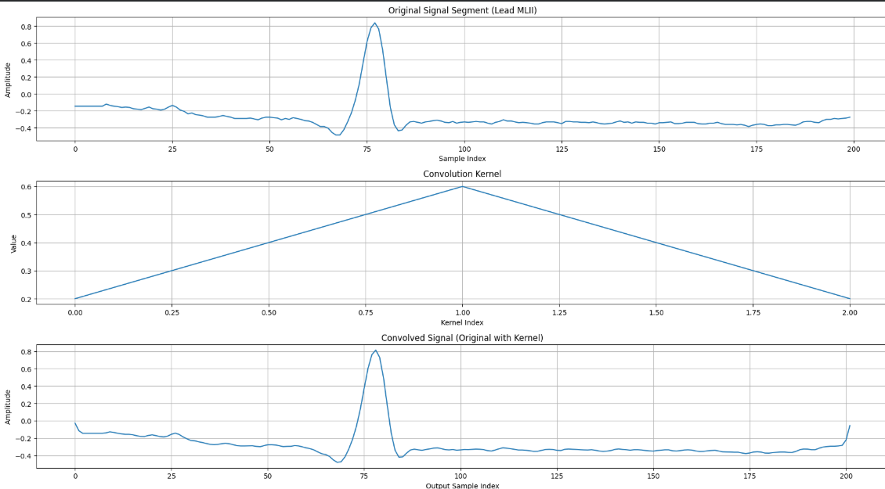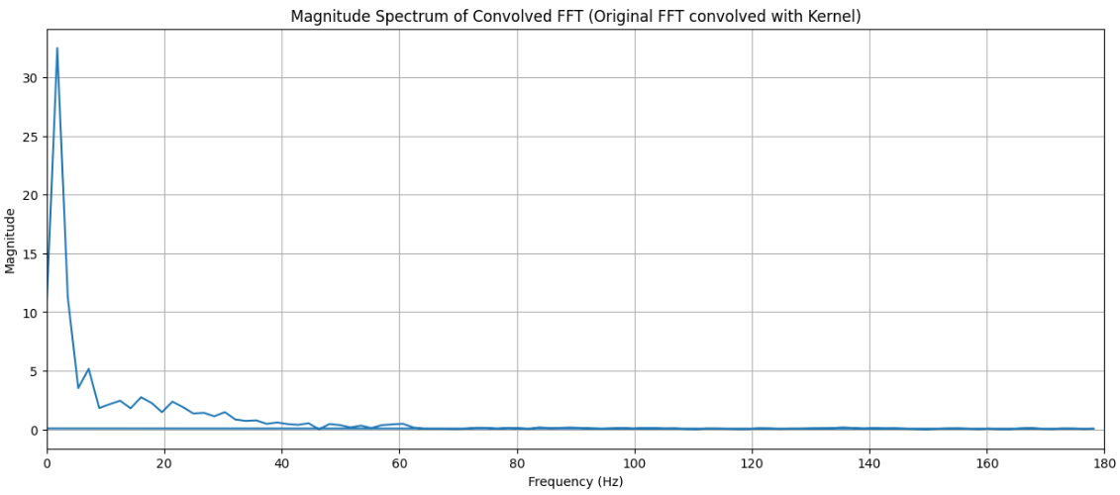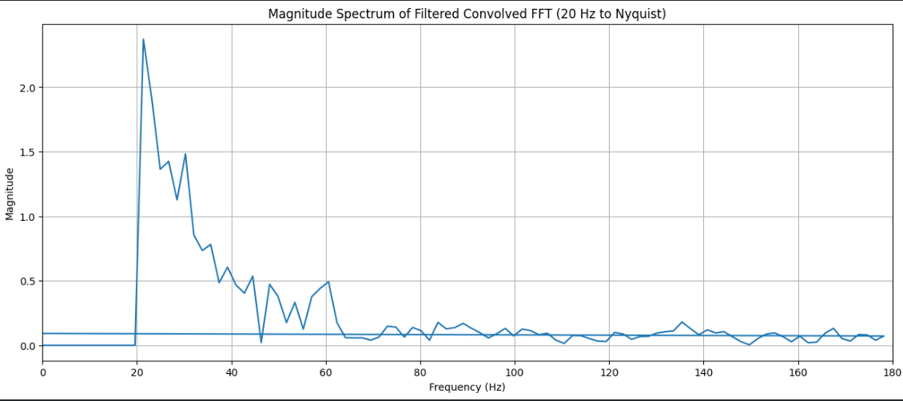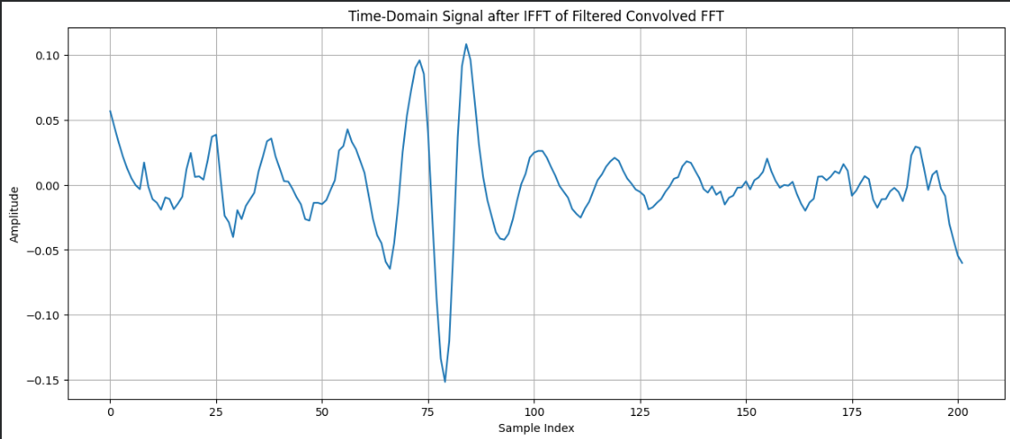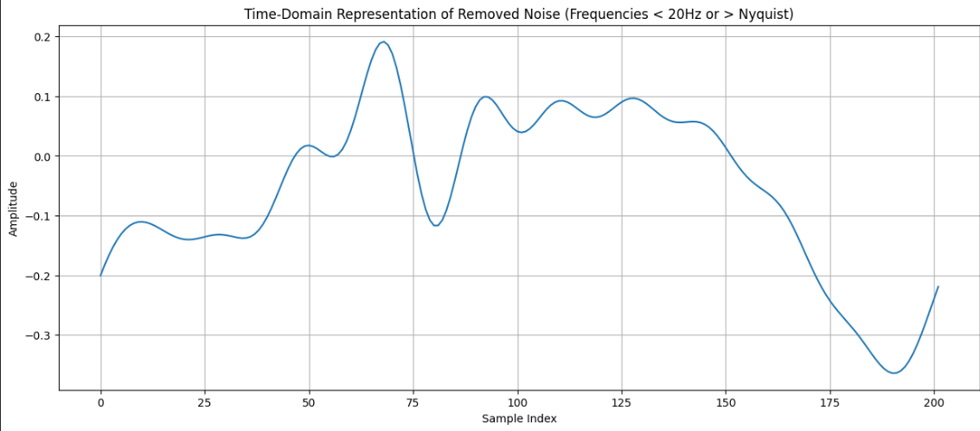
Challenges & Solutions | Noise high between 0 to 20 HZ.  Convolution signal
Next Week Plan | Analog , Digital
Declaraion | I hereby declare that for the assignment / academic activity submitted by me, I confirm ONE of the following statements by ticking (☐) the appropriate box:  ☐ (1) I have prepared the assignment / academic activity entirely by myself.  ☐ (2) I have completed the assignment / academic activity with academic guidance or discussion from seniors / friends / peers, while ensuring the work is my own.  ☐ (3) I have used AI-based tools only as an aid and have appropriately acknowledged or cited their use as per the ethical guidelines of the Institute.  ☐ (4) I have used AI-based tools and directly copy-pasted content for the assignment / academic activity.  ☐ (5) I have copied the assignment / academic activity from peers / friends.  I understand that selecting options (4) or (5) indicates unethical academic practice and may attract academic penalties, including rejection of the assignment or disciplinary action, as per the rules of Vidyalankar Institute of Technology, Mumbai. I submit this declaration truthfully and accept full responsibility for the same.  Student Name: Rehan Raza Shaikh Roll No.: 24105A0037  Signature: 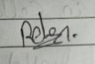 Date: 21/07/2026

