Practical - 1
Practical Title: Project Initiation, Requirement Analysis, Sitemap, Wireframe, and GitHub Setup

Problem Definition: Initiate the semester-long StudentHub portal by identifying the problem scope, user roles, key modules, navigation flow, and minimum 10 pages. Create a sitemap, low-fidelity wireframe, project folder structure, README file, and GitHub repository.

Theory

What is URL and parts of URL?
Answer: A URL (Uniform Resource Locator) is a unique address used to locate and access resources on the internet.
Part of url:
- Scheme: Defines the protocol used to access the resource (e.g., http, https, ftp).
- Subdomain: Specifies a subdivision of the main domain (e.g., www).
- Domain: Identifies the main website name (e.g., example).
- Top-Level Domain (TLD): Indicates the domain extension (e.g., .com, .org).
- Port Number: Specifies the server port (default: 80 for HTTP, 443 for HTTPS).
- Path: Points to the resource location on the server.
- Query String Separator: The ? symbol that starts query parameters.
- Query String / Parameters: Passes data as key–value pairs using &.
- Fragment: Refers to a specific section within the resource using #.
(geekforgeeks.com)

How does HTML file process in web browser?
Answer: You Write HTML Code
You create an HTML file (.html) that contains the structure and content of your webpage — text, headings, images, links, forms, etc.
You Open the File in a Browser
When you double-click the file or open it through a web server, a browser like Chrome, Firefox, or Safari reads the code.
The Browser Parses the HTML
The browser scans your code from top to bottom. It starts with the <!DOCTYPE html> declaration, then reads the ,
, and sections.
The Browser Builds the Page
It displays content (like text, images, and videos) inside the
.
It applies styles from CSS (if linked or embedded).
It runs JavaScript for interactivity (if included).
Result: A Visual Web Page
What you see in the browser is a visual version of the HTML. The browser turns your code into a formatted page that looks clean and interactive — just like any website you visit.
(dev.to)

3. How will page navigation flow managed among all HTML pages?
Answer: Page navigation among all HTML pages will be managed using the HTML <a> (anchor) tag with the href attribute. Each page will contain links or buttons that direct the user to the required page. For example, a user can move from the Home page to the Login page, then to the Dashboard, and use a Logout button to return to the Home page. By using proper relative file paths, all the pages remain connected, making the website easy to navigate and user-friendly. (geekforgeeks.com)

4. How will GitHub commits be maintained after each practical?
Answer: we can use github commit to display changes like when im doing practical 2 I will use commit as prac 2(whatever changes I did) then last commit will be prac2.

Implementation/ Output/Result (Keep only one option which is suitable to practical)

Here you can add your learning code/tags/style etc

Evidence of Work (Screenshots)
Screenshot 1 (Add proper title and figure number Figure 1.1)
Description:
Screenshot 2 (Add proper title and figure number Figure 1.2)

Description:

GitHub Repository Link: https://github.com/rehansaiyed72/student-hub-portal

Challenges Faced:the challenges I faced while doing this were not major like building the code structure but I did it with the help of faculty

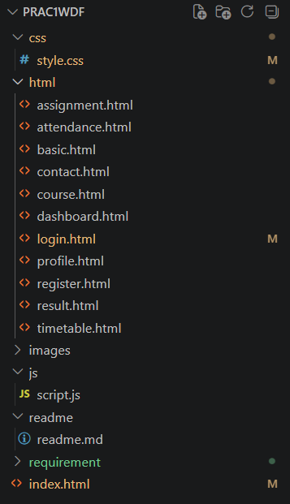

Learning Outcomes:

After this practical I learned how the html is connected how links are used what to di before starting the web page building like making wireframe having the requirement analysis etc.

Faculty Remarks: (Keep this blank for faculty)

