**Background**

Toronto is a vibrant multicultural city. Finding a right neighbourhood is not easy. A young family with children have to decide which neighbourhood to live in. So, there are certain criteria for the family to choose what is important for them in the neighbourhood. They are:

1) Grocery Stores - Since most families eat at home, they have to be closed to at least one grocery store.

2) Shopping Mall - For a busy family a shopping mall would be an ideal place to shop in one area and also for entertainment.

3) Parks - For a family to enjoy the outdoors and get exercise.

4) Movie Theatres - This is for family entertainment.

5) Gym - The family also have to have access to a gym for exercise.

6) Pharmacy - Family do get sick (especially children) and they would require access to medicines from the pharmacy.

7) Metro Station – To use for commute to work.

There could be other criteria for family to consider in a neighbourhood but for this analysis, the above criteria are selected.

**Data**

For the analysis, the following are the data sources are useda:

1) Toronto Geospatial data - This is required for mapping out neighbourhoods and also for visualization for different neighbourhood clusters. http://cocl.us/Geospatial_data

2) Postal code data - This will be necessary to identify neighbourhoods that needed to be studied as well as being linked with geospatial data. [List of postal codes of Canada: M](https://en.wikipedia.org/wiki/List_of_postal_codes_of_Canada:_M)

3) Foursquare data for Toronto - This is necessary for selecting venues such as grocery stores, shopping mall and so on for cluster analysis.

**Data cleansing**

Since there are three datasets that are going to be combined together, there is bound to be some dataset with null value. Throughout the analysis any null value will be removed from the dataset for the purpose of this analysis. No other data cleaning is required for this data analysis.

**Feature selected:**

Geographical Information:

Postal Code

Borough

Neighbourhood

Longitude and Latitude.

Venue Selection:

Playground

Supermarket

Metro Station

Gym, Park

Shopping Mall

Grocery Store

Organic Grocery

Salon / Barbarshop

**Analysis**

The first step is to determine which neighbourhood to choose for analysis. For this analysis, three largest neighbourhoods are select to provide choice for a family. Based on Geographical information, the following bar chart is generated to determine the size of the neighbourhood.

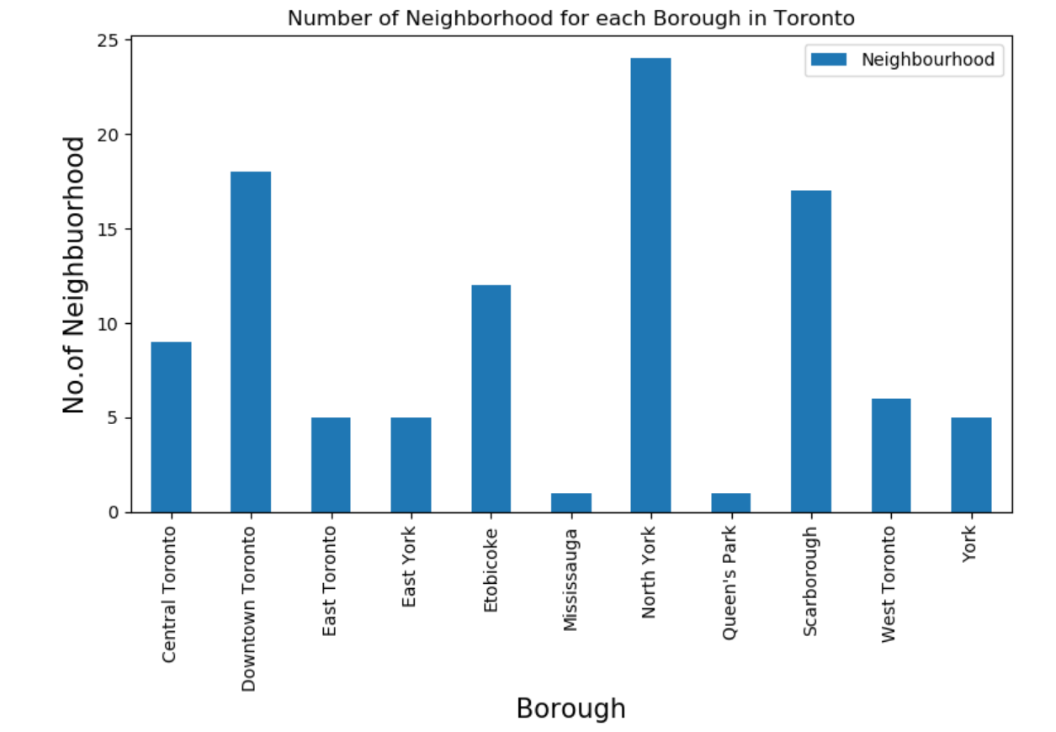

Based on the above bar chart, the top 3 neighbourhood are:

1) North York

2) Scarborough

3) Downtown Toronto

The next step is to look at venues with the criteria from the Four Square data.

The following are the criteria chosen from Four Square dataset:

Playground

Metro Station

Gym

Park

Shopping Mall

Grocery Store

Gym / Fitness Center

Organic Grocery

Pharmacy

Salon / Barbershop

Cluster Analysis

For the cluster analysis, K=5 was selected. Also, the top 10 most common venue analysis was done as part of the cluster analysis.

After the analysis was completed, the following results are presented.

Cluster 1

|  |  |  |  |  |  |  |  |  |  |  |  |
| --- | --- | --- | --- | --- | --- | --- | --- | --- | --- | --- | --- |
| **Neighbourhood** | **Cluster** | **1st Most Common Venue** | **2nd Most Common Venue** | **3rd Most Common Venue** | **4th Most Common Venue** | **5th Most Common Venue** | **6th Most Common Venue** | **7th Most Common Venue** | **8th Most Common Venue** | **9th Most Common Venue** | **10th Most Common Venue** |
| York Mills West | 0 | Park | Salon / Barbershop | Pharmacy | Organic Grocery | Gym / Fitness Center | Grocery Store | Shopping Mall | Gym | Metro Station | Supermarket |
| Parkwoods | 0 | Park | Salon / Barbershop | Pharmacy | Organic Grocery | Gym / Fitness Center | Grocery Store | Shopping Mall | Gym | Metro Station | Supermarket |
| CFB Toronto, Downsview East | 0 | Park | Salon / Barbershop | Pharmacy | Organic Grocery | Gym / Fitness Center | Grocery Store | Shopping Mall | Gym | Metro Station | Supermarket |
| Glencairn | 0 | Park | Salon / Barbershop | Pharmacy | Organic Grocery | Gym / Fitness Center | Grocery Store | Shopping Mall | Gym | Metro Station | Supermarket |
| Downsview, North Park, Upwood Park | 0 | Park | Salon / Barbershop | Pharmacy | Organic Grocery | Gym / Fitness Center | Grocery Store | Shopping Mall | Gym | Metro Station | Supermarket |

Cluster 2

|  |  |  |  |  |  |  |  |  |  |  |  |  |
| --- | --- | --- | --- | --- | --- | --- | --- | --- | --- | --- | --- | --- |
| **Neighbourhood** | **Cluster** | **Cluster** | **1st Most Common Venue** | **2nd Most Common Venue** | **3rd Most Common Venue** | **4th Most Common Venue** | **5th Most Common Venue** | **6th Most Common Venue** | **7th Most Common Venue** | **8th Most Common Venue** | **9th Most Common Venue** | **10th Most Common Venue** |
| Cabbagetown, St. James Town | 1 | 1 | Park | Playground | Salon / Barbershop | Pharmacy | Organic Grocery | Gym / Fitness Center | Grocery Store | Shopping Mall | Gym | Metro Station |
| Church and Wellesley | 1 | 1 | Salon / Barbershop | Park | Pharmacy | Organic Grocery | Gym / Fitness Center | Grocery Store | Shopping Mall | Gym | Metro Station | Supermarket |
| Harbourfront, Regent Park | 1 | 1 | Park | Gym / Fitness Center | Salon / Barbershop | Pharmacy | Organic Grocery | Grocery Store | Shopping Mall | Gym | Metro Station | Supermarket |
| Ryerson, Garden District | 1 | 1 | Salon / Barbershop | Pharmacy | Organic Grocery | Gym / Fitness Center | Grocery Store | Shopping Mall | Park | Gym | Metro Station | Supermarket |
| St. James Town | 1 | 1 | Gym | Salon / Barbershop | Pharmacy | Organic Grocery | Gym / Fitness Center | Grocery Store | Shopping Mall | Park | Metro Station | Supermarket |
| Berczy Park | 1 | 1 | Park | Salon / Barbershop | Pharmacy | Organic Grocery | Gym / Fitness Center | Grocery Store | Shopping Mall | Gym | Metro Station | Supermarket |
| Central Bay Street | 1 | 1 | Park | Salon / Barbershop | Pharmacy | Organic Grocery | Gym / Fitness Center | Grocery Store | Shopping Mall | Gym | Metro Station | Supermarket |
| Adelaide, King, Richmond | 1 | 1 | Gym / Fitness Center | Salon / Barbershop | Pharmacy | Organic Grocery | Grocery Store | Shopping Mall | Park | Gym | Metro Station | Supermarket |
| Harbourfront East, Toronto Islands, Union Station | 1 | 1 | Park | Supermarket | Salon / Barbershop | Pharmacy | Organic Grocery | Gym / Fitness Center | Grocery Store | Shopping Mall | Gym | Metro Station |
| Design Exchange, Toronto Dominion Centre | 1 | 1 | Gym / Fitness Center | Gym | Salon / Barbershop | Pharmacy | Organic Grocery | Grocery Store | Shopping Mall | Park | Metro Station | Supermarket |
| Commerce Court, Victoria Hotel | 1 | 1 | Gym | Gym / Fitness Center | Salon / Barbershop | Pharmacy | Organic Grocery | Grocery Store | Shopping Mall | Park | Metro Station | Supermarket |
| Harbord, University of Toronto | 1 | 1 | Gym | Salon / Barbershop | Pharmacy | Organic Grocery | Gym / Fitness Center | Grocery Store | Shopping Mall | Park | Metro Station | Supermarket |
| Chinatown, Grange Park, Kensington Market | 1 | 1 | Organic Grocery | Salon / Barbershop | Pharmacy | Gym / Fitness Center | Grocery Store | Shopping Mall | Park | Gym | Metro Station | Supermarket |
| CN Tower, Bathurst Quay, Island airport, Harbo... | 1 | 1 | Salon / Barbershop | Pharmacy | Organic Grocery | Gym / Fitness Center | Grocery Store | Shopping Mall | Park | Gym | Metro Station | Supermarket |
| Stn A PO Boxes 25 The Esplanade | 1 | 1 | Park | Salon / Barbershop | Pharmacy | Organic Grocery | Gym / Fitness Center | Grocery Store | Shopping Mall | Gym | Metro Station | Supermarket |
| First Canadian Place, Underground city | 1 | 1 | Gym / Fitness Center | Gym | Salon / Barbershop | Pharmacy | Organic Grocery | Grocery Store | Shopping Mall | Park | Metro Station | Supermarket |
| Hillcrest Village | 1 | 1 | Salon / Barbershop | Pharmacy | Organic Grocery | Gym / Fitness Center | Grocery Store | Shopping Mall | Park | Gym | Metro Station | Supermarket |
| Fairview, Henry Farm, Oriole | 1 | 1 | Salon / Barbershop | Pharmacy | Shopping Mall | Organic Grocery | Gym / Fitness Center | Grocery Store | Park | Gym | Metro Station | Supermarket |
| Bayview Village | 1 | 1 | Salon / Barbershop | Pharmacy | Organic Grocery | Gym / Fitness Center | Grocery Store | Shopping Mall | Park | Gym | Metro Station | Supermarket |
| Silver Hills, York Mills | 1 | 1 | Salon / Barbershop | Pharmacy | Organic Grocery | Gym / Fitness Center | Grocery Store | Shopping Mall | Park | Gym | Metro Station | Supermarket |
| Willowdale South | 1 | 1 | Grocery Store | Shopping Mall | Salon / Barbershop | Pharmacy | Organic Grocery | Gym / Fitness Center | Park | Gym | Metro Station | Supermarket |
| Don Mills North | 1 | 1 | Gym / Fitness Center | Salon / Barbershop | Pharmacy | Organic Grocery | Grocery Store | Shopping Mall | Park | Gym | Metro Station | Supermarket |
| Flemingdon Park, Don Mills South | 1 | 1 | Gym | Grocery Store | Salon / Barbershop | Pharmacy | Organic Grocery | Gym / Fitness Center | Shopping Mall | Park | Metro Station | Supermarket |
| Bathurst Manor, Downsview North, Wilson Heights | 1 | 1 | Pharmacy | Shopping Mall | Supermarket | Salon / Barbershop | Organic Grocery | Gym / Fitness Center | Grocery Store | Park | Gym | Metro Station |
| Northwood Park, York University | 1 | 1 | Metro Station | Salon / Barbershop | Pharmacy | Organic Grocery | Gym / Fitness Center | Grocery Store | Shopping Mall | Park | Gym | Supermarket |
| Downsview Central | 1 | 1 | Salon / Barbershop | Pharmacy | Organic Grocery | Gym / Fitness Center | Grocery Store | Shopping Mall | Park | Gym | Metro Station | Supermarket |
| Victoria Village | 1 | 1 | Salon / Barbershop | Pharmacy | Organic Grocery | Gym / Fitness Center | Grocery Store | Shopping Mall | Park | Gym | Metro Station | Supermarket |
| Bedford Park, Lawrence Manor East | 1 | 1 | Pharmacy | Grocery Store | Salon / Barbershop | Organic Grocery | Gym / Fitness Center | Shopping Mall | Park | Gym | Metro Station | Supermarket |
| Lawrence Heights, Lawrence Manor | 1 | 1 | Salon / Barbershop | Pharmacy | Organic Grocery | Gym / Fitness Center | Grocery Store | Shopping Mall | Park | Gym | Metro Station | Supermarket |
| Humber Summit | 1 | 1 | Pharmacy | Salon / Barbershop | Organic Grocery | Gym / Fitness Center | Grocery Store | Shopping Mall | Park | Gym | Metro Station | Supermarket |
| Emery, Humberlea | 1 | 1 | Salon / Barbershop | Pharmacy | Organic Grocery | Gym / Fitness Center | Grocery Store | Shopping Mall | Park | Gym | Metro Station | Supermarket |
| Rouge, Malvern | 1 | 1 | Salon / Barbershop | Pharmacy | Organic Grocery | Gym / Fitness Center | Grocery Store | Shopping Mall | Park | Gym | Metro Station | Supermarket |
| Highland Creek, Rouge Hill, Port Union | 1 | 1 | Salon / Barbershop | Pharmacy | Organic Grocery | Gym / Fitness Center | Grocery Store | Shopping Mall | Park | Gym | Metro Station | Supermarket |
| Guildwood, Morningside, West Hill | 1 | 1 | Salon / Barbershop | Pharmacy | Organic Grocery | Gym / Fitness Center | Grocery Store | Shopping Mall | Park | Gym | Metro Station | Supermarket |
| Woburn | 1 | 1 | Salon / Barbershop | Pharmacy | Organic Grocery | Gym / Fitness Center | Grocery Store | Shopping Mall | Park | Gym | Metro Station | Supermarket |
| Cedarbrae | 1 | 1 | Salon / Barbershop | Pharmacy | Organic Grocery | Gym / Fitness Center | Grocery Store | Shopping Mall | Park | Gym | Metro Station | Supermarket |
| East Birchmount Park, Ionview, Kennedy Park | 1 | 1 | Playground | Salon / Barbershop | Pharmacy | Organic Grocery | Gym / Fitness Center | Grocery Store | Shopping Mall | Park | Gym | Metro Station |
| Clairlea, Golden Mile, Oakridge | 1 | 1 | Park | Metro Station | Salon / Barbershop | Pharmacy | Organic Grocery | Gym / Fitness Center | Grocery Store | Shopping Mall | Gym | Supermarket |
| Cliffcrest, Cliffside, Scarborough Village West | 1 | 1 | Salon / Barbershop | Pharmacy | Organic Grocery | Gym / Fitness Center | Grocery Store | Shopping Mall | Park | Gym | Metro Station | Supermarket |
| Birch Cliff, Cliffside West | 1 | 1 | Salon / Barbershop | Pharmacy | Organic Grocery | Gym / Fitness Center | Grocery Store | Shopping Mall | Park | Gym | Metro Station | Supermarket |
| Dorset Park, Scarborough Town Centre, Wexford ... | 1 | 1 | Salon / Barbershop | Pharmacy | Organic Grocery | Gym / Fitness Center | Grocery Store | Shopping Mall | Park | Gym | Metro Station | Supermarket |
| Maryvale, Wexford | 1 | 1 | Shopping Mall | Salon / Barbershop | Pharmacy | Organic Grocery | Gym / Fitness Center | Grocery Store | Park | Gym | Metro Station | Supermarket |
| Agincourt | 1 | 1 | Salon / Barbershop | Pharmacy | Organic Grocery | Gym / Fitness Center | Grocery Store | Shopping Mall | Park | Gym | Metro Station | Supermarket |
| Clarks Corners, Sullivan, Tam O'Shanter | 1 | 1 | Pharmacy | Salon / Barbershop | Organic Grocery | Gym / Fitness Center | Grocery Store | Shopping Mall | Park | Gym | Metro Station | Supermarket |
| L'Amoreaux West | 1 | 1 | Pharmacy | Grocery Store | Salon / Barbershop | Organic Grocery | Gym / Fitness Center | Shopping Mall | Park | Gym | Metro Station | Supermarket |

Cluster 3

|  |  |  |  |  |  |  |  |  |  |  |  |
| --- | --- | --- | --- | --- | --- | --- | --- | --- | --- | --- | --- |
| **Neighbourhood** | **Cluster** | **1st Most Common Venue** | **2nd Most Common Venue** | **3rd Most Common Venue** | **4th Most Common Venue** | **5th Most Common Venue** | **6th Most Common Venue** | **7th Most Common Venue** | **8th Most Common Venue** | **9th Most Common Venue** | **10th Most Common Venue** |
| Scarborough Village | 2 | Playground | Salon / Barbershop | Pharmacy | Organic Grocery | Gym / Fitness Center | Grocery Store | Shopping Mall | Park | Gym | Metro Station |

Cluster 4

|  |  |  |  |  |  |  |  |  |  |  |  |
| --- | --- | --- | --- | --- | --- | --- | --- | --- | --- | --- | --- |
| **Neighbourhood** | **Cluster** | **1st Most Common Venue** | **2nd Most Common Venue** | **3rd Most Common Venue** | **4th Most Common Venue** | **5th Most Common Venue** | **6th Most Common Venue** | **7th Most Common Venue** | **8th Most Common Venue** | **9th Most Common Venue** | **10th Most Common Venue** |
| Rosedale | 3 | Park | Playground | Salon / Barbershop | Pharmacy | Organic Grocery | Gym / Fitness Center | Grocery Store | Shopping Mall | Gym | Metro Station |
| Agincourt North, L'Amoreaux East, Milliken, St... | 3 | Park | Playground | Salon / Barbershop | Pharmacy | Organic Grocery | Gym / Fitness Center | Grocery Store | Shopping Mall | Gym | Metro Station |

Cluster 5

|  |  |  |  |  |  |  |  |  |  |  |  |
| --- | --- | --- | --- | --- | --- | --- | --- | --- | --- | --- | --- |
| **Neighbourhood** | **Cluster** | **1st Most Common Venue** | **2nd Most Common Venue** | **3rd Most Common Venue** | **4th Most Common Venue** | **5th Most Common Venue** | **6th Most Common Venue** | **7th Most Common Venue** | **8th Most Common Venue** | **9th Most Common Venue** | **10th Most Common Venue** |
| Christie | 4 | Grocery Store | Park | Salon / Barbershop | Pharmacy | Organic Grocery | Gym / Fitness Center | Shopping Mall | Gym | Metro Station | Supermarket |
| Willowdale West | 4 | Pharmacy | Grocery Store | Salon / Barbershop | Organic Grocery | Gym / Fitness Center | Shopping Mall | Park | Gym | Metro Station | Supermarket |
| Downsview West | 4 | Grocery Store | Shopping Mall | Salon / Barbershop | Pharmacy | Organic Grocery | Gym / Fitness Center | Park | Gym | Metro Station | Supermarket |
| Downsview Northwest | 4 | Gym / Fitness Center | Grocery Store | Salon / Barbershop | Pharmacy | Organic Grocery | Shopping Mall | Park | Gym | Metro Station | Supermarket |

Toronto map with clusters

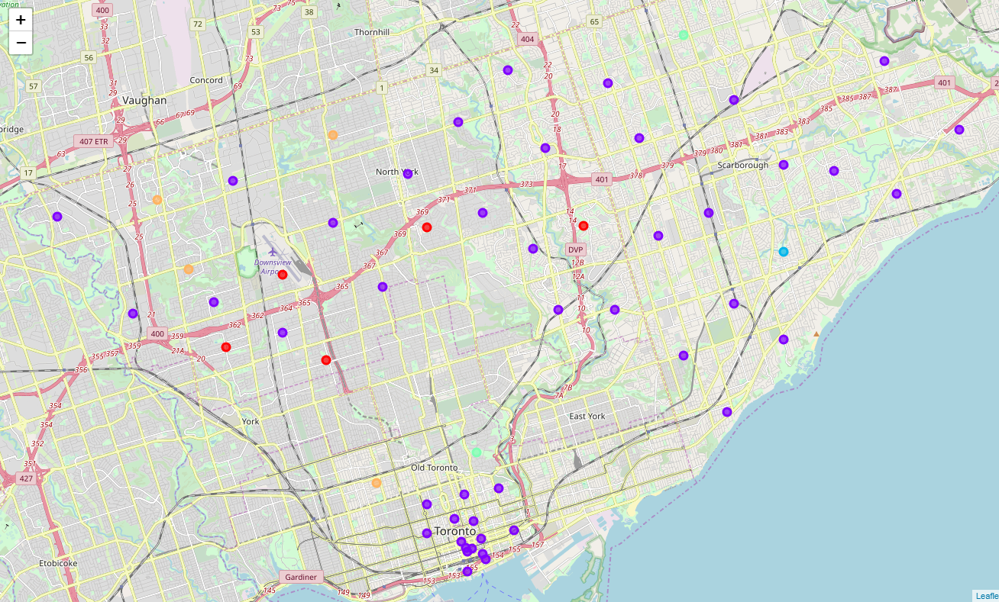

k-cluster analysis

Cluster 1 is in the North York neighbourhood. The most common venues (1-10) are the same for this cluster.

Cluster 2 has the largest number of neighbourhoods. They are spread out in the three boroughs. There is no commonality in the venues (1-10). As it was in Cluster 1

Cluster 3 has only one neighbourhood and it is in Scarborough.

Cluster 4 has two neighbourhood (one downtown Toronto and one Scarborough). The most common venues (1-10) are the same for this cluster.

Cluster 5 has 4 neighbourhoods. There are some similarities in venues. Also, the neighbourhood is the downtown Toronto and North York.

Further consideration for analysis

This analysis was done based on Four Square data. However, other consideration for families to decide which neighbourhood to choose are as follows:

1) School and their ranking in the city

2) Price of houses

3) The ethnic makeup of the neighbourhoods.