

CVD Prevention

November 2023 Rehahn QUREHI

Table of contents
I.Objective 3
II. Data 3
II.1 Sources 3
II.2 Data Preparation 4
II.2.1 BRFSS 4
II.2.1.1 Data Extraction 4
II.2.1.2 Data Cleaning 5
II.2.2 API 8
II.2.3 Big Data System 9
III. Exploratory Data Analysis and Visualizations 9
IV. Database (SQL) 10
IV.1 Creation of the database in MySQL Workbench 10
IV.2 SQL queries 11
IV.2.1 Combine all the data in one table 11
IV.2.2 Correlation between CVD and Income 12
IV.2.3 Correlation between CVD and Income 13
IV.2.4 Relation between air pollution and CVD 14
IV.2.5 CVD per state 15
V. API 15
XX. Conclusion 18

I.Objective

Décrire la situation + expliquer le but de l’étude xxxxxxxxxxxxxxxx

II. Data

II.1 Sources

The data used for this study comes from 4 different sources and was obtained with 4 different methods :

- The 2021 annual telephone survey organized by the BRFSS (Behavioral Risk Factor Surveillance System). The BRFSS is managed by the CDC (Center for Disease Control), a federal agency from the U.S. Department of Health.
The data was downloaded as an ASCII file from the following website :
https://www.cdc.gov/brfss/annual_data/annual_2021.html

- In order to complete the BRFSS data file, informations from 2 web pages were scraped :
https://www.cdc.gov/brfss/annual_data/2021/llcp_varlayout_21_onecolumn.html – to get the name of the 330 features in the BRFSS dataset.
https://en.wikipedia.org/wiki/Federal_Information_Processing_Standard_state_code - to replace the US State ID code by their name.

- Information about the 50 U.S. states were obtained from an API :
https://datausa.io/api/data?drilldowns=State&measures=Air%20Pollution&year=2021 – to get the level of air polution per state in 2021.
https://datausa.io/api/data?drilldowns=State&measures=Population&Year=2021 – to get the population in each state in 2021.

- Additional health information from the AHR (America’s Health Rankings established by the United Health Foundation). The dataset is hosted on a Big Data system (BigQuery / GCP).

II.2 Data Preparation

II.2.1 BRFSS

II.2.1.1 Data Extraction
The original file is in ASCII format and is an output from the SAS software that centralized all the data sent by each of the 50 states (actually 49 as the data for Florida is missing).
It has a fixed record length of 2072 characters,
438k rows (people interviewed)
and contains the results on 303 variables.
Extract :
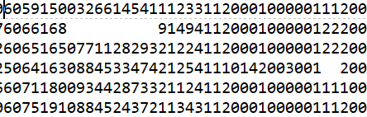

For example the « column » in yellow corresponds to the BMI (Body Mass Index) with the following code :
1 = underweight / 2 = normal weight / 3 = overweight / 4 = obese / 7 = don’t know / 9 = refuse to answer / <blank> = not asked or missing

Extract of the scraped table columns naming (via the Python library Beautiful Soup) :
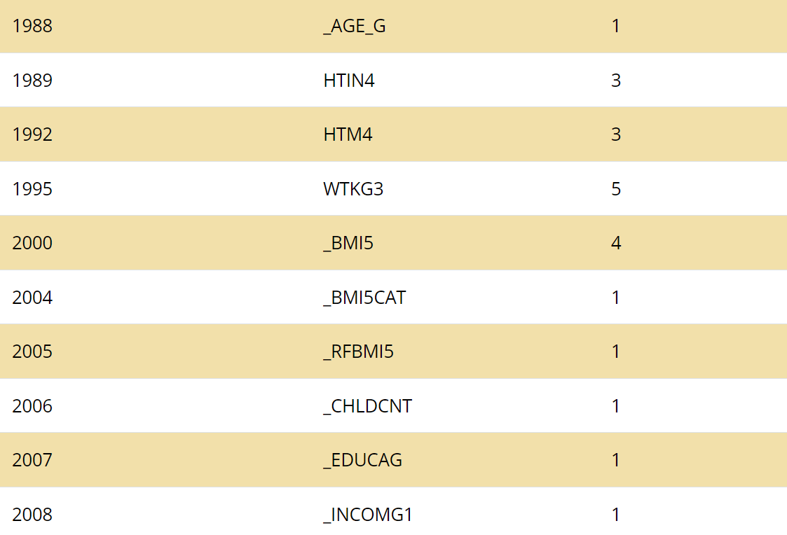

In a 170 pages pdf file, we can find the description for each of the Variable « Name », e.g. :

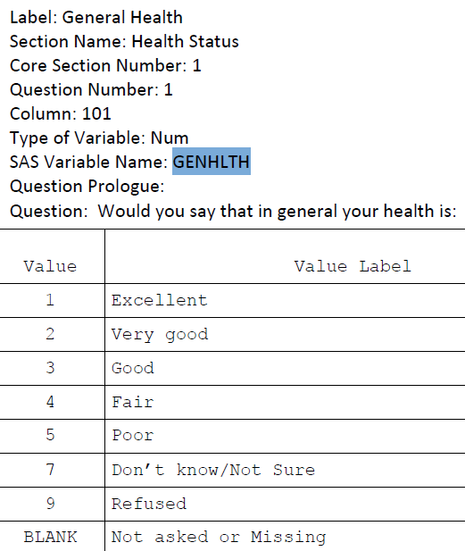
Many of the columns are not interesting for our analysis on CVD (cardio-vascular diseases) such as land line/cellular phone ?, own/rent ?, caregiver ?, firearms ?, ...
After studying the description, the following 30 variables were selected :
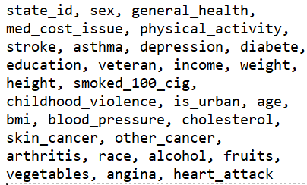

Both ‘skin cancer ‘ and «’other_cancer’ variables were removed and summed up in one variable.
The target variable that we will want to predict named ‘cvd’ (for cardio-vascular diseases) was built by combining ‘heart attack’ and ‘angina’.

The data from the ASCII file was extracted with Pandas and saved as a classical csv file.

II.2.1.2 Data Cleaning
Data type
In the origina ASCII file, all the data are numbers (some numerical and mostly categorical variables). For a better illustration of the data during the EDA, the numerical categories are replaced by meaningful names like ‘yes’/’no’ for ‘cvd’ or ‘underweight’/’overweight’/… for the ‘bmi’.

Duplicates
There are no duplicated rows.

Missing values
The plot below shows in white the missing values in the dataset after replacing « I don’t know » or « I refuse to answer » by empty values.
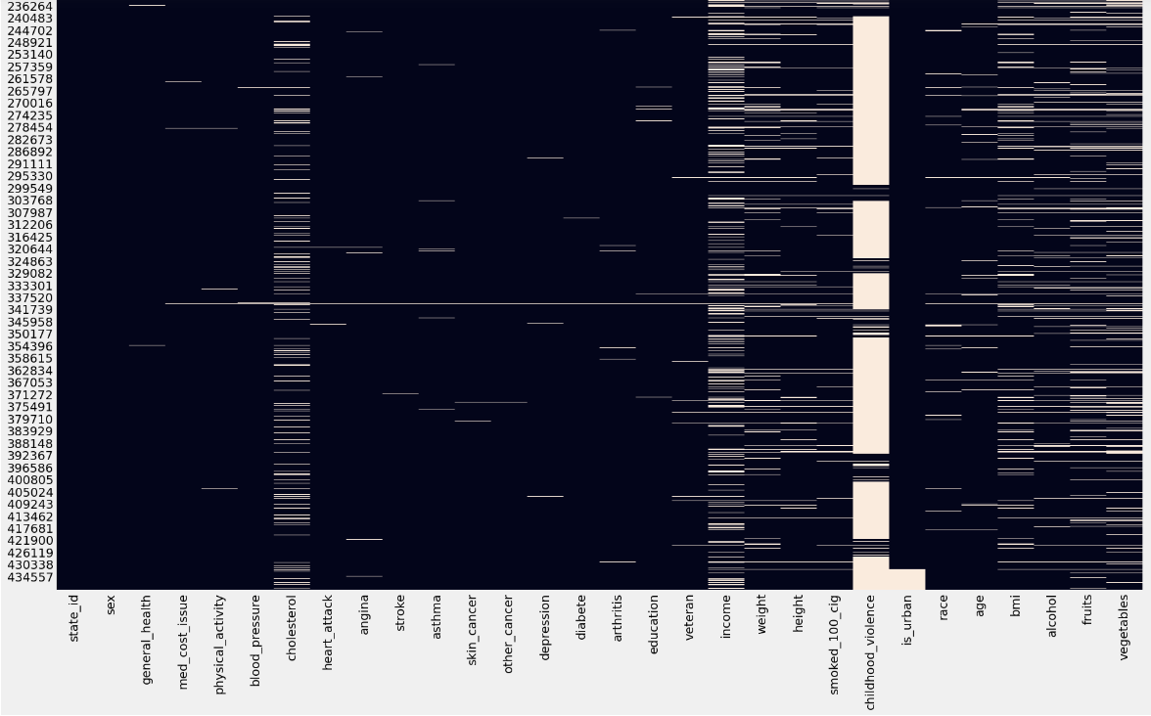
The feature ‘childhood_violence’ has too many missing data (85%) and is removed.
We also notice a white spot at the bottom (the rows are ordered by state of residence) for the is_urban column. This corresponds to 3 U.S. territories : Puerto-Rico, Guam and Virgin Island. A Google search show that they have only between 3 and 7 % of rural population so we impute the value 1.
The column ‘income’ has 33 % of missing data. We assume than the income is closely related to 2 variables available in the datset : age and education. So the data is grouped by age and education and the most frequent income category is chosen for each of these groups and used to replace the missing values.
As we have a lot of data and that it doesn’t seem possible to impute the remaining missing values, these rows are removed.
After this step, the dataset has 275k rows(persons).

Outliers
The heights and weights have a mix of imperial (mostly) and metric system. The heights are transformed to unit in meter and the weight to kilograms.

Fruits, vegetables and alcohol are also transformed to be a daily number of servings.

Even after these corrections, looking at a distribution plot for all the numerical variables, it appears that there are many outliers.
For fruits, vegetables and alcohol we can notice “strange” peaks at multiple of 100:
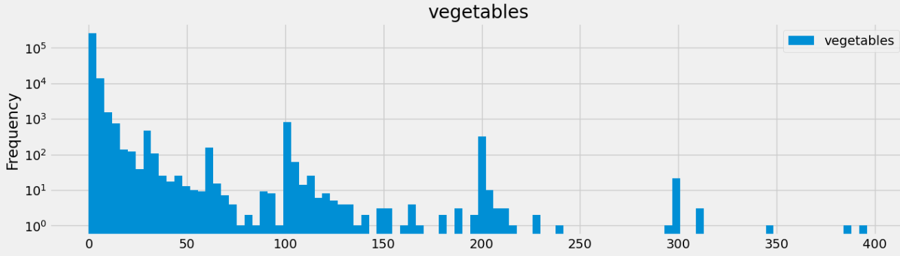
Looking at the origin of these variables, it appears that they are calculated by BRFSS from original data. For example, for the vegetables it is the sum of 4 types of vegetables.
Though it is not documented, and as for other original variables the code 99 means “refused” or “don’t know”, it seems that they forgot to remove the rows with the value 99 and added to the other vegetable variables as if it was a real number of vegetables. So we remove multiples of 99 around these peaks and get:
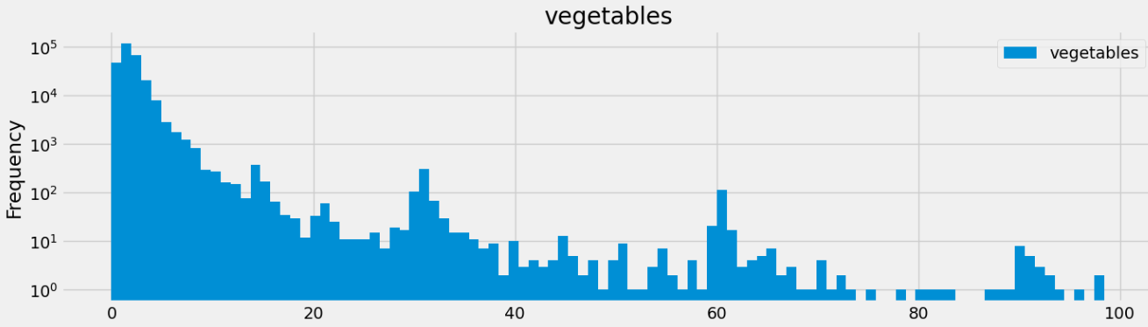
Now we can notice some peaks at multiples of 30. As some of the original variables were quantities per day and other per month, it looks like there were some confusion for some rows so we divide by 30 (to get a number per day) the values around these peaks.
After all these corrections there are still some outliers with values not reasonable. As a consequence the rows with a value over a chosen threshold shown below are removed from the data.
vegetables: 20 servings / day
fruits': 15 servings / day
alcohol: 8 glasses / day

For the height and weight, many outliers also appears on the distribution plots.
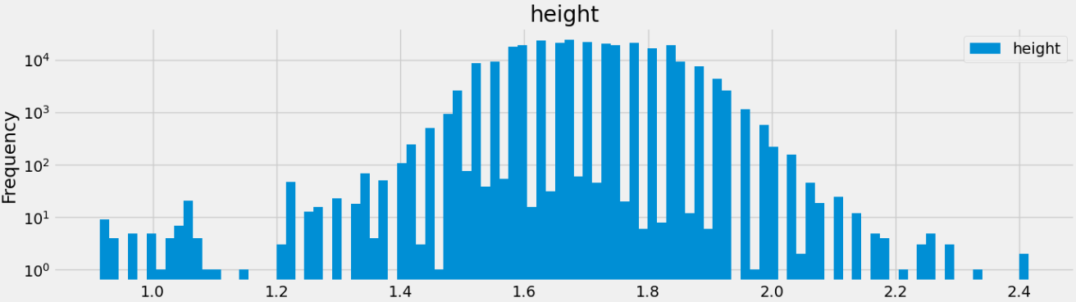
The gaps between bars are due to the fact that the data had a mix of imperial and metric units and that the imperial units were transformed to metrics. As the imperial system counts by inches (1 feet is 12 inches) and that 1 inch is 2.54cm, we have ‘peaks’ at multiples of 2.54 cm … which are not very aesthetic!
Also instead of a Gaussian distribution that was expected, the plot shows fat tails, certainly outliers.
One can wonders why there are so many outliers as all the survey respondents should be adults. One hypothesis: jokers. As the survey was done by phone, it is easy to invent answers for the minority of people who would find this funny. Especially as we can notice a lot of small heights, maybe some of these people are teenagers that answers the phone at their home and pretend to be one of their parent and though they lied on their age and probably other features some of them gave their real height and weight.
For example, there are 36 people whose height is more than 7 feet (2.13m) out of the 275,000 survey participants ie 1 out of 8,000 persons. But a quick search on Internet shows that it is estimated that there are 200 to 400 7-footers in the USA so roughly 1 out of 900,000 adults!
As a consequence, based on a biased ‘common sense’ the rows with values outside the below ranges were removed:
height: [1.30, 2.10] meter
weight: [45, 220] kilograms

II.2.2 API
The data from the API at datausa.io were clean and did not need transformations or corrections.
A request was sent with the requests Python library to the wanted endpoints like https://datausa.io/api/data?drilldowns=State&measures=Air%20Pollution&year=2021 and the json sent back was saved as csv file for later use.

II.2.3 Big Data System
The public datasets available on GCP datawarehouse bigquery was explored. An interesting dataset about Health set up by AHR was found. The useful columns of the dataset were extracted with SQL queries and the data downloaded as a csv files
CREATE TABLE `rehahn.final_project_ahr_filtered`
-- PARTITION BY measure_name
CLUSTER BY measure_name, subpopulation
AS
SELECT
measure_name,
state_name,
subpopulation,
value,
source
FROM `bigquery-public-data.america_health_rankings.ahr`
WHERE measure_name in
('Cancer', 'Smoking', 'Diabetes', 'Depression',
'Per Capita Income', 'Excessive Drinking',
'Physical Inactivity', 'Cardiovascular Diseases'
);

The original data has 18k rows and 10 columns. We extracted 6k rows and 5 columns of interest containing information on 9 variables linked to Health in particular Cardiovascular diseases and for 3 groups of sub-populations (education, sex and race).
The data sources are the CDC and the U.S. Census Bureau.

The 3 groups of sub-populations were all in the column ‘subdomain’ and all the 9 variables in the column ‘measure_name’ so the data had to be reshaped in Pandas (unstack) to be used with the other datasets collected.

III. Exploratory Data Analysis and Visualizations

IV. Database (SQL)

The different datasets obtained being in a structured and tabular format a relational database (MySQL) is naturally chosen to further the study the data and trying to find interesting information by combining the data from different sources.

IV.1 Creation of the database in MySQL Workbench
The tables created previously were imported inside MysQL WorkBench, the columns type adjusted as necessary and the Primary/Foreign keys constraints chosen as seen on the ERD.
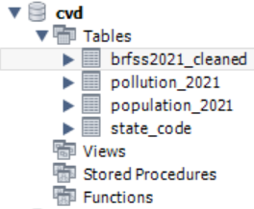

The Table Data Import Wizard was used to easily import the tables but the main table (brfss2021_cleaned) with 275k rows and almost 30 columns was too big as it would have required around 1h30 to import it. A solution was found by using the option “local infile” on the server and the client-side to load the data.
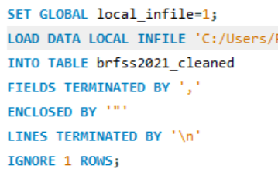
This enables to import the data in 7 seconds instead of 90 minutes!
Also to gain time and not enter manually the descriptions for the 30 fields, the import wizard was first used as it creates automatically the schema and stopped after few seconds. Then the content of the table was emptied before using the procedure above.

The Entity Relationship Diagram is shown below:
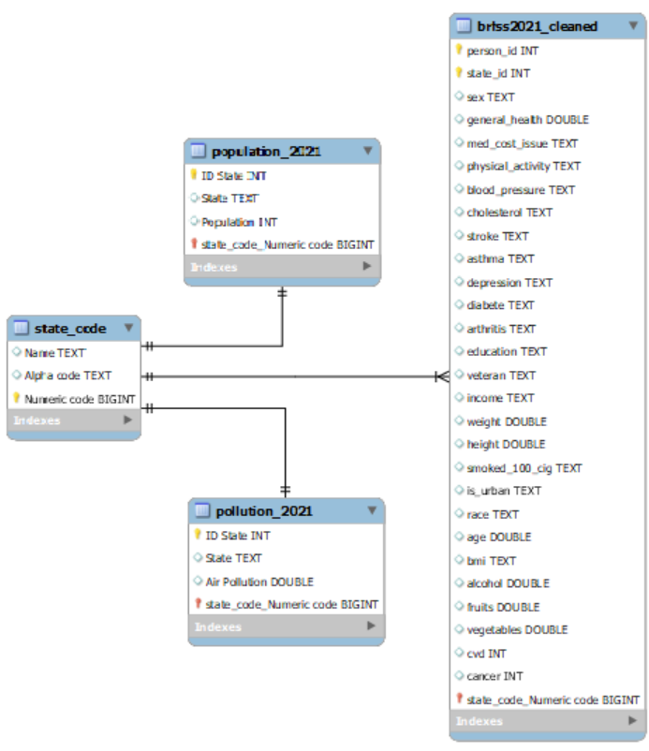

IV.2 SQL queries

To gain insights from the data the queries below were performed.

IV.2.1 Combine all the data in one table
A view joining the 4 tables together was first created as it will be useful for further analysis.
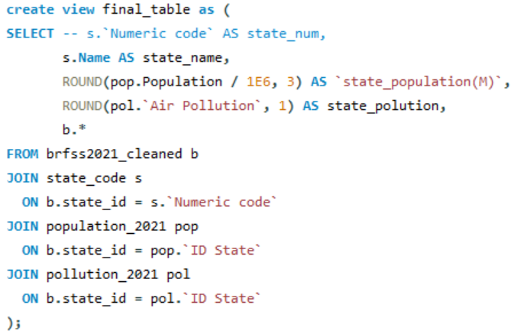
Extract output:
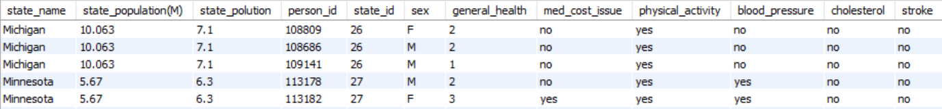

IV.2.2 Correlation between CVD and Income
A GroupBy function is used to study the relation between CVD and Income.
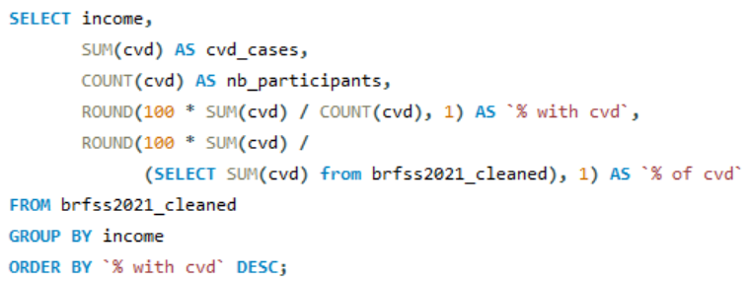

Output:
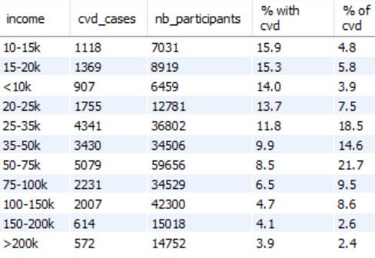
There is a clear correlation between Income and CVD.

IV.2.3 Correlation between CVD and Income
A GroupBy function is used to study the relation between CVD and Income.
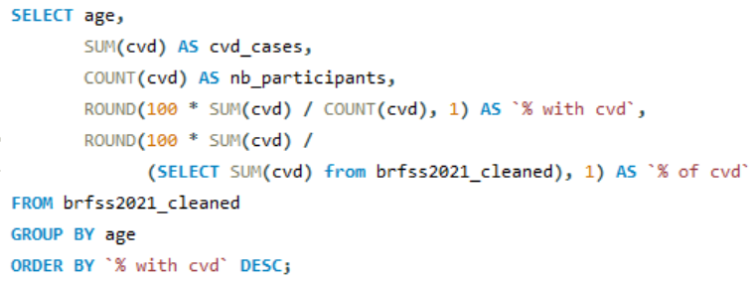

Output:
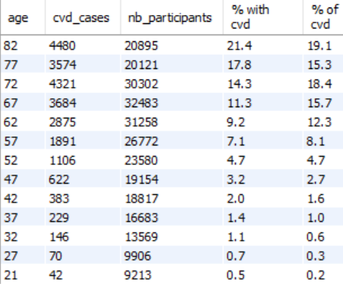
Here again we can notice a clear relationships between CVD and Age.

IV.2.4 Relation between air pollution and CVD
A subquery is made with a window function to normalize between 0 and 1 (MinMax scaling) the values in the columns CVD and Air Pollution and in the main query another window function is used to get the ranks on the 2 columns for each state.

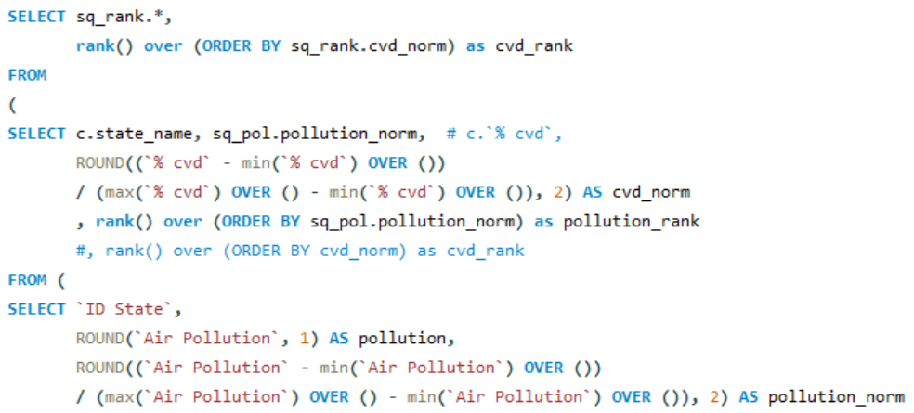
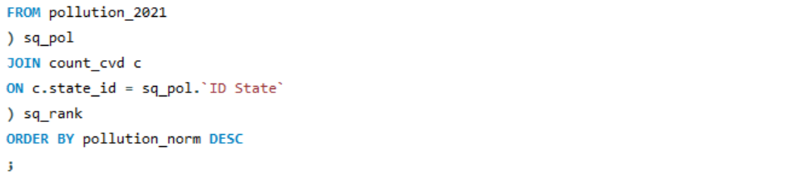

Output (extract):
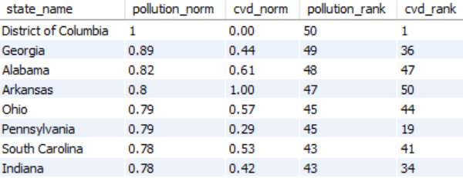
There is no clear correlation between both variables but except some important exceptions it may seem that relatively often the more pollution the more CVD. But in any case, the measures are the average per state which is certainly not local enough to draw a useful observation.

IV.2.5 CVD per state
A view with a subquery is also created to show the amount of persons who had a CVD in the past classified by U.S. state.

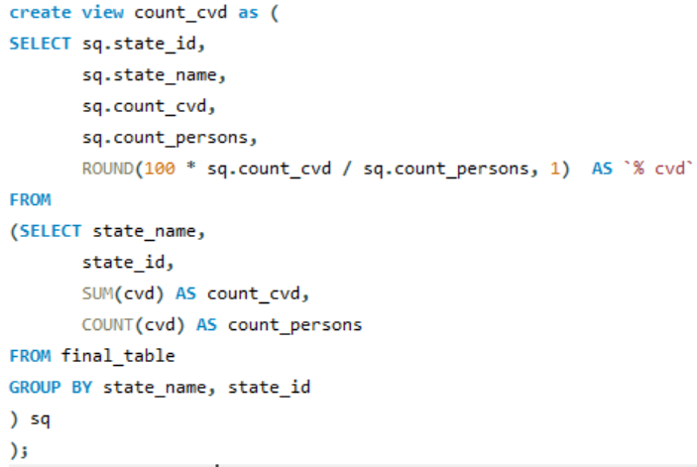

Top 5:
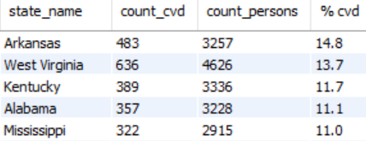
Bottom 5:
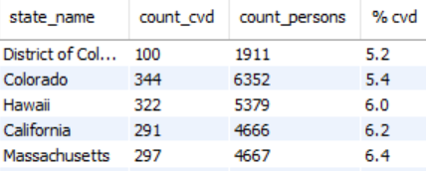

V. API

An API was created with the Pyhton library Flask in order for users to access the data that was prepared and analyzed in the previous parts of this report. The library pymysql is used to connect to the MySQL database created previously and send the SQL queries to retrieve the wanted data.
Four endpoints were created locally.

End Point 1: http://localhost:8080/persons/123
This API gives all the information available for a given person based on his ID.
Extract of the output:
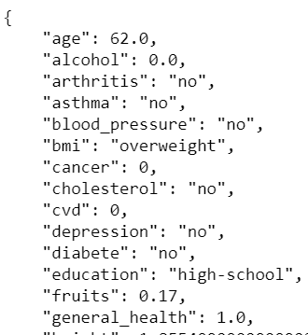

End Point 2: http://localhost:8080/persons?page=2&page_size=5
This API allows the user to request all the information in the main table from BRFSS. As there are 275k persons in the database, the user can add the optional parameters page and page_size to display the data for the page number chosen on the basis of the page_size given.
The API returns the data requested and the url of the next page and the url of the last possible page.
Extract of the output:
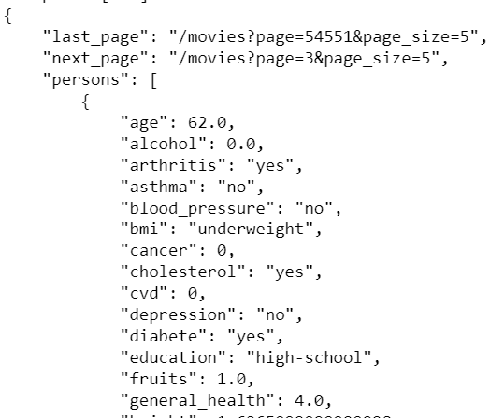

End Point 3: http://localhost:8080/states/pollution/texas
This API gives the air pollution level for the chosen state.

End Point 4: http://localhost:8080/states/population/california
This API gives the population for the chosen state.

Another endpoint http://localhost:8080/help gives the instructions to use this API as described above.

XX. Conclusion

Plan
- Objective
- Data
- Exploratory analysis/vizualisation
- SQL, no nosql, create db+tables in mysq, erd, l, 5 scripts
- API
- Conclusion

biais du survivant!!

