#Task 1

file_name = 'good_file.csv'

file = open(file_name, 'w')

for i in range(1,11):

file.write(input('Good :'))

file.write(',')

file.write(input('Price :'))

file.write(',')

file.write(input('Expiration :'))

file.write('\n')

file.close()

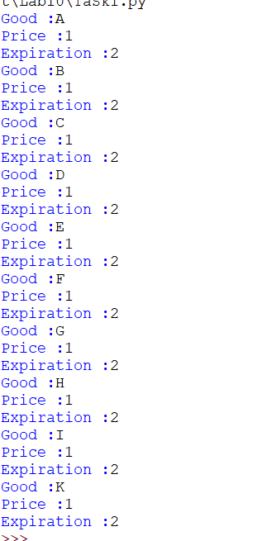

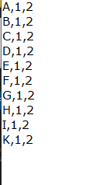

# Task 2

fiel=open('exam-results.txt', 'r')

s_f=open('st.txt', 'w')

c=0

while c <=10:

p = fiel.readline()

if c >= 2:

s_f.write(p)

c = c+1

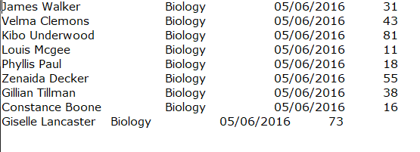

# Task 3

f=open('exam-results.txt', 'r')

d = f.read().split('\n')

print(len(d))

