ABP — Milestone 1, Part A: Onboarding + Authentication
Build Documentation (UI-Only Build — for AI coding agent / developer handoff)
Scope of this document: Onboarding screen + Authentication UI (Sign Up, Sign In, Password Reset) — pixel/UI layer only.
Supabase is intentionally NOT wired up in this step. Buttons, forms, and navigation should all work using local/mock state (form validation, loading spinners triggered by a fake delay, etc.), so the UI is fully clickable and demo-able on its own. Real Supabase auth calls are a separate next step, once this UI is approved.
Mare / Breeding / Embryo Transfer / Camera & Gallery / Schema work will be delivered as a separate documentation part once those Figma screens are finalized.
Architecture: Flutter, Feature-First folder structure, built so later milestones (Mare, Dog module, multi-user, offline, notifications) slot in cleanly.

1. Design System (extracted directly from the Figma exports)

1.1 Colors
Token | Hex | Usage
background | #0A192F | Primary app background (dark navy)
surface | #112240 | Icon containers, elevated surfaces
inputField | #131B2D | Text field background
inputBorder | #080E1A | Text field border (default state)
primaryGold | #D4AF37 | Headings, labels, links, active states
goldGradientStart | #D6B23F | CTA button gradient start
goldGradientEnd | #EDD086 | CTA button gradient end
textPrimary | #FFFFFF | Titles on dark background
textSecondary | #8A8F98 | Body copy / descriptions
textMuted | #525358 | Fine print, footer captions

1.2 Typography
- Display/Headline ("Animal BirthDay Predictor", "Welcome Back"): Serif display face, ~28–32sp, gold or white.
- Section Label ("WHY ABP?", "OR CONTINUE WITH"): Small caps, letter-spaced, gold, ~11–12sp.
- Feature Title ("Precision Tracking" etc.): Sans-serif, semi-bold, gold, ~16sp.
- Body (descriptions, subtitles): Sans-serif regular, textSecondary, ~14sp, line-height ~1.5.
- Button label: Sans-serif bold, dark navy text on gold gradient buttons.
Build these as AppTypography constants — don't inline sizes per screen.

1.3 Shape & Spacing
- Card / button corner radius: ~16px (pill-style on the primary CTA).
- Icon containers: ~48x48px, rounded square (~12px radius), surface background, gold icon glyph.
- Screen horizontal padding: ~24px.
- Section vertical spacing: ~32–40px between major blocks.

1.4 Core Reusable Components (core/widgets/)
Component | Used in
GradientCtaButton | Onboarding CTA, Sign Up, Sign In, Password Reset
SectionDividerLabel | "WHY ABP?", "OR CONTINUE WITH", "SOCIAL ACCESS"
FeatureListItem | Onboarding's 3 feature rows
AuthHeaderBanner | One component, reused 3x with different image/icon/title/subtitle — not three separate widgets
CustomTextField | All form fields (leading icon, label, placeholder, optional trailing action)
SocialAuthButton | Apple / Google buttons
TrustCard | Onboarding testimonial image block

2. Screens

2.1 Onboarding Screen
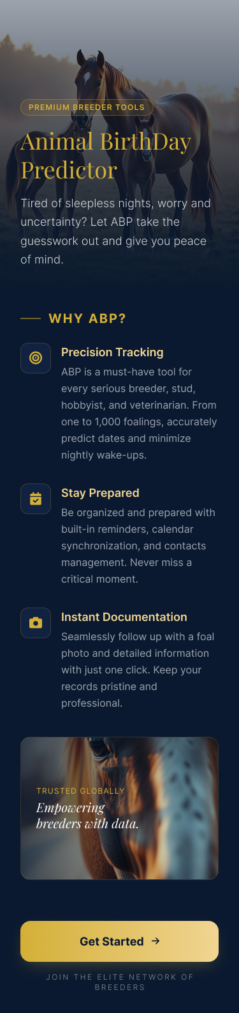
Reference: onboarding_screen.png — selected base design (3 alternate concepts shared earlier are not being built — see Section 7)
Layout (top to bottom):
- Full-bleed hero image (horse + foal), dark gradient overlay so text stays readable.
- Pill badge: PREMIUM BREEDER TOOLS.
- Title: "Animal BirthDay Predictor" — serif, gold, two lines.
- Subtitle: "Tired of sleepless nights, worry and uncertainty? Let ABP take the guesswork out and give you peace of mind."
- SectionDividerLabel: WHY ABP?
- Feature — Precision Tracking (bullseye icon): "ABP is a must-have tool for every serious breeder, stud, hobbyist, and veterinarian. From one to 1,000 foalings, accurately predict dates and minimize nightly wake-ups."
- Feature — Stay Prepared (calendar-check icon): "Be organized and prepared with built-in reminders, calendar synchronization, and contacts management. Never miss a critical moment."
- Feature — Instant Documentation (camera icon): "Seamlessly follow up with a foal photo and detailed information with just one click. Keep your records pristine and professional."
- TrustCard: rounded horse close-up image, overlay text "TRUSTED GLOBALLY" + "Empowering breeders with data."
- GradientCtaButton: "Get Started →" — full width.
- Footer caption: JOIN THE ELITE NETWORK OF BREEDERS.
UI-only behavior for this step:
- Screen scrolls vertically.
- "Get Started" navigates to Sign Up screen (plain navigation call — no session/state check needed yet).
- Skip the "only show once" local-storage logic for now; that's a small addition wired in alongside the real auth logic next step.

2.2 Authentication Screens
The three AuthHeaderBanner images below are one reusable component — build it once with backgroundImage, icon, title, subtitle as parameters, not three separate widgets. The blue dashed box visible on the "Welcome Back" export is a Figma selection marker, not part of the actual UI — ignore it.
Join the Mystery | Welcome Back | Lost Your Way?
 | 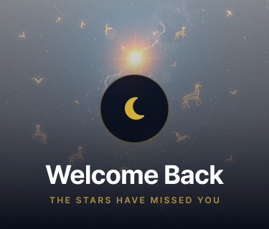 | 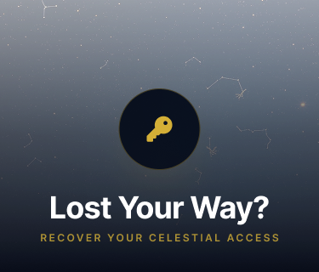

A. Sign Up Screen
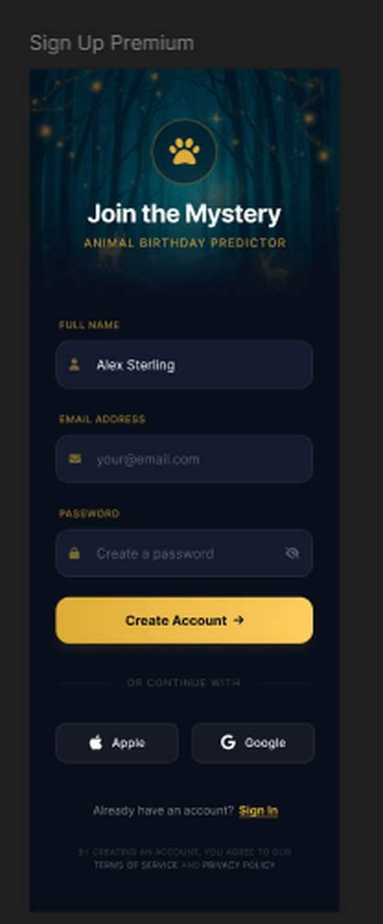
- Header banner: forest/firefly background, gold paw icon, title "Join the Mystery", subtitle "ANIMAL BIRTHDAY PREDICTOR".
- Fields: Full Name ("Alex Sterling"), Email Address ("your@email.com"), Password ("Create a password", show/hide toggle).
- Primary CTA: "Create Account →"
- Divider: OR CONTINUE WITH
- Social buttons: Apple, Google
- Footer: "Already have an account? Sign In" → navigates to Sign In screen.
- Fine print: "By creating an account, you agree to our Terms of Service and Privacy Policy" (no destination page yet — leave as plain text or a disabled link for now).
UI-only behavior for this step:
- Validate Full Name (non-empty), Email (format), Password (min 8 characters — placeholder rule, confirm final rule later).
- "Create Account" button: show a loading state briefly (mock/fake delay), then navigate to a placeholder next screen (real Supabase signUp call comes in the next step).
- Apple/Google buttons: wire up the tap target and pressed state; the actual OAuth call is deferred.

B. Sign In Screen
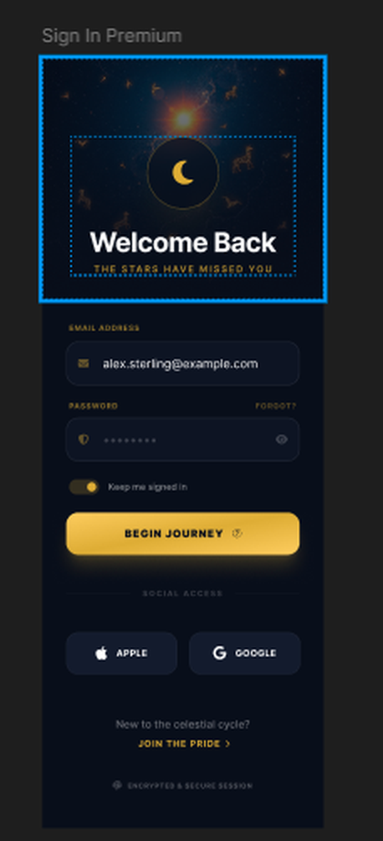
- Header banner: starry sky, gold crescent-moon icon, title "Welcome Back", subtitle "THE STARS HAVE MISSED YOU".
- Fields: Email Address ("alex.sterling@example.com"), Password (with "Forgot" link), "Keep me signed in" toggle.
- Primary CTA: "Begin Journey ✦"
- Divider: SOCIAL ACCESS
- Social buttons: Apple, Google
- Footer: "New to the celestial cycle? Join the Pride →" → navigates to Sign Up.
- Small trust line: "Encrypted & Secure Session"
UI-only behavior for this step:
- Validate Email + Password required.
- "Forgot" link → navigates to Password Reset screen.
- "Begin Journey" button: mock loading state → placeholder navigation (real signInWithPassword call deferred).
- "Keep me signed in" toggle: just needs to visually switch state for now; real persistence behavior decided before the logic step.

C. Password Reset Screen
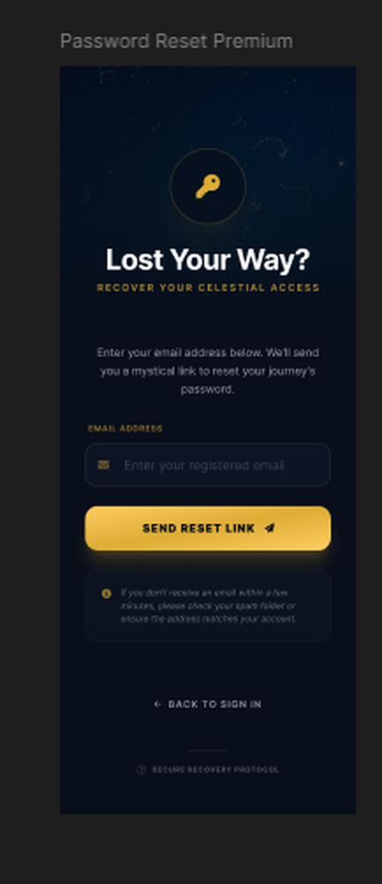
- Header banner: starry sky, gold key icon, title "Lost Your Way?", subtitle "RECOVER YOUR CELESTIAL ACCESS".
- Body copy: "Enter your email address below. We'll send you a mystical link to reset your journey's password."
- Field: Email Address ("Enter your registered email").
- Primary CTA: "Send Reset Link ➤"
- Info note box: "If you don't receive an email in a few minutes, please check your spam folder or ensure the address matches your account."
- Footer: ← Back to Sign In
- Small trust line: Secure Recovery Protocol
UI-only behavior for this step:
- Validate email format.
- "Send Reset Link": mock loading state → swap the form for a "check your email" confirmation UI (this state-swap should be built now, even though the actual email isn't sent yet — it's a UI state, not a backend call).

3. Feature-First Folder Structure (Flutter)
Feature-first: each feature owns its own screens/widgets/state, with only truly shared pieces (design tokens, shared widgets) living in core/. This step only needs the presentation layer per feature — domain/data folders are stubbed as empty placeholders now and filled in during the Supabase/logic step, so the structure doesn't need to be reshuffled later.
lib/
├── main.dart
├── core/
│ ├── constants/
│ │ ├── app_colors.dart
│ │ ├── app_typography.dart
│ │ └── app_spacing.dart
│ ├── theme/
│ │ └── app_theme.dart
│ ├── router/
│ │ └── app_router.dart
│ └── widgets/
│ ├── gradient_cta_button.dart
│ ├── section_divider_label.dart
│ ├── feature_list_item.dart
│ ├── auth_header_banner.dart
│ ├── custom_text_field.dart
│ ├── social_auth_button.dart
│ └── trust_card.dart
│
└── features/
├── onboarding/
│ └── presentation/
│ ├── screens/
│ │ └── onboarding_screen.dart
│ └── widgets/
│ └── (onboarding-specific widgets, if any)
│
└── auth/
└── presentation/
├── screens/
│ ├── sign_up_screen.dart
│ ├── sign_in_screen.dart
│ └── password_reset_screen.dart
├── widgets/
│ └── (auth-specific widgets, if any)
└── state/
└── auth_form_state.dart # local-only form/loading state (no network) for this step
# domain/ and data/ folders intentionally deferred to the Supabase step
Why this ordering works: because domain/data for auth are just not created yet (rather than created empty and unused), there's nothing to rip out later — the next step adds those folders and swaps auth_form_state.dart's fake-delay logic for real repository calls, without touching how the screens are built.

4. State Management (UI-only step)
Use simple local state (StatefulWidget + setState, or a lightweight ChangeNotifier/StateNotifier scoped to each screen) to handle:
- Form field values and validation errors.
- An isLoading boolean toggled by a fake Future.delayed(...) when a button is tapped, so the loading spinner/disabled-button UI can be built and tested now.
- Password-reset success state swap (form → confirmation view).
No app-wide auth state, no Riverpod/Bloc provider wiring to a backend yet — that architecture decision can be made in the next step once real Supabase calls are being introduced, since it affects the app more broadly than this UI-only pass does.

5. Open Items (flagged, not blockers for this UI-only step)
- Password minimum-length/complexity rule — using 8 characters as a placeholder; confirm before the logic step.
- Terms of Service / Privacy Policy destination pages — don't exist yet; leave as plain text/disabled link.
- "Keep me signed in" toggle's real behavior — decide before wiring actual session persistence.
- Whether Sign Up leads to an email-confirmation state or straight into the app — depends on Supabase project settings, decided in the next step.

6. Assets Needed
- onboarding_screen.png (hero + trust card imagery)
- auth_header_join_the_mystery.png, auth_header_welcome_back.png, auth_header_lost_your_way.png (the 3 AuthHeaderBanner backgrounds)
- Icon set: paw, crescent moon, key, target/bullseye, calendar-check, camera, Apple logo, Google "G" logo, eye/eye-off
- Export all at 2x/3x from Figma into assets/images/ and assets/icons/, registered in pubspec.yaml.
All reference screen exports for this document are embedded above at each relevant section.

7. Design Variants Not Used (for reference only)
Three alternate onboarding concepts were shared alongside the selected one — logged here for traceability, not part of this build:
- "Precision Breeding" concept (avatar row + "Trusted by Elite Studs")
- "Redefining Excellence" concept (testimonial card, "500+ Elite Studs Registered")
- "Elevating the Standard of Care" concept (icon set variant, "Join 500+ Elite Studs")

