PIZZA SALES PROJECT QUERIES
A. KPI's
1. Total Revenue:
SELECT SUM(total_price) AS total_revenue FROM PIZZA_SALES;
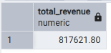
2. Total Orders:
SELECT COUNT(DISTINCT order_id) AS total_orders FROM PIZZA_SALES;
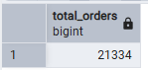
3. Average Order Value:
SELECT ROUND(SUM(total_price) / COUNT(DISTINCT order_id),2) AS average_order_value FROM PIZZA_SALES;
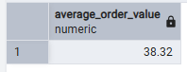
4. Total Pizzas Sold:
SELECT SUM(quantity) AS total_pizza_sold FROM PIZZA_SALES;
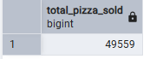
5. Average Pizzas Per Order:
SELECT SUM(quantity) / COUNT(DISTINCT order_id) AS avg_pizza_per_order FROM PIZZA_SALES;
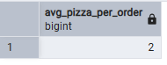
B. Trend & Distribution Analysis
6. Monthly Trend for Total Revenue:
SELECT TO_CHAR(order_date, 'MONTH') AS month, SUM(total_price) AS total_revenue FROM PIZZA_SALES GROUP BY TO_CHAR(order_date, 'MONTH'), EXTRACT(MONTH FROM order_date) ORDER BY EXTRACT(MONTH FROM order_date);
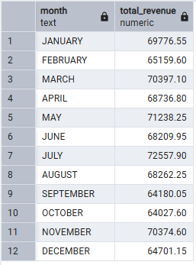
7. Daily Trend for Total Orders:
SELECT TO_CHAR(order_date,'DAY') AS days, COUNT(DISTINCT order_id) AS total_orders FROM PIZZA_SALES GROUP BY TO_CHAR(order_date,'DAY'), EXTRACT(ISODOW FROM order_date) ORDER BY EXTRACT(ISODOW FROM order_date);
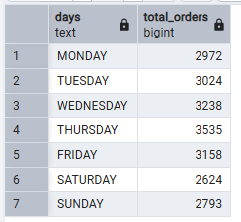
8. Percentage of Sales by Pizza Category:
SELECT pizza_category, round(SUM(total_price) * 100.0 / (SELECT SUM(total_price) FROM PIZZA_SALES),2) AS sales_in_percentage FROM PIZZA_SALES GROUP BY pizza_category;
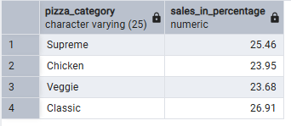
9. Percentage of Sales by Pizza Size:
SELECT pizza_size, round(SUM(total_price) * 100.0 / (SELECT SUM(total_price) FROM PIZZA_SALES),2) AS sales_in_percentage FROM PIZZA_SALES GROUP BY pizza_size;
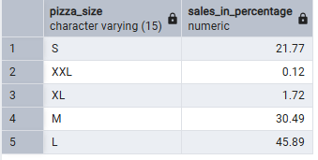
10. Total Pizzas Sold by Pizza Size and Category:
SELECT pizza_category, pizza_size, SUM(quantity) AS total_pizza_sold from PIZZA_SALES GROUP BY pizza_category, pizza_size ORDER BY pizza_category;
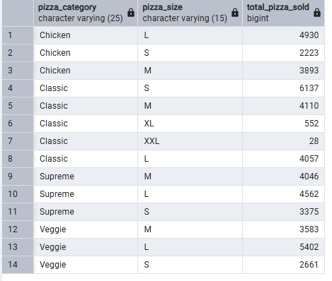
11. Top 5 Pizza Names by Revenue:
SELECT pizza_name, SUM(total_price) AS total_revenue FROM PIZZA_SALES GROUP BY pizza_name ORDER BY SUM(total_price) DESC LIMIT 5;
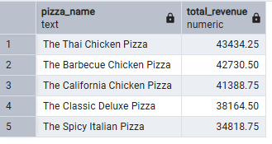
C. Top / Bottom Analysis
12. Top Pizza by Revenue:
SELECT pizza_name, SUM(total_price) AS total_revenue FROM PIZZA_SALES GROUP BY pizza_name ORDER BY SUM(total_price) desc LIMIT 1 ;
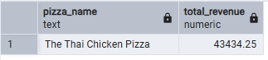
13. Worst Pizza by Revenue:
SELECT pizza_name, SUM(total_price) AS total_revenue FROM PIZZA_SALES GROUP BY pizza_name ORDER BY SUM(total_price) LIMIT 1 ;
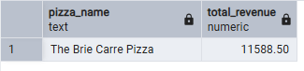
14. Top Pizza by Orders:
SELECT pizza_name, COUNT(DISTINCT order_id) AS total_orders FROM PIZZA_SALES GROUP BY pizza_name ORDER BY COUNT(DISTINCT order_id) DESC LIMIT 1 ;
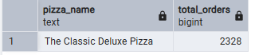
15. Worst Pizza by Orders:
SELECT pizza_name, COUNT(DISTINCT order_id) AS total_orders FROM PIZZA_SALES GROUP BY pizza_name ORDER BY COUNT(DISTINCT order_id) LIMIT 1 ;
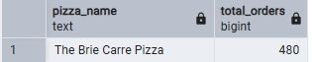
16. Top Pizza by Quantity Sold:
SELECT pizza_name, SUM(quantity) AS total_quantity FROM PIZZA_SALES GROUP BY pizza_name ORDER BY SUM(quantity) DESC LIMIT 1 ;
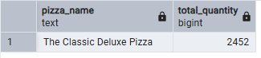
17. Worst Pizza by Quantity Sold:
SELECT pizza_name, SUM(quantity) AS total_quantity FROM PIZZA_SALES GROUP BY pizza_name ORDER BY SUM(quantity) LIMIT 1 ;
