BOOOM More Product and Design Brief
Producer and developer specification | Draft 1 | 25 September 2026
BOOOM More is a proposed AI campaign workspace for entrepreneurs and small teams. This brief defines a responsive web product that takes a business brief through audience choice, campaign concepts, editable assets, budget planning, and export. It separates the first release from connected ad accounts and performance optimization, so the initial build can be estimated and tested on its own.
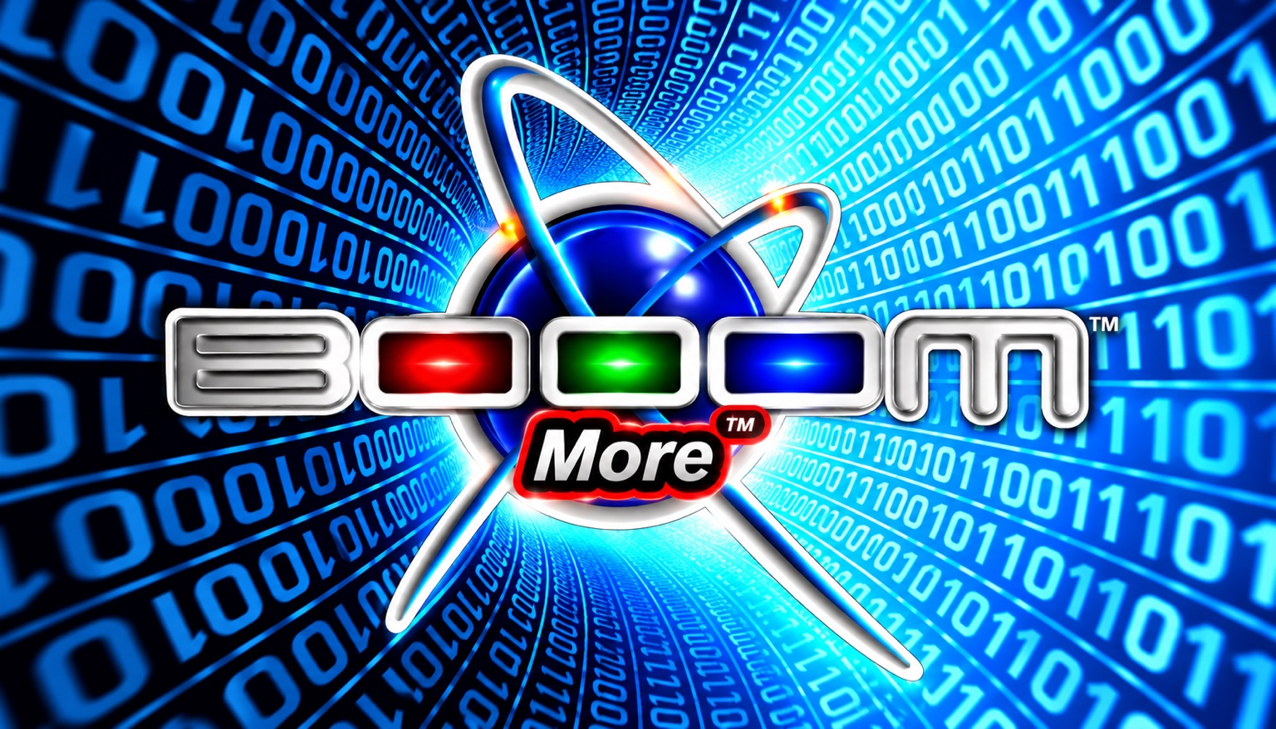
Supplied BOOOM More logo. The visual system below interprets its blue data tunnel, orbital form, chrome lettering, and red, green, and blue lights; production artwork and trademark usage require owner review.

1 Product decision
Product promise. Make more from an idea: one guided workspace for campaign strategy, creative, and budget.
Primary user. A founder, independent marketer, or small agency operator preparing a campaign without a large creative team.
Core job. Create a coherent, editable campaign package quickly enough to test in market, while retaining human judgment and control.
Platform. Responsive web application, designed desktop first for editing and fully usable on mobile. Native iOS and Android apps are outside the first release.
Positioning. BOOOM More is the hands-on product expression of Generate Campaign, Identify Target, Manage Conversions, and Allocate Budget. In the first release, conversion management means goals, tracking instructions, and review prompts; live conversion data requires integrations.

2 Scope and release boundaries
Capability | First release | Later release
Campaign creation | Guided brief, AI concepts, editable channel assets, export | Brand kits for teams, approval workflows, asset variants at scale
Target identification | User defined inputs and AI audience hypotheses with reasons | Connected first party audience analysis and testing
Budget allocation | Editable scenario and estimates with stated assumptions | Channel performance based recommendations
Conversions | Goal and measurement plan, manual result entry | Ad and analytics connections, attribution, automated recommendations
Publishing | Copy or download assets; user publishes externally | Direct publishing after explicit per action approval

Excluded from first release: autonomous ad spend, claims of guaranteed revenue or return on ad spend, buying media, billing for ad platforms, automated posting, and unlicensed use of third party creative.

3 Primary user flow
- Create a project, add a business name, website or description, brand assets, location, offer, goal, timing, and indicative budget.
- Review a structured brief; fill missing essentials and confirm the offer, audience constraints, and conversion goal.
- Compare suggested audience hypotheses and select or edit the target for this campaign.
- Generate three campaign directions; compare their angle, promise, example headline, channels, and rationale.
- Choose one direction and produce editable copy and visual briefs by channel.
- Set a budget and see a transparent allocation with assumptions and a manual adjustment control.
- Review the campaign package, approve its components, export it, and optionally record results later.

4 Screen by screen requirements

4.1 Public landing page
Purpose: explain the product and move a visitor to a sample or account creation. Hero shows the full BOOOM More mark and a short animated transition into a real campaign preview. Include the four service capabilities, an example output, a clear call to action, pricing or waitlist placement when determined, and contact and legal links. Avoid presenting generated examples as real client outcomes.

4.2 Account and project dashboard
Sign in, create a project, resume a draft, duplicate a campaign, and see each project’s status and last edit. Empty state leads directly to the brief. Provide account, billing placeholder, privacy, export, and project deletion settings. A single owner role is sufficient for the first release.

4.3 Campaign brief
Fields: business and offer; product URL optional; one sentence description; target geography and language; desired action; price or offer terms; differentiators; brand voice; exclusions; campaign dates; total budget and currency; channels of interest; uploaded logo and reference assets. Mark required fields, support autosave, and allow users to review a normalized AI summary before generation. A URL may provide suggestions only after the user confirms extracted facts.

4.4 Identify Target
Show two to four editable audience hypotheses. Each card contains audience definition, likely need, motivation, objection, message angle, likely channels, and “based on” inputs. Label inferred traits as hypotheses. Users can select one primary audience, add exclusions, or supply their own. Do not infer protected or sensitive traits for ad targeting.

4.5 Generate Campaign
Show three substantively distinct campaign directions: name, central promise, sample headline, key message, creative concept, channel fit, risks, and rationale. The user compares, chooses, edits, or regenerates a single direction. Provide a brief history so regeneration cannot silently erase a selected idea.

4.6 Creative workspace
Tabs for campaign overview, landing page outline, short and long ad copy, email, social post, and visual production brief. Each asset has editable fields, character guidance where appropriate, regenerate this field, save version, copy, and approval status. Images may be added as a later phase; the first release should generate image directions rather than promising finished visual assets.

4.7 Allocate Budget
Accept total budget, dates, and available channels. Show recommended channel amounts and percentages; users can lock a channel and rebalance the rest. Explain each assumption and show the sum must equal the total. Separate media budget from optional production cost. Forecasts, if offered, must be ranges with input assumptions and clear uncertainty; the simplest first release can omit forecasts.

4.8 Manage Conversions
Define the desired action, landing destination, tracking checklist, and review cadence. Let the user enter actual spend, leads, sales, and revenue manually. Display straightforward calculations with definitions and missing data states. Recommendations are advisory and reference the entered data; there is no live optimization or automatic account action in the first release.

4.9 Review and export
Show an approval checklist for brief, target, concept, assets, budget, and measurement plan. Export a clean campaign brief as PDF and editable text or document format; support copying individual assets. Include selected assumptions, generation date, and a version label. Never imply an unapproved output has been published.

5 Visual and interaction system
Element | Direction
Brand expression | Full supplied art in launch, marketing, and selective transitions. Create a simplified vector wordmark and compact symbol for product UI; do not merely shrink the detailed JPEG.
Color | Near black navy base; saturated blue as primary action; icy cyan for data and active states. Red, green, and blue from the logo become restrained capability accents. Final accessible values require design testing.
Surface | Quiet dark workspace with legible high contrast text and neutral content panels. A light reading mode may be explored; dark is the initial brand direction.
Type | Distinctive display face for short brand moments; clean highly legible interface face for inputs, long AI text, tables, and mobile.
Motion | Short orbital or data burst transition at campaign generation; subtle progress feedback elsewhere. Respect reduced motion settings.
Components | Large concept cards, side by side comparison on desktop, stacked cards on phone, persistent save state, obvious edit and undo controls.

Accessibility target: keyboard operable core flows, visible focus, labels and error messages, text alternatives, and contrast appropriate to WCAG 2.2 AA. Color alone must not convey status. Request vector logo files and confirm rights to reuse and adapt the mark.

6 AI behavior and quality controls
- Use a staged generation pipeline: normalize brief, produce target options, produce concept options, expand the selected concept, then plan budget and measurement. Store each stage as structured data.
- Ground outputs in the user brief. Show input provenance and mark external or model inferred assumptions. Ask for missing facts instead of inventing prices, results, testimonials, credentials, or product claims.
- Give every generation a project version, prompt or template version, model identifier, timestamp, and user edits. The user can restore a prior version.
- Regeneration changes only the selected section unless the user explicitly regenerates the whole campaign. Preserve approved content.
- Validate required fields and output structure, detect contradictory budgets and dates, and flag potentially unsupported health, financial, or performance claims for review.
- Disclose that AI suggestions require review. User approval is mandatory before export is marked final; any future posting or spend action requires separate explicit authorization.
- Provide usable error recovery: retry a failed stage, preserve existing work, and show a specific error message without exposing private prompts or credentials.

7 Data and engineering requirements
Core objects. User, workspace, project, brand profile, campaign brief, audience hypothesis, concept, asset, budget plan, metric entry, export, and revision. Each belongs to a project with clear ownership.
Application design. Responsive client, authenticated application API, relational project store, private asset storage, background generation jobs, and an AI provider adapter so the model can be changed. The implementation team may select the stack in its estimate.
Security. Encrypted transport and storage, private projects by default, least privilege access, secrets held server side, rate limits, upload validation, and deletion of projects and uploaded assets. Define retention and AI provider data handling before launch.
Operations. Monitoring for job failures and latency, audit events for important edits and exports, backup and restore plan, environment separation, and a way to pause costly generation.
Performance. Save edits promptly and show generation progress. Generation may take longer than navigation; jobs must survive a page refresh. Establish measured service targets during implementation, not invented guarantees in marketing.
Analytics. Track activation, brief completion, audience selection, concept selection, asset edits, export, return use, generation failures, and per project AI cost. Do not place private campaign text into routine analytics events.

8 Acceptance criteria for first release
- A new user can create, save, leave, and resume a campaign on desktop and mobile without losing entered or edited content.
- The user can complete all stages from brief through export without any ad account connection.
- Three concept options are distinct and editable; regeneration of one asset retains all other approved work.
- Every budget line is editable and the displayed allocations total exactly the entered budget after rebalancing.
- AI output does not state invented business facts as established facts; inferred claims and assumptions are identifiable.
- A failed generation or interrupted connection does not erase the existing project, and the user can retry.
- The exported campaign matches the selected versions and includes the target, creative, budget, and measurement plan.
- Core flows pass keyboard, screen reader, mobile layout, and contrast checks before release.

9 Production sequence and estimate request
Phase | Producer or developer output | Decision gate
Discovery | Confirm target customer, pricing approach, sample campaigns, data policy, and success metric | Approve product scope and test content
Design | User flow, content model, vector logo adaptation, component system, responsive prototype | Approve screens and visual system
Build | Accounts, project persistence, staged AI generation, editors, budget planner, exports | Internal functional review
Pilot | Test with 5 to 10 representative users and varied campaign briefs; fix failures | Approve launch requirements
Launch | Production deployment, monitoring, support process, analytics baseline | Go live decision

Ask each bidder for an itemized estimate by phase and screen, assumptions, exclusions, schedule, team roles, third party and AI usage costs, ownership of code and designs, security approach, acceptance testing, warranty, and post launch support. Request a clickable prototype and fixed scope milestone definition before a final build price.

10 Decisions for BOOOM to confirm
- First paying customer: founder, internal marketing team, or agency serving clients?
- Preferred brand line and the meaning, if any, of the red, green, and blue lights.
- Pricing model and whether a free sample campaign is offered.
- Launch languages and markets, with English and US suggested for the initial estimate.
- Whether finished AI images are essential at launch; this draft scopes production briefs first.
- Whether the platform carries the BOOOM master brand alone or a distinct BOOOM More product identity.
Owner review of these choices can refine the estimate without changing the core user journey.

