AWS-CERTIFIED-CLOUD-PRACTITIONER

UDEMY: <https://fiserv.udemy.com/course/aws-certified-cloud-practitioner-new/learn/lecture/19891628#labs>

Creating an AWS Account

Registration: <https://signin.aws.amazon.com/signup?request_type=register>

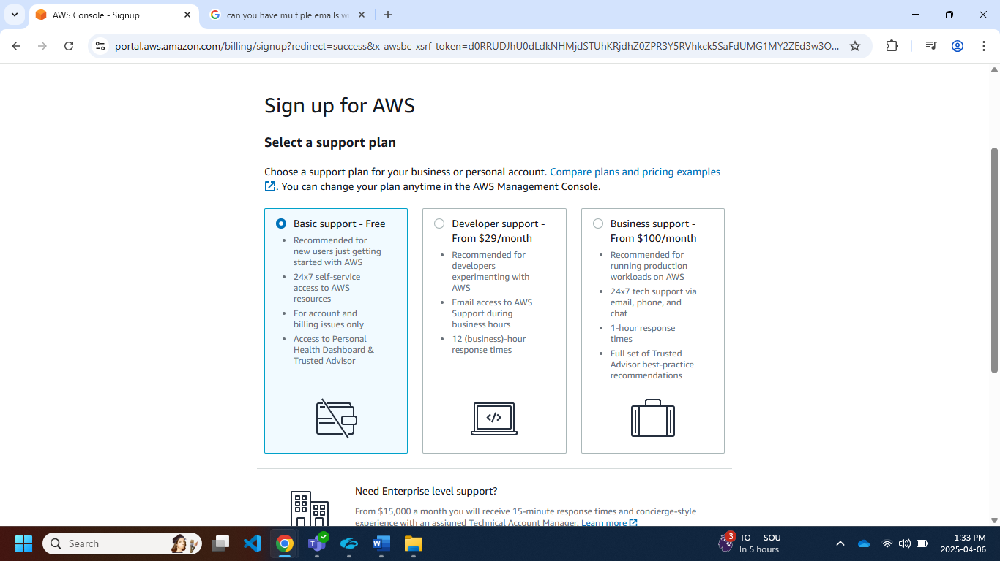

**IT Terminology**

• Network: cables, routers and servers connected with each other

• Router: A networking device that forwards data packets between computer networks. They know where to send your packets on the internet!

• Switch: Takes a packet and send it to the correct server / client on your network

**Problems with traditional IT approach**

• Pay for the rent for the data center

• Pay for power supply, cooling, maintenance

• Adding and replacing hardware takes time

• Scaling is limited

• Hire 24/7 team to monitor the infrastructure • How to deal with disasters? (earthquake, power shutdown, fire…

**Cloud**:

Cloud is a platform which provides infrastructure to build an application.

Before cloud came into picture, we had on premise infrastructure to host our application or website.

**Cloud computing**

Cloud computing is to store, process and access data on remote server.

Store data/apps on remote servers

Process data/apps on remote servers

Access data/apps on remote servers

**Types of cloud computing:**

|  |  |  |
| --- | --- | --- |
| Private Cloud: | Public Cloud: | Hybrid Cloud: |
| A private cloud refers to cloud computing resources used exclusively by a single business or organisation. A private cloud can be physically located on the company’s on-site datacentre.  • Cloud services used by a single organization, not exposed to the public.  • Complete control  • Security for sensitive applications  • Meet specific business needs | • Cloud resources owned and operated by a third party cloud service provider delivered over the Internet.  (AWS,GCP,AZURE ETC) | • Keep some servers on premises and extend some capabilities to the Cloud  • Control over sensitive assets in your private infrastructure  • Flexibility and costeffectiveness of the public cloud |

**The Five Characteristics of Cloud Computing**

1. On-demand self-service: Users can provision resources and use them without human interaction from the service provider
2. Broad network access: Resources available over the network, and can be accessed by diverse client platforms
3. Multi-tenancy and resource pooling: Multiple customers can share the same infrastructure and applications with security and privacy. Multiple customers are serviced from the same physical resources
4. Rapid elasticity and scalability: Automatically and quickly acquire and dispose resources when needed. Quickly and easily scale based on demand
5. Measured service: Usage is measured, users pay correctly for what they have used

Six Advantages of Cloud Computing

1. Trade capital expense (CAPEX) for operational expense (OPEX): Pay On-Demand: don’t own hardware • Reduced Total Cost of Ownership (TCO) & Operational Expense (OPEX)
2. Benefit from massive economies of scale: Prices are reduced as AWS is more efficient due to large scale
3. Stop guessing capacity: Scale based on actual measured usage
4. Increase speed and agility
5. Stop spending money running and maintaining data centers
6. Go global in minutes: leverage the AWS global infrastructure

Problems solved by the Cloud

1. Flexibility: change resource types when needed
2. Cost-Effectiveness: pay as you go, for what you use
3. Scalability: accommodate larger loads by making hardware stronger or adding additional nodes
4. Elasticity: ability to scale out and scale-in when needed
5. High-availability and fault-tolerance: build across data centers
6. Agility: rapidly develop, test and launch software application

**Cloud services types:** Cloud resources covers wide range of resources that a service provider delivers to customer via internet

1. Infrastructure as a Service (IaaS) : IaaS contains the basic building blocks for cloud IT. It typically provides access to networking features, computers (virtual or on dedicated hardware), and data storage space. IaaS gives you the highest level of flexibility and management control over your IT resources. It is most similar to the existing IT resources with which many IT departments and developers are familiar.
2. Platform as a Service (PaaS) : PaaS removes the need for you to manage underlying infrastructure (usually hardware and operating systems), and allows you to focus on the deployment and management of your applications. This helps you be more efficient as you don’t need to worry about resource procurement, capacity planning, software maintenance, patching, or any of the other undifferentiated heavy lifting involved in running your application.
3. Software as a Service (SaaS) : SaaS provides you with a complete product that is run and managed by the service provider. In most cases, people referring to SaaS are referring to end-user applications (such as web-based email). With a SaaS offering, you don’t have to think about how the service is maintained or how the underlying infrastructure is managed. You only need to think about how you will use that particular software.

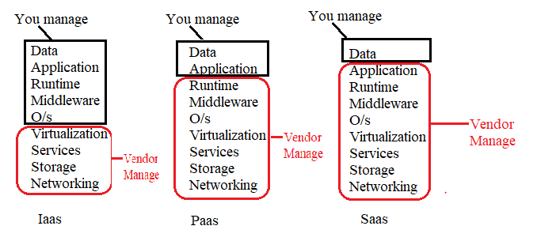

AWS Global Infrastructure

1. AWS Regions
2. AWS Availability Zones
3. AWS Data Centers
4. AWS Edge Locations / Points of Presence

https://infrastructure.aws

**AWS Region**

* Geographically separated area where AWS has set up its resources. (cluster of data centers)
* Each Region is independent of each other
* In India –Mumbai and Hyderabad (coming soon)

<https://aws.amazon.com/about-aws/global-infrastructure/>

How to choose an AWS Region

* Compliance with data governance and legal requirements: data never leaves a region without your explicit permission
* Proximity to customers: reduced latency
* Available services within a Region: new services and new features aren’t available in every Region
* Pricing: pricing varies region to region and is transparent in the service pricing page

**Availability Zone (AZ)**

* AZ’s are isolated, multiple and physically separated data center of each region.
* AZ’s are data centre
* They’re separate from each other, so that they’re isolated from disasters
* They’re connected with high bandwidth, ultra-low latency networking
* Each region has many availability zones (usually 3, min is 3, max is 6).

Example: • ap-southeast-2a • ap-southeast-2b • ap-southeast-2c

**Edge Location (AWS Points of Presence)**

* These are small data center where end user access services located at AWS
* Frequently used data will be stored in cache, helps to access fast.
* AWS will not disclose where AZ’s and edge location

Tour of the AWS Console

**AWS has Global Services:**

• Identity and Access Management (IAM)

• Route 53 (DNS service)

• CloudFront (Content Delivery Network)

• WAF (Web Application Firewall) •

Most AWS services are Region-scoped:

Amazon EC2 (Infrastructure as a Service)

Elastic Beanstalk (Platform as a Service)

Lambda (Function as a Service)

Rekognition (Software as a Service)

Region Table: https://aws.amazon.com/about-aws/global-infrastructure/regional-product-service

**IAM Section (global service)**

IAM: Users & Groups

* IAM = Identity and Access Management, Global service
* Root account created by default, shouldn’t be used or shared
* Users are people within your organization, and can be grouped
* Groups only contain users, not other groups
* Users don’t have to belong to a group, and user can belong to multiple group

IAM: Permissions

* Users or Groups can be assigned JSON documents called policies
* These policies define the permissions of the users
* In AWS you apply the least privilege principle: don’t give more permissions than a user need

