DATA BASE
PROJECT: ARTGALLERY
Name: Registration No:
Rehman Ali L1F21BSCS0051
Talha Javed L1F21BSCS1039
Muhammad Abbas L1F21BSCS1041
Section: D-14

Queries with LIKE:
Q1. SELECT * FROM Artwork WHERE Title LIKE '%Art%';
SELECT * FROM Artwork WHERE Title LIKE '%Art%';
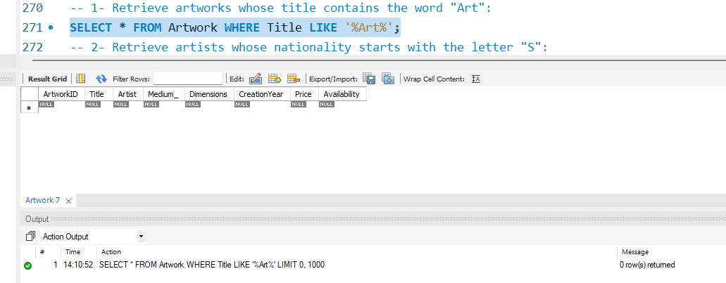

Q2. Retrieve artists whose nationality starts with the letter "S":
SELECT * FROM Artist WHERE Nationality LIKE 'S%';
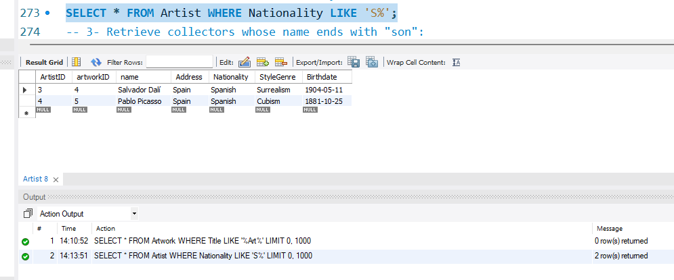

Q3. Retrieve collectors whose name ends with "son":
SELECT * FROM Collector WHERE Name LIKE '%son';
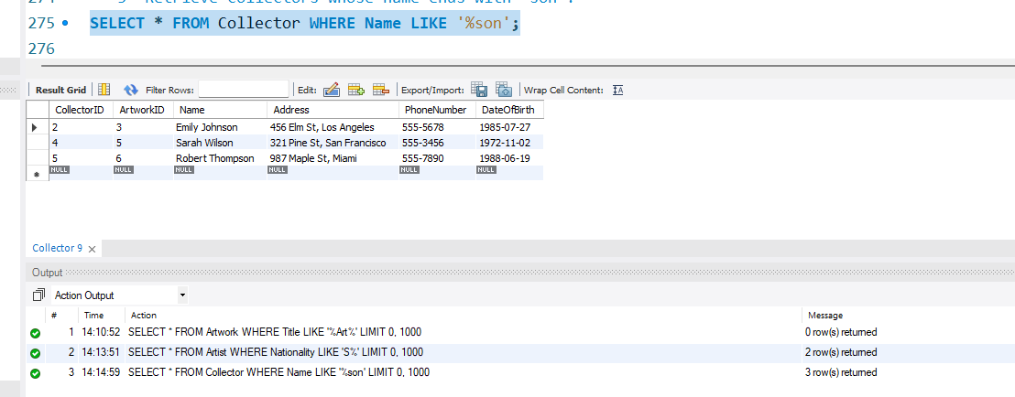

Queries with NOT - LIKE:
Q4. Retrieve artworks whose title does not contain the word "Abstract":
SELECT * FROM Artwork WHERE Title NOT LIKE '%Abstract%';
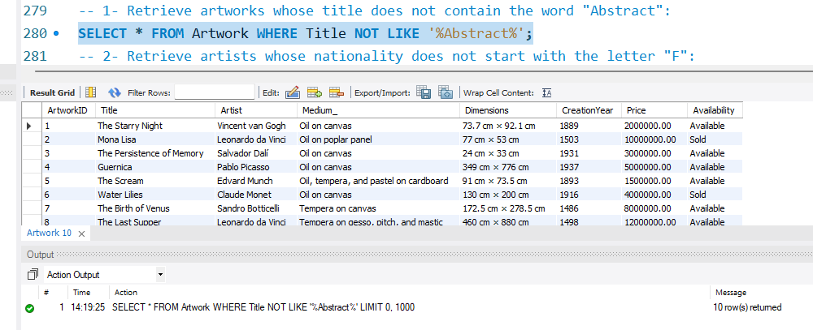
Q5. Retrieve artists whose nationality does not start with the letter "F":
SELECT * FROM Artist WHERE Nationality NOT LIKE 'F%';
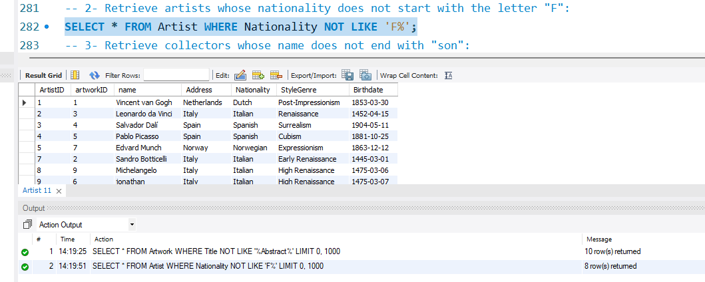
Q6. Retrieve collectors whose name does not end with "son":
SELECT * FROM Collector WHERE Name NOT LIKE '%son';
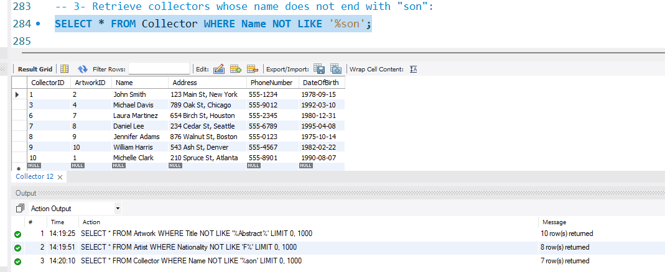

Queries with Between:
Q7. Retrieve artworks with a price between 2000000.00 and 5000000.00:
SELECT * FROM Artwork WHERE Price BETWEEN 2000000.00 AND 5000000.00;
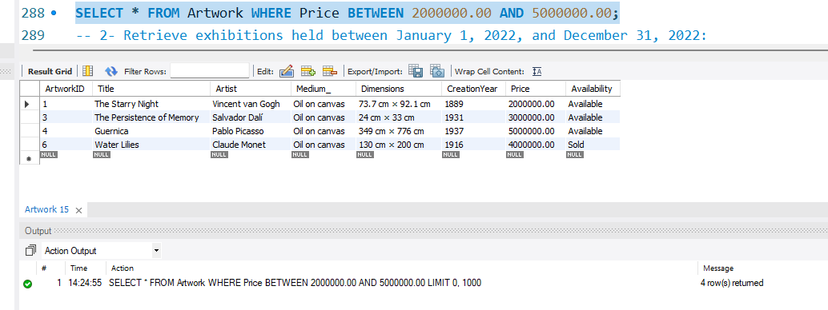
Q8. Retrieve exhibitions held between 2023-08-01 and 2023-10-01:
SELECT * FROM Exhibition WHERE StartDate BETWEEN '2023-08-01' AND '2023-10-01';
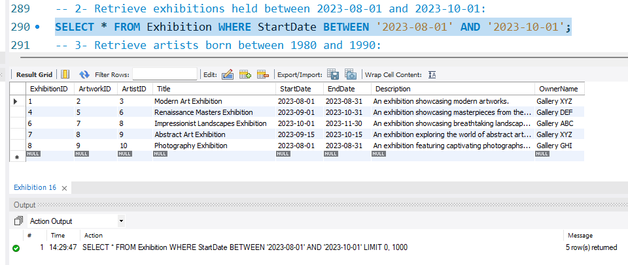
Q9. Retrieve artists born between 1476-02-03 and 1476-09-03:
SELECT * FROM Artist WHERE Birthdate BETWEEN '1476-02-03' AND '1476-09-03';
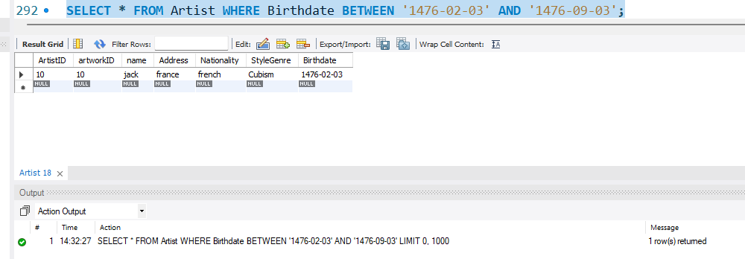

Queries with IN:
Q10. Retrieve artworks with a category of either '73.7 cm × 92.1 cm' or '349 cm × 776 cm':
SELECT * FROM Artwork WHERE Dimensions IN ('73.7 cm × 92.1 cm', '349 cm × 776 cm');
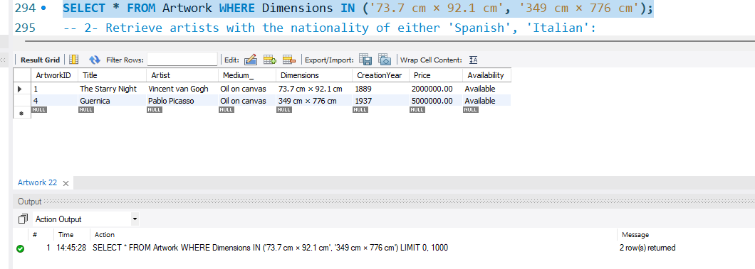
Q11. Retrieve artists with the nationality of either 'Spanish' or 'Italian'
SELECT * FROM Artist WHERE Nationality IN ('Spanish', 'Italian');
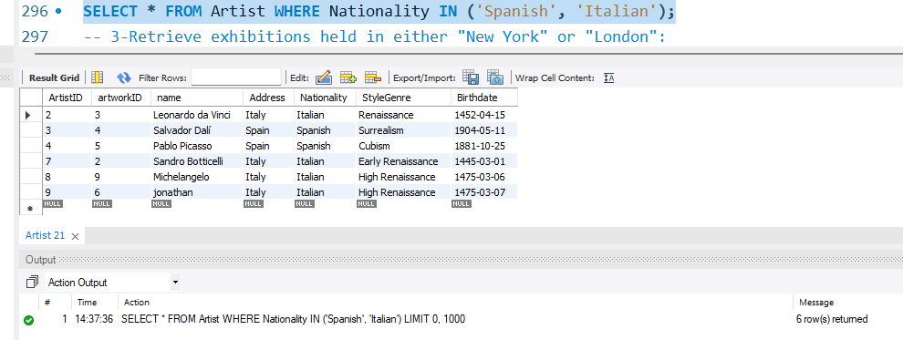

Q12. Retrieve customer phoneNo in either '555-1234' or '555-7890':
SELECT * FROM Customer WHERE PhoneNumber IN ('555-1234', '555-7890');
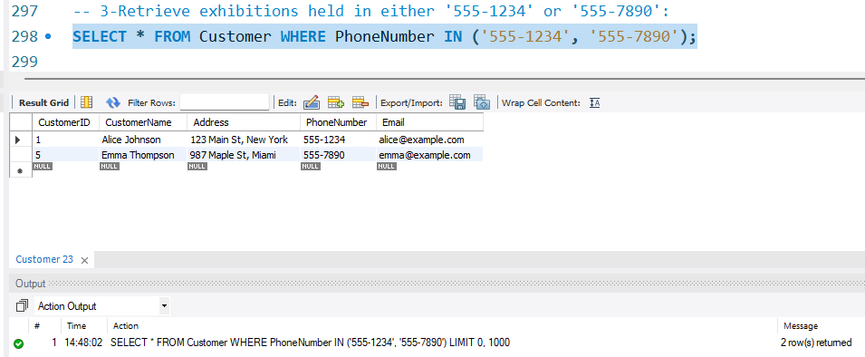
Queries with NOT-IN:
Q13. Retrieve artworks that are not categorized as either '73.7 cm × 92.1 cm' or '349 cm × 776 cm':
SELECT * FROM Artwork WHERE Dimensions NOT IN ('73.7 cm × 92.1 cm', '349 cm × 776 cm');
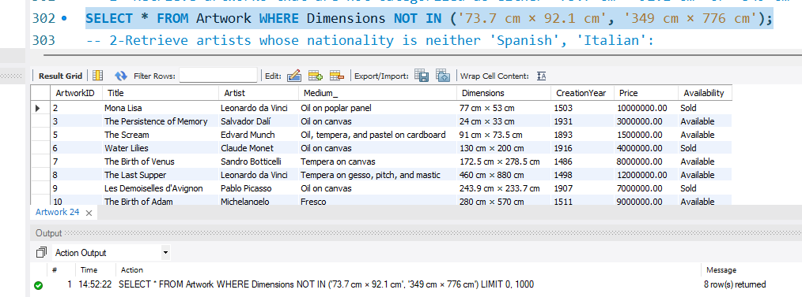
Q14. Retrieve artists whose nationality is neither 'Spanish', 'Italian':
SELECT * FROM Artist WHERE Nationality NOT IN ('Spanish', 'Italian');
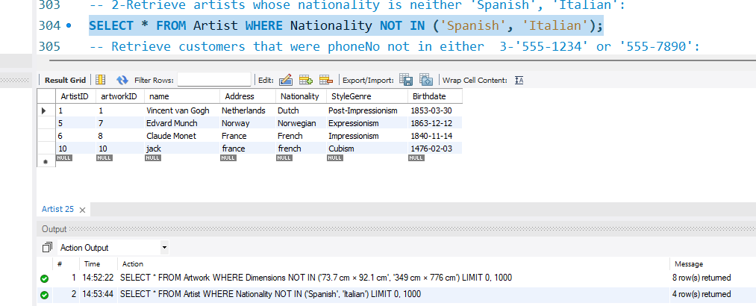
Q15. Retrieve customers that were phoneNo not in either 3-'555-1234' or '555-7890':
SELECT * FROM Customer WHERE PhoneNumber NOT IN ('555-1234', '555-7890');
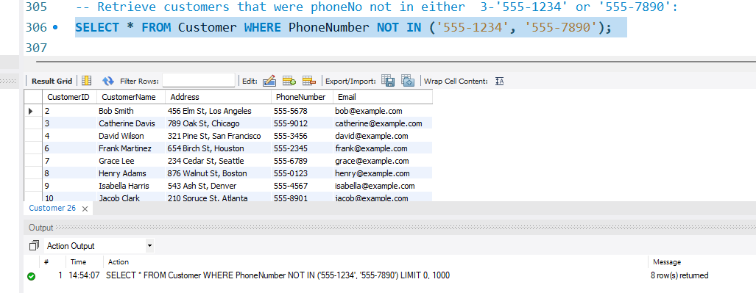

Q1. Write the query to display exhibition start date collector name, artist name, and price of art.(join)
select ex.startdate,c.name, a.name, aw.price
from Artwork aw
join artist a
on aw.ArtworkID=a.ArtworkID
join collector c
on c.ArtworkID=aw.ArtworkID
join exhibition ex
on ex.artistID=a.artistID;
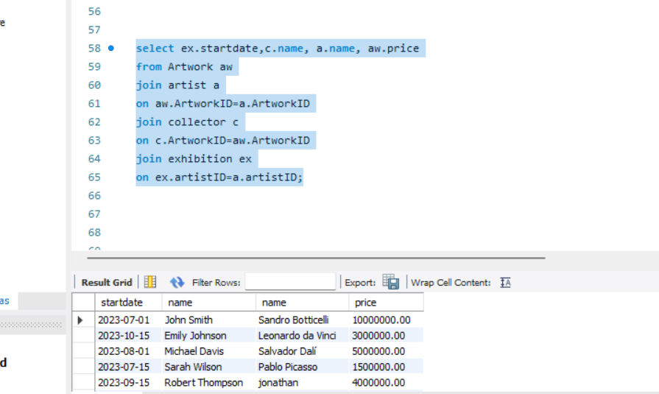
Q2. write the query to display gallery location, exhibition start date, artist, and artwork whose price is greater than 100000.(right join)
select g.location, ex.startdate,a.name,aw.price
from gallery g
right join exhibition ex
on g.exhibitionID=ex.exhibitionID
right join artist a
on ex.artistid=a.artistid
right join artwork aw
on ex.artworkID=aw.artworkID
where price>1000000;
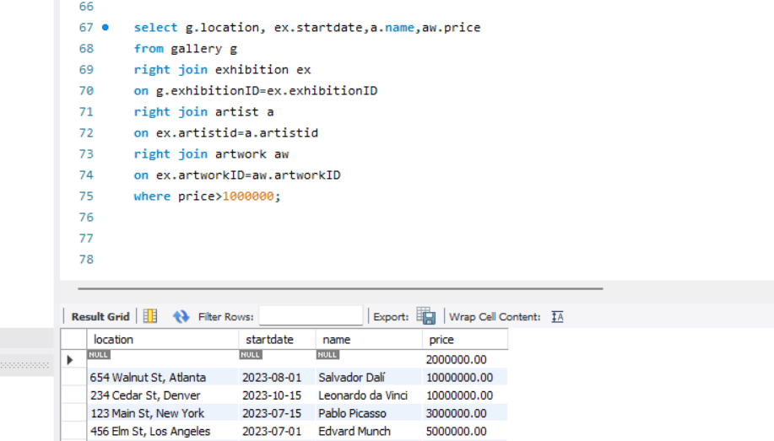
Q3. write the query to display gallery location, exhibition start date, artist, and artwork. Start date will be ‘2023-08-01'.(left join)
select g.location, ex.startdate,a.name,aw.price
from gallery g
left join exhibition ex
on g.exhibitionID=ex.exhibitionID
left join artist a
on ex.artistid=a.artistid
left join artwork aw
on ex.artworkID=aw.artworkID
where ex.startdate='2023-08-01';
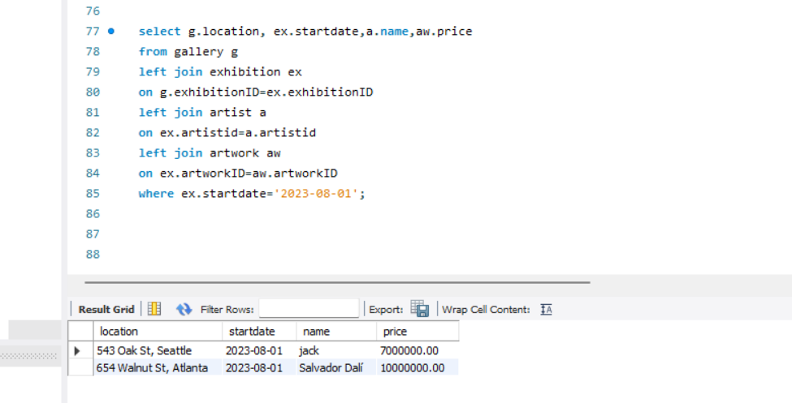

Q4. Write the query that display customer name, customer id, order id and order number whose order number only be 1003 and 1005(EXISTS Operator).
SELECT c.customername, c.customerid, o.orderid, o.ordernumber
FROM customer c
INNER JOIN ordertable o ON c.customerid = o.OrderCustomerID
AND EXISTS (
SELECT *
FROM ordertable o3
WHERE o3.OrderCustomerID = c.customerid
AND o3.ordernumber in( 1003,1005)
);
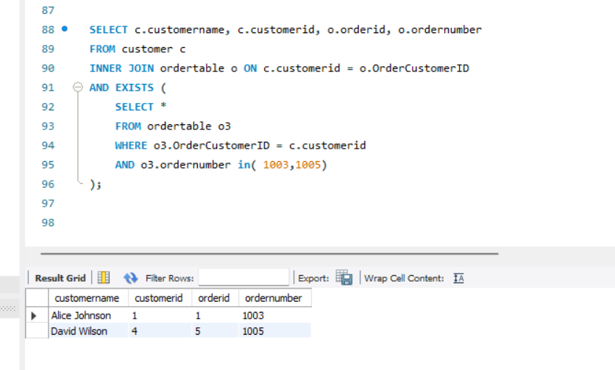
Q5. write the query which display end date of exhibition whose artist name is Leonardo da Vinci.(Exists).
select ex.enddate
from exhibition ex
where exists
(select * from artwork aw
where ex.artworkID=aw.artworkID )
and exists
(select * from artist a
where ex.artistID=a.artistID
and a.name='Leonardo da Vinci' )
;
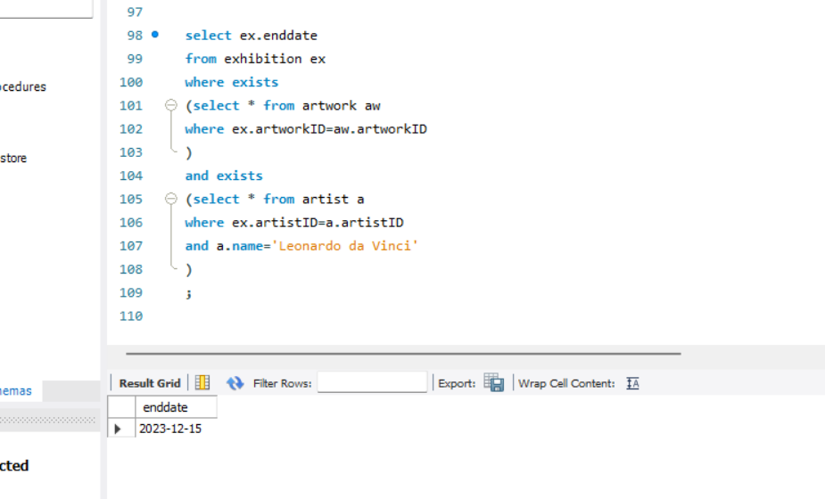
Q6. Write the query display location where title is ‘The Scream’.
select g.location
from gallery g
join exhibition ex
join artwork a
where exists(
select * from
exhibition ex
where g.exhibitionID=ex.exhibitionID
)
and exists(select * from
artist a where ex.artistID= a.artistID
)
and exists(
select * from artwork aw
where a.artworkID=aw.artist
and a.title='The Scream'
);