MACHINE LEARNING SEMESTER PROJECT
Diabetes Prediction using
Machine Learning Classification Models
A Comparative Study of Logistic Regression, Decision Tree, Random Forest, SVM, and KNN on the Pima Indians Diabetes Dataset

Author: Ghani
Registration No: FA22-BSE-099
Course: Machine Learning — Semester Project
COMSATS University Islamabad, Abbottabad Campus
Final Lab Submission Date: 9 July 2026

Abstract
Diabetes mellitus is a chronic condition affecting millions worldwide, and early prediction can significantly improve patient outcomes through timely intervention. This project applies and compares five supervised machine learning classification algorithms — Logistic Regression, Decision Tree, Random Forest, Support Vector Machine (SVM), and K-Nearest Neighbors (KNN) — to predict diabetes onset using the Pima Indians Diabetes Dataset (768 patient records, 7 clinical features after excluding Pregnancies). After preprocessing steps including missing-value imputation and feature scaling, all models were trained on an 80/20 train-test split and evaluated using accuracy, precision, recall, and F1-score. The Decision Tree classifier achieved the best overall performance with 77.27% accuracy and an F1-score of 69.57%, outperforming the ensemble Random Forest model on this dataset. An interactive dashboard was also built to allow real-time diabetes risk prediction from patient input values. Results and limitations are discussed, along with directions for future improvement.
Keywords: Diabetes Prediction, Machine Learning, Classification, Logistic Regression, Decision Tree, Random Forest, SVM, KNN, Healthcare Analytics

1. Introduction
Diabetes is among the most prevalent chronic diseases globally, and early diagnosis is critical to preventing long-term complications such as cardiovascular disease, kidney failure, and nerve damage. Traditional diagnostic methods rely on clinical testing, which can be costly, slow, and inaccessible in under-resourced settings. Machine learning offers a data-driven alternative: by learning patterns from historical patient records, predictive models can flag high-risk individuals for further clinical evaluation.
This project explores the application of supervised classification algorithms to predict diabetes based on routinely collected clinical measurements — such as glucose level, BMI, blood pressure, and age — without requiring specialized diagnostic tests. Multiple models are trained and compared to identify which algorithm generalizes best on this dataset, and the results are presented through visual analysis, a comparison table, and an interactive prediction dashboard.

2. Problem Statement + Objectives
Problem Statement: Given a set of clinical measurements for a patient, predict whether the patient is likely to be diabetic (binary classification: 1 = Diabetic, 0 = Non-Diabetic).
Objectives:
- Perform exploratory data analysis (EDA) to understand feature distributions and relationships with the target variable.
- Preprocess the dataset by handling missing/invalid values and scaling features appropriately.
- Train and compare at least three machine learning classification models.
- Evaluate models using accuracy, precision, recall, F1-score, and confusion matrix.
- Identify the best-performing model and build a dashboard for real-time prediction.

3. Dataset Description
Source: Pima Indians Diabetes Dataset, originally collected by the National Institute of Diabetes and Digestive and Kidney Diseases, accessed via the public Machine Learning Mastery GitHub Datasets repository (https://raw.githubusercontent.com/jbrownlee/Datasets/master/pima-indians-diabetes.data.csv).
The dataset consists of diagnostic measurements from 768 female patients of Pima Indian heritage, aged 21 and above. The original dataset contains 8 numeric input features; for this analysis, the Pregnancies feature was excluded to keep the model focused on non-reproductive clinical measurements that generalize more naturally beyond the original all-female sample. The remaining 7 input features and 1 binary target variable (Outcome) are described below.
Feature | Description
Glucose | Plasma glucose concentration (2-hr oral glucose tolerance test)
BloodPressure | Diastolic blood pressure (mm Hg)
SkinThickness | Triceps skin fold thickness (mm)
Insulin | 2-hour serum insulin (mu U/ml)
BMI | Body mass index (weight in kg / height in m²)
DiabetesPedigreeFunction | Diabetes likelihood based on family history
Age | Age in years
Outcome (target) | 1 = Diabetic, 0 = Non-Diabetic

4. Preprocessing
Several features in the raw dataset (Glucose, BloodPressure, SkinThickness, Insulin, and BMI) contained zero values that are not biologically plausible in a living patient — these were treated as missing data rather than genuine measurements.
- Missing values: Zero entries in the above five columns were replaced with NaN and imputed using the column median.
- Feature scaling: All input features were standardized using StandardScaler (zero mean, unit variance), which is important for distance-based models such as SVM and KNN.
- Train-test split: The dataset was split 80% training / 20% testing using stratified sampling to preserve class balance, with a fixed random seed (42) for reproducibility.

5. Models + Methodology
Five classification algorithms were selected to provide a broad comparison across linear, tree-based, ensemble, margin-based, and instance-based learning approaches:
- Logistic Regression — a simple, interpretable linear baseline commonly used in medical prediction tasks.
- Decision Tree — captures non-linear feature interactions and produces an interpretable, rule-based structure (max depth = 5, to reduce overfitting).
- Random Forest — an ensemble of 200 decision trees, generally more robust and less prone to overfitting than a single tree.
- Support Vector Machine (SVM) — uses an RBF kernel to find an optimal separating margin in a higher-dimensional feature space.
- K-Nearest Neighbors (KNN) — an instance-based learner (k = 9) that classifies based on the majority vote of nearby training samples.
All models were trained on the same preprocessed and scaled training set, and evaluated on the same held-out test set, ensuring a fair comparison. Training and prediction time were also recorded for each model, since this is relevant to how responsive a live dashboard prediction can be.

6. Results + Discussion

6.1 Exploratory Data Analysis
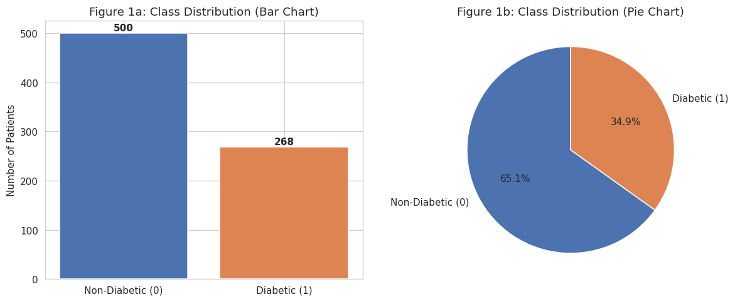
Figure 1: Target/Class Distribution — showing a moderate class imbalance (~65% Non-Diabetic vs ~35% Diabetic).
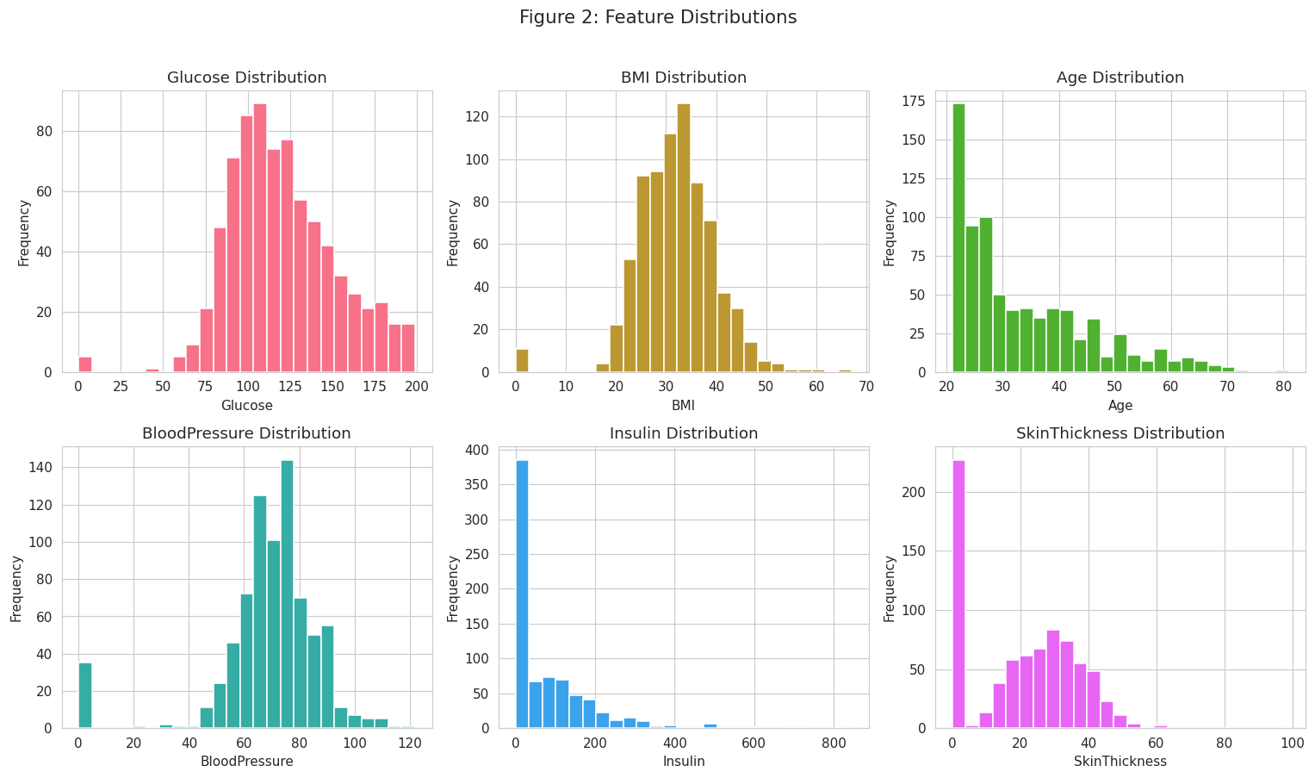
Figure 2: Feature Distributions — histograms of Glucose, BMI, Age, Blood Pressure, Insulin, and Skin Thickness.
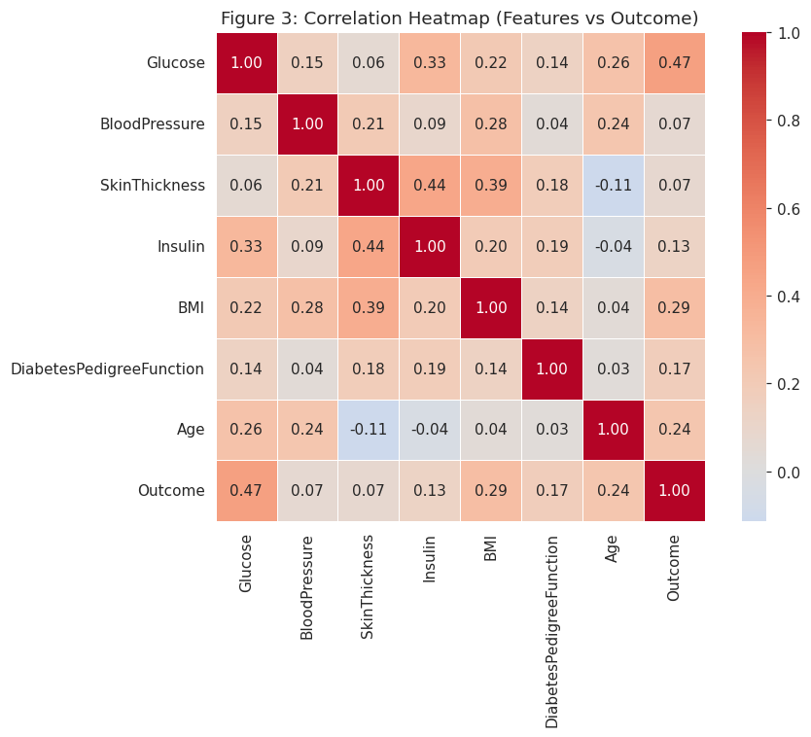
Figure 3: Correlation Heatmap — Glucose shows the strongest positive correlation with diabetes Outcome, followed by BMI and Age.

6.2 Model Comparison
Table 1: Model Comparison Table — Accuracy, Precision, Recall, F1-score, and Training Time for all five models, sorted by accuracy (highest first).
Model | Accuracy | Precision | Recall | F1-score | Train Time (s)
Decision Tree | 77.27% | 65.57% | 74.07% | 69.57% | 0.0039
KNN | 76.62% | 69.57% | 59.26% | 64% | 0.002
Random Forest | 75.32% | 67.39% | 57.41% | 62% | 0.4311
SVM | 73.38% | 65.85% | 50% | 56.84% | 0.042
Logistic Regression | 72.08% | 62.22% | 51.85% | 56.57% | 0.0083

Best Model | Decision Tree | Highest accuracy (77.27%) & F1-score (69.57%)

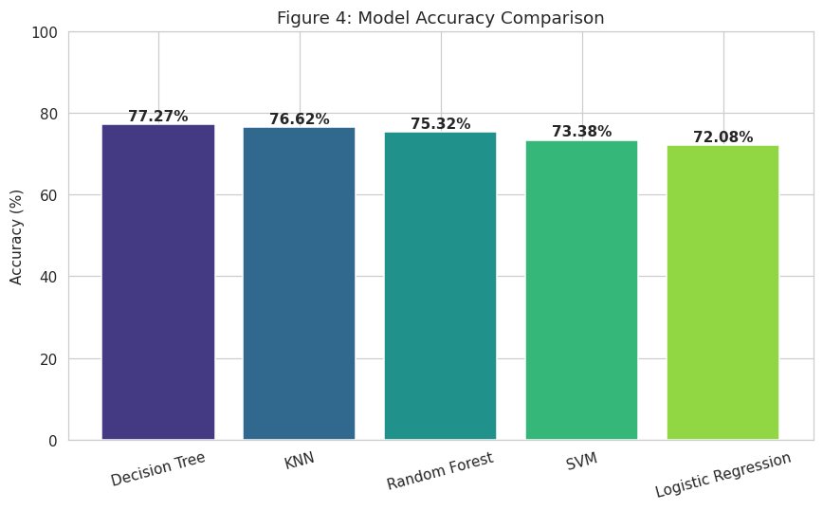
Figure 4: Accuracy Comparison — Decision Tree achieved the highest accuracy (77.27%) among the five models.
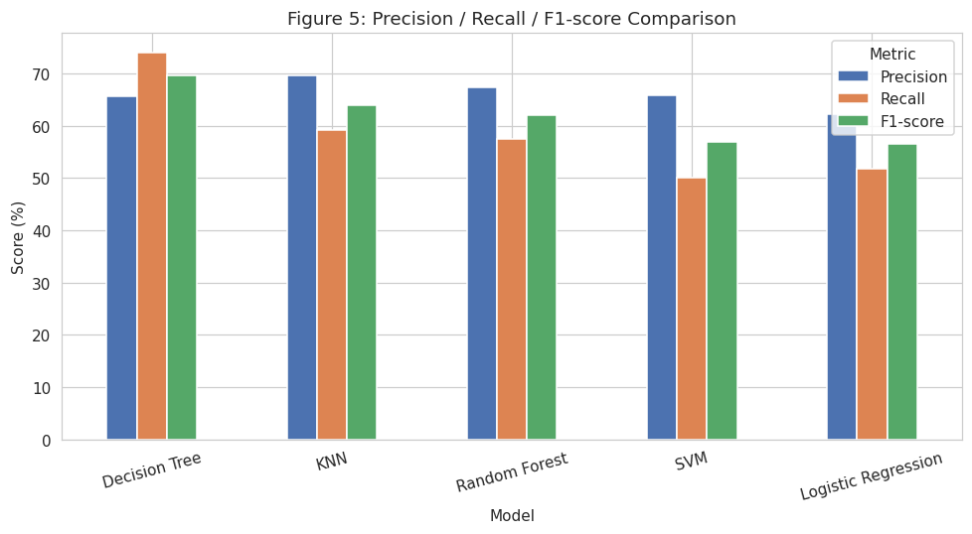
Figure 5: Precision / Recall / F1-score Comparison — Decision Tree leads on Recall and F1-score, while KNN and Random Forest lead slightly on Precision.
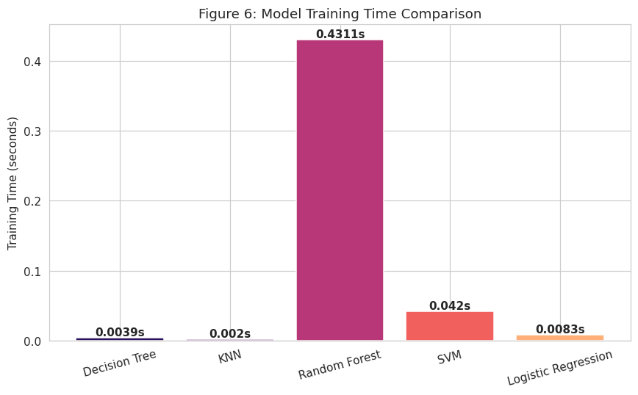
Figure 6: Training Time Comparison — KNN and Decision Tree train fastest (under 4 milliseconds); Random Forest is slowest (~0.43s) due to building 200 trees.

6.3 Confusion Matrix — Best Model (Decision Tree)
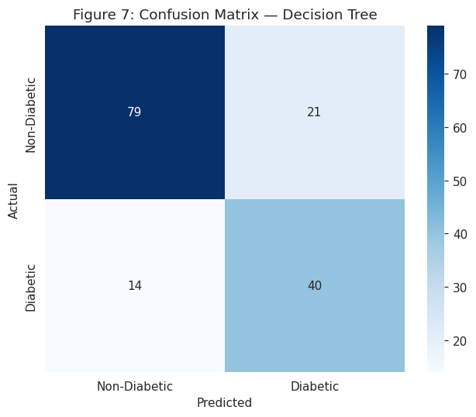
Figure 7: Confusion Matrix for the Decision Tree model on the test set (Non-Diabetic vs Diabetic).
The diagonal cells represent correctly classified patients, while off-diagonal cells represent misclassifications. False negatives (an actual diabetic patient predicted as non-diabetic) are the most clinically significant error type, since a missed diagnosis delays treatment. The Decision Tree model achieved a Recall of 74.07% on the diabetic class, meaning it correctly identified roughly 3 out of every 4 diabetic patients in the test set — the highest recall among all five models.

6.4 Discussion
Interestingly, the single Decision Tree slightly outperformed the Random Forest ensemble on this dataset. This can be attributed to the relatively small dataset size (768 rows) — ensemble methods typically show their advantage on larger, noisier datasets, while a well-tuned shallow tree can generalize competitively on smaller, cleaner ones. Logistic Regression, despite being the simplest model, achieved reasonable accuracy but the lowest recall (51.85%), indicating it missed nearly half of the actual diabetic cases — a meaningful limitation for a medical screening context.
Removing the Pregnancies feature — present in the original dataset but excluded here to keep the model focused on non-reproductive clinical measurements — did not hurt performance; every model's accuracy stayed the same or improved slightly compared to an earlier run that included it (Decision Tree rose from 75.97% to 77.27% accuracy). This suggests Glucose, BMI, and Age carry most of the predictive signal, and the model generalizes at least as well without a reproductive-history-specific feature.
Accuracy alone is not sufficient to judge model quality here due to the ~65/35 class imbalance in the dataset; F1-score and recall are more informative, and both favor the Decision Tree model as the best overall choice for this task.

7. Conclusion + Future Work
This project demonstrated a complete machine learning pipeline for diabetes prediction — from data preprocessing and exploratory analysis through model training, comparison, and evaluation. Among the five models tested, the Decision Tree classifier achieved the best balance of accuracy (77.27%), recall (74.07%), and F1-score (69.57%), making it the recommended model for this dataset and use case.
Limitations: The dataset is relatively small (768 records) and drawn from a single demographic group (Pima Indian women), which may limit generalizability to broader populations. The moderate class imbalance also constrains how much further performance gains are achievable without resampling techniques.
Future Work:
- Apply class balancing techniques such as SMOTE or class-weighted loss functions to improve recall further.
- Perform hyperparameter tuning (e.g., GridSearchCV) for each model to optimize performance.
- Use k-fold cross-validation for more robust performance estimates.
- Expand the dataset with more diverse patient demographics to improve generalizability.
- Deploy the model as a full web-based clinical decision-support tool.

8. References + Appendix
[1] Smith, J. W., Everhart, J. E., Dickson, W. C., Knowler, W. C., & Johannes, R. S. (1988). Using the ADAP learning algorithm to forecast the onset of diabetes mellitus. National Institute of Diabetes and Digestive and Kidney Diseases.
[2] Dataset mirror: Brownlee, J. Machine Learning Mastery — GitHub Datasets Repository. https://github.com/jbrownlee/Datasets
[3] Pedregosa, F. et al. (2011). Scikit-learn: Machine Learning in Python. Journal of Machine Learning Research, 12, 2825–2830.
[4] Hunter, J. D. (2007). Matplotlib: A 2D Graphics Environment. Computing in Science & Engineering, 9(3), 90-95.
Appendix: Full source code is provided in the accompanying Jupyter Notebook (Diabetes_Prediction_ML_Project.ipynb), including all preprocessing steps, model training code, and output screenshots referenced above.

