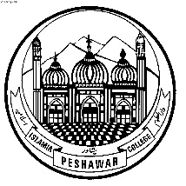 Islamia College Peshawar

Directorate of Students Affairs & Peripheral Campuses

KHYBER PAKHTUNKHAWA PAKISTAN

**Ph: 091-9216064, Fax: 091-9216432**

Dated: 11th April, 2017

**TO WHOM IT MAY CONCERN**

This is to certify that **Hamza Rehman­­­­** S/O **Fazal ur Rehman** has passed his Intermediate (FSc Pre-Engineering) Examination, Session **2014-2016**, securing **960/1100** marks Roll # **89575** according to the following Course Outline under the Board of Intermediate & Secondary Education Peshawar from **Islamia College, Peshawar**, Pakistan.

Coordinator Inter Studies