Classifying Chronic Kidney Disease Records

Julia Rehman
University of Alabama at Birmingham
HI 634-QJ: Foundations of AI for Health Services
Dr. Rahul Sharma
November 3, 2026

Classifying Chronic Kidney Disease Records
I used the UCI Chronic Kidney Disease dataset to examine how well clinical information distinguished records labeled chronic kidney disease (CKD) from those labeled non-CKD. I focused on the data, the reasons for my preparation choices, and what the results could support.

Question and Data Source
My research question was: How well can the recorded clinical information distinguish records labeled CKD from those labeled non-CKD? The measurements and health-history fields allowed me to compare predictions with supplied labels, rather than assess future disease risk.
I used the public UCI Chronic Kidney Disease dataset: 400 clinical records, 24 clinical and health-history fields, and one classification label per record (Rubini et al., 2015). Each row represents one clinical record. The codebook identifies a hospital in Tamil Nadu, India, as the source. The data and documentation are available at https://doi.org/10.24432/C5G020.
Project files: https://github.com/rehmanjulia4/HI-634-Foundns-AI-Hlth-Svcs

Initial Exploration
The initial review found no duplicate records. The dataset contained 250 CKD records and 150 non-CKD records.
My first concern was missing information: 1,012 of 9,600 input entries were missing (10.5%), and only 158 records were complete. Red blood cell appearance was missing most often (Figure 1). CKD records averaged 3.63 missing fields, compared with 0.69 for non-CKD records. Deleting incomplete records could change which records the analysis represented.
Three rows had an extra empty field, and 16 entries contained spaces or tabs, including two CKD labels. This could affect how the software read the data. Ten measurements fell outside broad screening ranges, but a flag did not establish that a value was wrong.
Figure 1
Most Records Had Missing Information
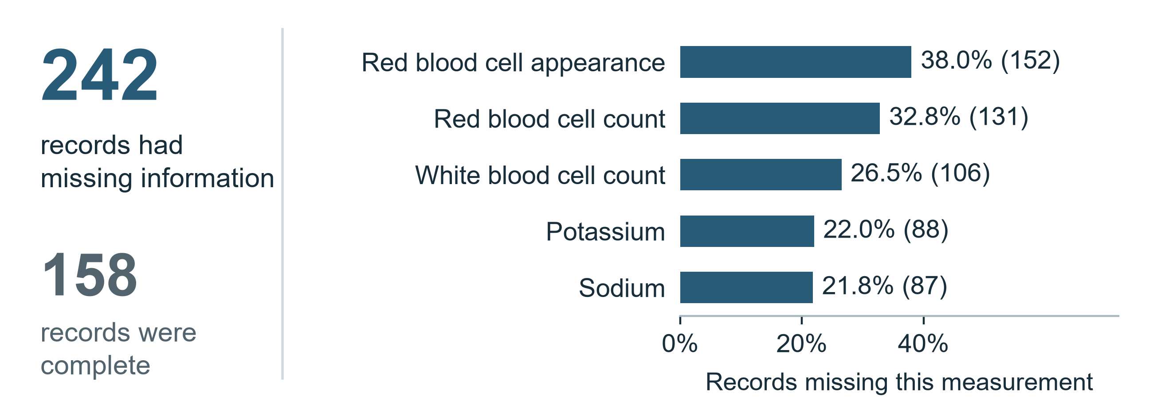
Note. N = 400 records. The five fields most often missing are shown. Deleting incomplete records would leave only 158 (Rubini et al., 2015).

Preparation and Reproducibility
I removed extra empty fields, trimmed spaces and tabs, treated question marks as missing values, and made sure numbers were read correctly. All 400 records and 1,012 missing entries remained. I kept unusual measurements because there were no confirmed errors. Appendix B explains these decisions; the original files were preserved.
Before estimating missing values, I split the records into 320 training records and 80 test records, preserving the group proportions. Training records were used to learn patterns; test records evaluated predictions. Seed 634 made the split repeatable. Appendix E shows group counts and before-and-after checks.
Only 122 training records were complete: 32 CKD and 90 non-CKD. I kept incomplete records because deleting them would discard most training data and reverse the group balance. I compared three ways to fill gaps (Appendix A). I chose the median, or middle value, for numbers and the most common category for other fields. This approach performed close to the best tested. The replacements were estimates, not recovered measurements.
The software learned replacement values, numerical scaling, and category conversions only from each training group. This prevented evaluation records from influencing those calculations. I excluded the label being predicted and the record identifier. Specific gravity, albumin, and sugar were treated as ordered numerical fields. Appendix B gives technical details.
Figure 2
CKD Records Outnumbered Non-CKD Records
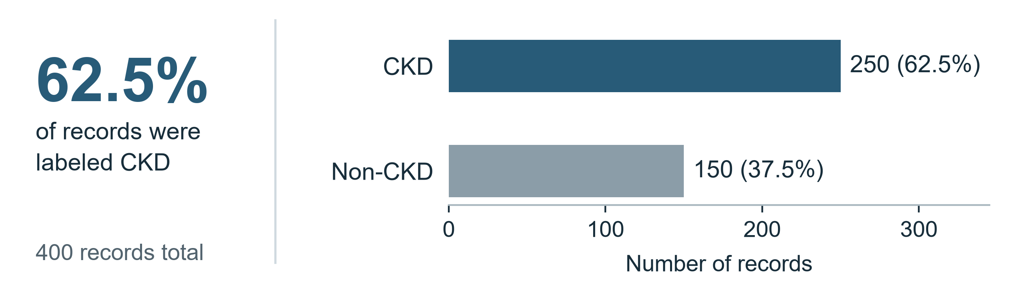
Note. N = 400 clinical records. Predicting CKD for everyone would be correct 62.5% of the time but miss every non-CKD record. I compared performance in both groups.

Model Comparison
I needed a starting point to judge the models. Predicting CKD for everyone would achieve 62.5% accuracy but miss every non-CKD record (Figure 2). I wanted to assess performance in both groups.
Logistic regression estimated the probability of a CKD label. The decision tree used branching rules; the random forest combined 300 trees. I ran all three with scikit-learn (Pedregosa et al., 2011; Scikit-learn developers, n.d.).
Using the 320 training records, I trained on four of five groups and evaluated the fifth, with each group taking a turn. I repeated this three times with different arrangements to examine consistency.
I used macro F1 because it balances missed cases and incorrect positive predictions while giving both groups equal importance. Higher scores are better, up to 1. I also required models to find at least 95% of CKD records on average during training comparisons. This was my project rule, not a clinical standard.
I selected logistic regression because it had the highest comparison score and was simpler than the random forest (Table 1). My rule favored simplicity when a score was within 0.01 of the highest. The close scores did not establish that these models would perform equally well with other patients.
Table 1
Comparison of Methods Using the Training Records
Method | Macro F1 score | CKD records found
Always predict CKD | 0.385 | 100.0%
Logistic regression | 0.993 | 99.0%
Decision tree | 0.961 | 97.0%
Random forest | 0.991 | 99.8%

Note. Averages from 15 checks using 320 training records. Higher macro F1 scores are better.

Test Results and Errors
Logistic regression matched the existing labels for all 80 test records: 50 CKD and 30 non-CKD (Figure 3). It missed no CKD records and incorrectly labeled no non-CKD records as CKD.
Figure 3
All 80 Test Predictions Matched the Existing Labels
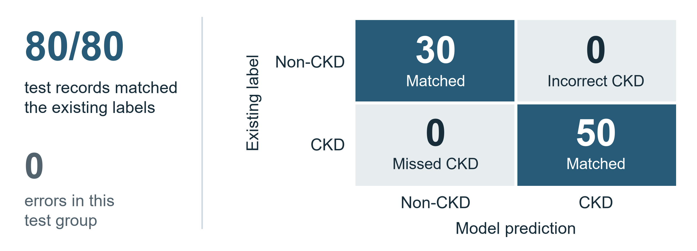
Note. The model matched 50 CKD and 30 non-CKD labels, with no errors in this test group. These results do not establish performance with other patients.
Test precision, recall, and F1 were each 1.000. Recall measured CKD records found; precision measured how often CKD predictions matched labels. F1 combines these measures; macro F1 weights both groups equally. Specificity measured non-CKD records correctly identified. Perfect scores in this sample do not prove error-free diagnosis.
If the model supported follow-up, I would prioritize avoiding missed CKD cases, or false negatives, because they could delay assessment. Incorrect CKD predictions, or false positives, could cause concern and unnecessary testing. Neither occurred in these 80 test records.
A separate five-group training check misclassified record 103 as non-CKD. It had a missing red blood cell count and hemoglobin of 13.9, but these details do not establish why the error occurred. This was separate from the final test.
The small test group still leaves uncertainty. Approximate 95% confidence intervals were 92.9%–100% for finding CKD records and 88.6%–100% for correctly identifying non-CKD records. These ranges reflect sample size, not differences between hospitals or populations.

Interpretation and Limitations
Before recommending healthcare use, I would clarify how diagnoses were established. Creatinine, hemoglobin, albumin, and specific gravity may have helped determine the labels the model reproduced. The documentation does not establish whether measurements preceded diagnosis, so these results cannot demonstrate early detection.
The model could also learn this hospital’s data-collection patterns along with clinical differences. Another hospital may collect information differently. Filling gaps kept records in the analysis but did not remove that uncertainty. Appendix D reports supporting checks.
The small dataset came from one hospital source, and repeat visits could not be confirmed. Initial exploration included all 400 records and labels, although model fitting and selection used training records only. The test records were not completely unseen throughout the project. I did not check different patient groups or the accuracy of estimated CKD probabilities.
My next step would be testing separate data from the intended population. I would confirm diagnosis procedures and measurement timing, then examine missed cases, incorrect CKD predictions, and different patient groups. I would need that evidence before recommending practical use.

References
Pedregosa, F., Varoquaux, G., Gramfort, A., Michel, V., Thirion, B., Grisel, O., Blondel, M., Prettenhofer, P., Weiss, R., Dubourg, V., Vanderplas, J., Passos, A., Cournapeau, D., Brucher, M., Perrot, M., & Duchesnay, É. (2011). Scikit-learn: Machine learning in Python. Journal of Machine Learning Research, 12, 2825–2830. https://jmlr.org/papers/v12/pedregosa11a.html
Rubini, L., Soundarapandian, P., & Eswaran, P. (2015). Chronic kidney disease [Data set]. UCI Machine Learning Repository. https://doi.org/10.24432/C5G020
Scikit-learn developers. (n.d.). Scikit-learn documentation. Retrieved November 3, 2026, from https://scikit-learn.org/stable/

Appendix A
Supporting Model Results
Table A1
Cross-Validated Performance on the Training Sample
Method | Recall | Precision | Macro F1 | Accuracy
Majority baseline | 1.000 | 0.625 | 0.385 | 0.625
Logistic regression | 0.990 | 1.000 | 0.993 | 0.994
Decision tree | 0.970 | 0.973 | 0.961 | 0.964
Random forest | 0.998 | 0.989 | 0.991 | 0.992
Note. n = 320 training records. Scores average 15 training checks; the checks reuse records. Recall and precision refer to CKD. The tree had a maximum depth of 4 and at least 5 records per final group. The forest used 300 trees and at least 2 records per final group. Logistic regression used the default regularization setting, which limits model complexity, with up to 3,000 fitting iterations.
The three missing-data treatments were compared using training data only. Logistic regression used numerical median filling with categorical most-frequent filling, with and without numerical missing data indicators, and an explicit Unknown category for missing categorical values. The simple option was retained without treating small score differences as proof of equivalence.

Appendix A Continued
Table A2
Missing-Data Treatments Compared During Training
Treatment | Method | Recall | Macro F1
Median/mode + numerical flags | Logistic | 0.982 | 0.987
Median/mode + numerical flags | Forest | 0.998 | 0.991
Median/mode | Logistic | 0.990 | 0.993
Median/mode | Forest | 0.998 | 0.991
Median/Unknown | Logistic | 0.997 | 0.998
Median/Unknown | Forest | 1.000 | 0.994
Note. n = 320 training records. Entries are means over repeated five-fold cross-validation. Mode means the most frequent category. Unknown is an explicit category for missing categorical values. The CSV files saved retain unrounded results and all other measures.
Precision is the share of CKD predictions that match CKD labels. Recall is the share of labeled CKD records found. F1 combines precision and recall; macro F1 gives the two groups equal importance. Specificity is the share of non-CKD records correctly identified.

Appendix B
Preparation Decision Log
Table B1
How Raw Findings Informed Preparation
Finding | Decision and Reason
Three extra empty fields | Remove only the extra empty field and log its position. Retain all 400 records.
Whitespace and question marks | Trim text and convert the documented missing marker. Missing predictor cells remain 1,012.
Two ckd labels with a tab | Merge spellings. No outcome label is missing or filled.
Few complete training records | Keep incomplete records and fit imputation inside training folds.
Ten flagged extreme values. | Retain and flag because an unusual value is not automatically an error.
Unequal class sizes | Use a stratified split and class-sensitive evaluation measures.
Note. Original ARFF (Attribute-Relation File Format) data are unchanged. Rows 70, 73, and 370 had extra empty fields. All 400 records remained after cleaning.
Observed ranges included age 2–90 years, blood pressure 50–180 mm Hg, serum creatinine 0.4–76 mg/dL, and hemoglobin 3.1–17.8 in the source hemoglobin units.
Within each training group, I filled numerical gaps with medians and categorical gaps with the most frequent category, standardized numbers, and encoded categories. Treating specific gravity, albumin, and sugar as ordered numbers was an analysis assumption.

Appendix C
Predictor Definitions and Missing Data
Table C1
Predictor Meanings and Missing Values
Field | Meaning | Units or Values | Missing
age | Age | years | 9 (2.2%)
bp | Blood pressure | mm Hg | 12 (3.0%)
bgr | Blood glucose random | mg/dL | 44 (11.0%)
bu | Blood urea | mg/dL | 19 (4.8%)
sc | Serum creatinine | mg/dL | 17 (4.2%)
sod | Sodium | mEq/L | 87 (21.8%)
pot | Potassium | mEq/L | 88 (22.0%)
hemo | Hemoglobin | g/dL (UCI says 'gms') | 52 (13.0%)
pcv | Packed cell volume | % (volume) | 71 (17.8%)
wbcc | White blood cell count | cells/cumm | 106 (26.5%)
rbcc | Red blood cell count | millions/cmm | 131 (32.8%)
sg | Specific gravity | ordinal 1.005-1.025 | 47 (11.8%)
al | Albumin | ordinal 0-5 | 46 (11.5%)
su | Sugar | ordinal 0-5 | 49 (12.2%)
Note. N = 400 records. Missing entries are shown as counts (percentages). Definitions and units follow the source codebook (Rubini et al., 2015); hemoglobin assay details are incomplete.

Appendix C Continued
Table C2
Categorical Predictors and Missing Values
Field | Meaning | Units or Values | Missing
rbc | Red blood cells | abnormal, normal | 152 (38.0%)
pc | Pus cell | abnormal, normal | 65 (16.2%)
pcc | Pus cell clumps | not present, present | 4 (1.0%)
ba | Bacteria | not present, present | 4 (1.0%)
htn | Hypertension | no, yes | 2 (0.5%)
dm | Diabetes mellitus | no, yes | 2 (0.5%)
cad | Coronary artery disease | no, yes | 2 (0.5%)
appet | Appetite | good, poor | 1 (0.2%)
pe | Pedal edema | no, yes | 1 (0.2%)
ane | Anemia | no, yes | 1 (0.2%)
Note. N = 400 records. Missing entries are shown as counts (percentages). Definitions and units follow the source codebook (Rubini et al., 2015); hemoglobin assay details are incomplete.
Appendix D
Supporting Checks and Coding Assistance
I also checked whether knowing which measurements were missing could help distinguish the labels. A model using only that information classified 80.1% of records correctly during training checks. This suggests that collection practices may contribute to the scores. Removing five informative measurements lowered macro F1 to 0.946. I selected those measurements using the full training sample, so this was an exploratory check rather than a separate, unbiased performance test.

Coding agents helped develop the project. I ran it in Anaconda and reviewed the verification results, comparisons, and predictions. I kept incomplete records because deleting them would change the group balance. I remain responsible for explaining these choices and limitations.
Appendix E
Data Review and Preparation Checks
The preserved downloads include the original ZIP archive, ARFF data files, and the source codebook. The original table has 400 rows and 25 fields: 24 measurements or health-history fields and the classification label. I added a record number for tracking; it was not a model input. Appendix C defines the numerical and categorical fields and gives missing counts and percentages.
Table E1
Examples From the Cleaned Table Before Filling Missing Values
Record | Age (years) | Blood pressure (mm Hg) | Creatinine (mg/dL) | Label
1 | 48.0 | 80.0 | 1.2 | ckd
2 | 7.0 | 50.0 | 0.8 | ckd
3 | 62.0 | 80.0 | 1.8 | ckd

Note. These are selected fields from three actual records. All 24 input fields were used; the source labels ckd and notckd mean CKD and non-CKD.
Table E2
CKD and Non-CKD Counts in Each Group
Group | CKD | Non-CKD | Total
All records | 250 | 150 | 400
Training | 200 | 120 | 320
Test | 50 | 30 | 80

Note. Both groups retained the original proportions: 62.5% CKD and 37.5% non-CKD.
Appendix E Continued
Effect of Filling Missing Measurements
Cleaning retained all 400 records and left 1,012 input entries missing. Filling gaps occurred later, within model training. The following check used the 320 training records to show how replacement values affected the numerical spread. It was a preparation check, not an additional test of prediction performance.
Table E3
Selected Training Measurements Before and After Filling Gaps
Measurement | Gaps filled | Median before/after | Spread before | Spread after
Red blood cell count | 104 | 4.8 / 4.8 | 0.989 | 0.813
White blood cell count | 82 | 8100.0 / 8100.0 | 2609.812 | 2253.538
Hemoglobin | 45 | 12.8 / 12.8 | 2.908 | 2.696

Note. Spread is measured by standard deviation, which describes how widely values vary. Units are listed in Appendix C. Median filling kept the middle values unchanged but reduced variation. For red blood cell count, the spread fell by 17.8%; replacement values did not recover the original measurements.
The original review also examined age, blood pressure, creatinine, and hemoglobin ranges (Appendix B). No duplicate records were found. Formatting corrections combined two CKD labels with trailing tabs; no missing outcome labels were filled. The saved file inventory and result tables provide a detailed record of these checks.

