AWS Infrastructure Documentation — DevNotes

1. IAM (Identity and Access Management)
Purpose: IAM helps manage access to AWS resources by controlling identities, permissions, and authentication.

Screenshot 1 — Root User Security Credentials
What I did: Reviewed the AWS root user's security credentials, MFA configuration, and access-key status.
Why did it: To verify account-level authentication security and check whether long-term root access keys were present.
Configuration:
- Multi-factor authentication (MFA): A passkey/security key is listed.
- Root user access keys: None listed.
- CloudFront key pairs: None listed.
Result: MFA is configured for the root user, and no root access keys are listed in this screenshot.
Security note: The root user should be reserved for tasks that specifically require root access. Use an IAM identity with appropriate permissions for routine administration. Never publish account identifiers or sensitive credential details unnecessarily.
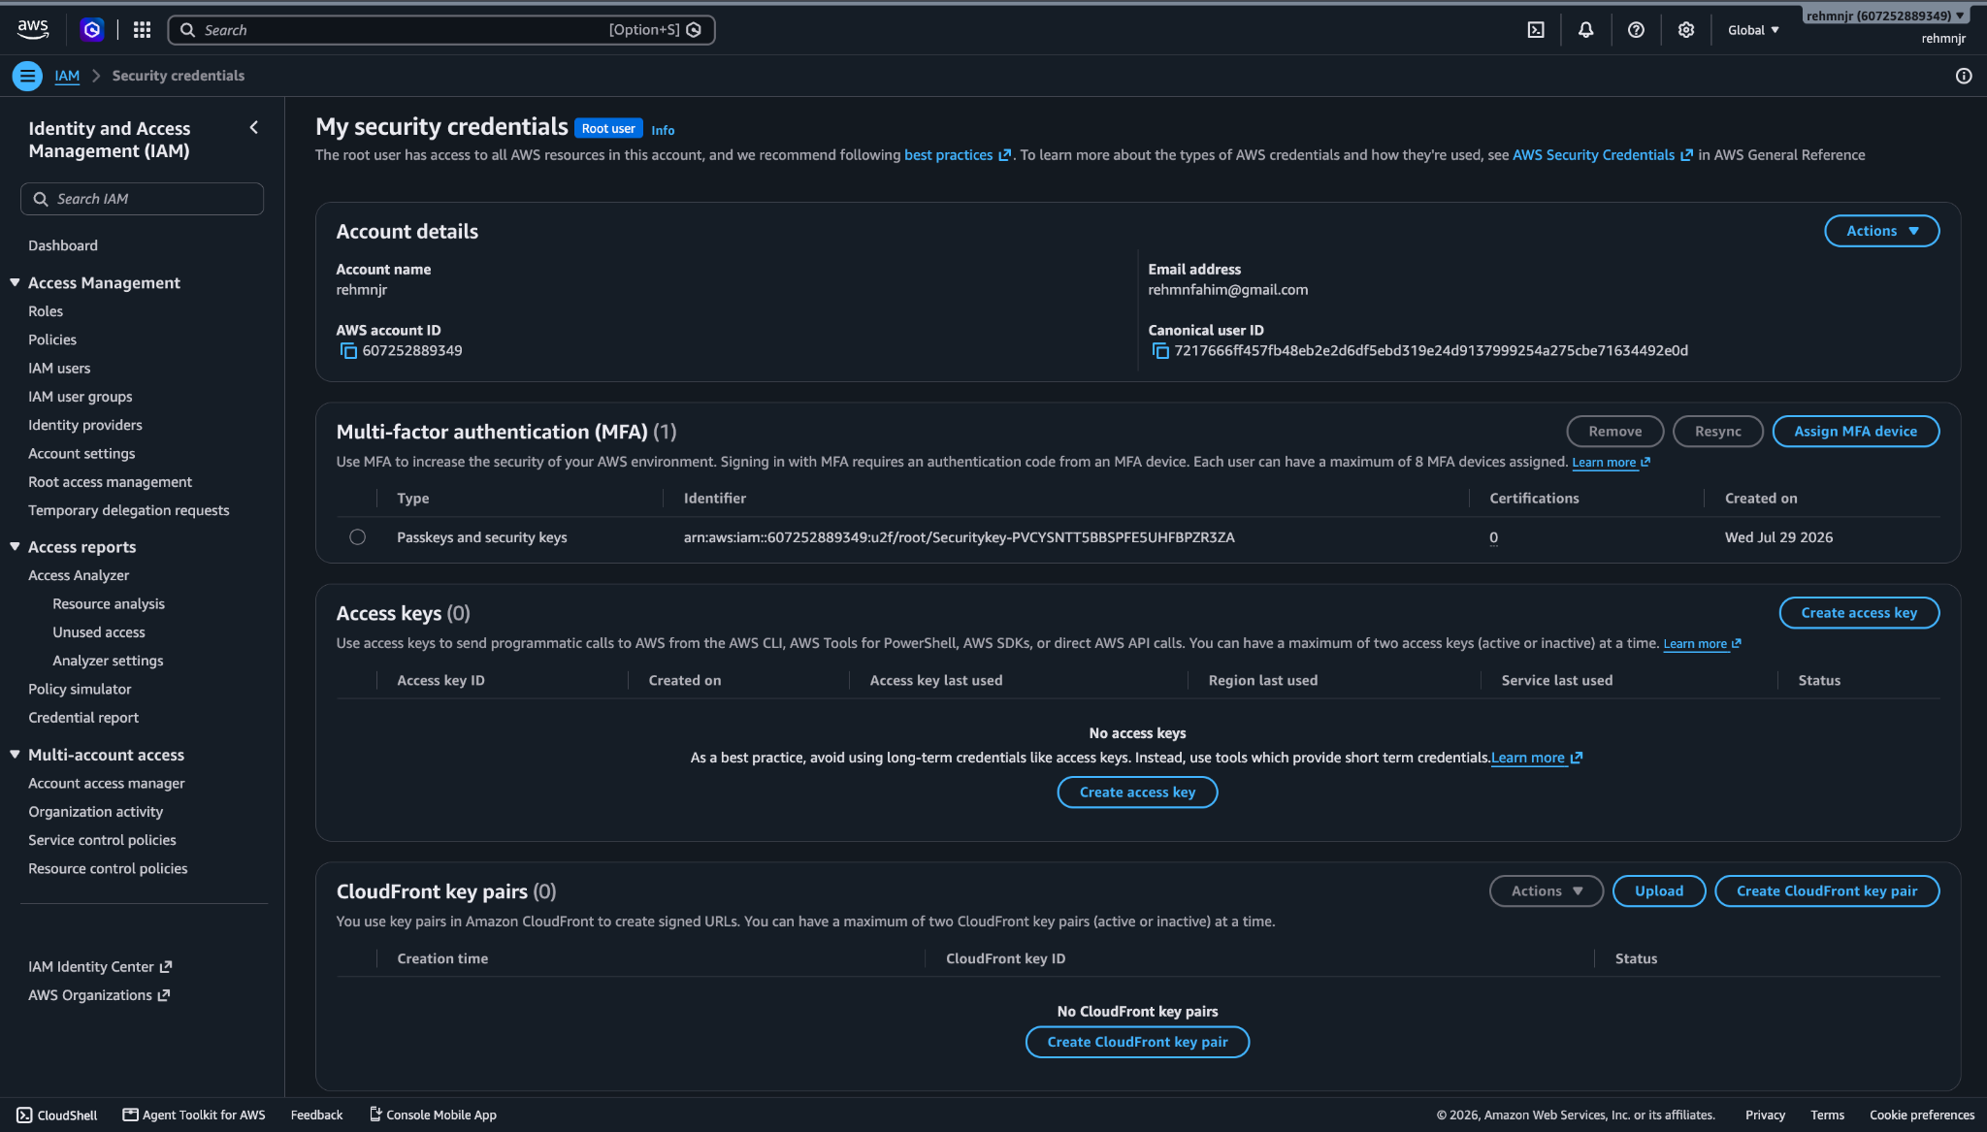
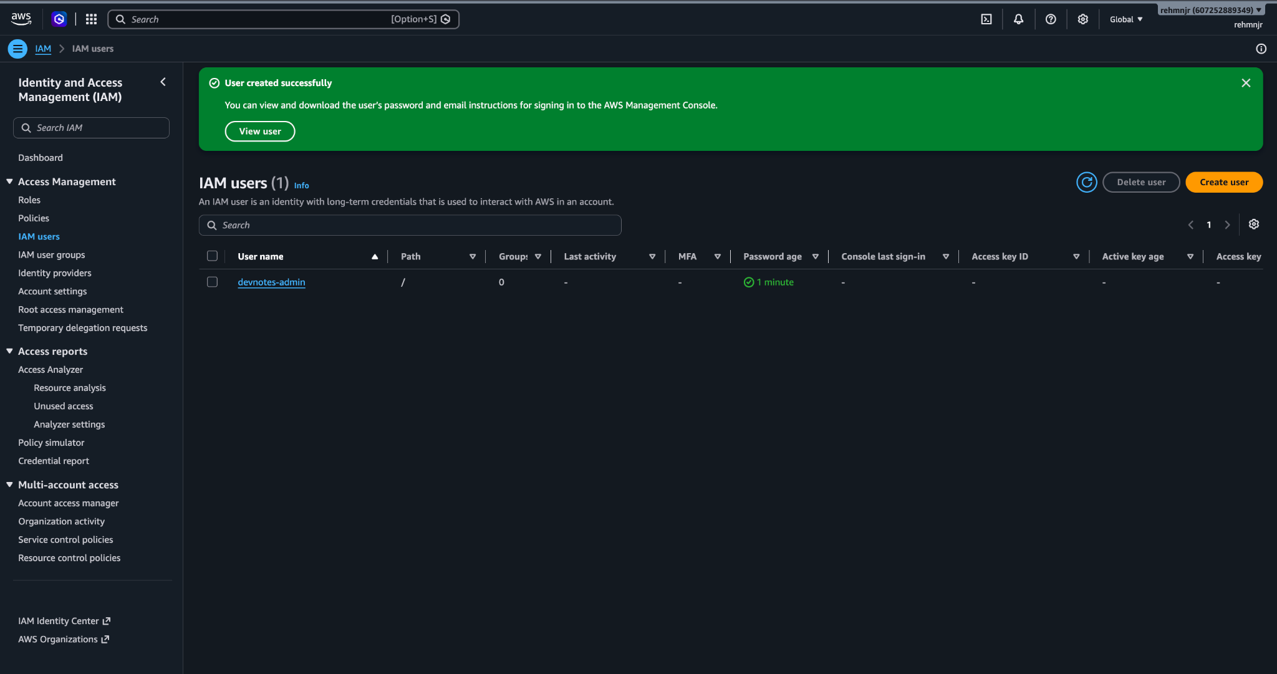

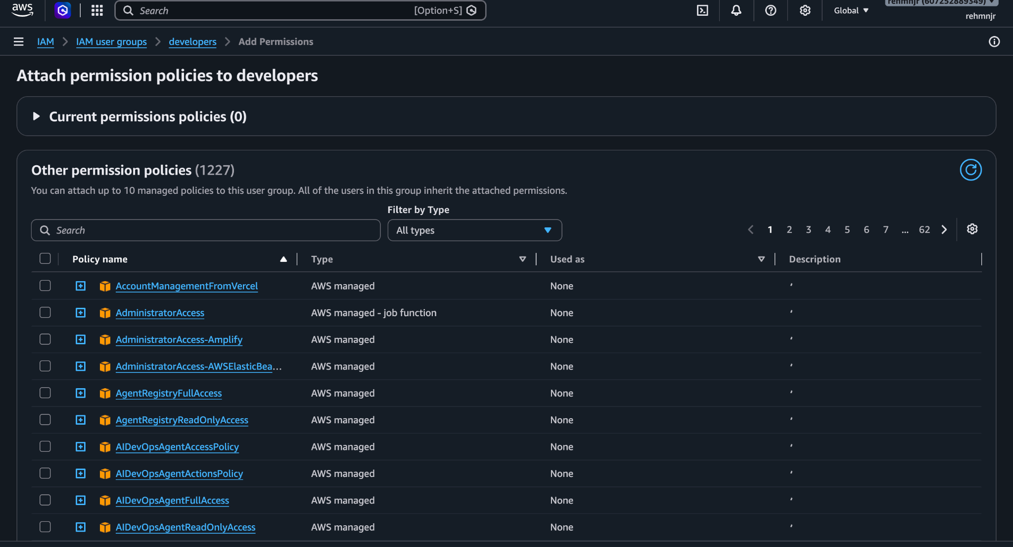

IAM User Group and Permissions
What I did: Created an IAM user group named developers and attached the AWS-managed AmazonEC2ReadOnlyAccess policy.
Why did it: To organize developer identities and manage permissions at the group level instead of assigning the same permissions individually to every user.
Configuration:
- Group name: developers
- Attached policy: AmazonEC2ReadOnlyAccess
- Policy type: AWS managed
- Purpose: Read-only access to supported EC2 resources.
Result: The policy was successfully attached to the group.
Security note: This policy does not grant permission to create, modify, or terminate EC2 instances. Group membership and the permissions of individual users should be reviewed separately.

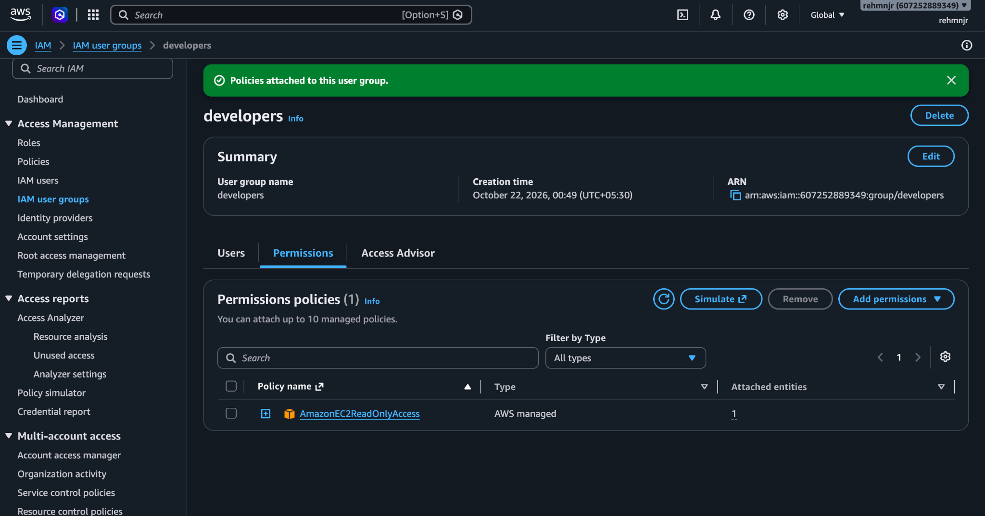

—--------—--------—--------—--------—--------—--------—--------—--------—--------—--------—--------—---

Screenshot 2 — EC2 IAM Role
What I did: Created an IAM role named DevNotes-EC2-S3-Role trusted by the Amazon EC2 service.
Why did it: To allow the EC2 instance to access permitted AWS services without storing long-term AWS access keys on the server.
Configuration:
- Role name: DevNotes-EC2-S3-Role
- Trusted entity: AWS Service — EC2
- Intended use: Grant the DevNotes EC2 instance permissions to access its required AWS resources, including S3 backups.
Result: The IAM role is present in AWS and configured to trust the EC2 service.
Note: This screenshot confirms the role and its trusted service, but does not show the attached policies. The actual S3 permissions must be verified in the role's Permissions tab.
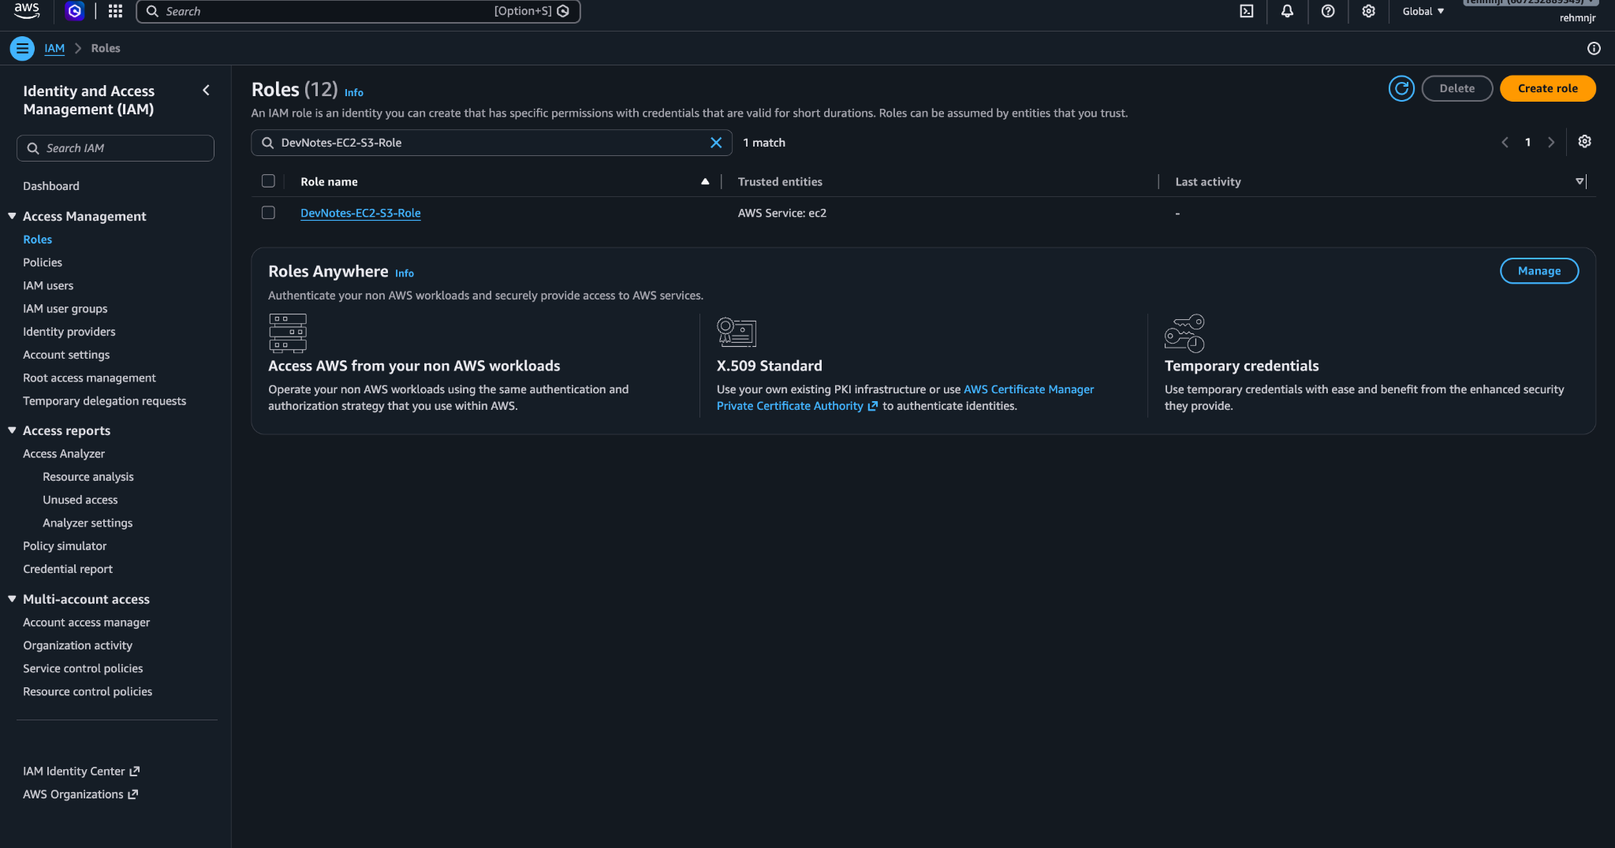

—--------—--------—--------—--------—--------—--------—--------—--------—--------—--------—--------—---

2. AWS Budgets — Cost Monitoring

Screenshot 3 — Monthly Cost Budget Configuration
What I did: Configured a monthly cost budget named DevNotes-Monthly-Budget.
Why did it: To receive email notifications when AWS spending reaches or is forecast to exceed the configured budget.
Configuration:
- Budget name: DevNotes-Monthly-Budget
- Budget type: Monthly cost budget
- Budget amount: $1.00
- Scope: All AWS services
- Notification recipient: Configured email address
- Alert thresholds: 85% actual spending, 100% actual spending, and forecasted spending reaching 100%.
Result: The budget configuration is designed to alert the account owner about project costs.
Important: This screenshot shows the budget setup form, not proof that the budget was successfully created or that notifications were delivered. AWS Budgets sends alerts; it does not automatically stop resources when the threshold is exceeded.
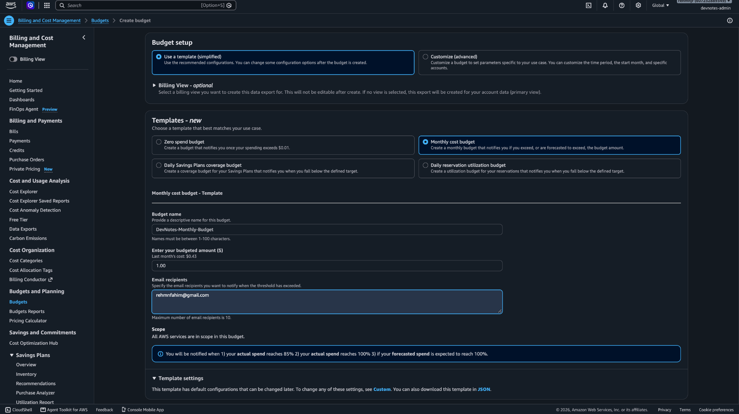

—--------—--------—--------—--------—--------—--------—--------—--------—--------—--------—--------—---

3. Amazon VPC — Network Infrastructure

Screenshot 4 — DevNotes VPC
What I did: Created a dedicated Virtual Private Cloud (VPC) named DevNotes-VPC-vpc.
Why did it: To isolate the application's AWS networking resources and control communication between the web server and database.
Configuration:
- VPC name: DevNotes-VPC-vpc
- VPC ID: vpc-0f132930898a5967e
- Status: Available
- Region: Asia Pacific (Mumbai), ap-south-1
Result: The dedicated VPC is available for the DevNotes infrastructure.
Note: The screenshot shows two VPCs in the account. Only the named DevNotes VPC is identified here as part of this project; the other VPC should not be assumed to be project-related.

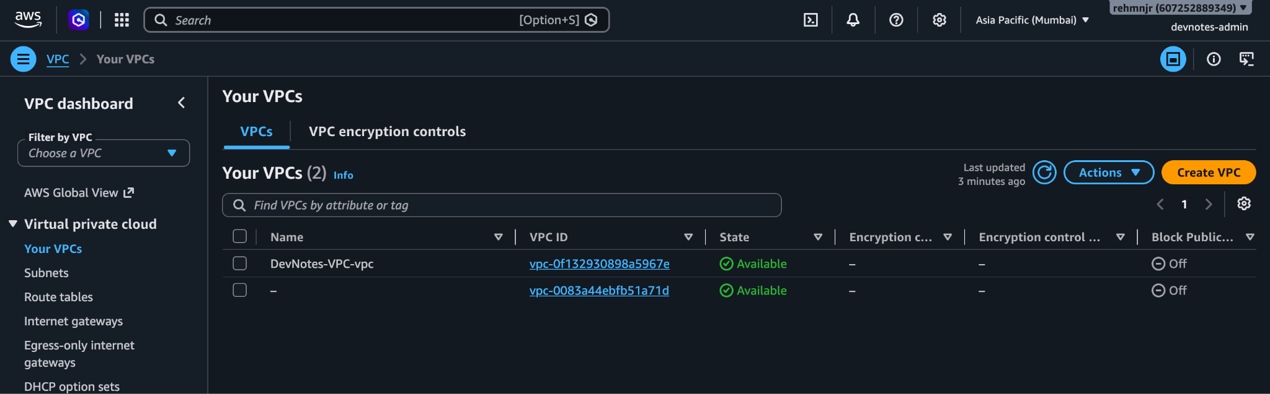

—--------—--------—--------—--------—--------—--------—--------—--------—--------—--------—--------—---

Screenshot 5 — VPC Subnets Configuration
What I did: Configured subnets within the DevNotes-VPC-vpc VPC, including two private subnets and a dedicated public subnet.
Why did it: To organize AWS resources into separate network segments and support controlled communication between the application server and database.
Configuration:
- VPC: DevNotes-VPC-vpc
- Private subnets: Two project subnets are listed.
- Public subnet: DevNotes-Public-Subnet
- Status: All listed subnets show Available.
- Additional subnets: The screenshot also shows subnets belonging to another VPC.
Result: The DevNotes VPC has separate public and private subnet resources.
Note: The screenshot truncates the CIDR ranges and does not show route-table associations. Public accessibility must be verified using the subnet's route table and public IP configuration, not just its name.
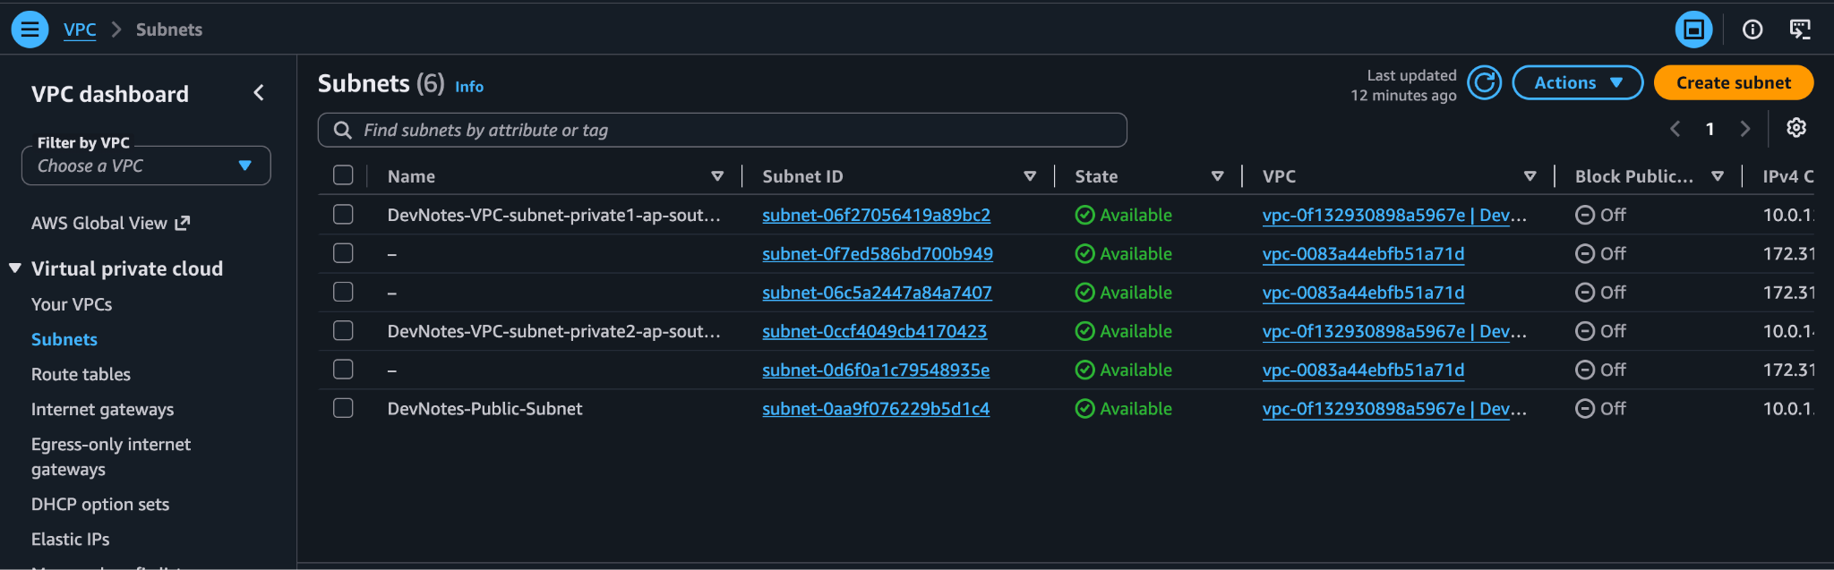
—--------—--------—--------—--------—--------—--------—--------—--------—--------—--------—--------—---

Screenshot 6 — VPC Route Tables
What I did: Configured separate route tables for the DevNotes VPC, including route tables associated with the two private subnets.
Why did it: Route tables determine where network traffic is directed, allowing public and private subnets to follow different routing rules.
Configuration:
- Private route table 1: DevNotes-VPC-rtb-private1-ap-south-1a
- Private route table 2: DevNotes-VPC-rtb-private2-ap-south-1b
- Subnet associations: The two named private route tables show explicit subnet associations.
- Additional route tables: The screenshot also shows main route tables for the DevNotes VPC and another VPC.
Result: Separate route tables are available for the DevNotes private subnets.
Note: This list view does not show the destination routes. The route table's Routes tab must be checked to confirm whether a default route points to an Internet Gateway, NAT Gateway, or another target.

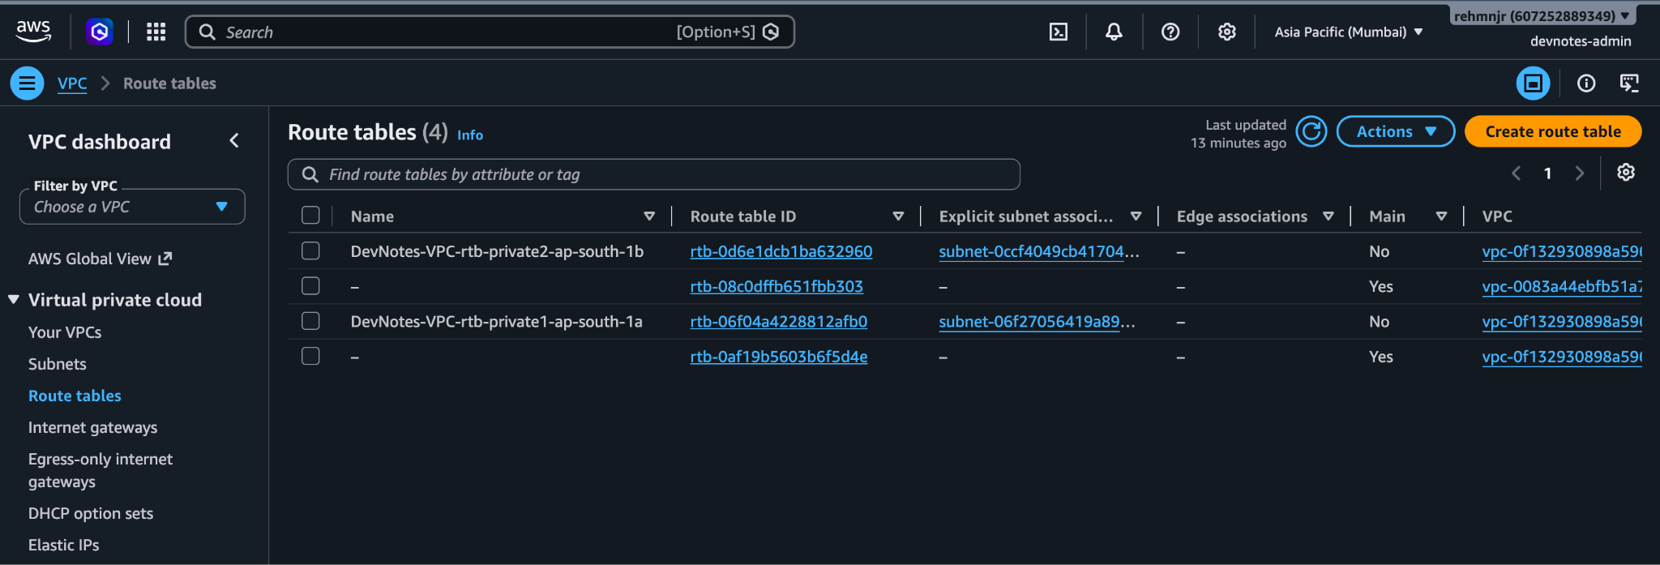
—--------—--------—--------—--------—--------—--------—--------—--------—--------—--------—--------—---

Screenshot 7 — Internet Gateway Configuration
What I did: Created an Internet Gateway named DevNotes-IGW and attached it to DevNotes-VPC-vpc.
Why did it: An Internet Gateway enables internet connectivity for resources in the VPC when the appropriate routes, public IP addressing, and security rules are configured.
Configuration:
- Name: DevNotes-IGW
- Gateway ID: igw-0d641d0b900e2f24c
- Attached VPC: DevNotes-VPC-vpc
- Status: Attached
Result: The Internet Gateway is successfully attached to the DevNotes VPC.
Important: Attaching an Internet Gateway alone does not make a subnet public. The route table must include a route such as 0.0.0.0/0 pointing to this gateway, and the instance must have suitable public addressing and security-group rules.

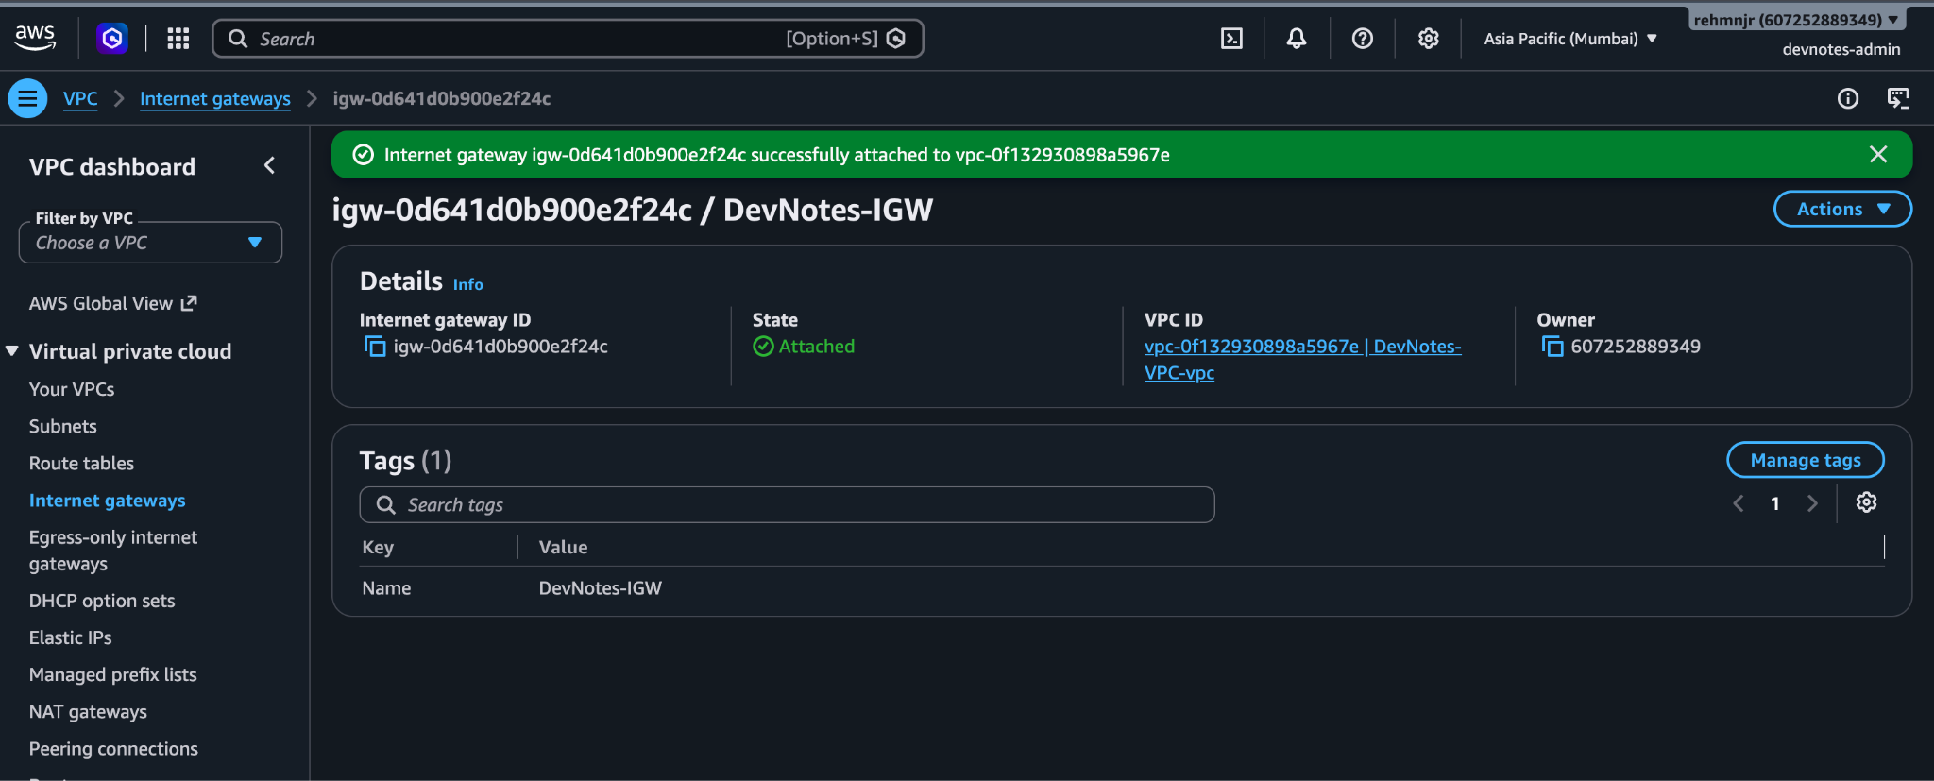

—--------—--------—--------—--------—--------—--------—--------—--------—--------—--------—--------—---

Screenshot 8 — EC2 Web Server Security Group
What I did: Created a security group named DevNotes-Web-SG for the DevNotes web server.
Why did it: To control incoming network traffic to the EC2 instance.
Configuration:
Protocol | Port | Source | Purpose
HTTP | 80 | 0.0.0.0/0 | Allows public HTTP access to the web application.
SSH | 22 | 160.202.37.233/32 | Restricts SSH access to one specific public IPv4 address.
Result: The security group was created successfully with two inbound rules.
Security note: HTTP on port 80 is publicly accessible. SSH is restricted to a single IP, which is safer than allowing SSH from 0.0.0.0/0. Confirm that the SSH source IP remains current and trusted.
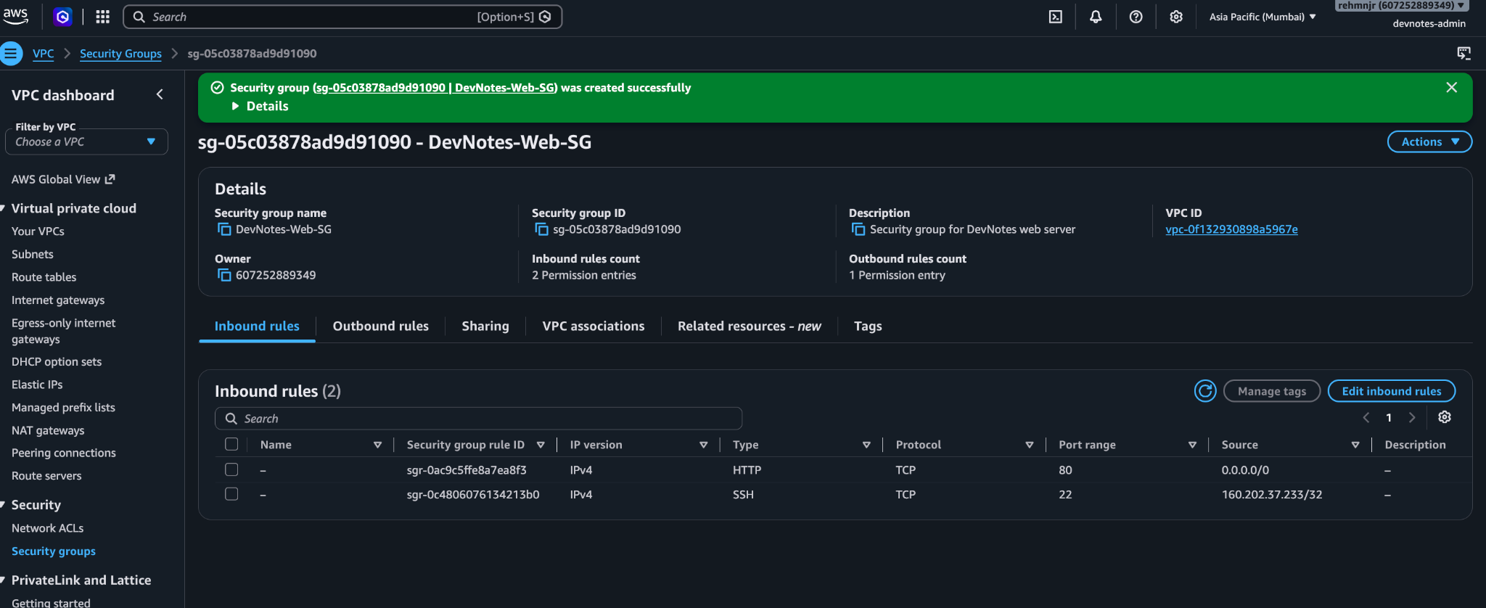

—--------—--------—--------—--------—--------—--------—--------—--------—--------—--------—--------—---

4. Amazon EC2 — Application Server

Screenshot 9 — DevNotes EC2 Instance Running
What I did: Launched an EC2 instance named DevNotes-Web-Server to host the containerized application.
Why did it: To run the DevNotes frontend and backend containers on a cloud-based virtual server.
Configuration:
- Instance ID: i-0949f90cacaef480b
- Instance type: t3.micro
- Availability Zone: ap-south-1a
- Instance state: Running
- AWS Region: Mumbai (ap-south-1)
Result: The EC2 instance was running when this screenshot was captured.
Note: The instance status check was still initializing in this screenshot. A running instance does not by itself prove that the application is healthy; application and API health checks must also pass.

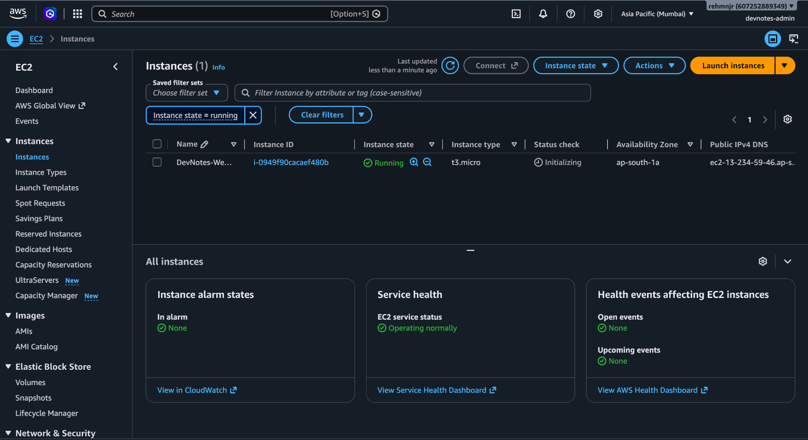

5. Amazon S3 — Backup Storage

Screenshot 10 — Create S3 Bucket
What I did: Created an S3 bucket named devnotes-attachments-607252889349.
Why did it: To store DevNotes database backup files separately from the EC2 application server, helping preserve backup copies if the server is replaced or terminated.
Configuration:
- Bucket name: devnotes-attachments-607252889349
- AWS Region: Asia Pacific (Mumbai), ap-south-1
- Bucket creation: Successful
- Objects shown: devnotes-attachments-607252889349.
Result: The S3 bucket was successfully created and was initially empty.
Next configuration: The bucket was later used to store database backup files under the backups/ prefix. Two backup files, each approximately 12 KB, were subsequently visible in that folder.
Note: This screenshot does not show the bucket's versioning, encryption, or public-access-block settings. Those should be documented from the bucket's Properties and Permissions tabs if screenshots are available.
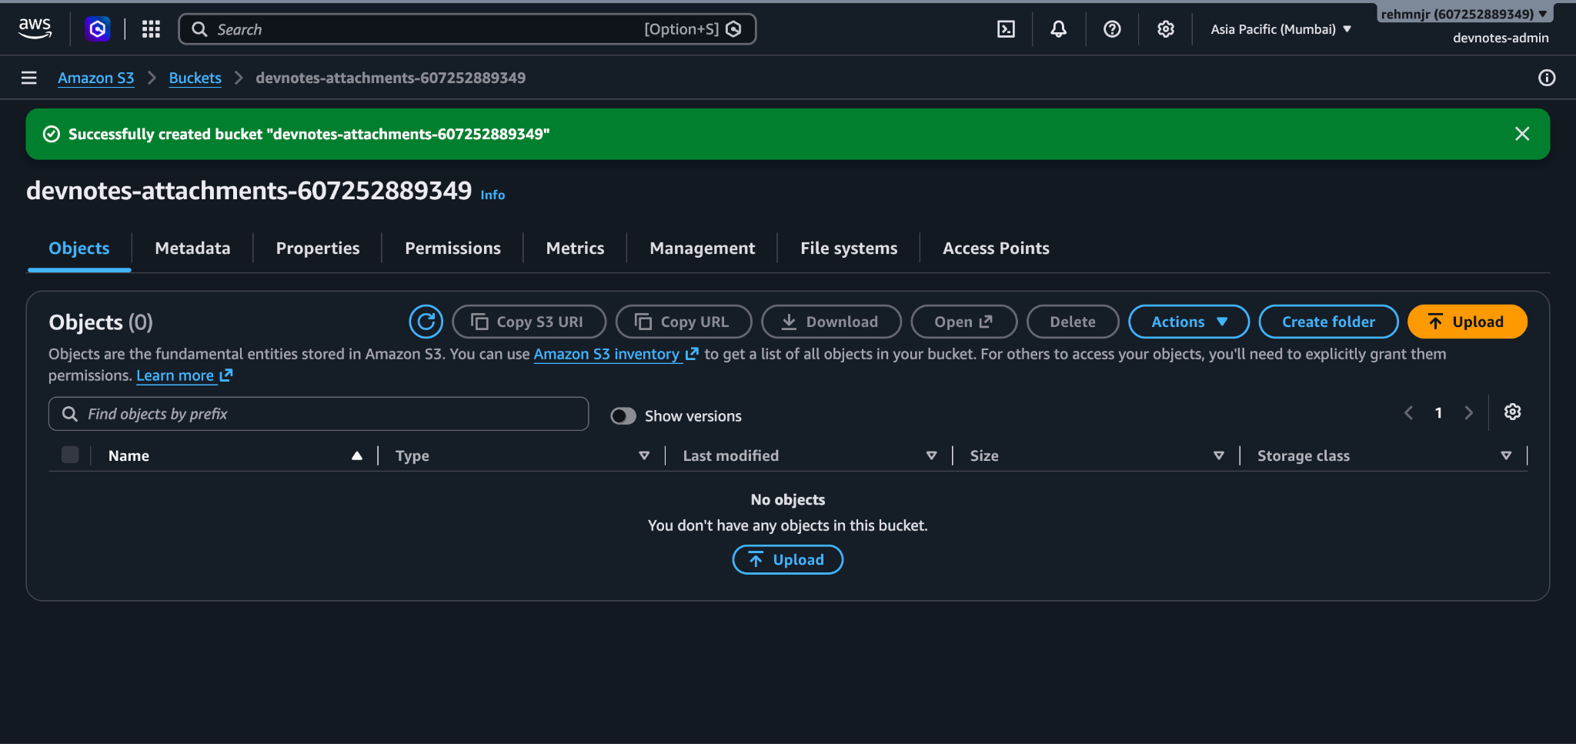
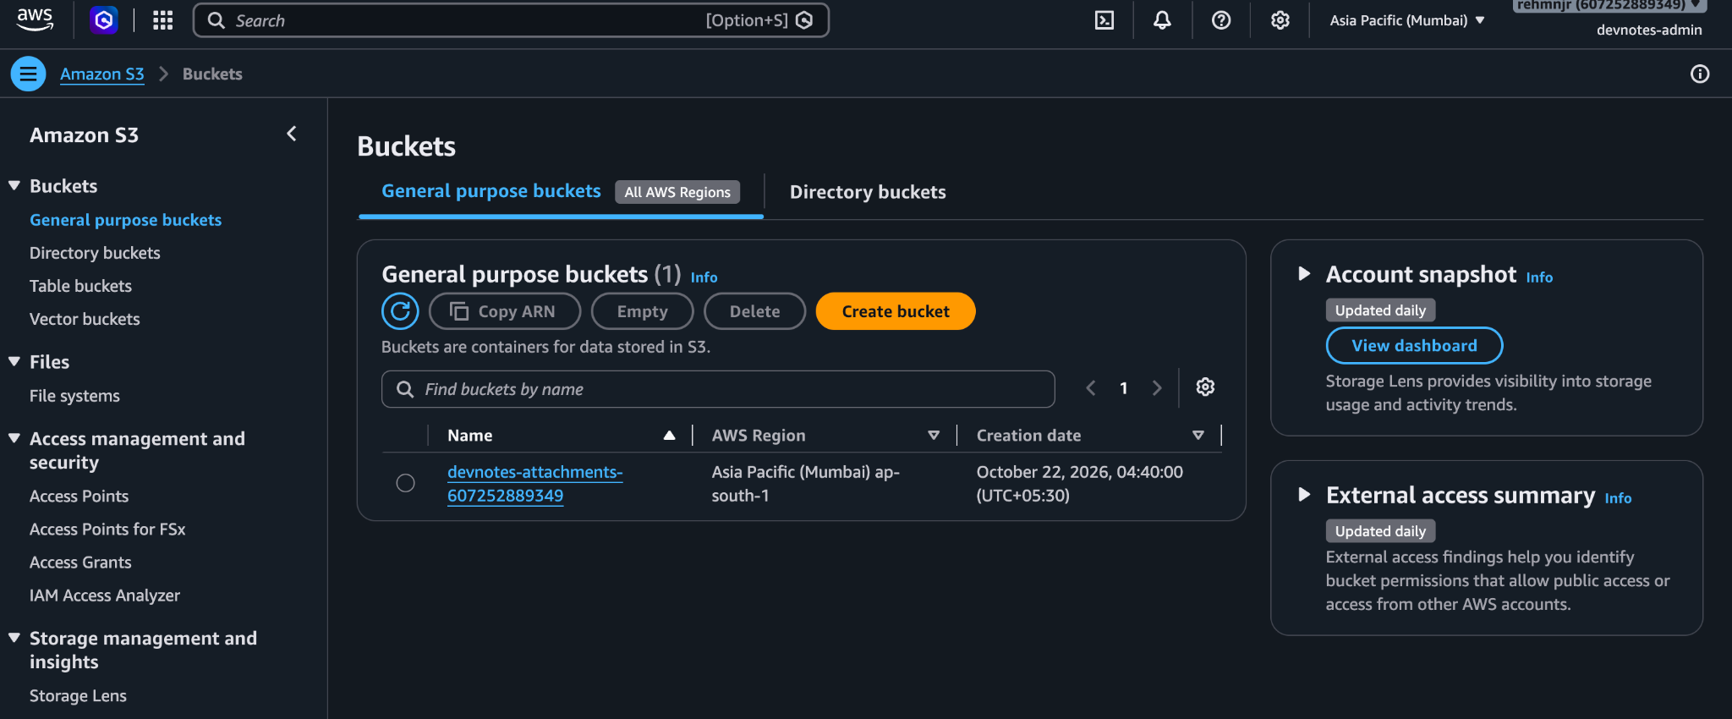

Screenshot 11 — SSH Connection and Nginx Installation
What I did: Connected to the EC2 instance using SSH and the DevNotes-Key.pem key pair. Updated the Amazon Linux 2023 package metadata and installed Nginx.
Why did it: SSH provided administrative access to the server, while Nginx was installed to serve HTTP traffic and support reverse-proxy routing.
Configuration:
- Operating system: Amazon Linux 2023
- SSH user: ec2-user
- SSH key: DevNotes-Key.pem
- Package manager: dnf
- Web server: Nginx
Commands used:
chmod 400 ~/Downloads/DevNotes-Key.pem
ssh -i ~/Downloads/DevNotes-Key.pem ec2-user@13.234.59.46
sudo dnf update -y
sudo dnf install nginx -y
Result: The SSH session was established, and Nginx was installed successfully.
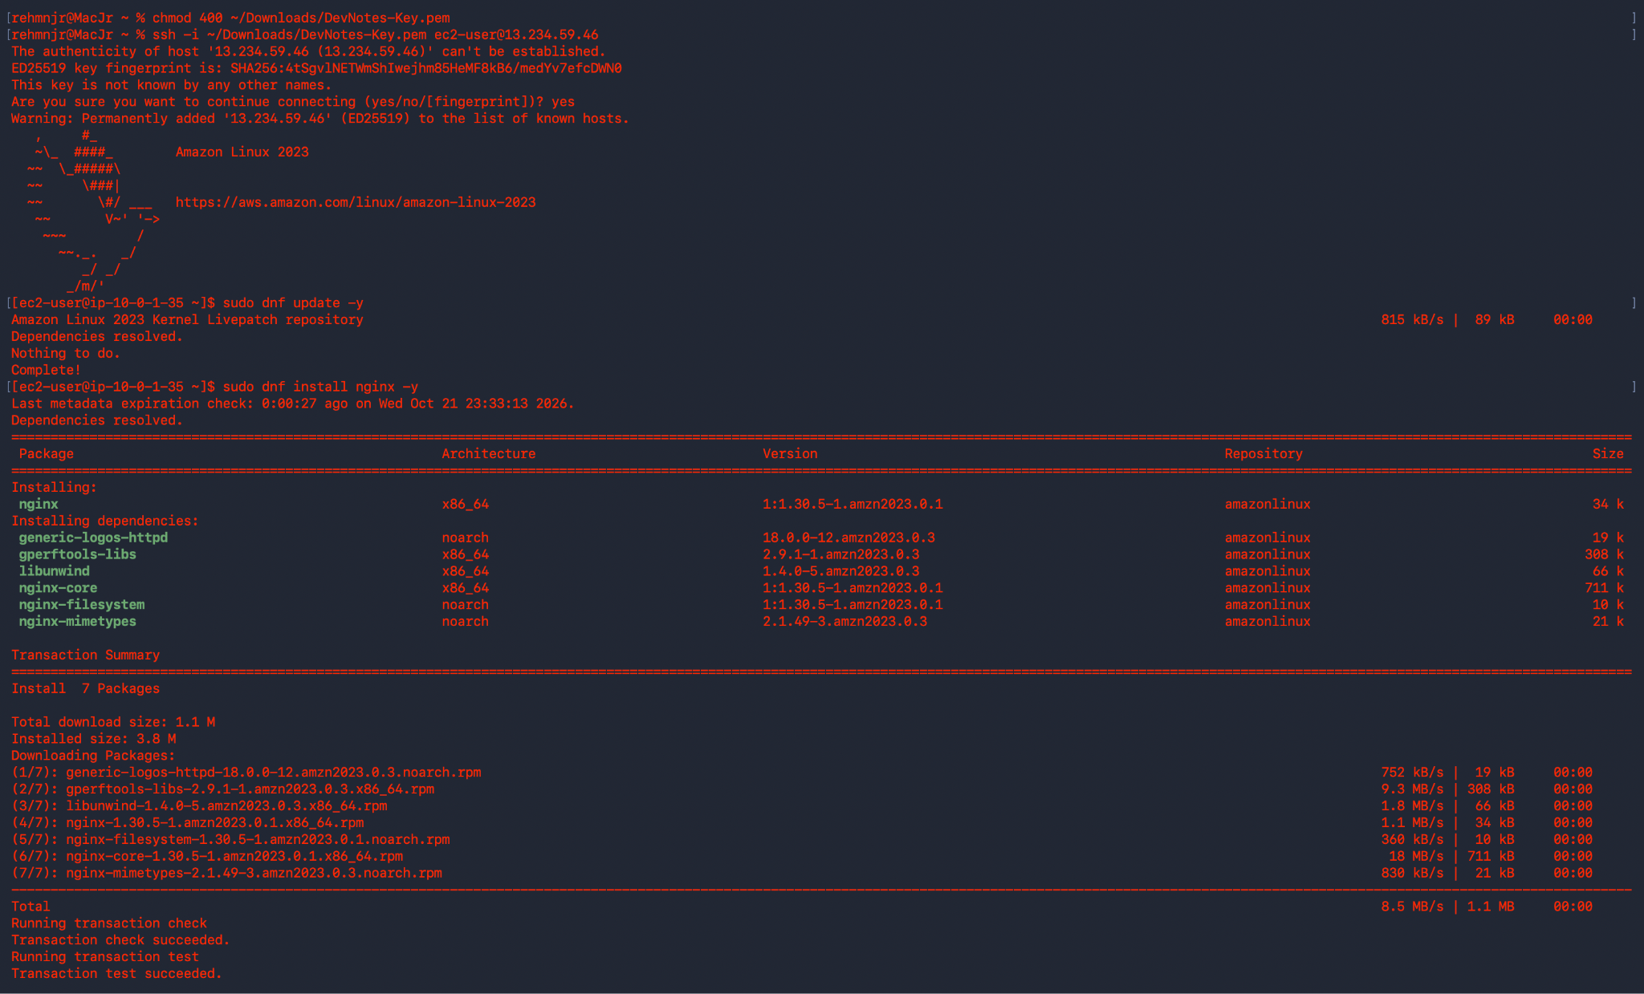

Screenshot 12 — Nginx Service Verification
What I did: Enabled Nginx to start automatically at boot and started the service immediately.
Why did it: To ensure that the web server runs as a managed system service and is available after a server restart.
Command used:
sudo systemctl enable --now nginx
sudo systemctl status nginx
Configuration:
- Service: nginx.service
- Enabled at boot: Yes
- Current status: Active (running)
- Configuration test: Successful
Result: The screenshot confirms that Nginx was running and its configuration syntax check succeeded.
Note: This verifies the Nginx service at that point in time; it does not by itself prove that the complete DevNotes application or backend API was working.
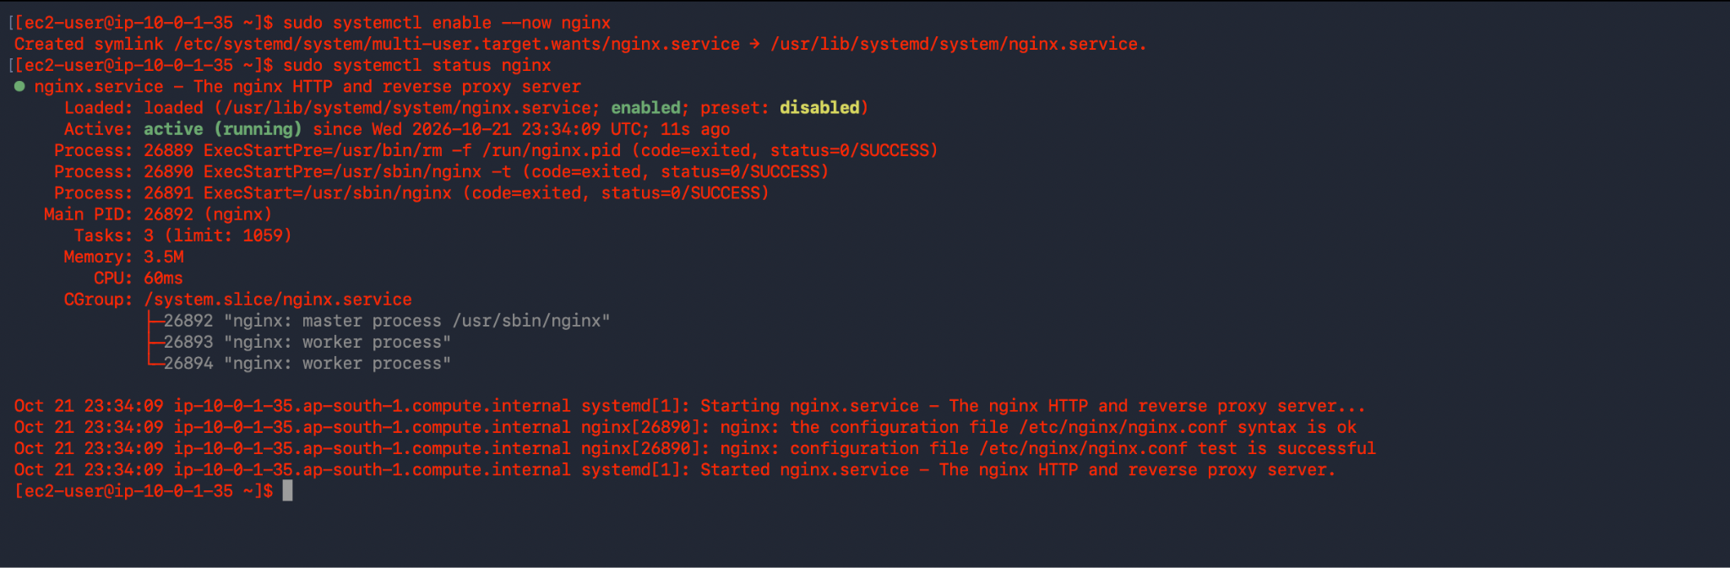

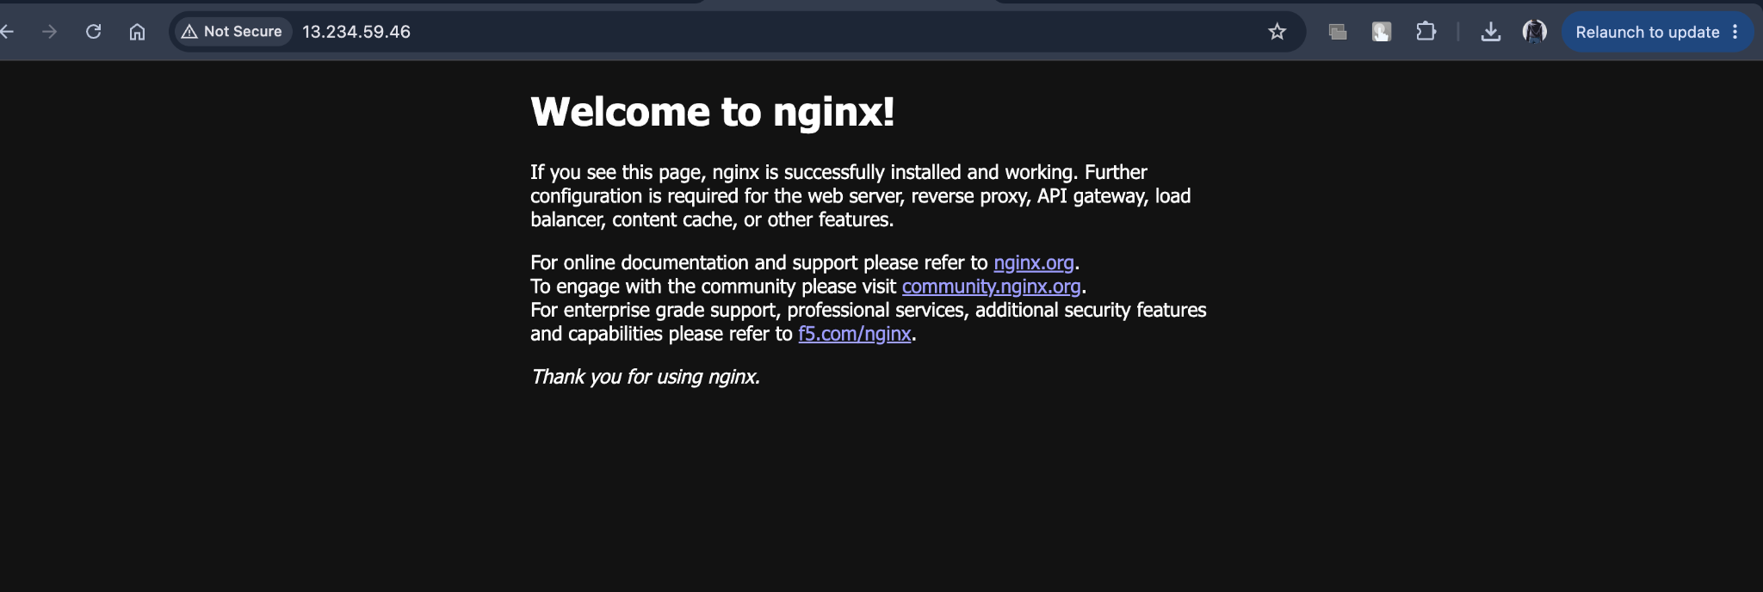

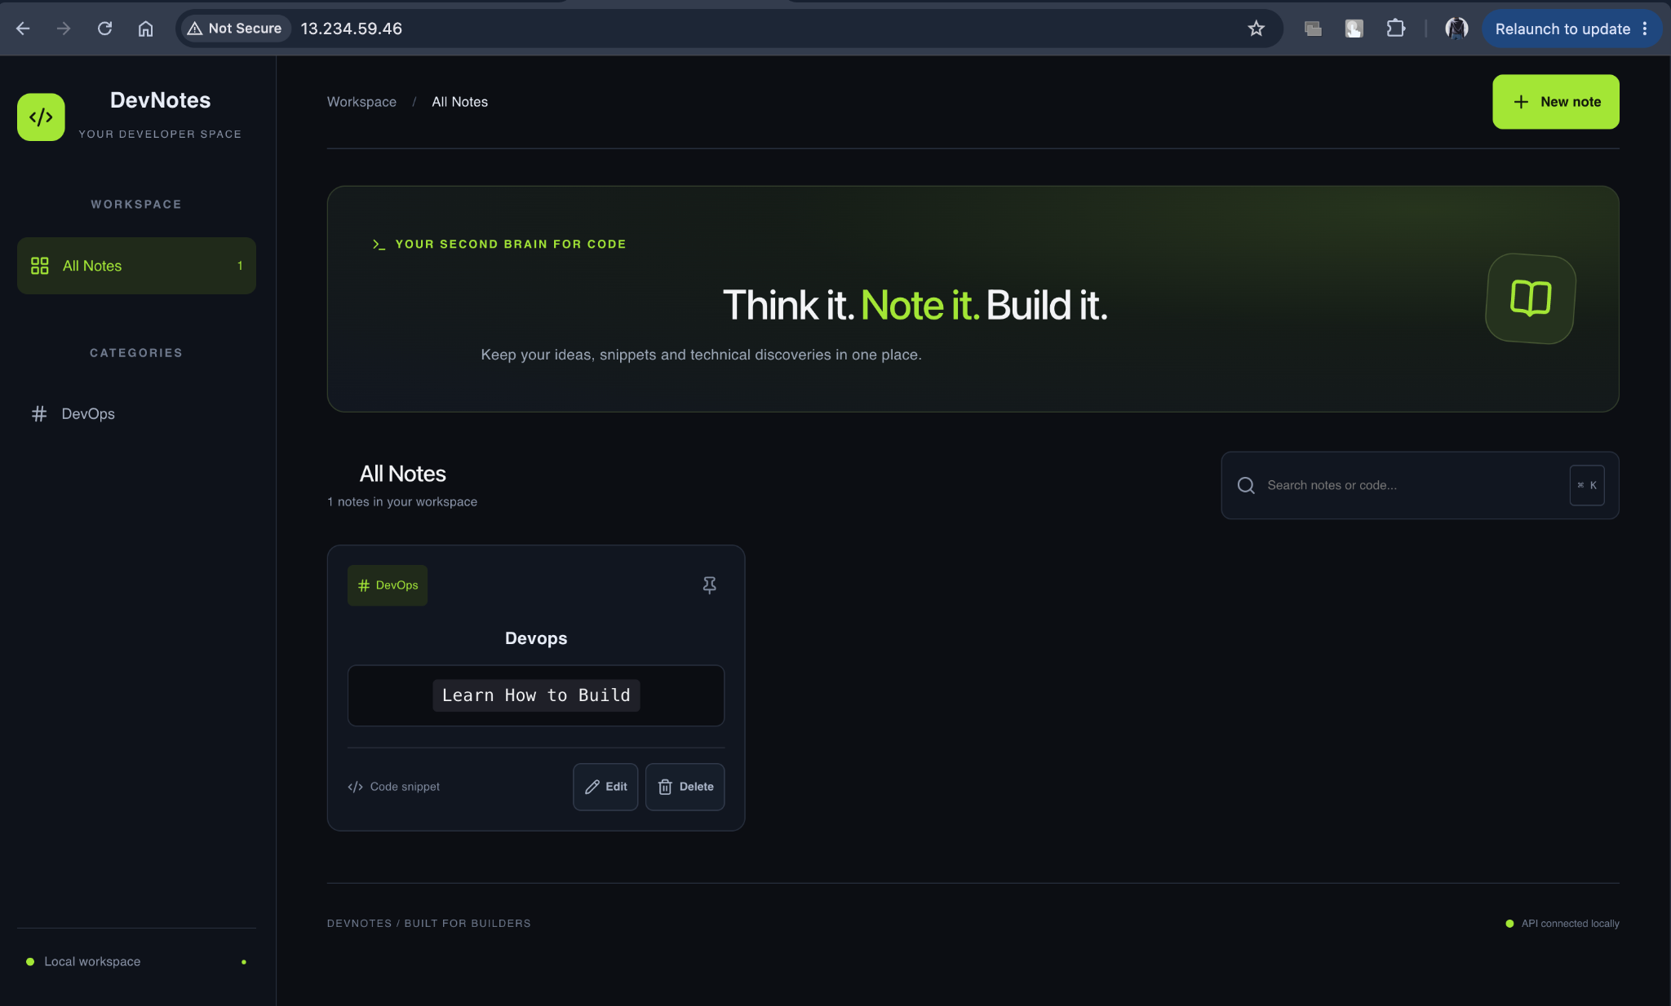

6. Amazon CloudWatch — Monitoring and Alerts

Screenshot 13 — EC2 CPU Utilization Alarm
What I did: Created a CloudWatch alarm named DevNotes-High-CPU-Alarm to monitor the EC2 instance's CPU utilization.
Why did it: To identify unusually high CPU usage and receive alerts when the server exceeds the configured threshold.
Configuration:
- Alarm name: DevNotes-High-CPU-Alarm
- Monitored metric: CPUUtilization
- Threshold: Greater than 70%
- Evaluation period: 1 datapoint within 5 minutes
- Current state shown: OK
- Insufficient data alarms: 0
Result: CloudWatch displays the alarm in the OK state, meaning the configured alarm condition was not currently breached based on the available evaluation data.
Note: This screenshot confirms the alarm and its threshold. It does not independently confirm that an email notification was delivered or that a high-CPU test successfully triggered the alarm.
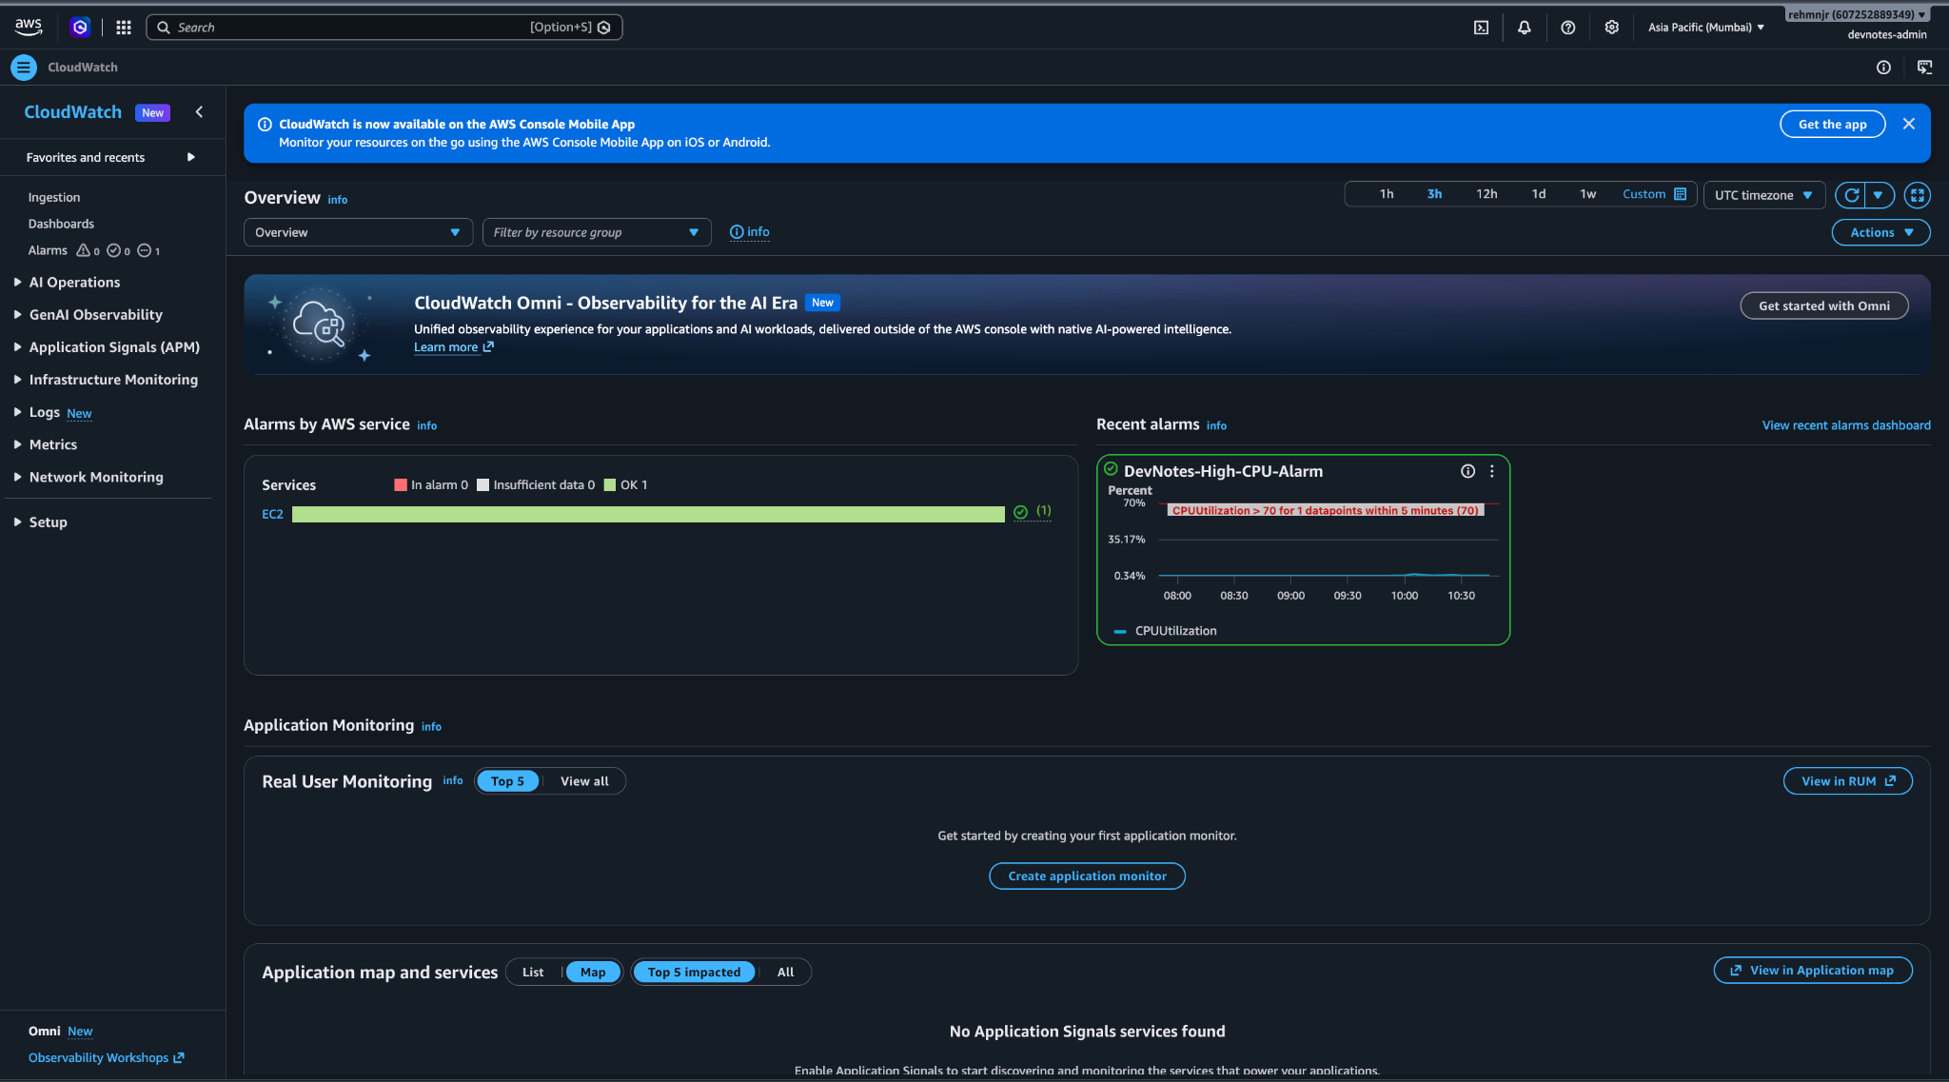

Amazon SNS — CloudWatch Alert Notifications
Amazon Simple Notification Service (SNS) was configured to provide email notifications for the DevNotes project's CloudWatch monitoring alerts.

Screenshot 14 — SNS Topic and Email Subscription
What I did: Created the Standard SNS topic fahim-project2-alerts and configured an email subscription.
Why did it: To provide a notification destination for CloudWatch alarms when their configured actions are triggered.
Configuration:
- Topic name: fahim-project2-alerts
- Topic type: Standard
- Region: Mumbai (ap-south-1)
- Email endpoint: rehmnjr@gmail.com
- Subscriptions: 1
- Subscription status: Confirmed
Result: The SNS topic and its email subscription were configured successfully.
Note: The screenshots confirm the topic and subscription status. They do not independently prove that an alarm notification was delivered to the inbox.
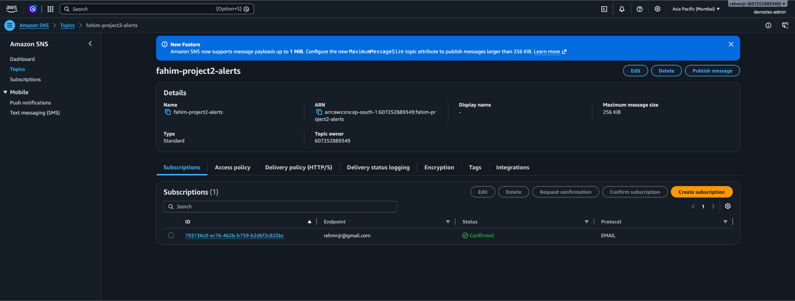
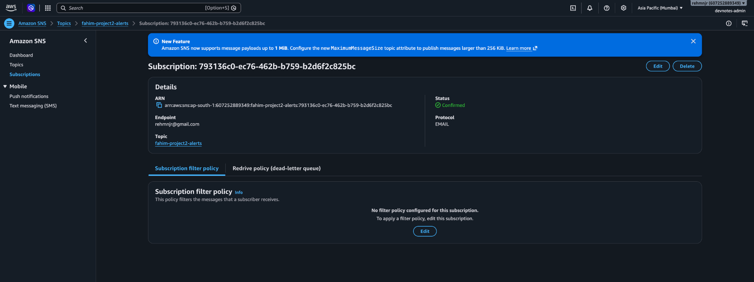

Amazon CloudWatch — EC2 CPU Monitoring

Screenshot 15 — DevNotes High CPU Alarm Configuration
What I did: Created a metric alarm named DevNotes-High-CPU-Alarm to monitor CPU utilization of the DevNotes EC2 instance.
Why did it: To detect high CPU usage and enable notifications when the server's resource consumption exceeds the configured threshold.
Configuration :
- Alarm name: DevNotes-High-CPU-Alarm
- EC2 instance: DevNotes-Web-Server
- Instance ID: i-0949f90cacaef480b
- Namespace: AWS/EC2
- Metric: CPUUtilization
- Statistic: Average
- Threshold: CPU utilization greater than 70%
- Period: 5 minutes
- Datapoints to alarm: 1 out of 1
- Missing data treatment: Treat missing data as missing
- Alarm actions: Enabled
- State shown: Insufficient data
Result: The alarm was configured with a 70% CPU threshold and a five-minute evaluation period. At the time of this screenshot, CloudWatch displayed Insufficient data, so the alarm's current evaluation could not be confirmed.
Note: Alarm actions were enabled. The SNS topic and confirmed email subscription were configured separately to support email notifications.
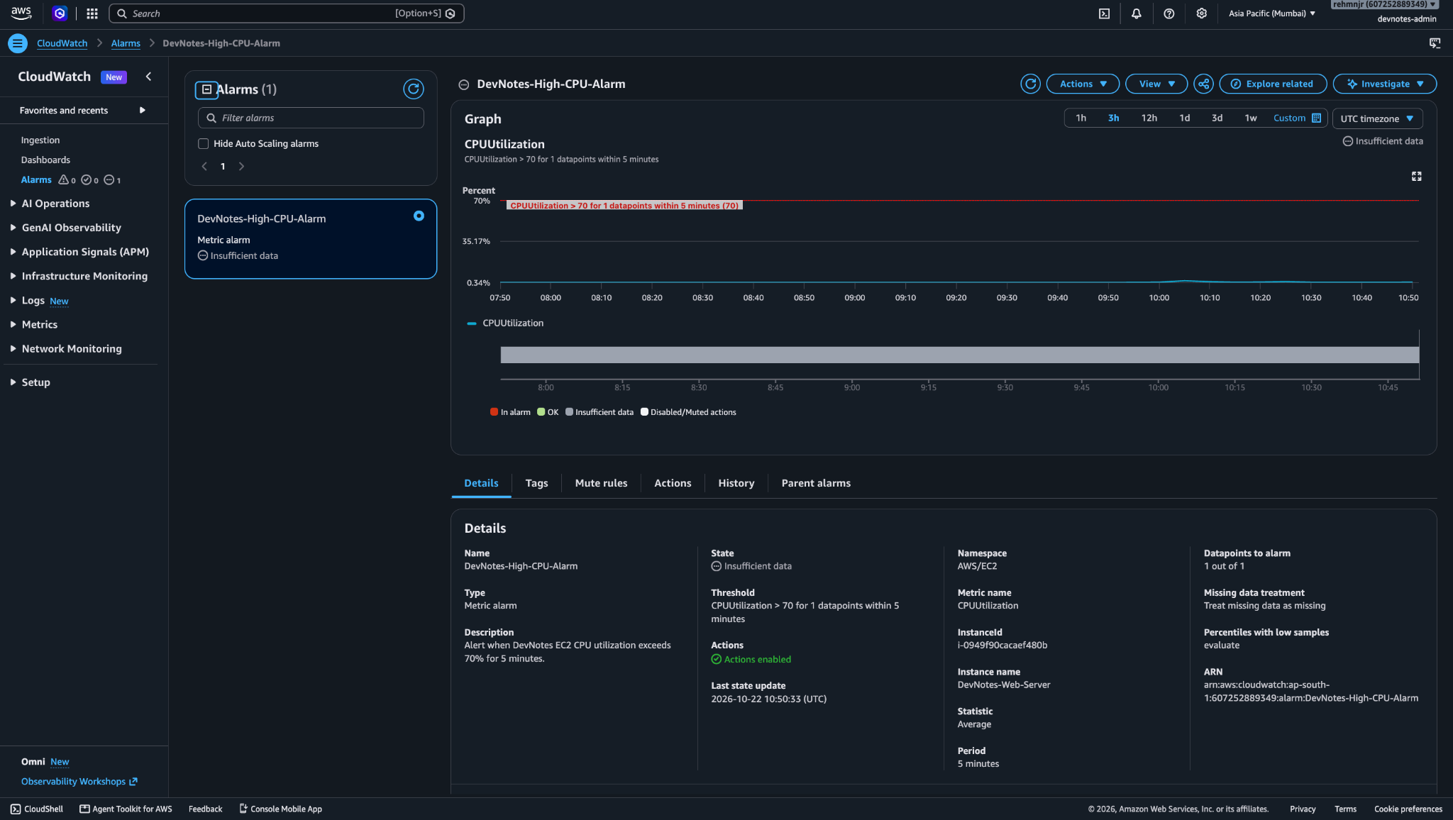

IAM — EC2 Role and Custom Policies
What I did: Created the IAM role DevNotes-EC2-S3-Role and attached two custom inline policies.
Why did it: To allow the EC2 application server to access required AWS resources through an IAM role instead of storing long-term AWS access keys on the server.
Configuration:
- Role name: DevNotes-EC2-S3-Role
- Trusted service: EC2 (as established in the role configuration)
- Instance profile: DevNotes-EC2-S3-Role
- Maximum session duration: 1 hour
- Inline policy 1: DevNotes-S3-Access
- Inline policy 2: DevNotes-EC2-DescribeInstances
- Permissions boundary: Not set
Purpose of the policies:
- DevNotes-S3-Access — grants the S3 permissions defined in the policy for the project's backup bucket.
- DevNotes-EC2-DescribeInstances — grants permission to describe EC2 instances.
Result: The IAM role and both inline policies were present in the AWS console.
Security note: The exact actions and resource scope must be verified by opening each policy. The role screenshot alone does not show the full policy JSON or prove that every permission is restricted to the intended resources.

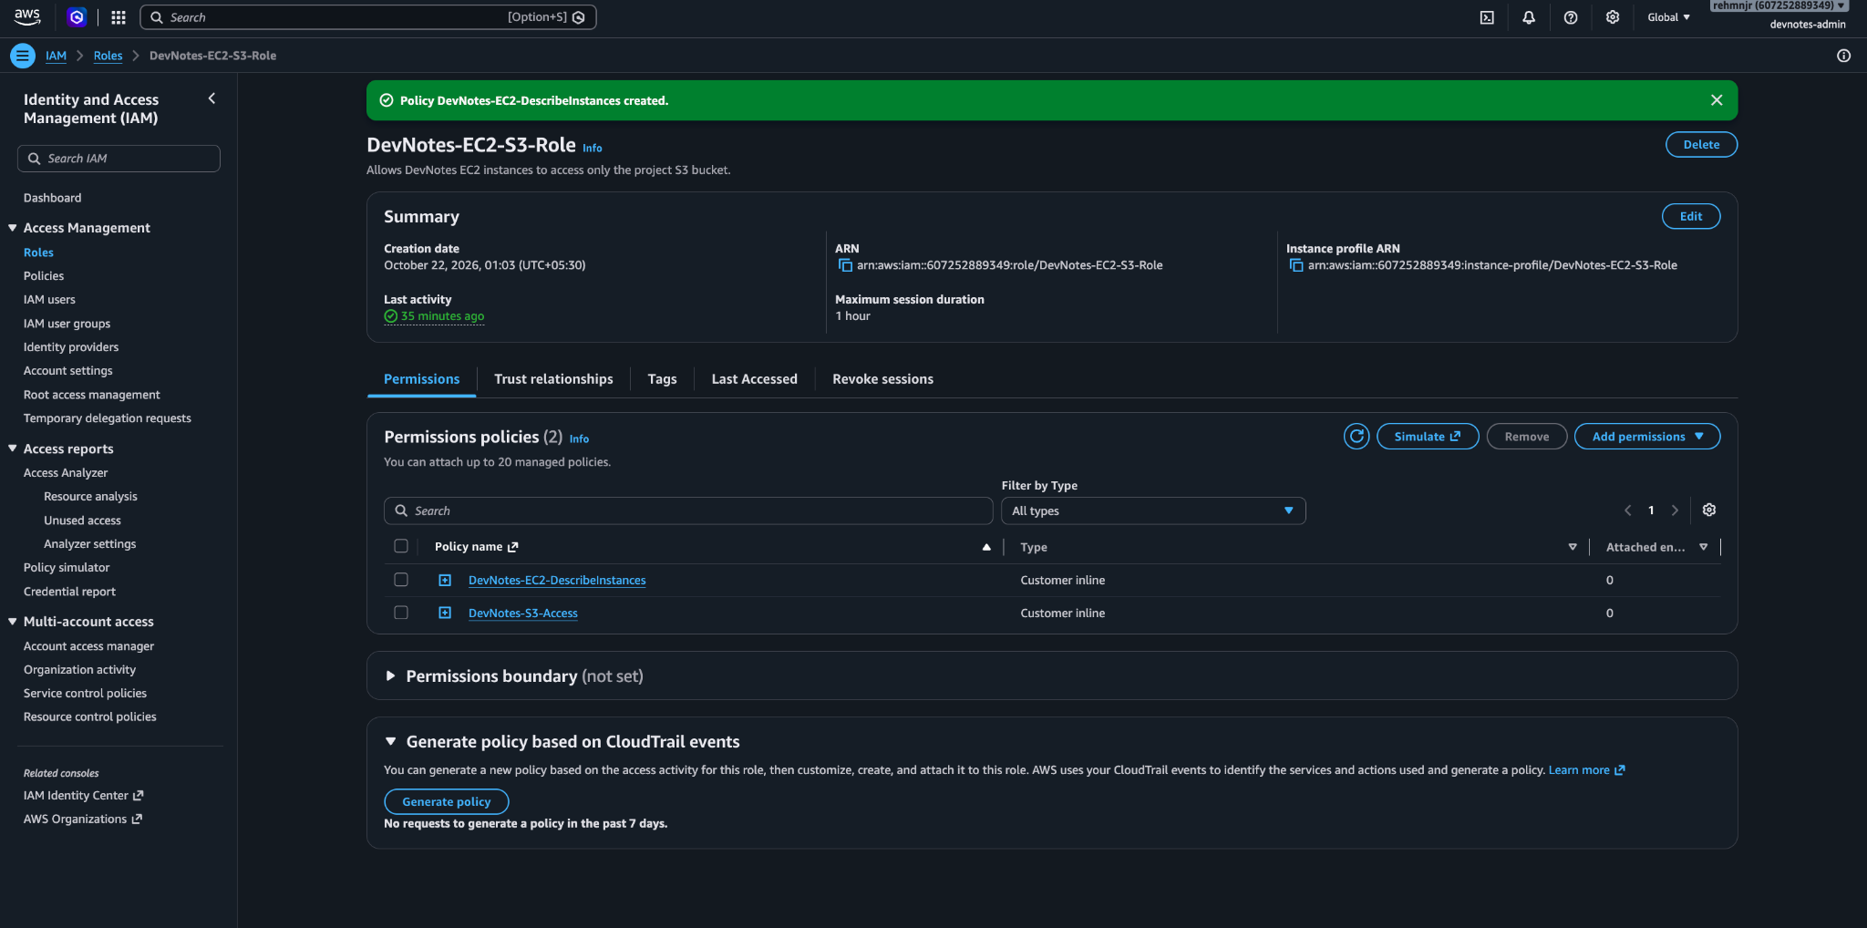

Amazon S3 — Database Backup Verification
What I did: Stored two database backup files in the backups/ folder of the DevNotes S3 bucket.
Why did it: To keep backup copies separate from the EC2 instance, so they can be recovered even if the application server is terminated.
Configuration:
- Bucket: devnotes-attachments-607252889349
- Prefix: backups/
- Backup files: devnotes-20261022-110717.db and devnotes-20261022-111030.db
- Size: 12 KB each
- Storage class: S3 Standard
Result: Two backup files were present in S3. One file was downloaded to the local machine, and its SQLite integrity check returned ok.
Important note: These .db files are SQLite backups. Since DevNotes was migrated to MySQL on Amazon RDS, the SQLite backup should not be treated as a verified backup of the latest RDS database.
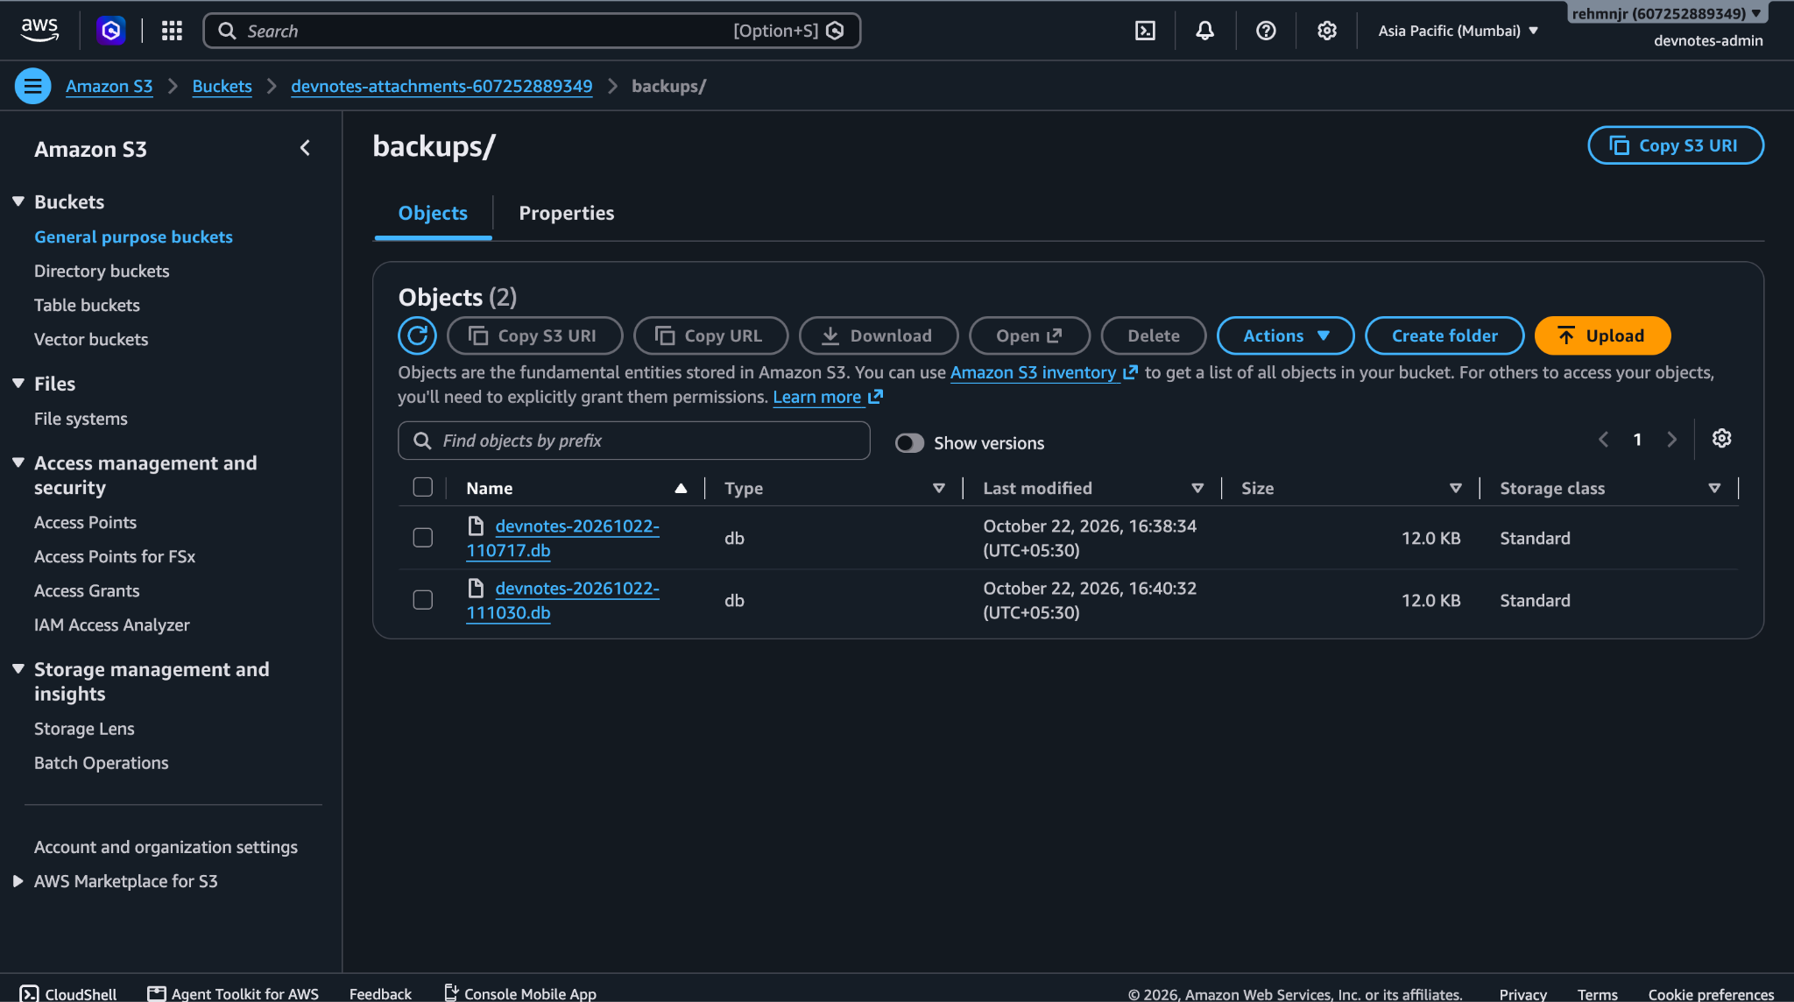
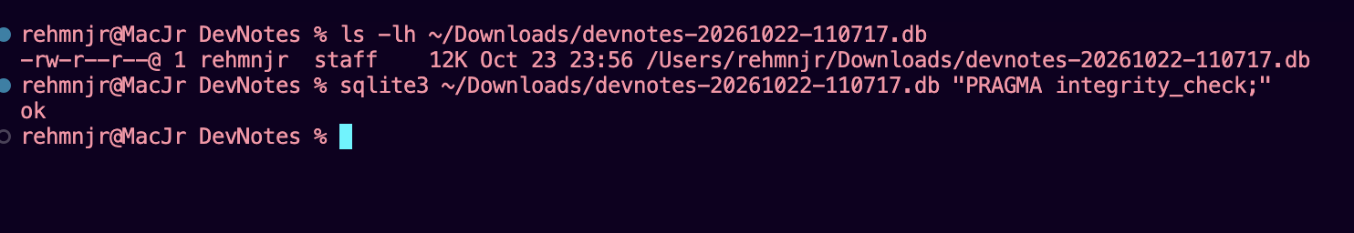

Amazon RDS — MySQL Database Setup
Configuration
- AWS Service: Amazon RDS
- DB Identifier: database-1
- Database Engine: MySQL-compatible engine
- Status: Available
- Instance Role: Instance
- Availability Zone: ap-south-1b (Mumbai Region)
- Instance Class: db.t4g.micro (as configured in the project)

What did I do?
We created a managed MySQL database using Amazon RDS for the DevNotes application. The database was configured to run in the Mumbai AWS Region.

Why did I use RDS?
Amazon RDS manages database infrastructure and supports automated database maintenance and backups. It separates application compute from database storage, making the architecture easier to manage.

Result
The RDS database database-1 is shown as Available, indicating that the database instance is ready for connections.
The DevNotes backend was configured to connect to this MySQL database instead of relying solely on its local SQLite database.
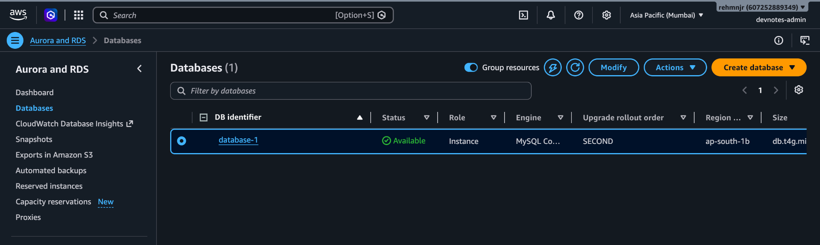

Amazon RDS — Connectivity & Security Configuration

1. Database Details
- DB Identifier: database-1
- Engine: MySQL Community
- Instance Class: db.t4g.micro
- Status: Available
- AWS Region: Asia Pacific (Mumbai)
- Availability Zone: ap-south-1b

2. Connection Configuration
- Database Name: mysql (as displayed in the connection panel)
- Master Username: devnotesadmin
- Port: 3306
- Internet Access Gateway: Disabled
- Endpoint: database-1.cluugk4m820m.ap-south-1.rds.amazonaws.com

3. Networking Configuration
- VPC: DevNotes-VPC-vpc
- VPC ID: vpc-0f132930898a5967e
- DB Subnet Group: default-vpc-0f132930898a5967e
- Network Type: IPv4
- Security Group: DevNotes-DB-SG
- Publicly Accessible: No

4. Security Explanation
The RDS database is configured as a private database and is not publicly accessible. The application server connects to it through the VPC network.
The database security group controls inbound database traffic on port 3306. In our project, the intended configuration allows MySQL traffic from DevNotes-Web-SG, rather than opening the database port to everyone.

5. Project Outcome
The DevNotes backend was configured to use Amazon RDS MySQL for persistent data storage. This separates the database layer from the EC2 application server and provides a more structured cloud architecture.
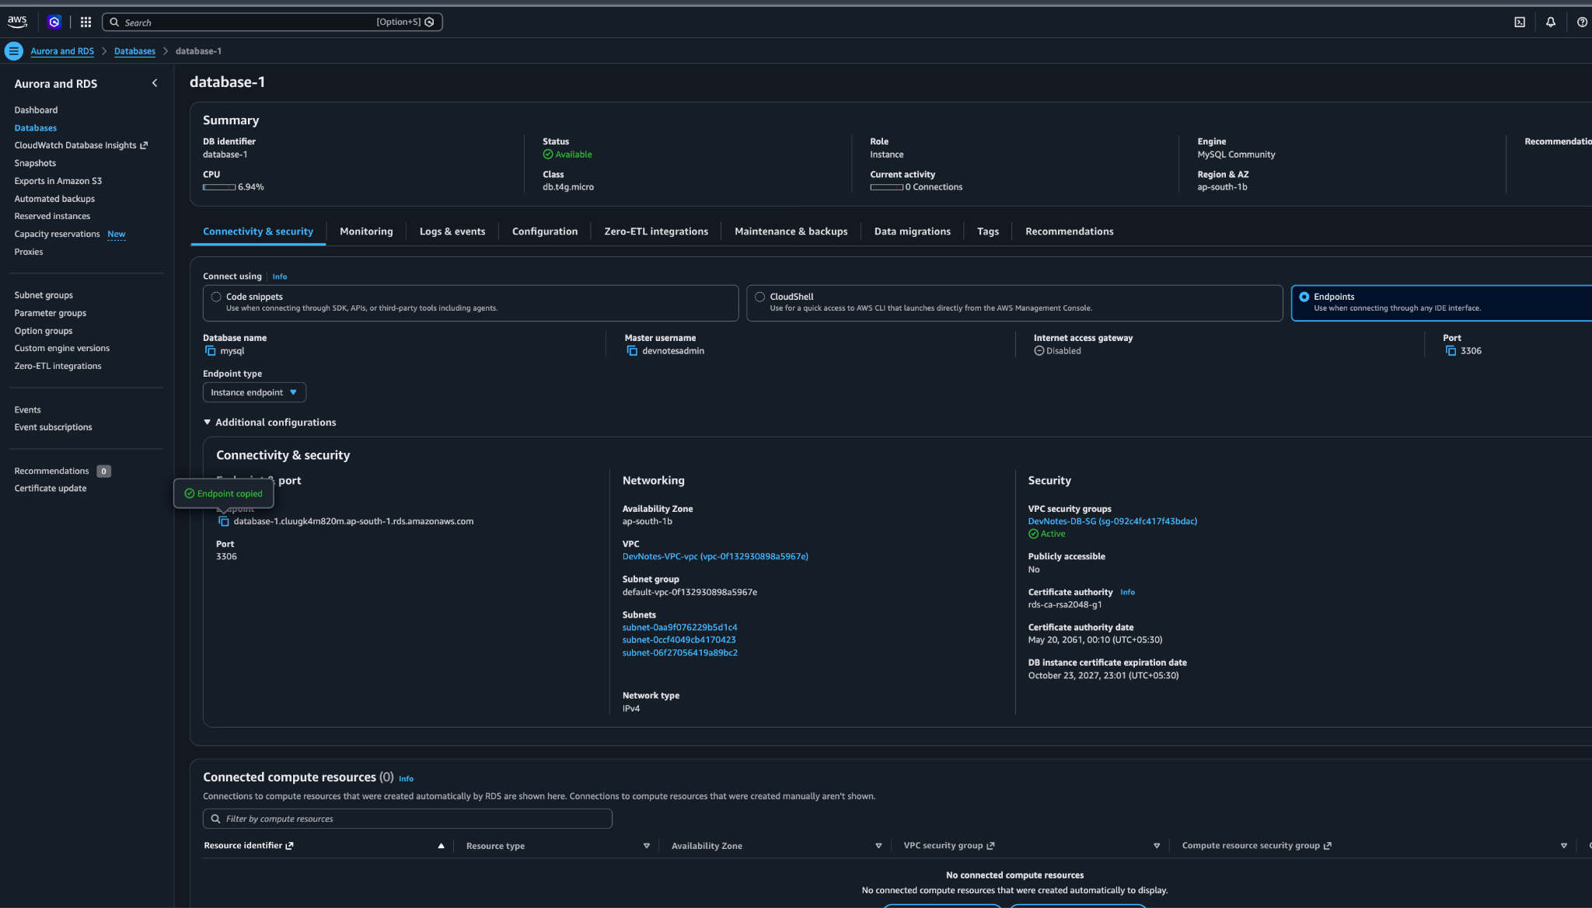

GitHub Actions — CI Workflow Configuration
Repository: rehmnjr/DevNotes
Workflow file: .github/workflows/deploy.yml
Branch: main
Commit: 7d7b5be — Add GitHub Actions CI workflow

What did I configure?
We created a GitHub Actions workflow in the .github/workflows/ directory. The workflow file, deploy.yml, defines the automation used to validate the DevNotes project when the configured workflow triggers.

How does it work?
- Code Repository: The DevNotes source code is maintained on GitHub.
- Workflow Configuration: The deploy.yml file defines the CI workflow.
- Automated Checks: The workflow runs the configured backend and frontend checks.
- Execution Status: GitHub Actions displays whether the workflow jobs pass or fail.

Project Outcome
GitHub Actions was integrated into the DevNotes repository to automate backend and frontend validation. This helps identify build or configuration issues before changes are considered ready.
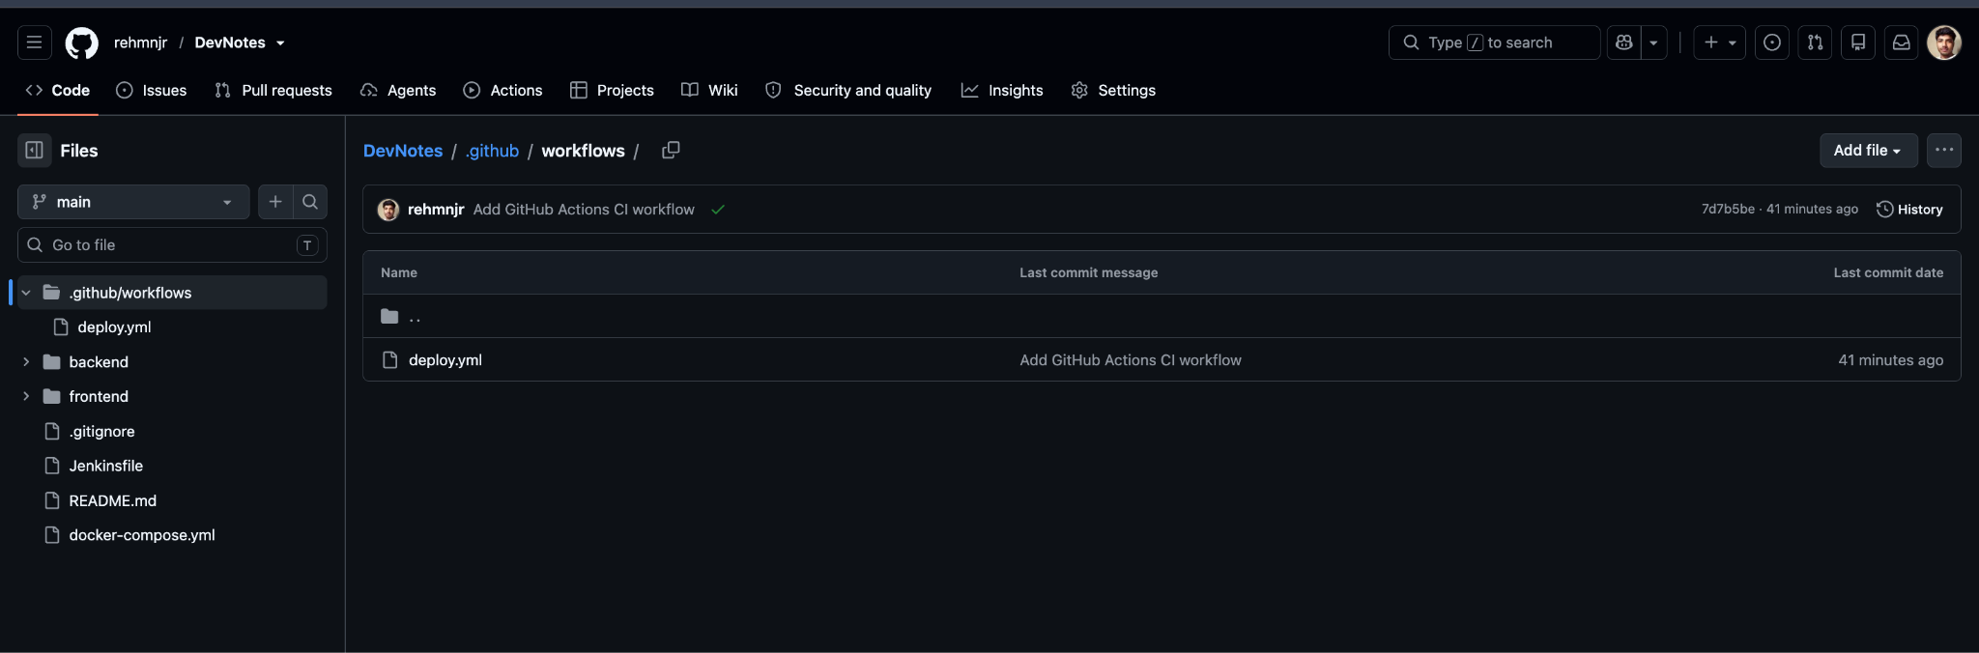
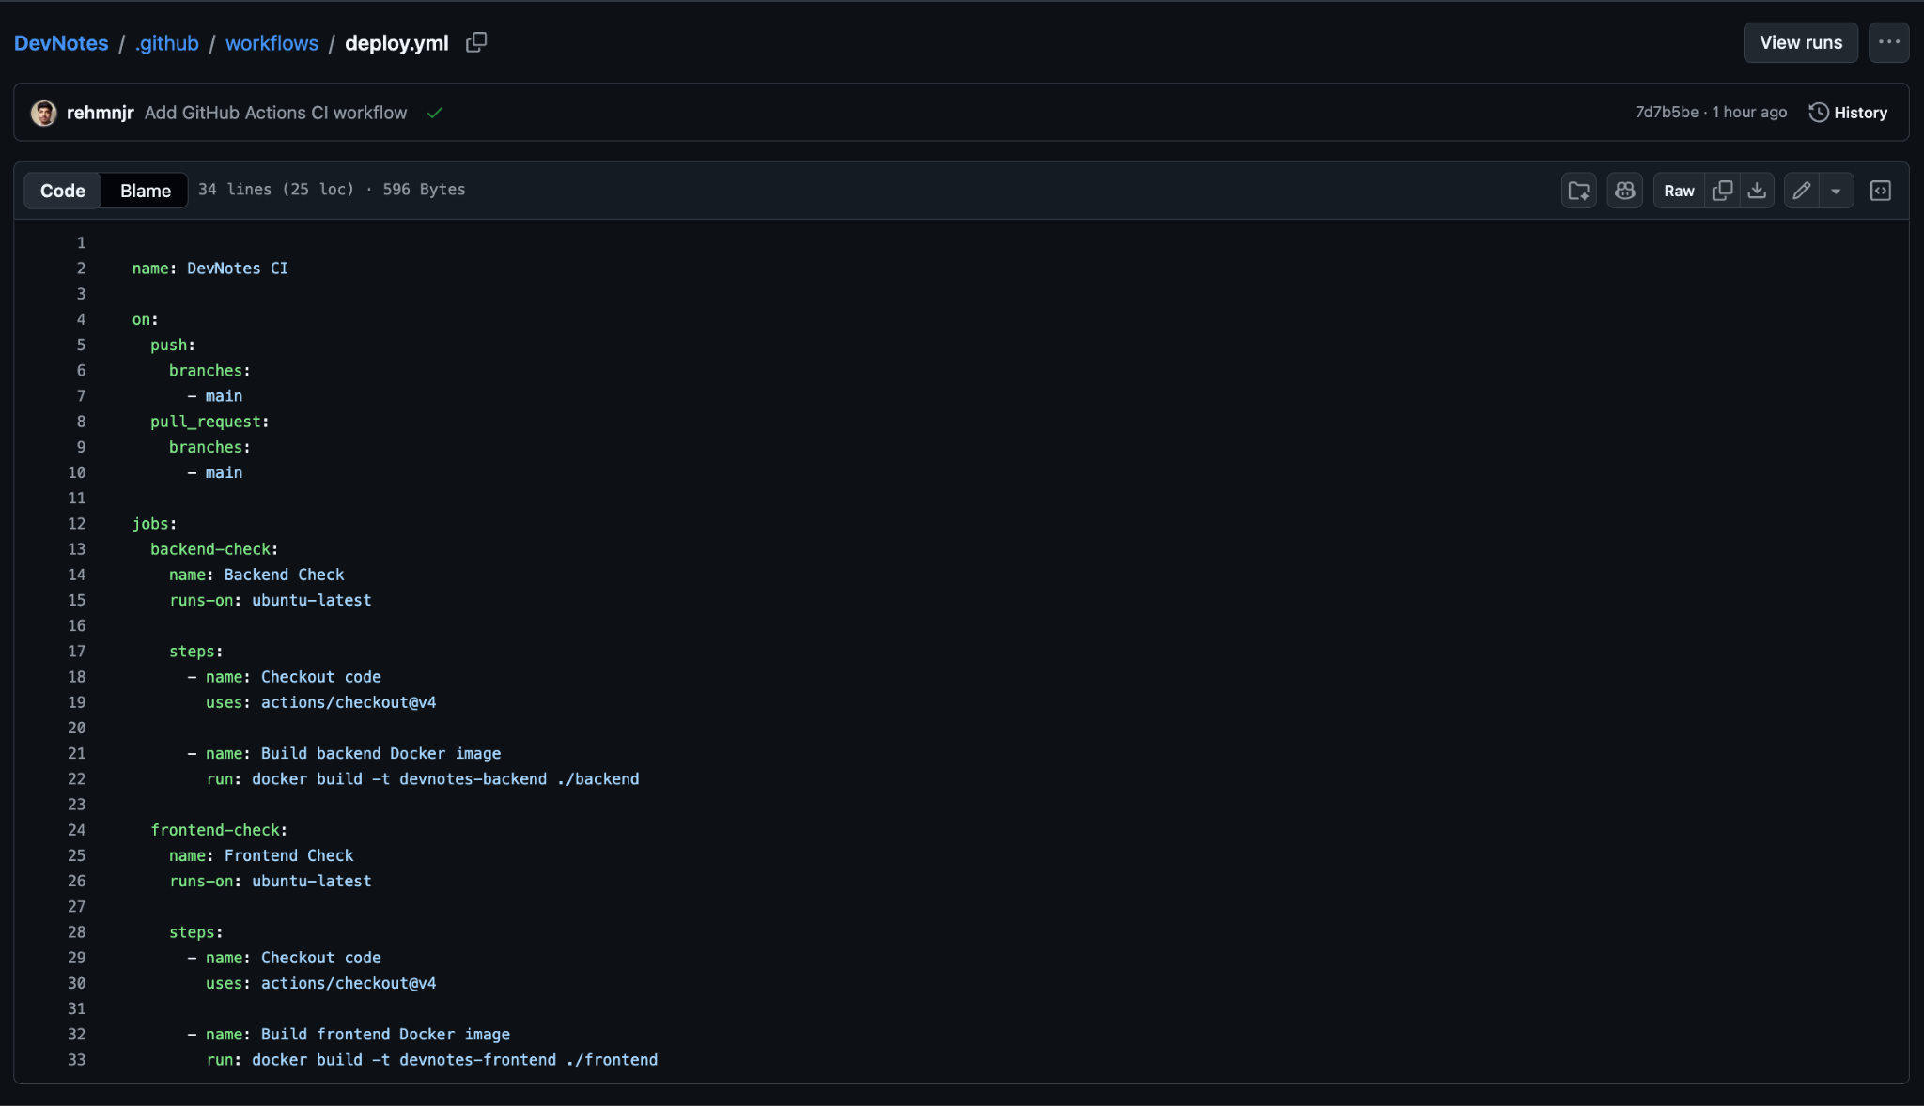

A. Workflow name
name: DevNotes CI
- name: Defines the workflow's display name.
- DevNotes CI: The name shown in the GitHub Actions tab.
- CI means Continuous Integration.
In simple words: This identifies the automation workflow for the DevNotes project.

B. Workflow triggers
on:
push:
branches:
- main
pull_request:
branches:
- main
Line | Explanation
on: | Defines when the workflow should run.
push: | Triggers the workflow when code is pushed.
branches: | Specifies which branches to monitor.
- main | Runs for pushes to the main branch.
pull_request: | Triggers the workflow for pull requests targeting main.
- main | Specifies main as the target branch for pull requests.
Example: You push a new commit to main. GitHub Actions starts the workflow automatically. If someone opens or updates a pull request targeting main, the workflow also runs.

C. Jobs section
jobs:
- jobs defines the tasks that GitHub Actions must execute.
- This workflow contains two jobs: backend-check and frontend-check.
- GitHub Actions can run these jobs in parallel because neither depends on the other.

D. Backend job
backend-check:
name: Backend Check
runs-on: ubuntu-latest
- backend-check: The unique ID of this job, used internally by GitHub Actions.
- name: Backend Check: The readable name displayed in the Actions interface.
- runs-on: ubuntu-latest: Runs the job on a GitHub-hosted virtual machine using the latest available Ubuntu runner image.
In simple words: GitHub provides a temporary Ubuntu machine to check whether the backend Docker image can be built.

E. Steps section
steps:
- steps contains the individual actions and commands that the job executes.
- Steps in a job run sequentially, from top to bottom.

F. Checkout code
- name: Checkout code
uses: actions/checkout@v4
- -: Starts a new step in the list.
- name: Checkout code: Gives the step a descriptive name.
- uses:: Tells GitHub Actions to use an existing action.
- actions/checkout@v4: Uses version 4 of GitHub's official checkout action to download the repository's source code into the runner's workspace.
Why is this necessary? The runner needs your project files before it can build the Docker image.

G. Build backend Docker image
- name: Build backend Docker image
run: docker build -t devnotes-backend ./backend
- name: Build backend Docker image: Describes the purpose of the step.
- run:: Executes a shell command on the runner.
- docker build: Builds a Docker image using a Dockerfile.
- -t devnotes-backend: Tags the resulting image with the name devnotes-backend.
- ./backend: Specifies the backend directory as the Docker build context. Docker uses this directory's files and its Dockerfile, if present, to build the image.
What happens? GitHub Actions attempts to build your backend image. If the command fails, the step and normally the job are marked as failed.

H. Frontend job
frontend-check:
name: Frontend Check
runs-on: ubuntu-latest
This is the second job.
- frontend-check: The job's unique ID.
- name: Frontend Check: The display name.
- runs-on: ubuntu-latest: Uses an Ubuntu runner for the frontend check.
It is independent of the backend job, so both jobs can run at the same time.

I. Frontend checkout
steps:
- name: Checkout code
uses: actions/checkout@v4
This performs the same checkout operation as the backend job, but in the frontend job's own runner workspace.
Important: Each job gets its own runner environment, so the frontend job also needs to check out the repository.

J. Build frontend Docker image
- name: Build frontend Docker image
run: docker build -t devnotes-frontend ./frontend
- name: Describes the frontend build step.
- run: Executes the Docker command.
- docker build: Builds the frontend Docker image.
- -t devnotes-frontend: Names the resulting image devnotes-frontend.
- ./frontend: Uses the frontend directory as the Docker build context.

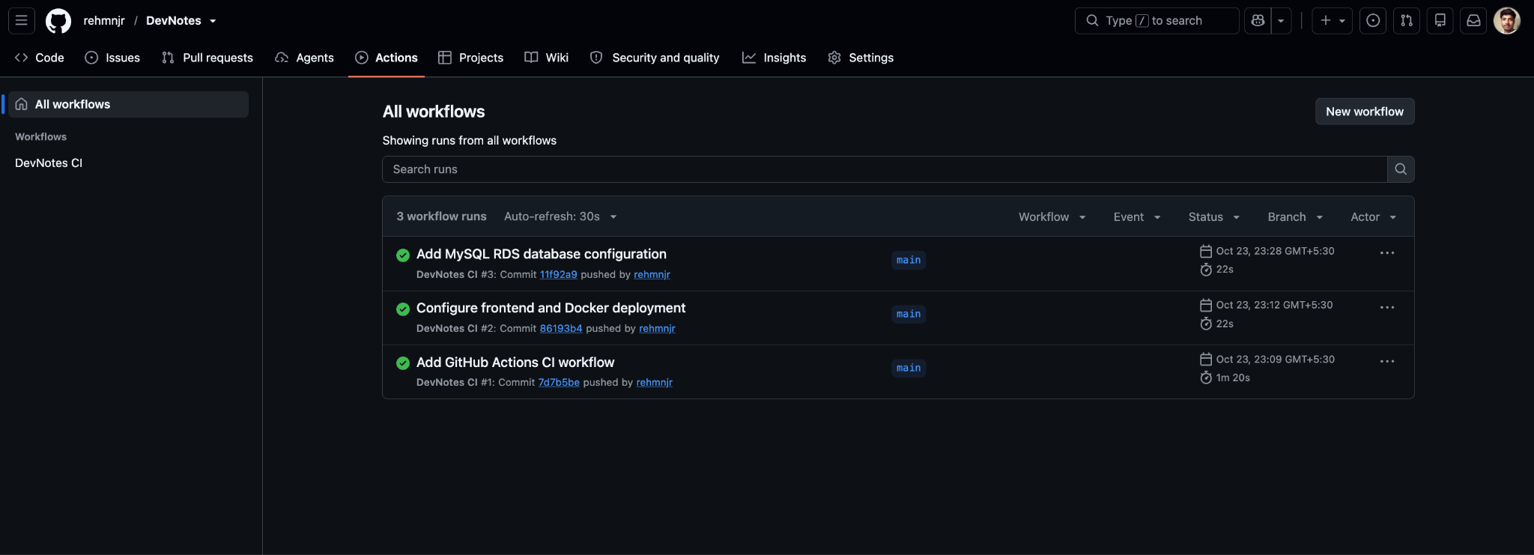
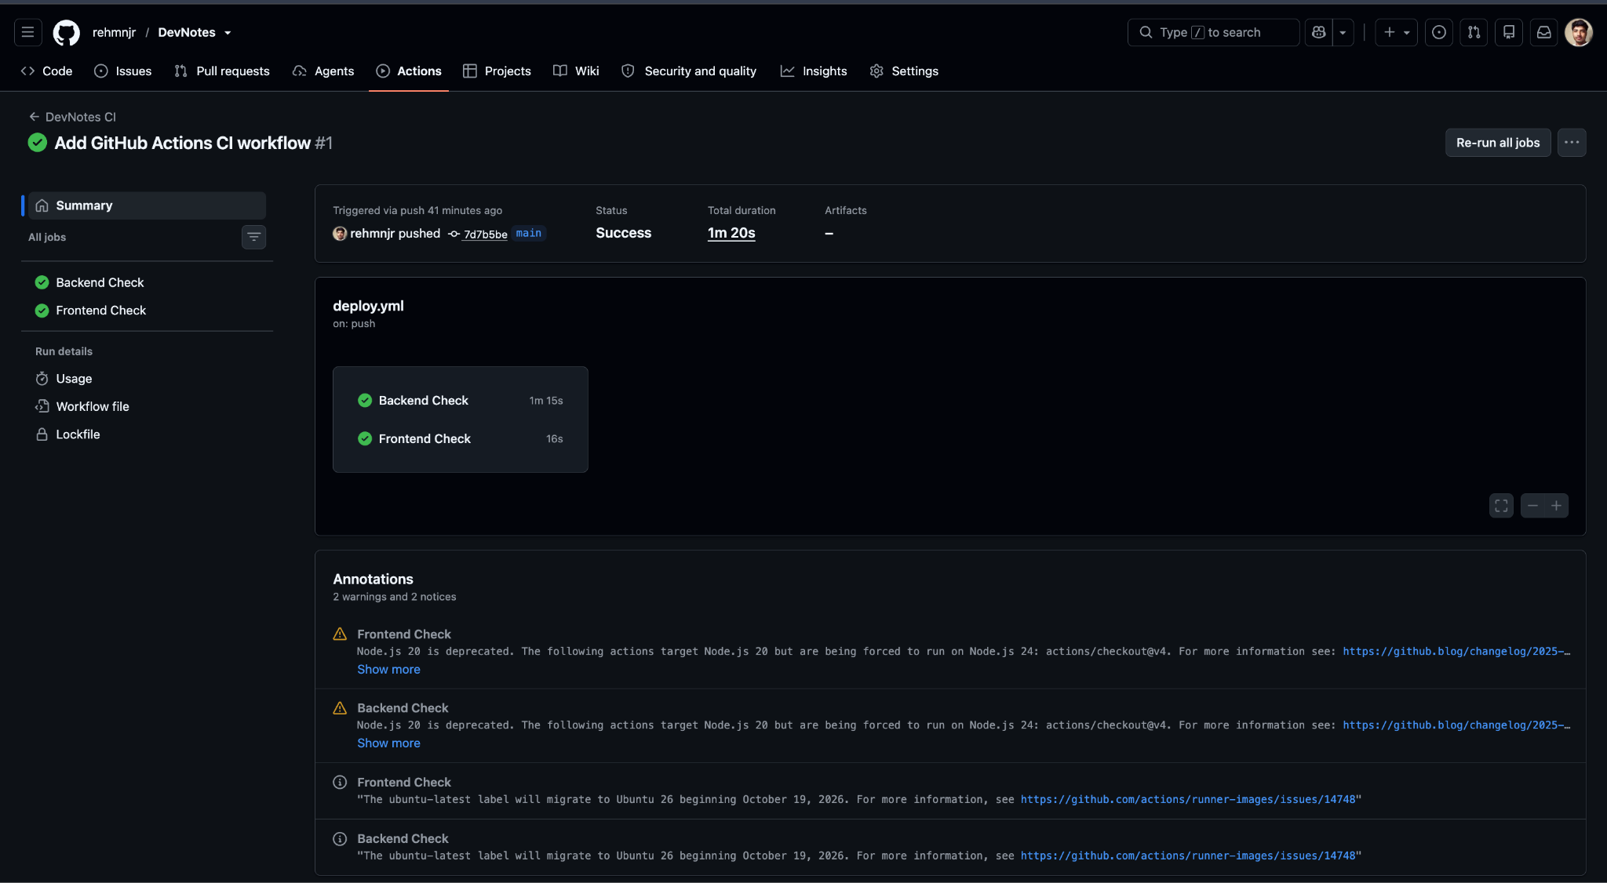

Jenkins CI/CD Pipeline — DevNotes

1. Jenkins Pipeline Overview
Pipeline Name: DevNotes-CI
Description: CI/CD pipeline for DevNotes — React frontend, FastAPI backend, and Docker Compose.
Jenkins is used to automate the application's build workflow. The pipeline retrieves source code from GitHub, verifies the project configuration, builds Docker images, and pushes images to Docker Hub.

Pipeline Execution Stages
Stage | Purpose
Declarative: Checkout SCM | Initializes the pipeline and checks out source code from the configured Source Code Management (SCM) system.
Checkout | Retrieves the repository code from GitHub.
Verify Project Structure | Checks whether the expected project files and directories exist.
Verify Docker Compose Config | Validates the Docker Compose configuration.
Build Backend Image | Builds the backend Docker image.
Build Frontend Image | Builds the frontend Docker image.
Push Images to Docker Hub | Uploads the built images to Docker Hub.
Declarative: Post Actions | Executes post-build actions defined in the Jenkinsfile.

Build Result
The Stage View shows build #6 with all displayed stages in green, indicating that the pipeline completed successfully.
The screenshot also shows earlier successful and failed builds, demonstrating that Jenkins maintains build history for troubleshooting and tracking changes.

2. Jenkins Job Configuration

General
- Job Name: DevNotes-CI
- Status: Enabled
- Description: CI/CD pipeline for DevNotes — React frontend, FastAPI backend, and Docker Compose.

Source Code Management (SCM)
- SCM Type: Git
- Repository URL: https://github.com/rehmnjr/DevNotes.git
- Branch Specifier: */main
- Script Path: Jenkinsfile
- Lightweight Checkout: Enabled
Explanation: Jenkins retrieves the project from the GitHub repository and reads the pipeline instructions from the Jenkinsfile located at the repository root.

Build Triggers
The visible trigger options are unchecked in the screenshot. Therefore, this configuration does not show a scheduled build or a configured polling/webhook trigger.
The pipeline can still be started manually using Build Now.

General Job Options
The visible checkboxes for discarding old builds, preventing concurrent builds, and other optional job settings are unchecked.

Pipeline Definition
- Definition: Pipeline script from SCM
- SCM: Git
- Repository: DevNotes GitHub repository
- Branch: */main
- Script Path: Jenkinsfile
This configuration keeps the pipeline code inside the GitHub repository rather than requiring the entire pipeline script to be entered directly in the Jenkins UI.

3. Overall Workflow
- Jenkins checks out the DevNotes repository.
- It verifies the project structure and Docker Compose configuration.
- It builds the backend and frontend Docker images.
- It pushes the images to Docker Hub.
- It executes the configured post-build actions.
- Jenkins records the result and displays each stage in Stage View.

4. Conclusion
Jenkins is integrated with the DevNotes GitHub repository through a Jenkinsfile stored in source control. The pipeline automates Docker image building and publishing, while Stage View provides visibility into each stage and its execution status.
Evidence: The first screenshot documents the successful pipeline execution. The second documents the Jenkins job configuration and Git repository integration.
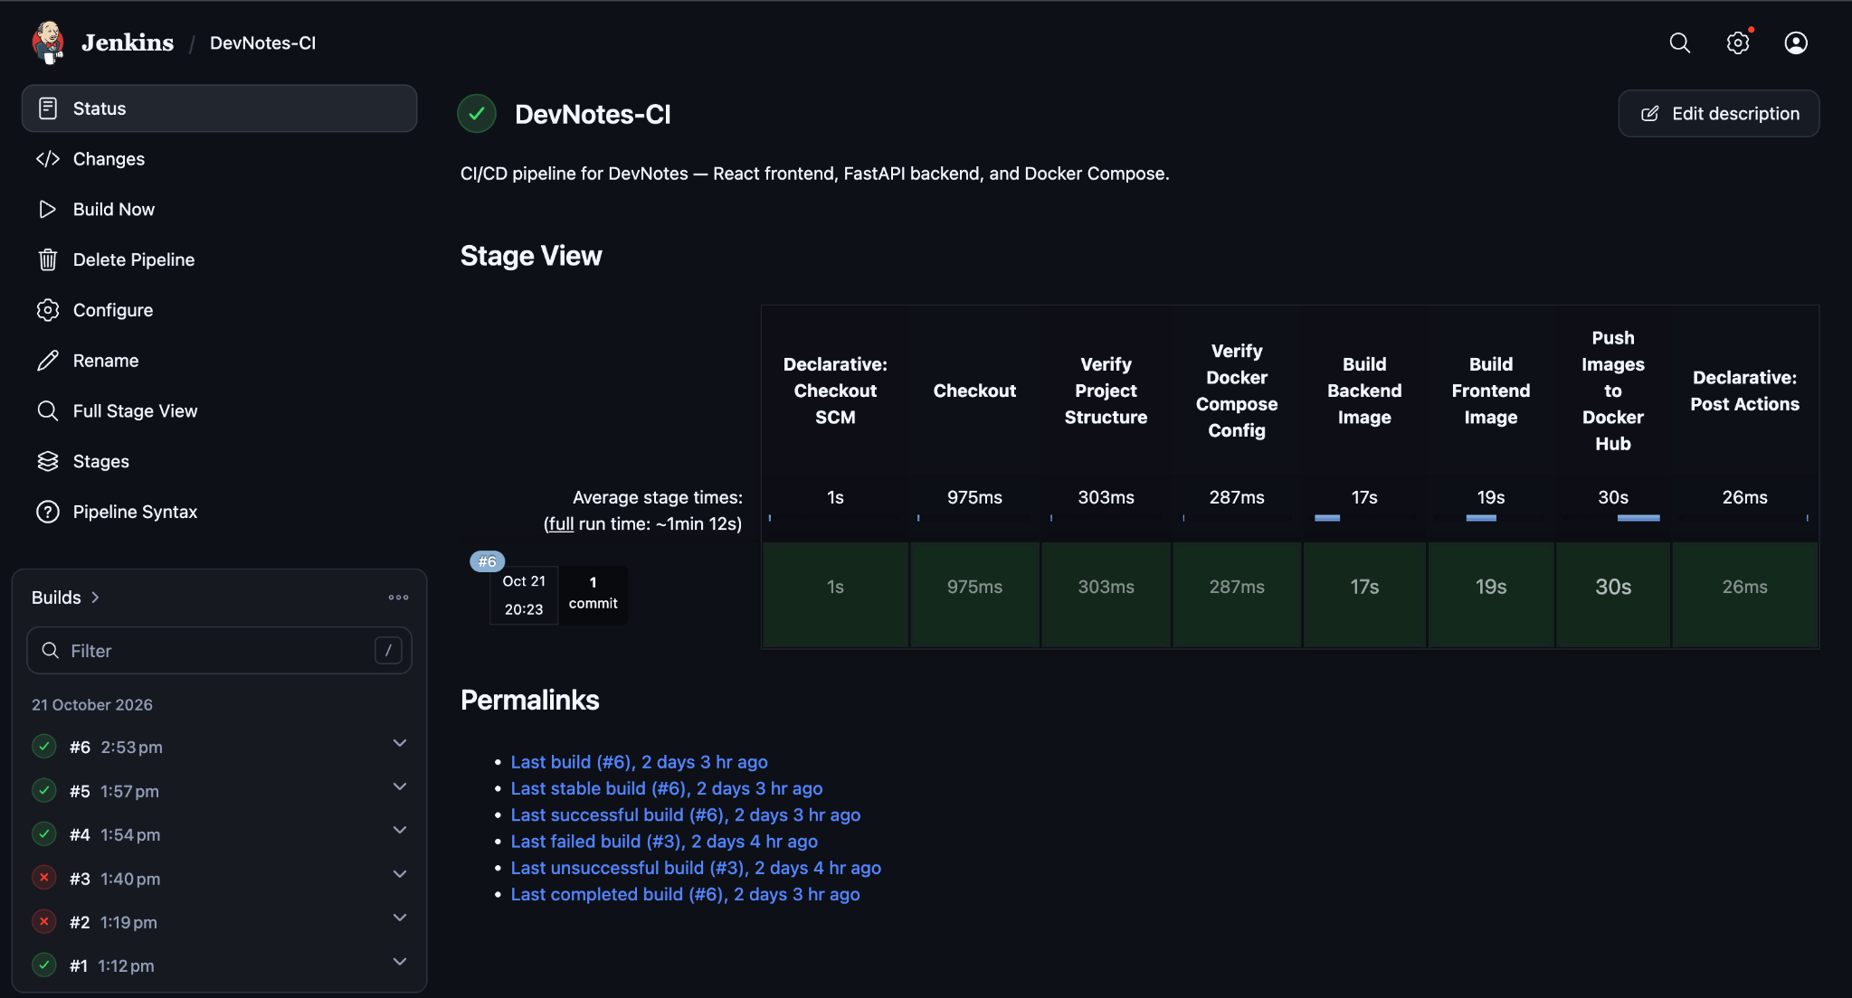
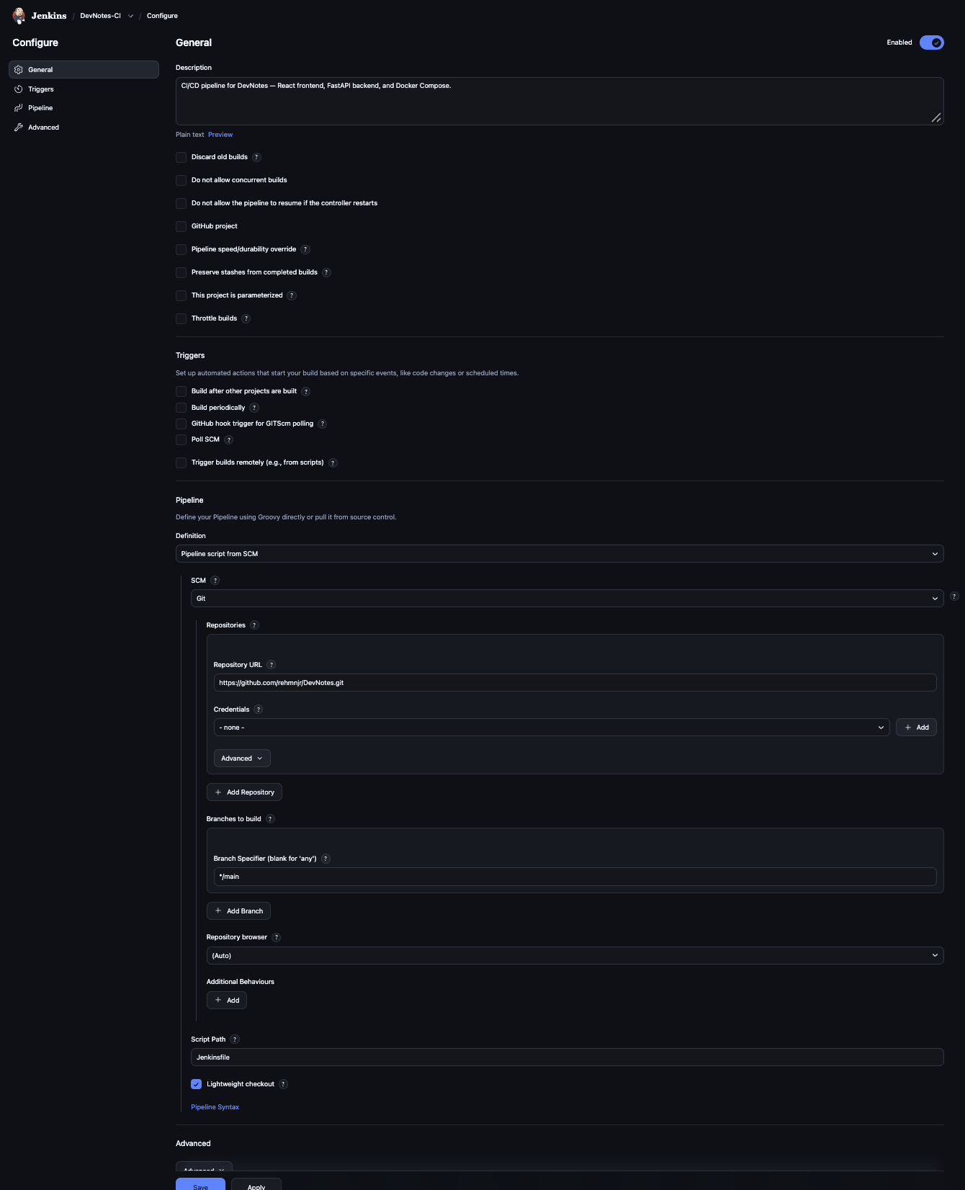

DOCKER

Step 1: Docker Hub Repositories
Docker Hub contains two repositories: devnotes-backend and devnotes-frontend. These repositories store the Docker images of the backend and frontend services, which can be pulled and deployed on the EC2 instance.

Step 2: Checking Running Docker Containers
The docker ps -a command displays all Docker containers, including running and stopped containers. The output shows the Jenkins server, DevNotes UI, and DevNotes API containers running successfully on the local machine, along with their exposed ports.

Step 3: Listing Docker Images
The docker images command lists the Docker images available locally. The output includes the DevNotes backend and frontend images, their Docker Hub-tagged versions, the Jenkins image, and the Alpine image.

Step 4: Checking Docker Compose on EC2
The docker compose ps command returned an error because the Docker CLI could not recognize the Compose command. This indicates that the Compose v2 plugin may not be installed or available. The existing application status should be verified before making any configuration changes.

