

CAPSTONE PROJECT REPORT
Report 3 – Software Requirement Specification

– Ho Chi Minh City, October 2026 –
Table of Contents
I. Record of Changes 3
II. Software Requirement Specification 4
1. Product Overview 4
2. User Requirements 5
2.1 Actors 5
2.2 Use Cases 6
3. Functional Requirements 11
3.1 System Functional Overview 11
3.2 Authentication 20
3.2.1 View Home Page 20
3.2.2 Login 21
3.2.3 Register Member 21
3.2.4 Register Organization 22
3.2.5 Verify Account by OTP 23
3.2.6 Forgot Password 23
3.2.7 Logout 24
3.3 Member Account Management 24
3.3.1 View and Edit Member Profile 24
3.3.2 Change Password 24
3.3.3 View Shipping Address List 25
3.3.4 Add or Edit Shipping Address 25
3.3.5 View Followed Organizations 26
3.3.6 Submit Violation Report 26
3.4 Product Browsing and Shopping 27
3.4.1 Browse Product List 27
3.4.2 View Product Details 27
3.4.3 Manage Cart 28
3.5 Order and Delivery 28
3.5.1 Checkout 28
3.5.2 View Order List 29
3.5.3 View Order Details 29
3.5.4 Cancel Order 30
3.5.5 Confirm Order Receipt 30
3.5.6 Auto Confirm Order Receipt 31
3.5.7 Auto Cancel Unpaid Order 31
3.6 Payment 32
3.6.1 Pay for an Order 32
3.6.2 View Payment Result 32
3.6.3 Process Refund 33
3.7 Wallet and Payout 34
3.7.1 View Wallet 34
3.7.2 View Wallet Transaction History 34
3.7.3 Create Payout Request 34
3.7.4 Credit Seller Wallet After Dispute Window 35
3.8 Return and Complaint 36
3.8.1 Create Return Request 36
3.8.2 View Return Request List 36
3.8.3 View Return Request Details 37
3.9 Review and Rating 37
3.9.1 Create Review 37
3.9.2 View Product Reviews 38
3.10 AI Virtual Try-On 38
3.10.1 Generate Try-On Image 38
3.10.2 View Try-On Image List 39
3.10.3 View Try-On Image Details 39
3.11 Consignment (Member) 40
3.11.1 Create Consignment Form 40
3.11.2 View Consignment Form List 41
3.11.3 View Consignment Form Details 41
3.11.4 Create Item Withdrawal Request 42
3.11.5 Submit End of Term Decision 42
3.12 Donation Community (Member) 43
3.12.1 Browse Donation Campaigns 43
3.12.2 View Campaign Details 43
3.12.3 Browse Community Posts 44
3.12.4 View Community Post Details 44
3.13 Messaging and Notification (Member) 45
3.13.1 View Conversation List 45
3.13.2 Send Message 45
3.13.3 View Notification List 46
3.13.4 View Notification Details 46
3.14 Organization Account and Verification 47
3.14.1 View and Edit Organization Profile 47
3.14.2 Create Legal Change Request 47
3.14.3 View Legal Change Request List 48
3.14.4 View Legal Change Request Details 48
3.15 Campaign Management (Organization) 49
3.15.1 View Campaign List 49
3.15.2 Create or Edit Campaign 49
3.15.3 End Campaign 50
3.16 Community Post Management (Organization) 50
3.16.1 View Post List 50
3.16.2 Create or Edit Post 51
3.16.3 Manage Post Comments 51
3.16.4 Delete Post 52
3.17 Counter Reception (Moderator) 52
3.17.1 Look Up Member 52
3.17.2 View Member Counter Tasks 53
3.18 Inspection and Stock-in (Moderator) 53
3.18.1 View Inspection Queue 53
3.18.2 Inspect and Stock In an Item 54
3.18.3 Issue Consignment Receipt 55
3.19 Inventory (Moderator) 55
3.19.1 View Inventory List 55
3.19.2 View Item Stock Detail 56
3.20 Pack Orders (Moderator) 56
3.20.1 View Packing Queue 56
3.20.2 Pack Order and Create Shipment 57
3.21 Return Request Processing (Moderator) 58
3.21.1 View Return Request Queue 58
3.21.2 Resolve Return Request 58
3.21.3 Record Degraded Item Case 59
3.22 Organization Profile Verification (Moderator) 60
3.22.1 View Organization Registration Queue 60
3.22.2 Verify Organization Registration 60
3.22.3 Review Legal Change Request 61
3.23 Violation Report Processing (Moderator) 61
3.23.1 View Violation Report Queue 61
3.23.2 Resolve Violation Report 62
3.24 Category and Brand Management (Moderator) 62
3.24.1 Manage Categories 62
3.24.2 Manage Brands 63
3.25 Dashboard and Reporting (Administrator) 64
3.25.1 View Dashboard 64
3.25.2 View Commission and Fee Report 64
3.26 Account Management (Administrator) 65
3.26.1 View Account List 65
3.26.2 View Account Details and Apply Sanction 65
3.27 Moderator Management (Administrator) 66
3.27.1 View Moderator List 66
3.27.2 Create or Edit Moderator Account 66
3.28 Consignment Point Management (Administrator) 67
3.28.1 View Consignment Point List 67
3.28.2 Create or Edit Consignment Point 67
3.28.3 Review Payout Requests 68
3.29 System Configuration (Administrator) 68
3.29.1 Manage System Parameters 69
3.30 Audit Log (Administrator) 69
3.30.1 View Audit Log List 69
3.30.2 View Audit Log Entry Details 70
4. Non-Functional Requirements 71
4.1 External Interfaces 71
4.2 Quality Attributes 71
5. Requirement Appendix 72
5.1 Business Rules 72
5.2 Common Requirements 74
5.3 Application Messages List 74

I. Record of Changes
Date | A*  M, D | In charge | Change Description
*A - Added M - Modified D - Deleted

II. Software Requirement Specification

1. Product Overview
ReHome is a new web and mobile platform for buying, selling, and donating pre-owned clothing in Vietnam through a centralized, warehouse-verified consignment model, replacing today's unverified peer-to-peer listings and informal donation channels. A Member consigns an item by bringing it to a ReHome warehouse, where a Moderator authenticates it, sets the price, and lists it for sale; the warehouse also packs, ships, and handles returns. Buyers pay the platform rather than the seller, and sellers are credited to their in-app wallet only once an order completes, so neither side has to trust the other. From a product page, a Member can also generate an AI image on a preset model to preview the outfit before buying. Separately, verified charitable organizations publish donation campaigns and posts stating drop-off times, locations, and wanted item types. The system serves five actor types across two clients: Guest, Member, and Organization use the mobile app; Moderator and Administrator use a web console for warehouse operations and platform configuration.
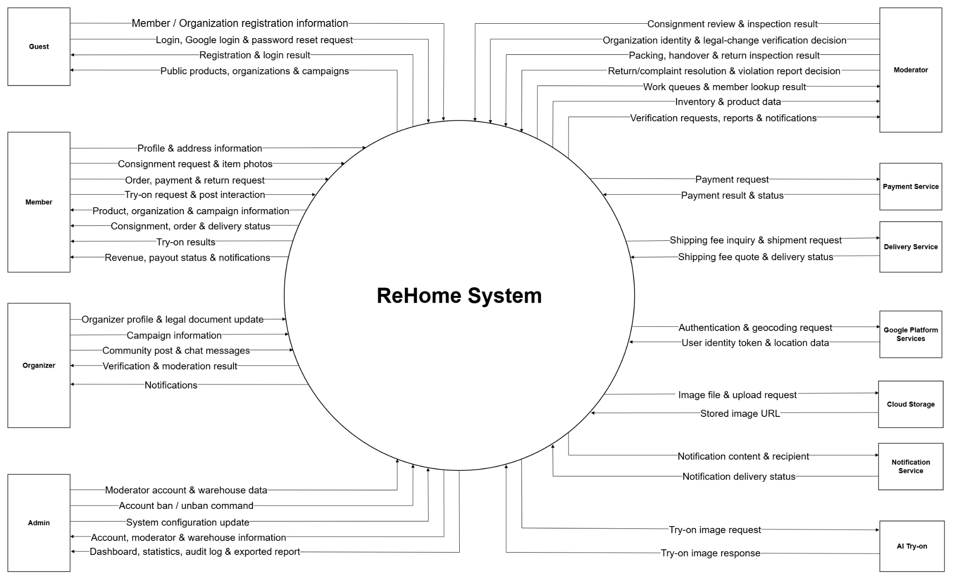

2. User Requirements

2.1 Actors
# | Actor | Description
1 | Guest | A visitor who can browse products, organizations, campaigns, and community posts, and can register an account or log in.
2 | Member | A registered user who buys and consigns clothing, manages a wallet, uses the AI virtual try-on feature, and interacts with the donation community.
3 | Organizer | A verified charity that creates donation campaigns, publishes community posts, and chats with Members.
4 | Moderator | A staff member who reviews and inspects consigned items, manages inventory, fulfills and processes orders/returns, and verifies organizations.
5 | Administrator | A system administrator who manages accounts, consignment point, Moderators, system configuration, and reports.

2.2 Use Cases

2.2.1 Diagram(s)
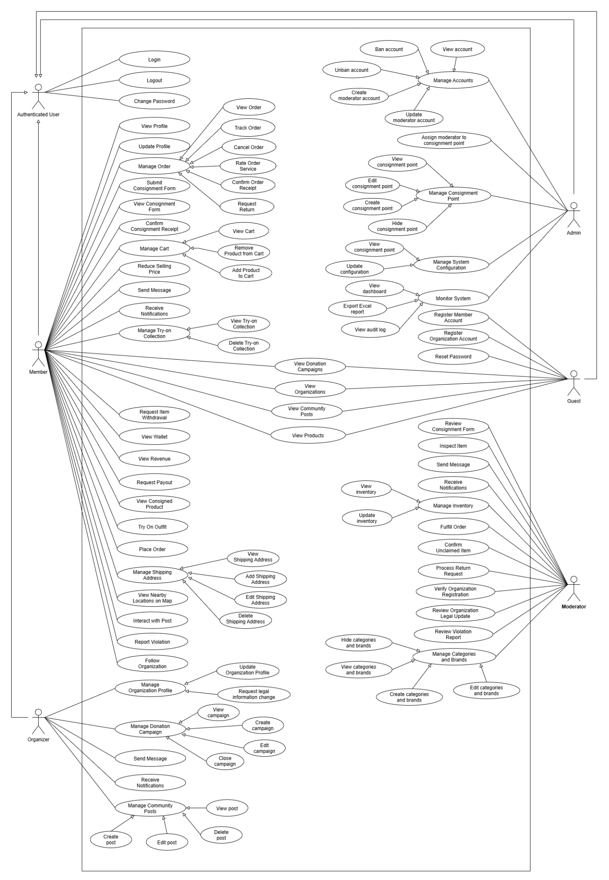

2.2.2 Descriptions
ID | Use Case | Actors | Use Case Description
01 | Login | Guest | Logs in with an account or Google; organizations are routed according to their verification status.
02 | Reset Password | Guest | Resets a forgotten password via a link sent to email.
03 | Register Member Account | Guest | Creates a Member account to buy, consign, and donate.
04 | Register Organization Account | Guest | Submits an organization profile with legal documents for Moderator verification.
05 | Logout | Authenticated User | Ends the current session and invalidates the token.
06 | Change Password | Authenticated User | Changes the password by entering the old and new password.
07 | View Profile | Member | Views name, avatar, phone, email, and identity verification status.
08 | Update Profile | Member | Updates name, avatar, and phone number.
09 | Show Member Code | Member | Displays the Member code for the Moderator to look up at the consignment point.
10 | Browse Products | Guest, Member | Views, searches, filters, and opens the detail of products for sale.
11 | View Organization Profile | Guest, Member | Views a verified organization's profile, campaigns, and posts.
12 | View Donation Campaign | Guest, Member | Views campaign details: location, receiving hours, and priority item types.
13 | View Community Post | Guest, Member | Views organizations' community posts; Members also get a news feed.
14 | Submit Consignment Form | Member | Submits an item with photos, brand, and other product information.
15 | View Consignment Form | Member | Views a form's status, rejection reason, and the deadline to bring the item to the consignment point.
16 | Confirm Consignment Receipt | Member | Reviews the terms and confirms at the counter so the item can be listed.
17 | View Consigned Product | Member | Views SKU, consignment point, price, term, term end date, current commission rate, and expected proceeds.
18 | Reduce Selling Price | Member | Enters a new price at any time; takes effect immediately and can only go down, never below the floor price.
19 | Handle End of Term | Member | After 90 days, chooses to take the item back or consign it again at a new price.
20 | Renew Consignment | Member | Negotiates a new price with the Moderator and confirms a new receipt while the item stays at the consignment point.
21 | Request Item Withdrawal | Member | Withdraws a product from sale, paying a fee if outside the free-withdrawal window.
22 | Handle Degraded Item | Member | When an item returns in worse condition, chooses between compensation or taking it back with partial compensation.
23 | View Wallet | Member | Views the wallet balance and full transaction history.
24 | View Revenue | Member | Views each completed order and the amount credited to the wallet.
25 | Request Payout | Member | Withdraws money from the wallet; the system records it as a payout transaction.
26 | Add Product to Cart | Member | Adds a product to the cart from the product page or try-on results.
27 | View Cart | Member | Views cart items with their consignment point and the provisional total.
28 | Remove Product from Cart | Member | Removes a product from the cart.
29 | View Shipping Address | Member | Views the list of addresses and the default address.
30 | Add Shipping Address | Member | Enters a recipient name, phone number, and detailed address.
31 | Edit Shipping Address | Member | Edits address details or sets an address as default.
32 | Delete Shipping Address | Member | Removes an address from the list.
33 | Place Order | Member | Orders from the cart or buys now; a cart spanning multiple consignment points is split into multiple orders.
34 | Make Online Payment | Member | Pays for an order in full using either the wallet or MoMo.
35 | View Order | Member | Views the order list and details, including the tracking code.
36 | Track Order | Member | Tracks order status synced.
37 | Cancel Order | Member | Cancels a paid order before packing begins, with a full refund.
38 | Confirm Order Receipt | Member | Confirms a delivered order; the system auto-completes it if the Member does not confirm.
39 | Rate Order Service | Member | Rates the order from 1 to 5 stars.
40 | Request Return | Member | Requests a return within the allowed window, with a reason and photos.
41 | Try On Outfit | Member | From a product page, picks a model and combines a top and a bottom to generate a try-on image.
42 | View Try-on Collection | Member | Views saved try-on images.
43 | Delete Try-on Image | Member | Deletes an image from the try-on collection.
44 | Follow Organization | Member | Follows an organization to see its posts in the news feed and get notified of new campaigns or posts.
45 | View Nearby Locations on Map | Member | Views organizations and drop-off points near the current location.
46 | Like and Comment Post | Member | Likes and comments on a community post.
47 | Report Violation | Member | Reports a post, campaign, or organization account.
48 | Send Message | Member, Organization, Moderator | Chats between a Member and an organization, or between a Member and the consignment point's shared inbox.
49 | Receive Notification | Member, Organization, Moderator | Receives real-time notifications relevant to the user's role.
50 | Update Organization Profile | Organization | Edits the avatar, description, phone number, and receiving hours; applied immediately.
51 | Request Legal Information Change | Organization | Requests a change to its name, representative, or legal documents for Moderator approval.
52 | View Own Campaign | Organization | Views the list and details of its own campaigns.
53 | Create Campaign | Organization | Creates a campaign with a description, receiving period, location, and priority item types.
54 | Edit Campaign | Organization | Updates a running campaign.
55 | Close Campaign | Organization | Closes a campaign manually; it also closes automatically once the receiving period ends.
56 | View Own Post | Organization | Views its own published posts, including likes and comments.
57 | Create Community Post | Organization | Publishes a post with photos; it is shown immediately.
58 | Edit Community Post | Organization | Edits the content of its own post.
59 | Delete Community Post | Organization | Deletes its own post.
60 | Look Up Member at Counter | Moderator | Looks up a Member by member code or phone number to open their profile and pending tasks.
61 | Review Consignment Form | Moderator | Picks up a form from the consignment point's queue and approves or rejects it with a reason.
62 | Inspect and Stock Item | Moderator | Verifies authenticity, sets the price and consignment term, stocks the item, and assigns an SKU and label.
63 | View Inventory | Moderator | Views items at their consignment point, including SKU, shelf location, and stock-movement history.
64 | Update Inventory | Moderator | Updates shelf location and records stock movements.
65 | Pack and Ship Order | Moderator | Scans and verifies SKUs, packs the order, and creates a shipment.
66 | Hand Over Item to Member | Moderator | Hands an item to a Member withdrawing it, or to a buyer picking up a returned item.
67 | Handle Unclaimed Item | Moderator | Confirms an item as unclaimed.
68 | Process Return Request | Moderator | Approves a return request, inspects the returned item, and decides how to handle it.
69 | Verify Organization Registration | Moderator | Checks documents against a checklist and verifies or rejects the registration with a reason.
70 | Review Legal Change Request | Moderator | Approves or rejects an organization's legal information change request.
71 | Handle Violation Report | Moderator | Removes content, hides a campaign, or dismisses the report.
72 | View Category and Brand | Moderator | Views categories, including their try-on slots, and accepted brands.
73 | Create Category and Brand | Moderator | Adds a new category with a top/bottom try-on slot, or a new brand.
74 | Edit Category and Brand | Moderator | Edits a category's name or its try-on slot.
75 | Hide Category and Brand | Moderator | Hides an item no longer in use while keeping its historical data.
76 | View Account | Admin | Views, searches, and opens the detail of any account.
77 | Ban Account | Admin | Locks an account that violates policy.
78 | Unban Account | Admin | Unlocks a previously banned account.
79 | Create Moderator Account | Admin | Creates a new Moderator account and assigns it to a consignment point.
80 | Update Moderator Account | Admin | Edits a Moderator's information; Moderators cannot edit it themselves.
81 | Assign Moderator to Consignment Point | Admin | Assigns or transfers a Moderator to a different consignment point.
82 | View Consignment Point | Admin | Views the list of consignment points, including Moderator count and stock status.
83 | Create Consignment Point | Admin | Creates a new consignment point with an address, coordinates, and opening hours.
84 | Edit Consignment Point | Admin | Updates consignment point information.
85 | Hide Consignment Point | Admin | Hides a consignment point no longer in operation.
86 | View System Configuration | Admin | Views fees, commission rates, tax, consignment terms, floor price, and deadlines.
87 | Update System Configuration | Admin | Edits a parameter; applies only to transactions created afterward.
88 | View Dashboard | Admin | Views revenue, orders, inventory, service ratings, and wallet balances.
89 | Export Excel Report | Admin | Exports dashboard figures to an Excel file.
90 | View Audit Log | Admin | Views the log of Moderator actions, money transactions, and configuration changes.

3. Functional Requirements

3.1 System Functional Overview

3.1.1 Screens Flow

3.1.1.1 Member Mobile Application Screens Flow
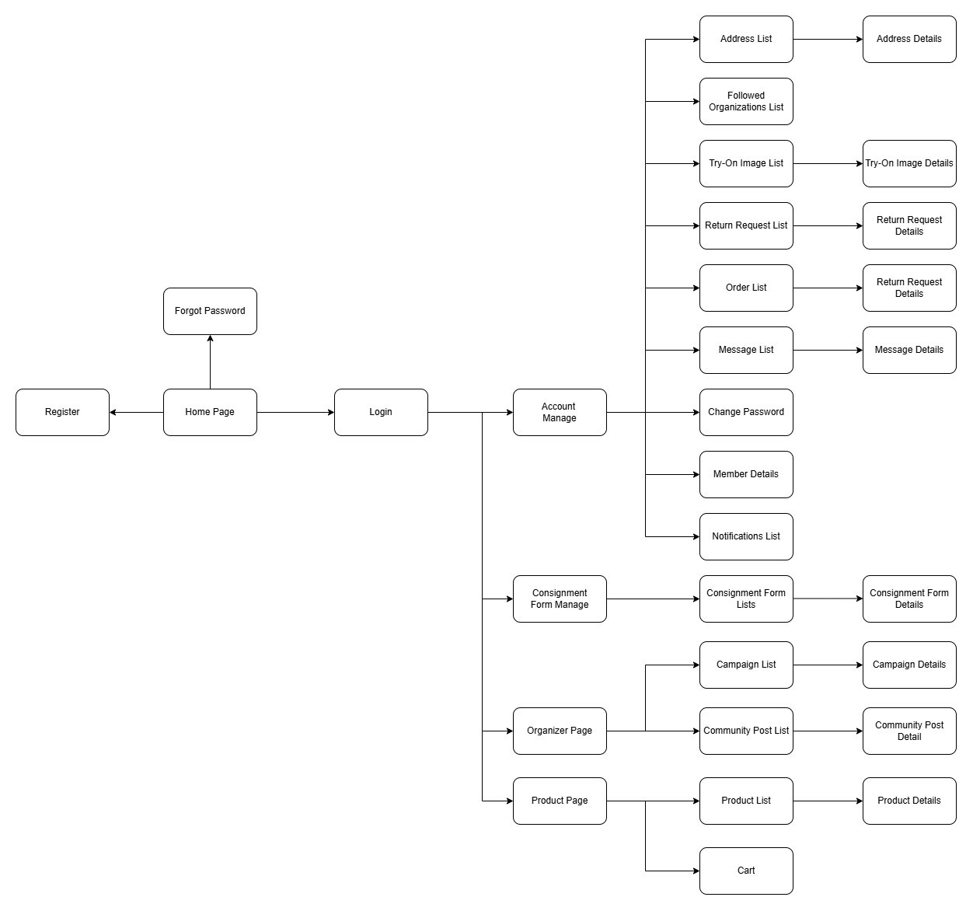

3.1.1.2 Organizer Mobile Application Screens Flow
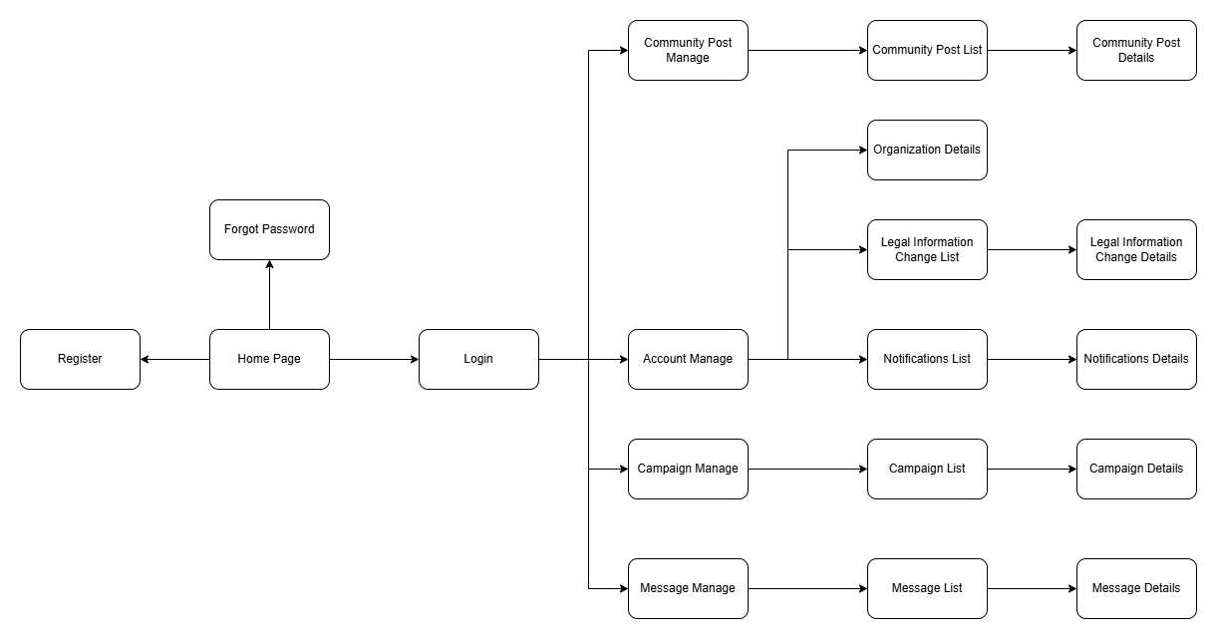

3.1.1.3 Moderator Web Application Screens Flow
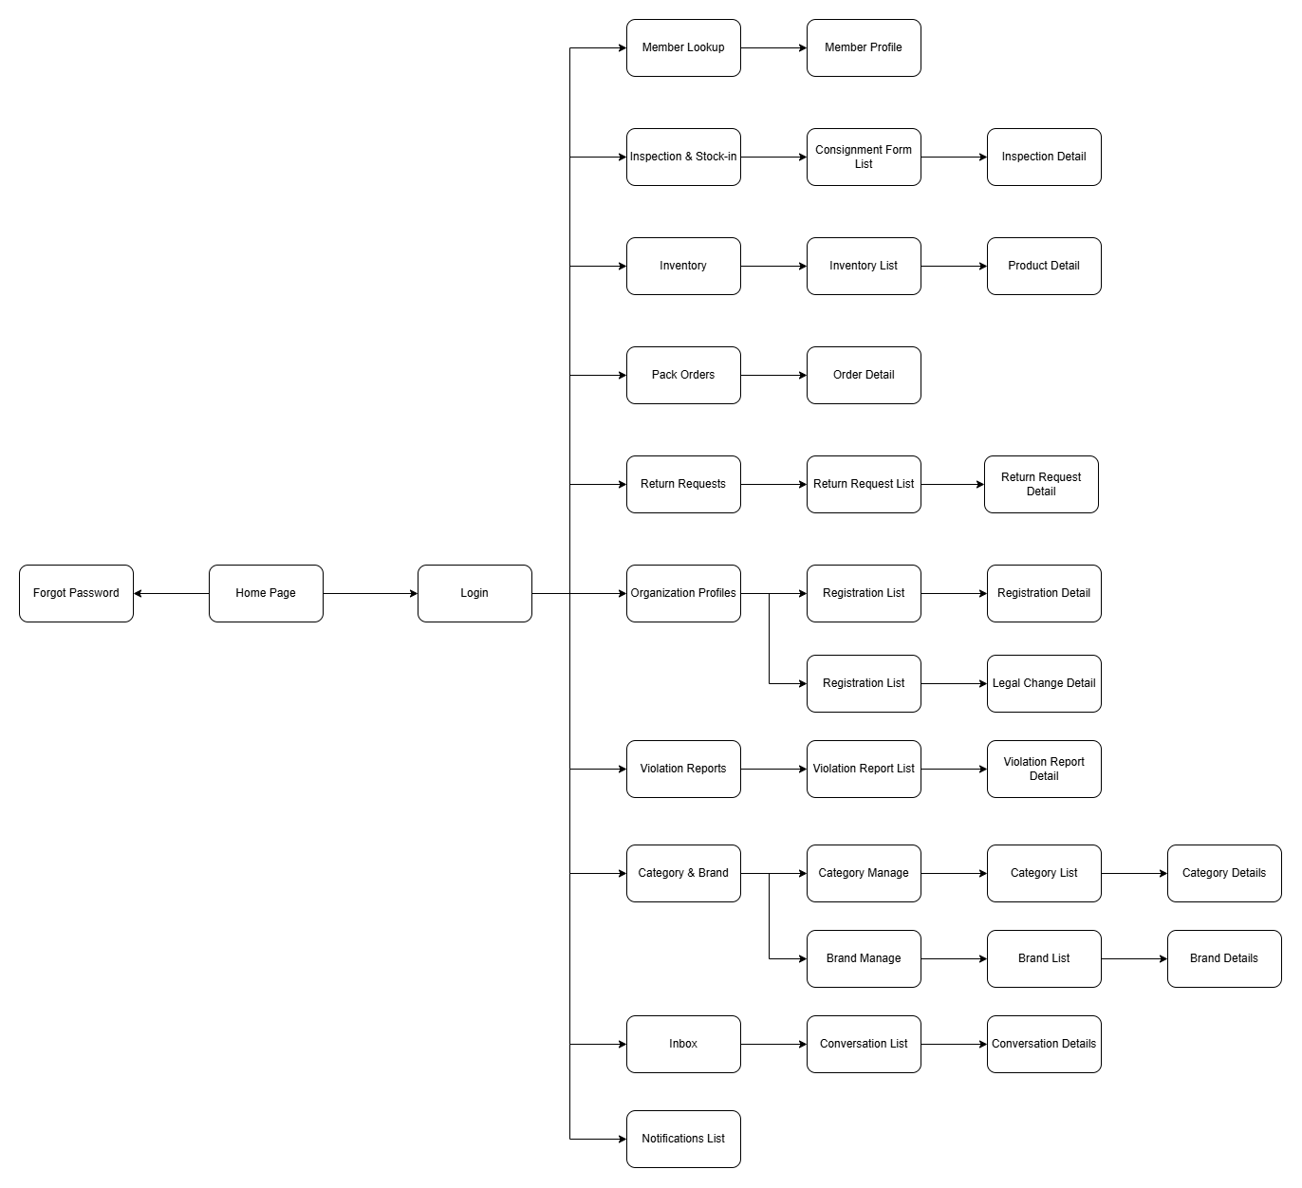

3.1.1.3 Admin Web Application Screens Flow
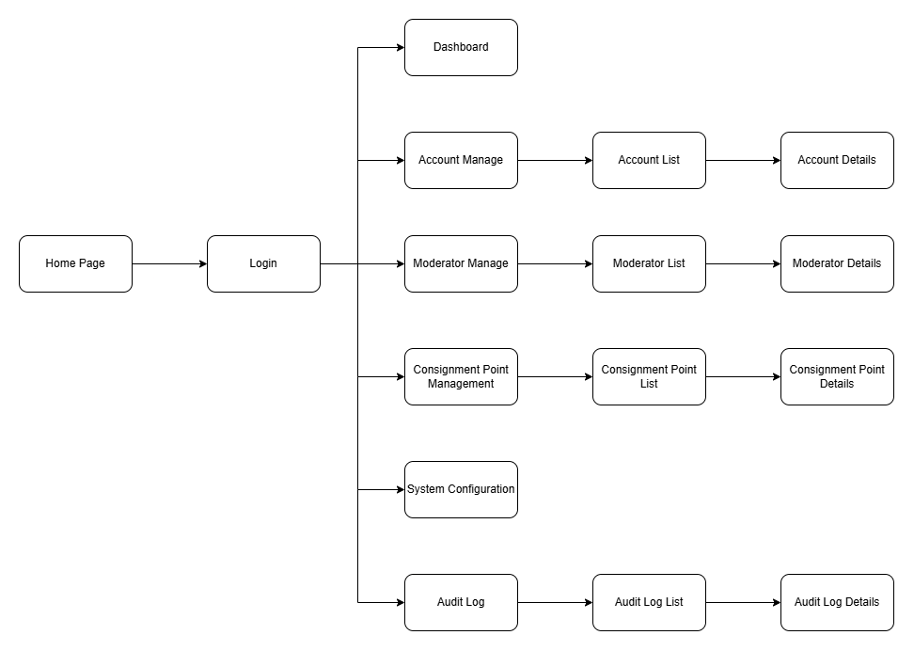

3.1.2 Screen Descriptions
# | Feature | Screen | Description
1 | Authentication | Home Page | Landing screen to browse products and campaigns before logging in.
2 | Authentication | Login | Log in with account or Google.
3 | Authentication | Register | Create a new Member account.
4 | Authentication | Forgot Password | Reset a forgotten password via email.
5 | Account Management | Account Manage | Menu of account-related features.
6 | Account Management | Address List | List of saved shipping addresses.
7 | Account Management | Address Details | Add or edit a shipping address.
8 | Account Management | Followed Organizations List | List of organizations the Member follows.
9 | Account Management | Try-On Image List | Collection of saved try-on images.
10 | Account Management | Try-On Image Details | View or delete a saved try-on image.
11 | Account Management | Return Request List | List of submitted return requests.
12 | Account Management | Return Request Details | Status and details of a return request.
13 | Account Management | Order List | List of placed orders.
14 | Account Management | Order Details | Status and details of an order, including tracking and confirm/rate actions.
15 | Account Management | Message List | List of chat conversations.
16 | Account Management | Message Details | Chat room with an organization or Consignment Point.
17 | Account Management | Change Password | Change the account password.
18 | Account Management | Member Details | View and edit personal profile.
19 | Account Management | Notifications List | List of system notifications.
20 | Consignment | Consignment Form Manage | Entry point to consignment features.
21 | Consignment | Consignment Form Lists | List of submitted consignment forms.
22 | Consignment | Consignment Form Details | Status, receipt, and details of a consignment form.
23 | Donation Community | Organizer Page | Entry point to donation community features.
24 | Donation Community | Campaign List | List of donation campaigns.
25 | Donation Community | Campaign Details | Details of a donation campaign.
26 | Donation Community | Community Post List | List of community posts.
27 | Donation Community | Community Post Detail | Full content of a community post.
28 | Shopping | Product Page | Entry point to browse
29 | Shopping | Product List | List of products for sale.
30 | Shopping | Product Details | Details of a product; entry point for try-on.
31 | Shopping | Cart | Items added to cart before checkout.
32 | Account Management | Organization Details | View and edit organization profile: avatar, description, receiving hours.
33 | Account Management | Legal Information Change List | List of submitted legal information change requests.
34 | Account Management | Legal Information Change Details | Status and details of a legal information change request.
35 | Account Management | Notifications List | List of system notifications.
36 | Account Management | Notifications Details | Full content of a notification.
37 | Campaign | Campaign Manage | Entry point to campaign features.
38 | Campaign | Campaign List | List of the organization's donation campaigns.
39 | Campaign | Campaign Details | Create, edit, or view a donation campaign.
40 | Community Post | Community Post Manage | Entry point to community post features.
41 | Community Post | Community Post List | List of the organization's published posts.
42 | Community Post | Community Post Details | Create, edit, or view a post, including likes and comments.
43 | Message | Message Manage | Entry point to chat features.
44 | Message | Message List | List of chat conversations with Members.
45 | Message | Message Details | Chat room with a Member.
46 | Counter Reception | Member Lookup | Look up a Member by member code or phone number.
47 | Counter Reception | Member Profile | Member's profile and pending tasks to process at the counter.
48 | Inspection & Stock-in | Inspection & Stock-in | Entry point to consignment review and inspection features.
49 | Inspection & Stock-in | Consignment Form List | Queue of consignment forms awaiting review.
50 | Inspection & Stock-in | Inspection Detail | Review, inspect, finalize price and term, and stock in a consigned item.
51 | Inventory | Inventory | Entry point to inventory features.
52 | Inventory | Inventory List | List of items stocked at this consignment point.
53 | Inventory | Product Detail | SKU, shelf location, and stock-movement history of an item.
54 | Pack Orders | Pack Orders | Queue of orders ready to pack and ship.
55 | Pack Orders | Order Detail | Verify SKUs, pack the order, and create a GHN shipment.
56 | Return Requests | Return Requests | Entry point to return request features.
57 | Return Requests | Return Request List | Queue of submitted return requests.
58 | Return Requests | Return Request Detail | Review, inspect, and resolve a return request.
59 | Organization Profiles | Organization Profiles | Entry point to organization verification features.
60 | Organization Profiles | Registration List | Queue of new organization registration requests.
61 | Organization Profiles | Registration Detail | Review documents and verify or reject a registration.
62 | Organization Profiles | Legal Change List | Queue of organization legal information change requests.
63 | Organization Profiles | Legal Change Detail | Review and approve or reject a legal information change request.
64 | Violation Reports | Violation Reports | Entry point to violation report features.
65 | Violation Reports | Violation Report List | Queue of submitted violation reports.
66 | Violation Reports | Violation Report Detail | Review and resolve a violation report.
67 | Category & Brand | Category & Brand | Entry point to category and brand features.
68 | Category & Brand | Category Manage | Entry point to category features.
69 | Category & Brand | Category List | List of product categories and their try-on slots.
70 | Category & Brand | Category Details | Add or edit a category.
71 | Category & Brand | Brand Manage | Entry point to brand features.
72 | Category & Brand | Brand List | List of accepted brands.
73 | Category & Brand | Brand Details | Add or edit a brand.
74 | Inbox | Inbox | Entry point to the consignment point's shared inbox.
75 | Inbox | Conversation List | List of chat conversations with Members.
76 | Inbox | Conversation Details | Chat room with a Member.
77 | Notifications | Notifications List | List of system notifications.
78 | Dashboard | Dashboard | Platform fund, revenue, orders, inventory, service ratings, and wallet balances; export to Excel.
79 | Account Management | Account Manage | Entry point to account management features.
80 | Account Management | Account List | List of all Member Organization and Moderator accounts.
81 | Account Management | Account Details | View an account's details; ban or unban it.
82 | Moderator Management | Moderator Manage | Entry point to Moderator account features.
83 | Moderator Management | Moderator List | List of Moderator accounts.
84 | Moderator Management | Moderator Details | Create or edit a Moderator account and assign it to a consignment point.
85 | Consignment Point Management | Consignment Point Management | Entry point to consignment point features.
86 | Consignment Point Management | Consignment Point List | List of consignment points, with Moderator count and stock status.
87 | Consignment Point Management | Consignment Point Details | Create, edit, or hide a consignment point.
88 | System Configuration | System Configuration | View and edit system parameters: commission, fees, tax, deadlines.
89 | Audit Log | Audit Log | Entry point to audit log features.
90 | Audit Log | Audit Log List | Log of Moderator actions, money transactions, and configuration changes.
91 | Audit Log | Audit Log Details | Full detail of one audit log entry.

3.1.3 Screen Authorization

3.1.3.1 Mobile Screen Authorization
Screen | Guest | Member | Organizer
Home Page | x | x | x
Login | x
Register | x
Forgot Password | x
Product List | x | x
Product Details | x | x
Cart |  | x
Campaign List | x | x | x
Campaign Details | x | x | x
Community Post List | x | x | x
Community Post Details | x | x | x
Account Manage |  | x | x
Change Password |  | x | x
Notifications List |  | x | x
Message List |  | x | x
Message Details |  | x | x
Member Details |  | x
Address List |  | x
Address Details |  | x
Try-On Image List |  | x
Try-On Image Details |  | x
Return Request List |  | x
Return Request Details |  | x
Order List |  | x
Order Details |  | x
Consignment Form Manage |  | x
Consignment Form Lists |  | x
Consignment Form Details |  | x
Organization Details |  |  | x
Legal Information Change List |  |  | x
Legal Information Change Details |  |  | x
 |  |  | x

3.1.3.2 Web Screen Authorization

Screen | Moderator | Admin
Login | x | x
Dashboard |  | x
Member Lookup | x
Member Profile | x
Inspection & Stock-in | x
Consignment Form List | x
Inspection Detail | x
Inventory | x
Inventory List | x
Product Detail | x
Pack Orders | x
Order Detail
Return Requests
Return Request List
Return Request Detail
Organization Profiles
Registration List
Registration Detail
Legal Change List
Legal Change Detail
Violation Reports
Violation Report List
Violation Report Detail
Category & Brand
Category Manage | x
Category List | x
Category Details | x
Brand Manage | x
Brand List | x
Brand Details | x
Inbox | x
Conversation List | x
Conversation Details | x
Notifications List | x
Account Manage |  | x
Account List |  | x
Account Details |  | x
Moderator Manage |  | x
Moderator List |  | x
Moderator Details |  | x
Consignment Point Management |  | x
Consignment Point List |  | x
Consignment Point Details |  | x
System Configuration |  | x
Audit Log |  | x
Audit Log List |  | x
Audit Log Details |  | x

3.1.4 Non-Screen Functions
# | Feature | System Function | Description
1 | Payment | Payment Webhook | Receives payment confirmation from the gateway and updates the order status.
2 | Order Management | Unpaid Order Auto-Cancellation | Automatically cancels an order unpaid after 15 minutes and releases the product back to the shelf.
3 | Shipping | Status Synchronization | Periodically syncs shipment status from the delivery carrier to keep order tracking up to date.
4 | Wallet | Wallet Transaction Posting | Credits the seller's wallet and records the matching platform-fund entry when an order is completed.
5 | AI Try-on | Try-on Image Generation | Calls the AI model to generate a composite try-on image of the selected outfit.
6 | Audit | Audit Log Recording | Records every moderator action, money transaction, and configuration change for traceability.

3.1.5 Entity Relationship Diagram
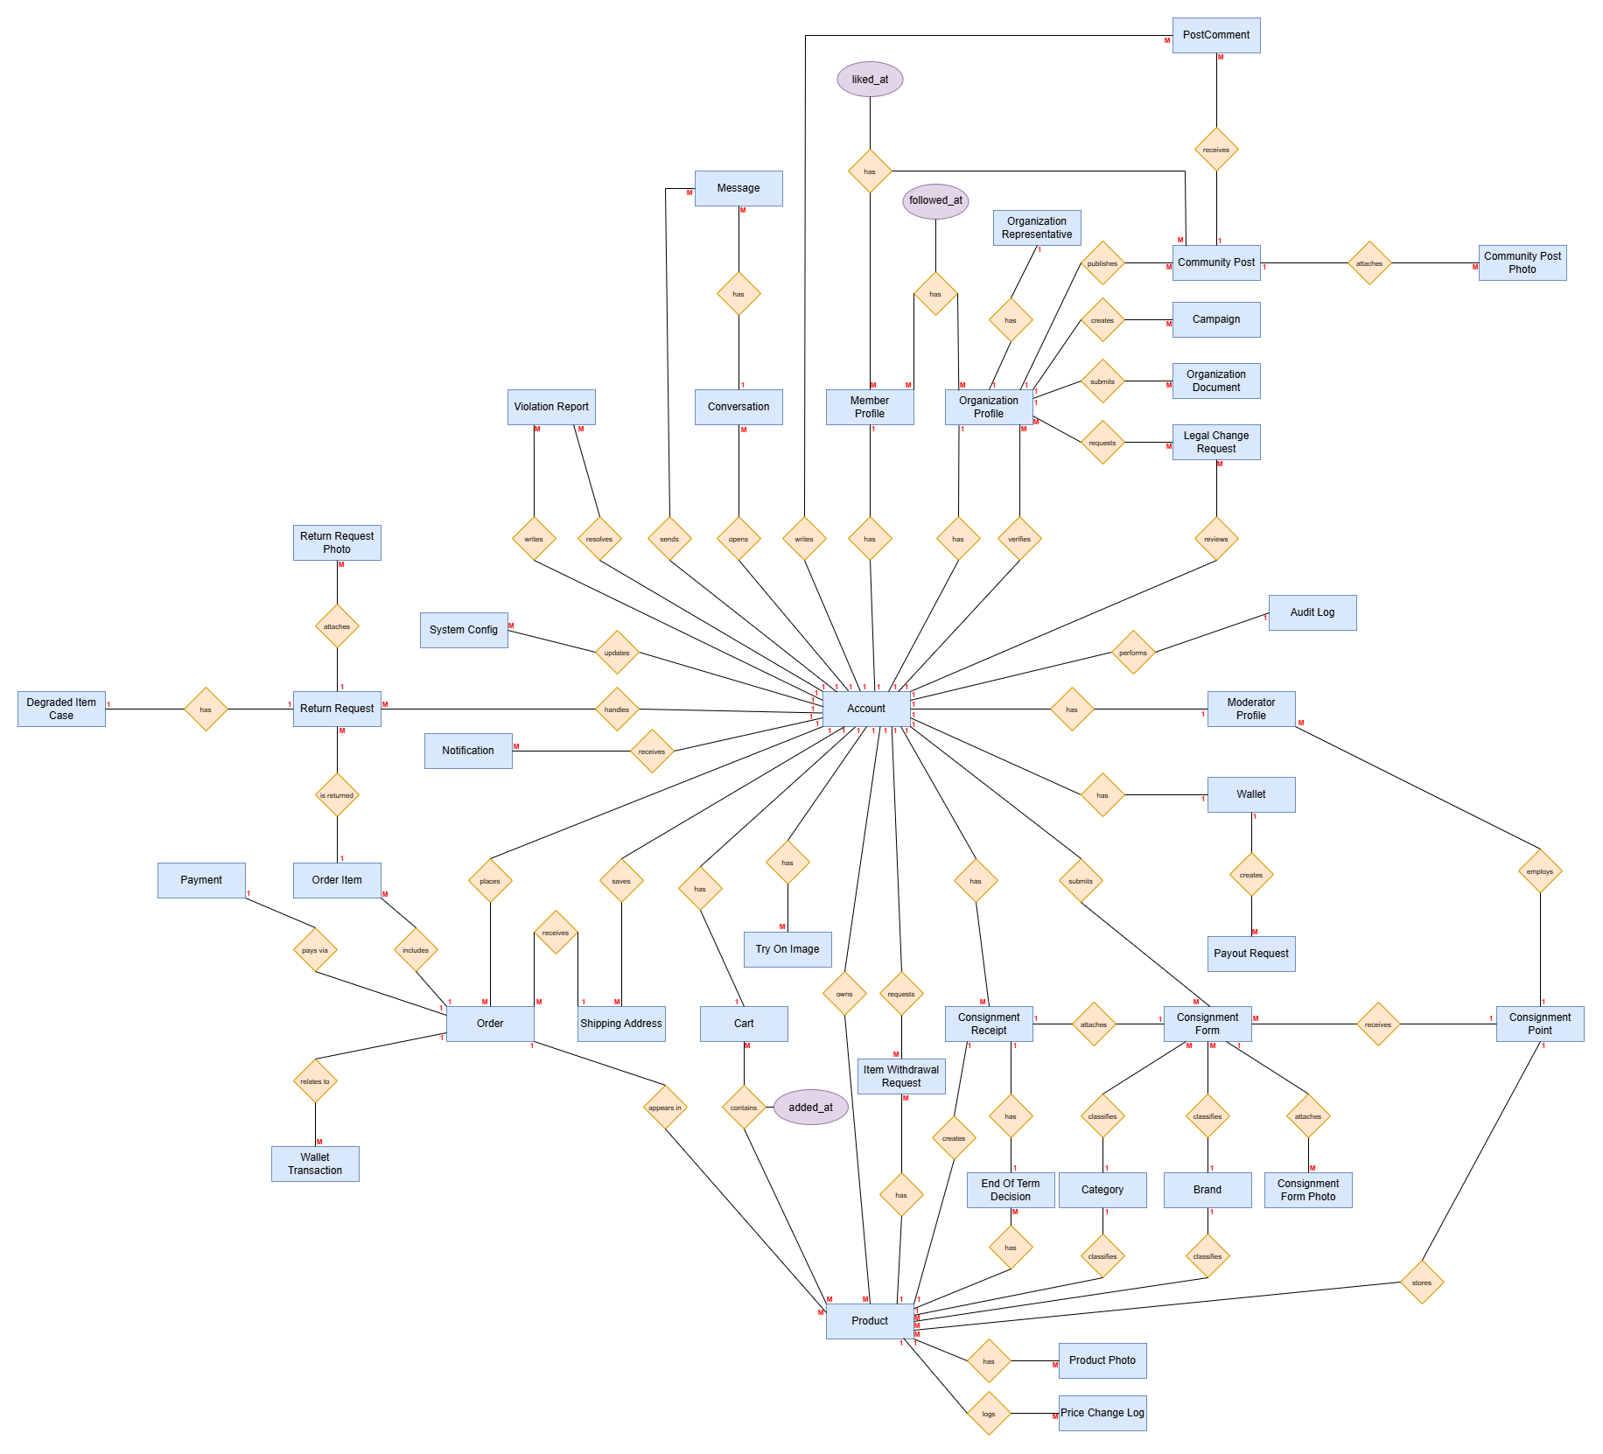
Entities Description
# | Entity | Description
1 | Account | Login account shared by all roles (Member, Organization, Staff, Admin)
2 | Member Profile | Profile of a regular buyer/seller user
3 | Organization Profile | Profile of a registered charity organization
4 | Organization Representative | Legal/contact representative of an organization
5 | Moderator Profile | Profile of a content moderation staff member
6 | Organization Document | Legal documents submitted by an organization for verification
7 | Legal Change Request | Request to update an organization’s legal information
8 | Product | Clothing item that has passed inspection and is ready for sale
9 | Product Photo | Photo of a product
10 | Price Change Log | History of price changes for a product
11 | Category | Product classification category
12 | Brand | Product brand
13 | Consignment Point | Physical location where sellers drop off items for consignment
14 | Consignment Form | Form recording the items a seller drops off for consignment
15 | Consignment Form Photo | Photo attached to a consignment form
16 | Consignment Receipt | Receipt confirming consigned items were received
17 | End Of Term Decision | Decision on how to handle consigned items once the term expires
18 | Item Withdrawal Request | Request to withdraw unsold consigned items
19 | Cart | Temporary holding list of products before placing an order
20 | Order | A purchase order for products
21 | Order Item | Line-item detail of a product within an order
22 | Shipping Address | Buyer’s delivery address
23 | Payment | Payment transaction for an order
24 | Return Request | Buyer’s return/complaint request
25 | Return Request Photo | Evidence photo attached to a return request
26 | Degraded Item Case | Record of a product found damaged or not as described
27 | Wallet | E-wallet holding balance earned from sales only (no top-up)
28 | Wallet Transaction | History of balance changes in a wallet
29 | Payout Request | Request to withdraw funds from the wallet to a bank account
30 | Try On Image | AI-generated virtual try-on composite image
31 | Community Post | Post shared within the community
32 | Community Post Photo | Photo attached to a community post
33 | PostComment | Comment on a community post
34 | Campaign | Donation campaign created by an organization
35 | Conversation | A chat thread between two accounts
36 | Message | A single message within a conversation
37 | Notification | System notification sent to an account
38 | Violation Report | Report of a rule violation submitted by a user
39 | Audit Log | Log of administrative actions on the system
40 | System Config | System-level configuration parameters (e.g. dispute window days)

3.2 Authentication

3.2.1 View Home Page
- Function trigger: Guest opens the application, or clicks the "Trang chủ" tab
- Function description:
  - Actors: Guest, Member
  - Purpose: Allow a visitor to browse featured products and donation campaigns before logging in, so that the value of the platform is visible without an account
- Function details:
  - Data requirements:
    - Featured product list: product image, name, price, category
    - Featured campaign list: campaign image, title, organization name
    - Search entry point
  - Validation:
    - Only products in Available status are displayed
    - Only approved and ongoing campaigns are displayed
    - Actions requiring an account (add to cart, try-on, follow) redirect a Guest to the Login screen
- Business rules: BR-07

3.2.2 Login
- Function trigger: Guest clicks the "Đăng nhập" button
- Function description:
  - Actors: Guest
  - Purpose: Authenticate a user by email and password, or through a Google account, so that they can access features restricted to registered users
- Function details:
  - Data requirements: email, password; or Google account authorization
  - Validation:
    - email:
      - Type: Email
      - Required
      - Must exist in the system
    - password:
      - Type: Password
      - Required
      - Minimum length: 8 characters
      - Must contain at least 1 uppercase letter, 1 lowercase letter, 1 digit, 1 special character
    - Account:
      - Must be verified (activated)
      - Must not be banned by an Administrator
- Business rules: BR-01, BR-02, BR-03

3.2.3 Register Member
- Function trigger: Guest clicks the "Đăng ký" button on the Login screen
- Function description:
  - Actors: Guest
  - Purpose: Allow a guest to create a Member account so that they can buy products, consign items, and use community features
- Function details:
  - Data requirements: full name, phone number, email, password, confirm password, acceptance of terms and conditions
  - Validation:
    - Full name:
      - Type: Text
      - Required
    - Phone number:
      - Type: Phone number
      - Required
      - Must follow a valid Vietnamese phone number format
      - Must be unique in the system
    - Email:
      - Type: Email
      - Required
      - Must follow standard email format
      - Must be unique in the system
    - Password:
      - Type: Password
      - Required
      - Minimum length: 8 characters
      - Must contain at least 1 uppercase letter, 1 lowercase letter, 1 digit, 1 special character
    - Confirm password:
      - Must match the entered password
    - Terms and conditions:
      - Type: Checkbox
      - Required
- Business rules: BR-01, BR-02, BR-03

3.2.4 Register Organization
- Function trigger: Guest selects "Đăng ký tổ chức" on the Register screen
- Function description:
  - Actors: Guest
  - Purpose: Allow a charity organization to submit a registration request with its legal documents, so that a Moderator can verify its legitimacy before it is allowed to publish campaigns
- Function details:
  - Data requirements:
    - Organization information: organization name, description, email, phone number, address, logo
    - Representative information: full name, position, citizen ID number, contact phone number
    - Legal documents: operating licence or establishment decision (PDF or image, multiple files allowed)
    - Account credentials: password, confirm password
    - Acceptance of terms and conditions
  - Validation:
    - Organization name, description, address:
      - Required
    - Email and phone number:
      - Must be unique in the system
    - Representative:
      - Full name and position are required
    - Legal documents:
      - At least one document is required
      - Accepted formats: PDF, JPG, PNG
      - Maximum size per file as configured by the Administrator
    - Account:
      - Created in Pending Verification status; it cannot publish campaigns until approved
- Business rules: BR-01, BR-02, BR-03, BR-04

3.2.5 Verify Account by OTP
- Function trigger: System displays the OTP screen immediately after a registration request is submitted
- Function description:
  - Actors: Guest
  - Purpose: Confirm that the email address or phone number belongs to the registrant, so that the account can be activated and spam registrations are prevented
- Function details:
  - Data requirements: OTP code, resend action
  - Validation:
    - OTP code:
      - Type: Numeric string
      - Required
      - Length as configured by the Administrator
      - Must match the code issued for this registration
      - Must be used within its validity period
    - Resend:
      - Allowed only after the resend cooldown has elapsed
    - Account:
      - Set to Active on successful verification
      - Remains inactive and cannot log in while unverified
- Business rules: BR-01

3.2.6 Forgot Password
- Function trigger: Guest clicks "Quên mật khẩu" on the Login screen
- Function description:
  - Actors: Guest
  - Purpose: Allow a user who cannot access their account to reset their password through a link or code sent to their registered email
- Function details:
  - Data requirements: email, new password, confirm new password, OTP or reset token
  - Validation:
    - Email:
      - Type: Email
      - Required
      - Must exist in the system
    - Reset token or OTP:
      - Must be valid and not expired
    - New password:
      - Minimum length: 8 characters
      - Must contain at least 1 uppercase letter, 1 lowercase letter, 1 digit, 1 special character
      - Confirm password must match
- Business rules: BR-01, BR-03

3.2.7 Logout
- Function trigger: User clicks the "Đăng xuất" button on the Account Manage screen
- Function description:
  - Actors: Member, Organization, Moderator, Administrator
  - Purpose: End the current session and return the user to the Home page
- Function details:
  - Data requirements: None
  - Validation:
    - User must have an active session
- Business rules: None

3.3 Member Account Management

3.3.1 View and Edit Member Profile
- Function trigger: Member selects "Thông tin cá nhân" on the Account Manage screen
- Function description:
  - Actors: Member
  - Purpose: Allow a Member to view and update their personal information, and to see the member code used for identification at a consignment point counter
- Function details:
  - Data requirements: avatar, full name, date of birth, gender, phone number, email, member code (read-only)
  - Validation:
    - Full name:
      - Required
    - Phone number:
      - Must follow a valid phone number format
      - Must be unique in the system
    - Email:
      - Changing the email requires OTP verification of the new address
    - Avatar:
      - Accepted image formats only
    - Member code:
      - Generated by the system and cannot be edited
- Business rules: BR-01, BR-02

3.3.2 Change Password
- Function trigger: Member selects "Đổi mật khẩu" on the Account Manage screen
- Function description:
  - Actors: Member, Organization, Moderator, Administrator
  - Purpose: Allow a logged-in user to replace their current password with a new one
- Function details:
  - Data requirements: current password, new password, confirm new password
  - Validation:
    - Current password:
      - Required
      - Must match the stored password
    - New password:
      - Minimum length: 8 characters
      - Must contain at least 1 uppercase letter, 1 lowercase letter, 1 digit, 1 special character
      - Must differ from the current password
      - Confirm password must match
- Business rules: BR-03

3.3.3 View Shipping Address List
- Function trigger: Member selects "Sổ địa chỉ" on the Account Manage screen
- Function description:
  - Actors: Member
  - Purpose: Allow a Member to see all saved delivery addresses and to choose which one is the default for checkout
- Function details:
  - Data requirements:
    - Displayed information: recipient name, phone number, full address, default marker
    - Available actions: add, edit, delete, set as default
  - Validation:
    - Only addresses belonging to the logged-in Member are displayed
    - Exactly one address can be marked as default
    - An address currently attached to an order that is not yet completed cannot be deleted
- Business rules: None

3.3.4 Add or Edit Shipping Address
- Function trigger: Member clicks "Thêm địa chỉ" or the edit icon of an address
- Function description:
  - Actors: Member
  - Purpose: Allow a Member to record a delivery address so that shipping fees can be calculated and orders can be delivered
- Function details:
  - Data requirements: recipient name, phone number, province or city, district, ward, street address, default flag
  - Validation:
    - Recipient name:
      - Required
    - Phone number:
      - Required
      - Must follow a valid phone number format
    - Province, district, ward:
      - Required
      - Must be selected from the administrative list supported by the logistics partner
    - Street address:
      - Required
    - Default flag:
      - Setting this address as default clears the flag on the previous default address
- Business rules: BR-41

3.3.5 View Followed Organizations
- Function trigger: Member selects "Tổ chức đang theo dõi" on the Account Manage screen
- Function description:
  - Actors: Member
  - Purpose: Allow a Member to review the organizations they follow and to unfollow any of them
- Function details:
  - Data requirements:
    - Displayed information: organization logo, name, verification status, number of ongoing campaigns
    - Available actions: view organization, unfollow
  - Validation:
    - Only organizations followed by the logged-in Member are displayed
    - Unfollowing removes the follow record and stops campaign notifications from that organization
- Business rules: BR-33

3.3.6 Submit Violation Report
- Function trigger: Member clicks the "Báo cáo" icon on a community post, a comment, a product, or an organization profile
- Function description:
  - Actors: Member
  - Purpose: Allow a Member to report content or an account that violates platform policy, so that a Moderator can review and act on it
- Function details:
  - Data requirements: reported target (post, comment, product, or account), violation category, description, evidence images (optional)
  - Validation:
    - Reported target:
      - Must exist in the system
      - A Member cannot report their own content
    - Violation category:
      - Required
      - Selected from the list configured by the Administrator
    - Description:
      - Required
    - Duplicate report:
      - A Member cannot submit more than one open report for the same target
- Business rules: BR-30, BR-34

3.4 Product Browsing and Shopping

3.4.1 Browse Product List
- Function trigger: Member or Guest opens the "Sản phẩm" tab, or performs a search from the Home page
- Function description:
  - Actors: Guest, Member
  - Purpose: Allow a user to browse, search, filter, and sort the products on sale so that they can find items matching their needs
- Function details:
  - Data requirements:
    - Displayed information per product: image, name, price, size, condition grade, category, brand
    - Filters: category, brand, size, price range, condition grade, consignment point
    - Sort options: newest, price ascending, price descending
    - Keyword search
  - Validation:
    - Only products in Available status are displayed
    - Products that are reserved, sold, withdrawn, or hidden are excluded from the list
    - Price range filter: the minimum value must not exceed the maximum value
- Business rules: BR-14, BR-40

3.4.2 View Product Details
- Function trigger: Member or Guest taps a product in the Product List
- Function description:
  - Actors: Guest, Member
  - Purpose: Allow a user to see the full description, condition, measurements, and photographs of a single item before deciding to try it on or add it to the cart
- Function details:
  - Data requirements:
    - Product information: name, description, price, size, measurements, material, condition grade, category, brand, consignment point
    - Product photos (multiple)
    - Inspection summary recorded at stock-in
    - Available actions: add to cart, virtual try-on, report product
  - Validation:
    - Product:
      - Must exist in the system
      - Must not be hidden by a Moderator
    - Add to cart and try-on actions:
      - Require a logged-in Member
      - Disabled when the product is no longer Available
    - Each product is a single unique item; quantity is always one and cannot be changed
- Business rules: BR-07, BR-14, BR-40

3.4.3 Manage Cart
- Function trigger: Member clicks the cart icon, or clicks "Thêm vào giỏ" on the Product Details screen
- Function description:
  - Actors: Member
  - Purpose: Allow a Member to collect the items they intend to buy and to review them before checkout
- Function details:
  - Data requirements:
    - Displayed information per line: product image, name, price, consignment point, availability status
    - Cart summary: number of items, provisional total
    - Available actions: remove item, proceed to checkout
  - Validation:
    - Cart:
      - Belongs to the logged-in Member
    - Adding an item:
      - The product must be in Available status
      - A product already reserved by another Member's cart or order cannot be added
      - The same product cannot appear twice in one cart
    - Items that became unavailable while in the cart are flagged and excluded from checkout
- Business rules: BR-07, BR-14, BR-40

3.5 Order and Delivery

3.5.1 Checkout
- Function trigger: Member clicks "Đặt hàng" on the Cart screen
- Function description:
  - Actors: Member
  - Purpose: Allow a Member to confirm the items, delivery address, and shipping fee, and to place an order that reserves the selected products
- Function details:
  - Data requirements:
    - Selected products with their prices
    - Delivery address, chosen from the address list
    - Shipping fee, calculated from the address and the logistics partner's rate
    - Cost summary: product total, shipping fee, final payable amount
    - Payment method
  - Validation:
    - Products:
      - All selected products must still be in Available status at the moment of submission
      - A product already reserved by another order is rejected and removed from the submission
    - Delivery address:
      - Required
      - Must belong to the logged-in Member
    - Shipping fee:
      - Must be successfully returned by the logistics partner before the order can be submitted
    - On successful submission:
      - The order is created in Pending Payment status
      - All its products are set to Reserved and become invisible to other buyers
- Business rules: BR-07, BR-14, BR-40, BR-41

3.5.2 View Order List
- Function trigger: Member selects "Đơn hàng của tôi" on the Account Manage screen
- Function description:
  - Actors: Member
  - Purpose: Allow a Member to track all orders they have placed, grouped by processing status
- Function details:
  - Data requirements:
    - Displayed information per order: order code, order date, thumbnail of items, number of items, total amount, order status
    - Status tabs: Pending Payment, Paid, Packing, Shipping, Delivered, Completed, Cancelled, Returned
  - Validation:
    - Only orders belonging to the logged-in Member are displayed
    - Orders are sorted by creation date, newest first
- Business rules: BR-40

3.5.3 View Order Details
- Function trigger: Member taps an order in the Order List
- Function description:
  - Actors: Member
  - Purpose: Allow a Member to see the full content, cost breakdown, delivery tracking, and available actions of a single order
- Function details:
  - Data requirements:
    - Order information: order code, status timeline, delivery address, expected delivery date, shipment tracking number
    - Product list: image, name, price, consignment point
    - Cost summary: product total, shipping fee, final payable amount, paid amount
    - Available actions, shown according to status: pay, cancel order, confirm receipt, create review, create return request
  - Validation:
    - Order:
      - Must exist in the system
      - Must belong to the logged-in Member
    - Action availability:
      - Pay is shown only in Pending Payment status
      - Cancel is shown only before the order enters Packing status
      - Confirm receipt is shown only in Delivered status
      - Review and return request are shown only in Completed status, within their allowed windows
- Business rules: BR-16, BR-17, BR-22, BR-29, BR-40

3.5.4 Cancel Order
- Function trigger: Member clicks "Hủy đơn" on the Order Details screen
- Function description:
  - Actors: Member
  - Purpose: Allow a Member to cancel an order that has not yet been packed, so that the reserved items return to sale and any payment made is refunded
- Function details:
  - Data requirements: cancellation reason, selected from a predefined list
  - Validation:
    - Order:
      - Must belong to the logged-in Member
      - Must be in Pending Payment or Paid status
      - Cannot be cancelled once packing has started
    - Cancellation reason:
      - Required
    - On cancellation:
      - All reserved products return to Available status
      - If the order was already paid, a full refund is issued through the original payment gateway
- Business rules: BR-16, BR-20, BR-21

3.5.5 Confirm Order Receipt
- Function trigger: Member clicks "Đã nhận hàng" on the Order Details screen after the order is delivered
- Function description:
  - Actors: Member
  - Purpose: Allow a Member to confirm that the goods were received, so that the order moves to Completed status and the review and complaint windows begin
- Function details:
  - Data requirements: None
  - Validation:
    - Order:
      - Must exist in the system
      - Must belong to the logged-in Member
      - Must be in Delivered status
    - On confirmation:
      - The order moves to Completed status
      - The dispute window of [Z] days opens
      - The review action becomes available
- Business rules: BR-17, BR-22, BR-29

3.5.6 Auto Confirm Order Receipt
- Function trigger: System job, run daily, on orders delivered more than [Y] days ago
- Function description:
  - Actors: System
  - Purpose: Move a delivered order to Completed status automatically when the buyer does not confirm receipt, so that the order lifecycle does not stall indefinitely
- Function details:
  - Data requirements:
    - Delivery timestamp of the order
    - System configuration: auto-confirm period in days
  - Validation:
    - Order:
      - Must be in Delivered status
      - Delivery timestamp must be older than the configured auto-confirm period
    - On execution:
      - The order moves to Completed status
      - The dispute window opens from the auto-confirm date
      - The buyer is notified that the order was confirmed automatically
- Business rules: BR-17, BR-18, BR-37

3.5.7 Auto Cancel Unpaid Order
- Function trigger: System job, run at the interval configured by the Administrator, on orders left in Pending Payment status beyond the payment time limit
- Function description:
  - Actors: System
  - Purpose: Release items reserved by an order that was never paid, so that unique consigned products are not locked out of sale
- Function details:
  - Data requirements:
    - Order creation timestamp
    - System configuration: payment time limit in minutes or hours
  - Validation:
    - Order:
      - Must be in Pending Payment status
      - Creation timestamp must be older than the configured payment time limit
    - On execution:
      - The order moves to Cancelled status
      - All reserved products return to Available status
      - The buyer is notified of the cancellation
- Business rules: BR-14, BR-15, BR-37

3.6 Payment

3.6.1 Pay for an Order
- Function trigger: Member clicks "Thanh toán" on the Checkout screen or on the Order Details screen of an unpaid order
- Function description:
  - Actors: Member
  - Purpose: Allow a Member to pay the full amount of an order through an online payment gateway, so that the order can proceed to packing
- Function details:
  - Data requirements:
    - Order code and final payable amount
    - Selected payment gateway: VNPay or Momo
  - Validation:
    - Order:
      - Must belong to the logged-in Member
      - Must be in Pending Payment status
      - Must be within the payment time limit
    - Payment amount:
      - Must equal the order's final payable amount; partial payment is not accepted
    - Payment gateway:
      - Required
    - The system records a Payment record in Pending status before redirecting the Member to the gateway
- Business rules: BR-15, BR-40

3.6.2 View Payment Result
- Function trigger: The payment gateway redirects the Member back to the application after the transaction is finished or abandoned
- Function description:
  - Actors: Member
  - Purpose: Show the outcome of the payment and update the order so that the Member knows whether to retry or wait for packing
- Function details:
  - Data requirements:
    - Gateway response: transaction code, amount, result code, signature
    - Order code
  - Validation:
    - Gateway response:
      - The signature must be verified before the result is accepted
      - The amount must match the order's final payable amount
    - On success:
      - The Payment record is set to Successful and the order moves to Paid status
      - The consignment point is notified that the order is ready to pack
    - On failure or cancellation:
      - The order remains in Pending Payment status and the Member may retry until the payment time limit expires
- Business rules: BR-15, BR-37, BR-40

3.6.3 Process Refund
- Function trigger: System is triggered when an order is cancelled after payment, or when a Moderator resolves a return request in favour of the buyer
- Function description:
  - Actors: System, Moderator
  - Purpose: Return the amount paid to the buyer through the original payment gateway, so that refunds are traceable and no partial amounts are disputed
- Function details:
  - Data requirements:
    - Original Payment record: transaction code, amount, gateway
    - Refund reason: cancelled order, or return request resolved as valid
  - Validation:
    - Payment:
      - Must exist and be in Successful status
      - Must not already have been refunded
    - Refund amount:
      - Must equal the full amount paid; partial refunds are not supported
    - Refund channel:
      - Must be the gateway used for the original payment
    - On completion:
      - A refund record is written and linked to the order
      - The buyer is notified and the entry appears in the Audit Log
- Business rules: BR-20, BR-21, BR-24, BR-36, BR-37, BR-40

3.7 Wallet and Payout

3.7.1 View Wallet
- Function trigger: Member selects "Ví của tôi" on the Account Manage screen
- Function description:
  - Actors: Member
  - Purpose: Allow a Member who has consigned items to see how much they have earned, how much is still held pending, and how much they may withdraw
- Function details:
  - Data requirements:
    - Available balance, withdrawable now
    - Pending balance, from sold items whose dispute window has not closed
    - Linked bank account, masked
    - Available actions: request payout, view transaction history, link or change bank account
  - Validation:
    - Wallet:
      - Belongs to the logged-in Member
      - Created automatically when the Member's first consigned item is sold
    - The wallet has no top-up function; it is credited only by completed sales
    - The payout action is disabled when the available balance is zero or no bank account is linked
- Business rules: BR-25, BR-26, BR-27, BR-40

3.7.2 View Wallet Transaction History
- Function trigger: Member clicks "Lịch sử giao dịch" on the Wallet screen
- Function description:
  - Actors: Member
  - Purpose: Allow a Member to trace every change to their balance, so that the amount received for each sold item and each withdrawal is verifiable
- Function details:
  - Data requirements:
    - Displayed information per transaction: date, type, related order or payout code, gross amount, commission deducted, net amount, resulting balance
    - Transaction types: sale credit, payout debit, refund reversal
    - Filters: type, date range
  - Validation:
    - Only transactions of the logged-in Member's wallet are displayed
    - Transactions are sorted by date, newest first
    - Transaction records are read-only and cannot be edited or deleted by any actor
- Business rules: BR-19, BR-36, BR-40

3.7.3 Create Payout Request
- Function trigger: Member clicks "Rút tiền" on the Wallet screen
- Function description:
  - Actors: Member
  - Purpose: Allow a Member to withdraw their available balance to a bank account, so that the proceeds of their consigned sales reach them
- Function details:
  - Data requirements: withdrawal amount, bank name, account number, account holder name
  - Validation:
    - Amount:
      - Required
      - Must be a positive number
      - Must not exceed the available balance
      - Must be at least the minimum withdrawal amount configured by the Administrator
    - Bank account:
      - All fields are required
      - Account holder name must match the Member's registered full name
    - Pending request:
      - A Member cannot submit a new request while an earlier one is still awaiting review
    - On submission:
      - The requested amount is held and removed from the available balance
      - The request enters the Moderator review queue in Pending status
- Business rules: BR-27, BR-28, BR-40

3.7.4 Credit Seller Wallet After Dispute Window
- Function trigger: System job, run daily, on completed orders whose dispute window has expired
- Function description:
  - Actors: System
  - Purpose: Move the proceeds of a sold item from pending to available only when no complaint can still be filed, so that money is not released before a dispute can arise
- Function details:
  - Data requirements:
    - Completed order and its items, each with its seller and sale price
    - System configuration: dispute window in days, commission percentage
  - Validation:
    - Order item:
      - Its order must be in Completed status
      - The dispute window must have fully expired
      - No open return request may exist for that item
    - On execution:
      - The commission is deducted from the sale price and the remainder is credited to the seller's available balance
      - A sale credit transaction is written to the wallet transaction history
      - The seller is notified
    - Because an order may contain items from several sellers, this evaluation is performed per order item, not per order
- Business rules: BR-19, BR-24, BR-25, BR-26, BR-37, BR-40

3.8 Return and Complaint

3.8.1 Create Return Request
- Function trigger: Member clicks "Yêu cầu trả hàng" on the Order Details screen of a completed order
- Function description:
  - Actors: Member
  - Purpose: Allow a buyer to report that a received item is damaged or not as described, with evidence, so that a Moderator can resolve the case
- Function details:
  - Data requirements:
    - Selected order items to return
    - Complaint reason, selected from a predefined list
    - Description of the problem
    - Evidence photos of the received item
  - Validation:
    - Order:
      - Must belong to the logged-in Member
      - Must be in Completed status
      - Must be within the dispute window of [Z] days
    - Selected items:
      - At least one order item must be selected
      - An item with an existing open return request cannot be selected again
    - Reason and description:
      - Required
    - Evidence photos:
      - At least one photo is required
      - Accepted image formats only
    - On submission:
      - The request enters the Moderator queue in Pending status
      - The wallet credit for the affected items is held until the case is resolved
- Business rules: BR-22, BR-23, BR-24, BR-25, BR-37

3.8.2 View Return Request List
- Function trigger: Member selects "Yêu cầu trả hàng" on the Account Manage screen
- Function description:
  - Actors: Member
  - Purpose: Allow a Member to track all return requests they have submitted and their current state
- Function details:
  - Data requirements:
    - Displayed information per request: request code, related order code, submission date, item thumbnail, request status
    - Status values: Pending, Under Review, Resolved as Valid, Resolved as Invalid, Awaiting Physical Return
  - Validation:
    - Only return requests submitted by the logged-in Member are displayed
    - Requests are sorted by submission date, newest first
- Business rules: BR-24

3.8.3 View Return Request Details
- Function trigger: Member taps a request in the Return Request List
- Function description:
  - Actors: Member
  - Purpose: Allow a Member to see the full content of a complaint, the Moderator's decision, and what happens next
- Function details:
  - Data requirements:
    - Request information: request code, related order, items, reason, description, evidence photos, submission date
    - Resolution information: outcome, Moderator's note, resolution date
    - Refund or physical return instructions, shown according to the outcome
  - Validation:
    - Request:
      - Must exist in the system
      - Must belong to the logged-in Member
    - Content:
      - Read-only once submitted; the Member cannot edit the request afterwards
    - Resolution information is displayed only after a Moderator has resolved the case
- Business rules: BR-20, BR-24, BR-37

3.9 Review and Rating

3.9.1 Create Review
- Function trigger: Member clicks "Đánh giá" on the Order Details screen of a completed order
- Function description:
  - Actors: Member
  - Purpose: Allow a buyer to rate the quality of the item and the service received, so that other buyers and the platform can judge the condition grading of consigned goods
- Function details:
  - Data requirements:
    - Rating: 1 to 5 stars
    - Review content: text
    - Review images: optional, multiple
  - Validation:
    - Order:
      - Must belong to the logged-in Member
      - Must be in Completed status, regardless of which process path led to completion
    - Rating:
      - Required
      - Must be an integer between 1 and 5
    - Review content:
      - Required
      - Must not contain offensive, discriminatory, or promotional content for other platforms
    - Duplicate review:
      - One review per order item; a reviewed item cannot be reviewed again
- Business rules: BR-29, BR-30

3.9.2 View Product Reviews
- Function trigger: Member or Guest scrolls to the review section of the Product Details screen, or opens the review tab of a consignment point
- Function description:
  - Actors: Guest, Member
  - Purpose: Allow a user to read the ratings left by previous buyers before deciding to purchase
- Function details:
  - Data requirements:
    - Average rating and total number of reviews
    - Displayed information per review: reviewer name, rating, content, images, review date
    - Filter by star rating
  - Validation:
    - Reviews hidden by a Moderator are excluded from the list and from the average rating
    - Reviews are sorted by date, newest first
    - The reviewer's name is displayed in masked form to protect privacy
- Business rules: BR-30

3.10 AI Virtual Try-On

3.10.1 Generate Try-On Image
- Function trigger: Member clicks "Thử đồ" on the Product Details screen
- Function description:
  - Actors: Member
  - Purpose: Allow a Member to see how a garment looks when composited onto a preset model, and to combine several garments into one outfit, so that they can judge the overall look before buying
- Function details:
  - Data requirements:
    - Selected preset model
    - Selected garments, one per try-on slot, where a slot is defined by the product category
    - Generated result image returned by the third-party try-on service
  - Validation:
    - Garments:
      - At least one garment must be selected
      - Only one garment may occupy a given try-on slot at a time
      - Only products with a try-on-eligible category may be selected
    - Preset model:
      - Required; the composite is produced on a preset model, not on a photograph of the user
    - Generation:
      - A failure or timeout from the third-party service is reported to the Member, who may retry
      - The number of generations per Member per day is limited by the value configured by the Administrator
    - The result is a visual reference only and does not guarantee actual fit
- Business rules: BR-07, BR-42

3.10.2 View Try-On Image List
- Function trigger: Member selects "Ảnh thử đồ" on the Account Manage screen
- Function description:
  - Actors: Member
  - Purpose: Allow a Member to revisit the outfits they have composed, so that they can compare looks across sessions
- Function details:
  - Data requirements:
    - Displayed information per image: thumbnail, creation date, number of garments used
    - Available actions: view details, delete
  - Validation:
    - Only try-on images belonging to the logged-in Member are displayed
    - Images are sorted by creation date, newest first
- Business rules: BR-42

3.10.3 View Try-On Image Details
- Function trigger: Member taps an image in the Try-On Image List
- Function description:
  - Actors: Member
  - Purpose: Allow a Member to view a saved outfit at full size and to move from it back to the products it used
- Function details:
  - Data requirements:
    - Full-size try-on image
    - List of garments used, each linking to its product
    - Creation date
    - Available actions: delete, go to product, add product to cart
  - Validation:
    - Image:
      - Must exist in the system
      - Must belong to the logged-in Member
    - A garment that is no longer available is shown with a Sold or Unavailable marker and cannot be added to the cart
    - Deletion removes the image permanently and cannot be undone
- Business rules: BR-14, BR-42

3.11 Consignment (Member)

3.11.1 Create Consignment Form
- Function trigger: Member clicks "Tạo phiếu ký gửi" on the Consignment Form Manage screen
- Function description:
  - Actors: Member
  - Purpose: Allow a Member to declare the items they intend to consign and the consignment point they will bring them to, so that staff can prepare for inspection
- Function details:
  - Data requirements:
    - Selected consignment point
    - Planned drop-off date
    - Item list, one entry per item: declared category, declared brand, size, condition self-assessment, description, expected price
    - Item photos
    - Acceptance of the consignment terms
  - Validation:
    - Consignment point:
      - Required
      - Must be active and accepting stock
    - Drop-off date:
      - Required
      - Must be later than the form creation date
      - Must fall within the consignment point's receiving hours
    - Item list:
      - At least one item is required
      - Category, size, and condition are required for each item
      - Expected price must be a positive number
    - Item photos:
      - At least one photo per item
      - Accepted image formats only
    - On submission:
      - The form enters the consignment point's review queue in Pending Inspection status
      - The declared values are provisional and may be revised by staff during inspection
- Business rules: BR-07, BR-08, BR-09, BR-40

3.11.2 View Consignment Form List
- Function trigger: Member selects "Phiếu ký gửi" on the Consignment Form Manage screen
- Function description:
  - Actors: Member
  - Purpose: Allow a Member to track every consignment form they have submitted and its current stage
- Function details:
  - Data requirements:
    - Displayed information per form: form code, consignment point, drop-off date, number of items, form status
    - Status values: Pending Inspection, Inspecting, Accepted, Partially Accepted, Rejected, On Sale, Term Ended
  - Validation:
    - Only forms belonging to the logged-in Member are displayed
    - Forms are sorted by creation date, newest first
- Business rules: BR-09

3.11.3 View Consignment Form Details
- Function trigger: Member taps a form in the Consignment Form List
- Function description:
  - Actors: Member
  - Purpose: Allow a Member to see the inspection outcome of each declared item, the final price and term agreed, and the receipt issued by the consignment point
- Function details:
  - Data requirements:
    - Form information: form code, consignment point, drop-off date, status
    - Item list with, per item: declared values, inspection result, condition grade assigned, final listing price, consignment term, current sale status
    - Consignment receipt, available once the items have been received
    - Rejection reason for any item that failed inspection
    - Available actions: request withdrawal, submit end-of-term decision
  - Validation:
    - Form:
      - Must exist in the system
      - Must belong to the logged-in Member
    - Inspection results, final prices, and the receipt are read-only for the Member
    - The withdrawal action appears only for items that are on sale and unsold
    - The end-of-term action appears only for items whose consignment term has expired
- Business rules: BR-09, BR-10, BR-11, BR-12, BR-13, BR-39

3.11.4 Create Item Withdrawal Request
- Function trigger: Member clicks "Yêu cầu rút hàng" on an unsold item in the Consignment Form Details screen
- Function description:
  - Actors: Member
  - Purpose: Allow a Member to take back an item that has not sold, before its consignment term expires
- Function details:
  - Data requirements: selected items, withdrawal reason, planned pick-up date
  - Validation:
    - Items:
      - At least one item must be selected
      - Each must be in Available status; a reserved or sold item cannot be withdrawn
    - Pick-up date:
      - Required
      - Must be later than the request date
      - Must fall within the consignment point's receiving hours
    - On submission:
      - The selected items are set to Withdrawal Pending and removed from sale
      - The consignment point is notified to prepare the items for pick-up
- Business rules: BR-12, BR-14, BR-37

3.11.5 Submit End of Term Decision
- Function trigger: Member opens the notification sent when a consignment term expires, or clicks "Xử lý hết hạn" on the Consignment Form Details screen
- Function description:
  - Actors: Member
  - Purpose: Allow a Member to decide what happens to an item that has not sold by the end of its consignment term, so that the consignment point is not left holding undecided stock
- Function details:
  - Data requirements:
    - Selected items whose term has expired
    - Decision, one of: extend the term, reclaim the item, donate the item to a verified organization
    - Planned pick-up date, required when the decision is to reclaim
    - Selected organization, required when the decision is to donate
  - Validation:
    - Items:
      - Must belong to the logged-in Member
      - Consignment term must have expired
      - Must still be unsold
    - Decision:
      - Required for each expired item
    - Extension:
      - The extended term length is the standard term configured by the Administrator
    - Donation:
      - The selected organization must be verified
    - Default handling:
      - If no decision is submitted within the grace period configured by the Administrator, the system applies the default decision and notifies the Member
- Business rules: BR-04, BR-13, BR-37

3.12 Donation Community (Member)

3.12.1 Browse Donation Campaigns
- Function trigger: Member or Guest opens the "Chiến dịch" tab on the Organizer Page
- Function description:
  - Actors: Guest, Member
  - Purpose: Allow a user to discover the donation campaigns running on the platform and the organizations behind them
- Function details:
  - Data requirements:
    - Displayed information per campaign: cover image, title, organization name, verification badge, start and end date, campaign status
    - Filters: organization, status, date range
  - Validation:
    - Only campaigns that have been approved are displayed
    - Campaigns from organizations whose verification has been revoked are excluded
    - Campaigns are sorted with ongoing ones first, then by start date
- Business rules: BR-04, BR-24

3.12.2 View Campaign Details
- Function trigger: Member or Guest taps a campaign in the Campaign List
- Function description:
  - Actors: Guest, Member
  - Purpose: Allow a user to read the full content of a campaign and reach the organization running it
- Function details:
  - Data requirements:
    - Campaign information: title, description, cover and content images, start and end date, target and current progress, status
    - Organization information: name, logo, verification badge
    - Available actions: follow organization, contact organization, report campaign
  - Validation:
    - Campaign:
      - Must exist in the system
      - Must be approved and not hidden by a Moderator
    - Follow and contact actions require a logged-in Member
- Business rules: BR-04, BR-07, BR-24, BR-34

3.12.3 Browse Community Posts
- Function trigger: Member or Guest opens the "Bài viết" tab on the Organizer Page
- Function description:
  - Actors: Guest, Member
  - Purpose: Allow a user to read posts published by organizations, so that the outcomes of donation activity are visible to the community
- Function details:
  - Data requirements:
    - Displayed information per post: cover image, title, organization name, publication date, like count, comment count
    - Filters: organization, followed organizations only
  - Validation:
    - Only published posts are displayed
    - Posts hidden by a Moderator are excluded
    - Posts are sorted by publication date, newest first
- Business rules: BR-30

3.12.4 View Community Post Details
- Function trigger: Member or Guest taps a post in the Community Post List
- Function description:
  - Actors: Guest, Member
  - Purpose: Allow a user to read a post in full and to interact with it by liking, commenting, or following its organization
- Function details:
  - Data requirements:
    - Post content: title, body text, images, publication date
    - Organization information: name, logo, verification badge
    - Comment list: commenter name, content, date
    - Available actions: like, comment, follow organization, report post
  - Validation:
    - Post:
      - Must exist and be published
      - Must not be hidden by a Moderator
    - Like:
      - Requires a logged-in Member
      - A Member may like a post only once; tapping again removes the like
    - Comment:
      - Requires a logged-in Member
      - Content is required and must not violate content policy
    - Follow:
      - Requires a logged-in Member
      - A Member may follow an organization only once
- Business rules: BR-07, BR-30, BR-33, BR-34

3.13 Messaging and Notification (Member)

3.13.1 View Conversation List
- Function trigger: Member selects "Tin nhắn" on the Account Manage screen
- Function description:
  - Actors: Member
  - Purpose: Allow a Member to see all conversations they hold with organizations and consignment points, ordered by recent activity
- Function details:
  - Data requirements:
    - Displayed information per conversation: counterpart name and avatar, last message preview, last message time, unread marker
  - Validation:
    - Only conversations involving the logged-in Member are displayed
    - Conversations are sorted by last message time, newest first
- Business rules: None

3.13.2 Send Message
- Function trigger: Member opens a conversation, or clicks "Nhắn tin" on an organization profile or consignment point page
- Function description:
  - Actors: Member, Organization, Moderator
  - Purpose: Allow a Member to communicate with an organization or a consignment point inside the platform, so that exchanges remain traceable and contact details are not leaked
- Function details:
  - Data requirements:
    - Message content: text
    - Attachments: images, optional
  - Validation:
    - Conversation:
      - Must involve the logged-in Member and exactly one counterpart
    - Message content:
      - Must not be empty
      - Phone numbers, email addresses, and bank account numbers detected in the text are masked before the message is stored
    - Attachments:
      - Accepted image formats only
    - Rate limit:
      - The number of messages a Member may send within a short interval is limited; exceeding it blocks further sending temporarily
- Business rules: BR-31, BR-32

3.13.3 View Notification List
- Function trigger: Member taps the notification bell
- Function description:
  - Actors: Member
  - Purpose: Allow a Member to see every event affecting their orders, consignments, wallet, complaints, and followed organizations in one place
- Function details:
  - Data requirements:
    - Displayed information per notification: icon by type, title, short content, received time, read marker
    - Notification types: order status change, consignment status change, wallet credit, payout result, complaint resolution, campaign from a followed organization
    - Available actions: mark as read, mark all as read
  - Validation:
    - Only notifications addressed to the logged-in Member are displayed
    - Notifications are sorted by received time, newest first
- Business rules: BR-37

3.13.4 View Notification Details
- Function trigger: Member taps a notification in the Notification List
- Function description:
  - Actors: Member
  - Purpose: Allow a Member to read a notification in full and move directly to the record it refers to
- Function details:
  - Data requirements:
    - Full notification content, received time, reference to the related order, consignment form, payout request, return request, or campaign
  - Validation:
    - Notification:
      - Must exist in the system
      - Must be addressed to the logged-in Member
    - Opening a notification marks it as read
    - A notification whose referenced record no longer exists is displayed without a navigation link
- Business rules: BR-37

3.14 Organization Account and Verification

3.14.1 View and Edit Organization Profile
- Function trigger: Organization selects "Thông tin tổ chức" on the Account Manage screen
- Function description:
  - Actors: Organization
  - Purpose: Allow an organization to maintain the public information members see, and to publish the hours during which it receives donated goods
- Function details:
  - Data requirements: logo, organization name, description, contact email, contact phone number, address, receiving hours, verification status (read-only)
  - Validation:
    - Organization name and description:
      - Required
    - Contact email and phone number:
      - Must follow valid formats
    - Receiving hours:
      - Closing time must be later than opening time for each day entered
    - Legal fields:
      - Legal name, licence number, and representative cannot be edited here; changing them requires a Legal Change Request
    - Verification status is set by a Moderator and cannot be edited by the organization
- Business rules: BR-04, BR-05

3.14.2 Create Legal Change Request
- Function trigger: Organization clicks "Yêu cầu thay đổi thông tin pháp lý" on the Organization Details screen
- Function description:
  - Actors: Organization
  - Purpose: Allow an organization to apply for a change to its legally verified details, with supporting documents, so that a Moderator can re-verify before the change takes effect
- Function details:
  - Data requirements:
    - Fields to change: legal name, licence number, representative name, representative position
    - New values for the selected fields
    - Reason for the change
    - Supporting documents: PDF or image, multiple files allowed
  - Validation:
    - Fields to change:
      - At least one field must be selected
      - The new value must differ from the current value
    - Reason:
      - Required
    - Supporting documents:
      - At least one document is required
      - Accepted formats: PDF, JPG, PNG
    - Pending request:
      - An organization cannot submit a new request while an earlier one is still under review
    - On submission:
      - The request enters the Moderator queue in Pending status
      - The organization's current legal information remains in effect until the request is approved
- Business rules: BR-05, BR-37

3.14.3 View Legal Change Request List
- Function trigger: Organization selects "Yêu cầu thay đổi thông tin" on the Account Manage screen
- Function description:
  - Actors: Organization
  - Purpose: Allow an organization to track the legal change requests it has submitted
- Function details:
  - Data requirements:
    - Displayed information per request: request code, fields requested, submission date, status
    - Status values: Pending, Approved, Rejected
  - Validation:
    - Only requests submitted by the logged-in organization are displayed
    - Requests are sorted by submission date, newest first
- Business rules: BR-05

3.14.4 View Legal Change Request Details
- Function trigger: Organization taps a request in the Legal Change Request List
- Function description:
  - Actors: Organization
  - Purpose: Allow an organization to see the content of a submitted request and the reviewing Moderator's decision
- Function details:
  - Data requirements:
    - Request information: fields requested, old and new values, reason, attached documents, submission date
    - Review information: decision, Moderator's note, decision date
  - Validation:
    - Request:
      - Must exist in the system
      - Must belong to the logged-in organization
    - Content is read-only once submitted
    - On approval, the new values replace the organization's legal information; on rejection, nothing changes
- Business rules: BR-05, BR-36, BR-37

3.15 Campaign Management (Organization)

3.15.1 View Campaign List
- Function trigger: Organization selects "Chiến dịch" on the Campaign Manage screen
- Function description:
  - Actors: Organization
  - Purpose: Allow an organization to manage the campaigns it has created and see which are awaiting moderation
- Function details:
  - Data requirements:
    - Displayed information per campaign: cover image, title, start and end date, moderation status, publication status
    - Available actions: create, view, edit, end early
  - Validation:
    - Only campaigns created by the logged-in organization are displayed
    - Campaigns are sorted by start date, newest first
    - The create action is disabled while the organization is not verified
- Business rules: BR-04

3.15.2 Create or Edit Campaign
- Function trigger: Organization clicks "Tạo chiến dịch", or the edit icon of an existing campaign
- Function description:
  - Actors: Organization
  - Purpose: Allow a verified organization to publish a donation campaign describing what it needs, when, and where
- Function details:
  - Data requirements:
    - Campaign title, description, cover image, content images
    - Start date, end date
    - Donation target: item categories accepted, target quantity
    - Receiving location and receiving hours
  - Validation:
    - Organization:
      - Must be in Verified status
    - Title, description, cover image:
      - Required
    - Start and end date:
      - Both required
      - End date must be later than start date
      - Start date must not be earlier than the creation date
    - Target quantity:
      - Must be a positive integer
    - Editing:
      - A campaign that has ended cannot be edited
      - Editing a published campaign returns it to moderation when the title, description, or images change
    - On submission:
      - A campaign from a verified organization with no open violation report is approved automatically and published
      - A campaign from a newly verified or previously reported organization enters the Moderator review queue
- Business rules: BR-04, BR-24, BR-35, BR-37

3.15.3 End Campaign
- Function trigger: Organization clicks "Kết thúc chiến dịch" on the Campaign Details screen
- Function description:
  - Actors: Organization
  - Purpose: Allow an organization to close a campaign before its planned end date, so that members stop sending donations to a campaign that has met its goal
- Function details:
  - Data requirements: closing reason, closing summary, optional result images
  - Validation:
    - Campaign:
      - Must belong to the logged-in organization
      - Must be in Ongoing status
    - Closing reason:
      - Required
    - On completion:
      - The campaign moves to Ended status and stops accepting donations
      - Members following the organization are notified
      - An ended campaign cannot be reopened
- Business rules: BR-37

3.16 Community Post Management (Organization)

3.16.1 View Post List
- Function trigger: Organization selects "Bài viết" on the Community Post Manage screen
- Function description:
  - Actors: Organization
  - Purpose: Allow an organization to manage the posts it has published and see how members are engaging with them
- Function details:
  - Data requirements:
    - Displayed information per post: cover image, title, publication date, like count, comment count, status
    - Status values: Draft, Published, Hidden by Moderator
    - Available actions: create, view, edit, delete
  - Validation:
    - Only posts created by the logged-in organization are displayed
    - Posts are sorted by publication date, newest first
    - A post hidden by a Moderator is displayed with its reason and cannot be republished without editing
- Business rules: BR-30

3.16.2 Create or Edit Post
- Function trigger: Organization clicks "Tạo bài viết", or the edit icon of an existing post
- Function description:
  - Actors: Organization
  - Purpose: Allow an organization to publish updates and transparency reports about the goods it has received, so that members can see the outcome of their donations
- Function details:
  - Data requirements: title, body content, cover image, content images, related campaign (optional), publish or save as draft
  - Validation:
    - Organization:
      - Must be in Verified status
    - Title and body content:
      - Required
      - Must not contain offensive, discriminatory, or promotional content for other platforms
    - Cover image:
      - Required for a published post
      - Accepted image formats only
    - Related campaign:
      - When selected, must belong to the logged-in organization
    - A post hidden by a Moderator returns to Draft status when edited and must be published again
- Business rules: BR-04, BR-30

3.16.3 Manage Post Comments
- Function trigger: Organization opens the comment section on the Community Post Details screen
- Function description:
  - Actors: Organization
  - Purpose: Allow an organization to reply to members commenting on its posts and to report comments that breach content policy
- Function details:
  - Data requirements:
    - Comment list: commenter name, content, date
    - Reply content
    - Report action with violation category
  - Validation:
    - Post:
      - Must belong to the logged-in organization
    - Reply content:
      - Must not be empty
      - Must comply with content policy
    - An organization cannot delete or edit a member's comment; it may only reply or report it
    - Reporting a comment sends it to the Moderator queue and does not hide it immediately
- Business rules: BR-30, BR-34

3.16.4 Delete Post
- Function trigger: Organization clicks the delete icon of a post in the Post List
- Function description:
  - Actors: Organization
  - Purpose: Allow an organization to remove a post it published, for example when its content is outdated or was published in error
- Function details:
  - Data requirements: confirmation of deletion
  - Validation:
    - Post:
      - Must belong to the logged-in organization
    - A post that is the subject of an open violation report cannot be deleted until the report is resolved
    - On deletion:
      - The post and its comments and likes are removed from the community feed
      - The action is recorded in the Audit Log and cannot be undone
- Business rules: BR-34, BR-36

3.17 Counter Reception (Moderator)

3.17.1 Look Up Member
- Function trigger: Moderator opens the Member Lookup screen when a member arrives at the counter
- Function description:
  - Actors: Moderator
  - Purpose: Allow counter staff to identify the member standing in front of them, so that the right consignment form, withdrawal, or return is processed
- Function details:
  - Data requirements: member code or phone number, scanned QR code from the member application
  - Validation:
    - Search input:
      - Required
      - Must be a member code or a phone number in valid format
    - Member:
      - Must exist in the system
      - A banned account is shown with its status and no tasks can be processed for it
    - No match returns an empty result rather than a partial list, to avoid exposing other members' data
- Business rules: BR-06

3.17.2 View Member Counter Tasks
- Function trigger: Moderator selects a member returned by the lookup
- Function description:
  - Actors: Moderator
  - Purpose: Show every pending task for that member at this consignment point, so that counter staff can handle the visit in one place
- Function details:
  - Data requirements:
    - Member information: name, member code, phone number
    - Pending task list: consignment forms awaiting drop-off, withdrawal requests awaiting pick-up, end-of-term reclaims, returns awaiting hand-back
    - Available action per task: start processing
  - Validation:
    - Only tasks assigned to the Moderator's own consignment point are displayed
    - A task already processed by another Moderator is shown as completed and cannot be processed twice
    - Personal details beyond name, member code, and phone number are not displayed at the counter
- Business rules: BR-06, BR-36

3.18 Inspection and Stock-in (Moderator)

3.18.1 View Inspection Queue
- Function trigger: Moderator selects "Phiếu chờ kiểm định" on the Inspection and Stock-in screen
- Function description:
  - Actors: Moderator
  - Purpose: Show the consignment forms waiting to be inspected at this consignment point, so that staff can work through them in order of arrival
- Function details:
  - Data requirements:
    - Displayed information per form: form code, member name, planned drop-off date, number of items, form status
    - Filters: status, drop-off date range
  - Validation:
    - Only forms addressed to the Moderator's own consignment point are displayed
    - Forms are sorted by planned drop-off date, earliest first
    - A form whose items have not yet been handed over cannot be opened for inspection
- Business rules: BR-09

3.18.2 Inspect and Stock In an Item
- Function trigger: Moderator opens a form in the inspection queue and selects an item to inspect
- Function description:
  - Actors: Moderator
  - Purpose: Allow staff to examine each consigned item, accept or reject it, set its final listing price and consignment term, and place it into inventory so that it can be sold
- Function details:
  - Data requirements:
    - Declared values from the member: category, brand, size, condition, expected price
    - Inspection result per item: accepted or rejected
    - Rejection reason, required when the item is rejected
    - Condition grade assigned after inspection
    - Confirmed category and brand
    - Measurements and material
    - Final listing price
    - Consignment term in days
    - Inspection photos taken at the counter
    - Shelf location and generated SKU
  - Validation:
    - Form:
      - Must belong to the Moderator's own consignment point
      - Must be in Pending Inspection or Inspecting status
    - Acceptance:
      - An item that is counterfeit, is underwear, or is heavily damaged must be rejected
      - A rejected item requires a reason and is never listed for sale
    - Final listing price:
      - Required for an accepted item
      - Must be a positive number, rounded to the nearest thousand VND
      - Set by the Moderator; the member's expected price is a reference only
    - Consignment term:
      - Required
      - Must be a positive integer within the range configured by the Administrator
    - Confirmed category:
      - Required; it determines the try-on slot of the resulting product
    - Inspection photos:
      - At least one photo per accepted item
    - On completion:
      - Each accepted item becomes a Product in Available status with its SKU and shelf location
      - The form status becomes Accepted, Partially Accepted, or Rejected according to the item outcomes
      - A Consignment Receipt is issued and the member is notified
- Business rules: BR-08, BR-09, BR-10, BR-11, BR-38, BR-39, BR-40

3.18.3 Issue Consignment Receipt
- Function trigger: System generates the receipt when inspection of a form is completed; the Moderator may reprint it from the Inspection Detail screen
- Function description:
  - Actors: Moderator, System
  - Purpose: Give the member a written record of which items the consignment point has taken into custody, on what terms, so that custody is provable for both sides
- Function details:
  - Data requirements:
    - Receipt code, issue date, consignment point, member name and member code
    - Accepted item list with SKU, description, condition grade, listing price, consignment term
    - Rejected item list with reasons
    - Moderator who performed the inspection
  - Validation:
    - Receipt:
      - Issued once per form, after inspection is completed
      - Read-only; its content cannot be edited after issue
    - A correction requires a new inspection record rather than an edit to the receipt
    - The receipt is delivered to the member in the application and is available for printing at the counter
- Business rules: BR-11, BR-36, BR-37

3.19 Inventory (Moderator)

3.19.1 View Inventory List
- Function trigger: Moderator selects "Danh sách tồn kho" on the Inventory screen
- Function description:
  - Actors: Moderator
  - Purpose: Show every item physically held at this consignment point with its current state, so that staff can locate stock and spot items approaching the end of their term
- Function details:
  - Data requirements:
    - Displayed information per item: SKU, photo, name, category, listing price, shelf location, item status, consignment term end date
    - Status values: Available, Reserved, Sold, Withdrawal Pending, Term Ended, Returned
    - Filters: status, category, shelf zone, term ending soon
    - Keyword and SKU search
  - Validation:
    - Only items stocked at the Moderator's own consignment point are displayed
    - Items whose term ends within the warning period configured by the Administrator are highlighted
    - The list is read-only; price and status are changed through their own functions
- Business rules: BR-13, BR-39, BR-40

3.19.2 View Item Stock Detail
- Function trigger: Moderator taps an item in the Inventory List
- Function description:
  - Actors: Moderator
  - Purpose: Show the full custody history of one item, so that staff can answer questions about where it is and what has happened to it
- Function details:
  - Data requirements:
    - Item information: SKU, photos, description, condition grade, listing price, shelf location, status
    - Source consignment form, seller, inspection record
    - Stock movement history: stocked in, moved shelf, reserved, packed, shipped, returned, withdrawn
    - Price change history
    - Available actions: adjust listing price, move shelf location
  - Validation:
    - Item:
      - Must be stocked at the Moderator's own consignment point
    - Price adjustment:
      - Must be a positive number, rounded to the nearest thousand VND
      - Not permitted while the item is Reserved or Sold
      - Every change is written to the price change history with the acting Moderator
    - Stock movement history is read-only
- Business rules: BR-38, BR-39, BR-40

3.20 Pack Orders (Moderator)

3.20.1 View Packing Queue
- Function trigger: Moderator selects "Đơn chờ đóng gói" on the Pack Orders screen
- Function description:
  - Actors: Moderator
  - Purpose: Show the paid orders containing items held at this consignment point, so that staff know what to pick and pack
- Function details:
  - Data requirements:
    - Displayed information per order: order code, payment date, number of items, delivery province, order status
    - Filters: status, payment date range
  - Validation:
    - Only orders containing items stocked at the Moderator's own consignment point are displayed
    - Only orders in Paid or Packing status appear in the queue
    - Orders are sorted by payment date, earliest first
- Business rules: BR-16

3.20.2 Pack Order and Create Shipment
- Function trigger: Moderator opens an order in the packing queue and clicks "Đóng gói"
- Function description:
  - Actors: Moderator
  - Purpose: Allow staff to verify that the picked items match the order, pack them, and hand the parcel to the logistics partner, so that the order moves to delivery
- Function details:
  - Data requirements:
    - Order information: order code, item list with SKU and shelf location, delivery address
    - Scanned SKU of each item picked
    - Parcel information: weight, dimensions
    - Selected logistics partner: GHN or GHTK
    - Shipment tracking number returned by the partner
  - Validation:
    - Order:
      - Must be in Paid status to start packing
    - SKU verification:
      - Every item in the order must be scanned and matched before the order can be packed
      - A mismatched or missing SKU blocks packing and is reported to the Administrator
    - Parcel information:
      - Weight and dimensions are required and must be positive numbers
    - Shipment:
      - Created only after all items are verified
      - A failure returned by the logistics partner leaves the order in Packing status for retry
    - On completion:
      - The order moves to Shipping status with its tracking number
      - The packed items move to Sold status in inventory
      - The buyer is notified that the order has been dispatched
    - Once packing has started, the buyer can no longer cancel the order
- Business rules: BR-16, BR-37, BR-41

3.21 Return Request Processing (Moderator)

3.21.1 View Return Request Queue
- Function trigger: Moderator selects "Yêu cầu trả hàng" on the Return Requests screen
- Function description:
  - Actors: Moderator
  - Purpose: Show the complaints awaiting review for orders fulfilled by this consignment point, so that they are resolved within the dispute window
- Function details:
  - Data requirements:
    - Displayed information per request: request code, order code, buyer name, submission date, complaint reason, request status
    - Filters: status, submission date range
  - Validation:
    - Only requests for orders fulfilled by the Moderator's own consignment point are displayed
    - Requests are sorted by submission date, earliest first
    - Requests whose review deadline is approaching are highlighted
- Business rules: BR-24

3.21.2 Resolve Return Request
- Function trigger: Moderator opens a request in the queue and clicks "Xử lý"
- Function description:
  - Actors: Moderator
  - Purpose: Allow staff to judge a complaint against the evidence and the inspection record, and to close it with one of the three permitted outcomes
- Function details:
  - Data requirements:
    - Request information: order, items, reason, description, buyer evidence photos
    - Original inspection record and photos of the item
    - Resolution outcome, one of: refund to buyer, payout to seller, physical return of goods
    - Resolution note explaining the decision
    - Inspection photos taken when the returned item is received, required for a physical return
  - Validation:
    - Request:
      - Must be addressed to the Moderator's own consignment point
      - Must be in Pending or Under Review status
    - Outcome:
      - Required
      - Exactly one of the three outcomes must be chosen; no partial resolution is permitted
    - Resolution note:
      - Required
    - Refund outcome:
      - A full refund is issued through the original payment gateway
      - The held wallet credit for the affected items is cancelled
    - Payout outcome:
      - The complaint is closed as invalid and the held wallet credit is released to the seller
    - Physical return outcome:
      - The returned item is received, re-inspected, and either returned to the seller or recorded as a degraded item case
    - On completion:
      - The request moves to a resolved status and both buyer and seller are notified
      - The decision is written to the Audit Log
- Business rules: BR-20, BR-23, BR-24, BR-25, BR-36, BR-37

3.21.3 Record Degraded Item Case
- Function trigger: Moderator clicks "Ghi nhận hàng lỗi" while resolving a return request, or during re-inspection of a returned item
- Function description:
  - Actors: Moderator
  - Purpose: Record that an item was found damaged or not as described, so that the consignment point's grading quality is traceable and the item is removed from sale
- Function details:
  - Data requirements:
    - Related item and return request
    - Damage description and damage category
    - Photographs of the damage
    - Responsibility assessment: grading error at inspection, damage in transit, or buyer-caused damage
    - Disposal decision: return to seller, discard, or donate
  - Validation:
    - Item:
      - Must belong to an order fulfilled by the Moderator's own consignment point
    - Damage description and category:
      - Required
    - Photographs:
      - At least one photo is required
    - Responsibility assessment and disposal decision:
      - Both required
    - On completion:
      - The item is removed from inventory and cannot be relisted
      - The case is written to the Audit Log and attached to the resolved return request
- Business rules: BR-10, BR-24, BR-36

3.22 Organization Profile Verification (Moderator)

3.22.1 View Organization Registration Queue
- Function trigger: Moderator selects "Đăng ký tổ chức" on the Organization Profiles screen
- Function description:
  - Actors: Moderator
  - Purpose: Show the organization registration requests awaiting verification, so that only legitimate organizations reach the community
- Function details:
  - Data requirements:
    - Displayed information per request: organization name, representative name, submission date, number of documents, status
    - Filters: status, submission date range
  - Validation:
    - Requests are sorted by submission date, earliest first
    - A request already claimed by another Moderator is marked as being reviewed
- Business rules: BR-04

3.22.2 Verify Organization Registration
- Function trigger: Moderator opens a registration request and clicks "Duyệt hồ sơ"
- Function description:
  - Actors: Moderator
  - Purpose: Allow staff to examine an organization's legal documents and decide whether it may operate on the platform
- Function details:
  - Data requirements:
    - Organization information: name, description, address, contact details
    - Representative information: name, position, citizen ID
    - Submitted legal documents
    - Decision: approve or reject
    - Decision note, required when rejecting
  - Validation:
    - Request:
      - Must be in Pending status
    - Decision:
      - Required
    - Rejection:
      - A note explaining the reason is required
      - The organization may correct its documents and submit again
    - On approval:
      - The organization moves to Verified status and may publish campaigns and posts
      - Campaigns from this organization are auto-approved from the next campaign onward
    - The decision is written to the Audit Log and the organization is notified either way
- Business rules: BR-04, BR-24, BR-36, BR-37

3.22.3 Review Legal Change Request
- Function trigger: Moderator opens a request in the Legal Change List and clicks "Duyệt"
- Function description:
  - Actors: Moderator
  - Purpose: Allow staff to re-verify an organization's legal details before a change takes effect, so that a verified badge always reflects current documents
- Function details:
  - Data requirements:
    - Requested fields with old and new values
    - Reason given by the organization
    - Supporting documents
    - Decision: approve or reject
    - Decision note, required when rejecting
  - Validation:
    - Request:
      - Must be in Pending status
    - Decision:
      - Required
    - On approval:
      - The new values replace the organization's legal information
      - The organization's verification status is retained
    - On rejection:
      - The organization's current legal information is unchanged
    - The decision is written to the Audit Log and the organization is notified either way
- Business rules: BR-05, BR-36, BR-37

3.23 Violation Report Processing (Moderator)

3.23.1 View Violation Report Queue
- Function trigger: Moderator selects "Báo cáo vi phạm" on the Violation Reports screen
- Function description:
  - Actors: Moderator
  - Purpose: Show the reports submitted by members, so that policy-breaking content is reviewed promptly
- Function details:
  - Data requirements:
    - Displayed information per report: report code, target type, target summary, violation category, reporter, submission date, status
    - Filters: target type, violation category, status
  - Validation:
    - Reports are sorted by submission date, earliest first
    - Several reports against the same target are grouped so that the target is reviewed once
- Business rules: BR-34

3.23.2 Resolve Violation Report
- Function trigger: Moderator opens a report in the queue and clicks "Xử lý"
- Function description:
  - Actors: Moderator
  - Purpose: Allow staff to judge reported content against platform policy and take the appropriate action
- Function details:
  - Data requirements:
    - Report information: target, violation category, description, evidence images, reporter
    - Target content shown in context
    - Action taken, one of: hide the content, warn the account, dismiss the report
    - Resolution note
    - Escalation flag, used to refer an account ban to the Administrator
  - Validation:
    - Report:
      - Must be in Pending or Under Review status
    - Action:
      - Required
      - Exactly one action must be chosen
    - Resolution note:
      - Required
    - Hiding content:
      - Removes it from public view immediately and notifies its author with the reason
    - Account ban:
      - Cannot be applied by a Moderator; it must be escalated to the Administrator
    - On completion:
      - The report moves to Resolved status and the reporter is notified of the outcome
      - The action is written to the Audit Log
- Business rules: BR-06, BR-30, BR-34, BR-36, BR-37

3.24 Category and Brand Management (Moderator)

3.24.1 Manage Categories
- Function trigger: Moderator selects "Danh mục" on the Category and Brand screen
- Function description:
  - Actors: Moderator
  - Purpose: Maintain the list of product categories used to classify consigned items, including the try-on slot each category occupies
- Function details:
  - Data requirements:
    - Displayed information per category: name, parent category, try-on slot, number of products, active flag
    - Category fields when adding or editing: name, parent category, try-on slot, description, active flag
    - Try-on slot values: top, bottom, outerwear, full-body, accessory, not applicable
  - Validation:
    - Category name:
      - Required
      - Must be unique among its siblings
    - Parent category:
      - Optional
      - A category cannot be its own ancestor
    - Try-on slot:
      - Required; it determines whether products in this category can be used in virtual try-on
    - Deactivation:
      - A category with products currently on sale cannot be deleted; it may only be deactivated
      - A deactivated category is hidden from filters but remains on existing products
- Business rules: BR-06, BR-42

3.24.2 Manage Brands
- Function trigger: Moderator selects "Thương hiệu" on the Category and Brand screen
- Function description:
  - Actors: Moderator
  - Purpose: Maintain the list of brands that may be recorded during inspection, so that brand labels on products are consistent
- Function details:
  - Data requirements:
    - Displayed information per brand: name, logo, number of products, active flag
    - Brand fields when adding or editing: name, logo, description, active flag
  - Validation:
    - Brand name:
      - Required
      - Must be unique in the system
    - Logo:
      - Accepted image formats only
    - Deactivation:
      - A brand with products currently on sale cannot be deleted; it may only be deactivated
      - A deactivated brand cannot be selected during new inspections but remains on existing products
- Business rules: BR-06, BR-08

3.25 Dashboard and Reporting (Administrator)

3.25.1 View Dashboard
- Function trigger: Administrator logs in, or selects "Tổng quan" from the menu
- Function description:
  - Actors: Administrator
  - Purpose: Give the Administrator a single view of platform revenue, order volume, inventory, and outstanding obligations, so that the health of the business is visible at a glance
- Function details:
  - Data requirements:
    - Financial figures: gross sales, commission revenue, refunds issued, wallet liabilities pending and available
    - Order figures: orders by status, completed orders, cancelled orders
    - Inventory figures: items in stock by consignment point, items with terms ending soon
    - Quality figures: average service rating, open return requests, open violation reports
    - Period filter: day, month, quarter, year, custom range
    - Export to Excel
  - Validation:
    - Period filter:
      - The start date must not be later than the end date
    - Figures are computed from completed transactions only; pending payments are excluded from revenue
    - All amounts are displayed in VND
    - The dashboard is read-only
- Business rules: BR-19, BR-40

3.25.2 View Commission and Fee Report
- Function trigger: Administrator selects "Báo cáo hoa hồng" on the Dashboard
- Function description:
  - Actors: Administrator
  - Purpose: Show how much commission the platform has earned per period, per consignment point, and per category, so that pricing and commission rates can be reviewed
- Function details:
  - Data requirements:
    - Report rows: period, consignment point, category, items sold, gross sales, commission rate applied, commission earned
    - Grouping: by period, by consignment point, by category
    - Period filter and export to Excel
  - Validation:
    - Only order items whose dispute window has closed are included, so that reported commission is final
    - The commission rate shown is the rate in effect at the time of each sale, not the current rate
    - All amounts are displayed in VND, rounded to the nearest thousand
    - The report is read-only
- Business rules: BR-19, BR-25, BR-40

3.26 Account Management (Administrator)

3.26.1 View Account List
- Function trigger: Administrator selects "Tài khoản" on the Account Manage screen
- Function description:
  - Actors: Administrator
  - Purpose: Show every Member and Organization account on the platform, so that the Administrator can find an account to inspect or sanction
- Function details:
  - Data requirements:
    - Displayed information per account: avatar, name, role, email, registration date, account status
    - Status values: Active, Pending Verification, Banned
    - Filters: role, status, registration date range
    - Keyword search by name, email, or phone number
  - Validation:
    - Moderator accounts are managed in their own screen and are excluded from this list
    - Accounts are sorted by registration date, newest first
    - Passwords are never displayed or exported
- Business rules: BR-06

3.26.2 View Account Details and Apply Sanction
- Function trigger: Administrator taps an account in the Account List
- Function description:
  - Actors: Administrator
  - Purpose: Allow the Administrator to review an account's history and to ban or unban it when platform policy is breached
- Function details:
  - Data requirements:
    - Account information: profile details, role, registration date, status
    - Activity summary: orders placed, items consigned, wallet balance, reviews written, violation reports received
    - Sanction action: ban or unban
    - Sanction reason, required for both actions
  - Validation:
    - Account:
      - Must exist in the system
    - Sanction:
      - Only the Administrator may ban or unban an account
      - A reason is required and is shown to the account holder
    - Ban effects:
      - The account can no longer log in
      - Its content is hidden from public view
      - Orders already paid are still fulfilled, and any available wallet balance remains withdrawable
    - Every sanction is written to the Audit Log and the account holder is notified
- Business rules: BR-06, BR-26, BR-36, BR-37

3.27 Moderator Management (Administrator)

3.27.1 View Moderator List
- Function trigger: Administrator selects "Nhân viên" on the Moderator Manage screen
- Function description:
  - Actors: Administrator
  - Purpose: Show every Moderator account and the consignment point each is assigned to, so that staffing across points is visible
- Function details:
  - Data requirements:
    - Displayed information per Moderator: name, email, assigned consignment point, account status, creation date
    - Filters: consignment point, status
  - Validation:
    - Only Moderator accounts are displayed
    - Moderators are sorted by consignment point, then by name
- Business rules: BR-06

3.27.2 Create or Edit Moderator Account
- Function trigger: Administrator clicks "Thêm nhân viên", or the edit icon of a Moderator
- Function description:
  - Actors: Administrator
  - Purpose: Allow the Administrator to create staff accounts and assign them to a consignment point, so that counter and inspection work is scoped to one location
- Function details:
  - Data requirements: full name, email, phone number, assigned consignment point, account status, initial password
  - Validation:
    - Full name, email, phone number:
      - Required
      - Email and phone number must be unique in the system
    - Assigned consignment point:
      - Required
      - Must be an active consignment point
      - A Moderator may be assigned to exactly one consignment point at a time
    - Initial password:
      - Generated by the system and sent to the Moderator's email
      - Must be changed at first login
    - Deactivation:
      - A Moderator with tasks still in progress cannot be deactivated until those tasks are reassigned
    - Creating, editing, and deactivating a Moderator are written to the Audit Log
- Business rules: BR-03, BR-06, BR-36

3.28 Consignment Point Management (Administrator)

3.28.1 View Consignment Point List
- Function trigger: Administrator selects "Điểm ký gửi" from the menu
- Function description:
  - Actors: Administrator
  - Purpose: Show every consignment point with its staffing and stock level, so that capacity problems are visible
- Function details:
  - Data requirements:
    - Displayed information per point: name, address, number of assigned Moderators, items in stock, capacity usage, active flag
    - Filters: province or city, active status
  - Validation:
    - Points are sorted by province, then by name
    - A point whose stock exceeds its configured capacity is highlighted
- Business rules: BR-06

3.28.2 Create or Edit Consignment Point
- Function trigger: Administrator clicks "Thêm điểm ký gửi", or the edit icon of a point
- Function description:
  - Actors: Administrator
  - Purpose: Allow the Administrator to open a new consignment point, change its details, or stop it from accepting new stock
- Function details:
  - Data requirements: point name, province or city, district, ward, street address, contact phone number, receiving hours, storage capacity, active flag
  - Validation:
    - Point name and address fields:
      - Required
      - The address must be selectable by the logistics partner
    - Receiving hours:
      - Closing time must be later than opening time for each day entered
    - Storage capacity:
      - Must be a positive integer
    - Deactivation:
      - A point holding items in stock cannot be deleted; it may only be set to stop accepting new consignments
      - Existing stock at a deactivated point continues to be sold and shipped until it is cleared
    - Creating, editing, and deactivating a point are written to the Audit Log
- Business rules: BR-06, BR-09, BR-36

3.28.3 Review Payout Requests
- Function trigger: Administrator selects "Yêu cầu rút tiền" from the menu and opens a request
- Function description:
  - Actors: Administrator
  - Purpose: Allow the Administrator to approve or reject members' withdrawal requests and to record the bank transfer that settles them
- Function details:
  - Data requirements:
    - Request information: request code, member name, requested amount, bank details, request date, wallet balance at request time
    - Decision: approve or reject
    - Bank transfer reference, required when approving
    - Rejection reason, required when rejecting
  - Validation:
    - Request:
      - Must be in Pending status
    - Amount:
      - Must not exceed the member's available balance at the time of approval
    - Approval:
      - A bank transfer reference is required and is shown to the member
      - The held amount is debited and a payout transaction is written to the wallet history
    - Rejection:
      - A reason is required
      - The held amount is returned to the member's available balance
    - Every decision is written to the Audit Log and the member is notified
- Business rules: BR-27, BR-28, BR-36, BR-37, BR-40

3.29 System Configuration (Administrator)

3.29.1 Manage System Parameters
- Function trigger: Administrator selects "Cấu hình hệ thống" from the menu
- Function description:
  - Actors: Administrator
  - Purpose: Allow the Administrator to set the commission rate, time limits, and thresholds that drive automated behaviour, without changing code
- Function details:
  - Data requirements:
    - Financial parameters: commission percentage, minimum withdrawal amount, rounding unit
    - Time parameters: payment time limit, auto-confirm period [Y], dispute window [Z], end-of-term grace period, standard consignment term
    - Operational parameters: try-on generations per member per day, chat rate limit, OTP validity period, term-ending warning period
    - Content parameters: violation categories, rejection reasons, complaint reasons
  - Validation:
    - Commission percentage:
      - Required
      - Must be between 0 and 100
    - Time parameters:
      - Required
      - Must be positive integers
    - Minimum withdrawal amount:
      - Must be a positive number and a multiple of the rounding unit
    - Effect of a change:
      - A new value applies to records created after the change; records already in progress keep the value in force when they were created
    - Every change is written to the Audit Log with the old value, the new value, and the acting Administrator
- Business rules: BR-06, BR-15, BR-18, BR-19, BR-22, BR-28, BR-36, BR-40

3.30 Audit Log (Administrator)

3.30.1 View Audit Log List
- Function trigger: Administrator selects "Nhật ký hệ thống" from the menu
- Function description:
  - Actors: Administrator
  - Purpose: Show every administrative action affecting accounts, money, verification, and configuration, so that the platform's operations are accountable
- Function details:
  - Data requirements:
    - Displayed information per entry: timestamp, actor, actor role, action type, affected record, consignment point
    - Action types: account ban or unban, payout decision, refund, organization verification, legal change decision, return resolution, configuration change, price change, content hidden
    - Filters: action type, actor, role, date range, consignment point
    - Keyword search and export to Excel
  - Validation:
    - Only the Administrator may view the Audit Log
    - Entries are sorted by timestamp, newest first
    - Entries are append-only; no actor can edit or delete them
- Business rules: BR-06, BR-36

3.30.2 View Audit Log Entry Details
- Function trigger: Administrator taps an entry in the Audit Log List
- Function description:
  - Actors: Administrator
  - Purpose: Show the full content of one logged action, including what changed, so that an incident can be reconstructed
- Function details:
  - Data requirements:
    - Entry information: timestamp, actor, actor role, action type, affected record with a link to it
    - Change detail: old value and new value for each field changed
    - Reason or note entered by the actor
  - Validation:
    - Entry:
      - Must exist in the system
    - Content is read-only for every actor, including the Administrator
    - A link to a record that has since been deleted is shown as unavailable rather than removed from the entry
- Business rules: BR-06, BR-36

4. Non-Functional Requirements

4.1 External Interfaces
User Interfaces: All text, labels, and system messages shall be displayed in Vietnamese as the primary language. The layout must be consistent across all screens (colors, fonts, button styles) following the branding guidelines, and the web application must be responsive on desktop and mobile browsers.
Software Interfaces:
- Payment Gateway: The system must integrate with third-party payment providers (VNPay, Momo) via RESTful APIs for secure transaction processing and refunds.
- Logistics Service: The system must integrate with shipping partners (GHN, GHTK) via RESTful APIs for shipping fee estimation, shipment creation, and delivery tracking.
- Notification Service: The system must deliver push notifications via Firebase Cloud Messaging and send OTP codes and account emails through a transactional email service.
Hardware Interfaces:
- Camera: The mobile application requires access to the device's camera for members to photograph items when creating a consignment form and to attach evidence to a return request.
- QR and barcode scanner: The web application at a consignment point requires camera access to scan item SKUs during packing and member QR codes at the counter.

4.2 Quality Attributes

4.2.1 Usability
- Accessibility: Fonts, colors, and layout must support clear readability and responsive design across web browsers and mobile devices. Status must never be conveyed by color alone.
- Error Prevention & Handling: The system must provide clear validation messages in Vietnamese to prevent user input errors, and must require confirmation before irreversible actions such as cancelling an order or resolving a complaint.
- Learnability: New members should be able to buy and consign items without a user manual, and a moderator should reach normal working speed at the inspection counter after one 30-minute training session.
- Consistency: The same action must carry the same label, icon, and position across all screens of a client.

4.2.2 Reliability
- Data Integrity: User data, inventory records, and financial transactions must maintain 100% consistency across all system components. The sum of a member's wallet transactions must always equal their wallet balance.
- Availability: The system should aim for 99% uptime during operating hours (7:00 AM - 10:00 PM). Scheduled maintenance should be performed during off-peak hours.
- Recoverability: The database must be backed up automatically every 24 hours, and the system should be able to recover from a crash within 2 hours.
- External Service Failure: A failure of a payment, logistics, or try-on provider must leave the affected record in its previous state and allow a retry, never advancing an order or consignment to a later status.

4.2.3 Performance
Response Time: The system's general response time (page load, search, filter) must be less than 2 seconds under normal conditions over a 4G or Wi-Fi connection.
- Real-Time Delivery: Chat messages and notifications must be delivered and displayed with a delay of less than 1 second.
- Virtual Try-On: A try-on image must be returned in under 120 seconds and processed asynchronously so that the application remains responsive while waiting for the result.
- Throughput: The system must handle at least 300 concurrent users without significant performance degradation, based on the planned pilot scale of three consignment points.
- Resource Usage: The mobile application should not consume excessive battery or data when running in the background.

4.2.4 Security
- Authentication & Authorization: All users must be authenticated using secure mechanisms (JWT). Access must be restricted by role, and a moderator may act only on records belonging to their assigned consignment point.
- Data Privacy: All sensitive user data, including passwords and personal information, must be strictly encrypted in the database. Passwords must be hashed with BCrypt, and bank account numbers must be displayed in masked form.
- Communication Security: All data transmission between the client (App/Web) and the server must be encrypted using SSL/TLS (HTTPS).
- Identity Verification: The system enforces OTP verification during registration and password recovery to prevent fake accounts.
- Audit Trail: Every administrative action affecting account status, financial transactions, verification approvals, and system configuration must be written to an append-only audit log that no actor can edit or delete.

5. Requirement Appendix

5.1 Business Rules
ID | Rule Definition
BR-01 | A user must verify their email or phone number via OTP before their account can be activated for login.
BR-02 | Each email address and phone number may be linked to only one account.
BR-03 | A password must contain at least 8 characters, including at least one uppercase letter, one digit, and one special character.
BR-04 | An Organization account must submit legal verification documents and be approved by Staff/Admin before it may publish donation campaigns.
BR-05 | A Legal Change Request submitted by an Organization must be reviewed and approved by Staff/Admin before the organization’s legal information is updated.
BR-06 | Only Administrators may lock or unlock accounts and modify system configuration parameters; Moderators are limited to reviewing and acting on content and community violations.
BR-07 | A user must be logged into a registered account to place an order or consign items; Guests may only browse products, campaigns, and community content.
BR-08 | Only clothing items meeting the platform’s published condition and hygiene standards are accepted for consignment; counterfeit goods, undergarments, and heavily damaged items are refused.
BR-09 | An item must be delivered to and inspected at a Consignment Point before it may be listed as a Product for sale.
BR-10 | An item that fails inspection is rejected and must be returned to or disposed of by agreement with the seller; it is never listed for sale.
BR-11 | A Consignment Receipt must be issued to the seller once their items have been received and inspected at the Consignment Point.
BR-12 | A seller may request to withdraw an unsold consigned item before the end of its consignment term.
BR-13 | At the end of the consignment term, an End-of-Term Decision must be recorded for any item that remains unsold.
BR-14 | A Product may be reserved by only one Cart or Order at a time; once reserved, it is unavailable to other buyers until the reservation expires or the order is cancelled.
BR-15 | An order that is not paid within the payment time limit configured by the Administrator is automatically cancelled and its reserved products are released back for sale.
BR-16 | A buyer may cancel an order only before the items have been packed; once packing has started, the order can no longer be cancelled.
BR-17 | An order must pass through the “Delivered – Awaiting Confirmation” status before it can be marked “Completed”.
BR-18 | If the buyer does not confirm receipt within 3 days of delivery, the order automatically transitions to “Completed”.
BR-19 | ReHome deducts a commission percentage from the sale price of each sold item before crediting the remainder to the seller’s wallet; the commission rate is configured by the Administrator.
BR-20 | No partial refunds are issued; a refund request is resolved as either fully refunded or rejected.
BR-21 | If a seller rejects a paid order, the amount already paid is refunded to the buyer through the original payment gateway.
BR-22 | A buyer may file a return or complaint request within 3 days after order completion.
BR-23 | A return or complaint request must include supporting evidence (photos of the received item, order information) before it can be submitted.
BR-24 | Every return or complaint must be resolved with exactly one of three outcomes: refund to the buyer, payout to the seller, or physical return of the goods.
BR-25 | A seller’s wallet is credited for a sale only after the dispute window for that order has fully expired with no open complaint.
BR-26 | A wallet may only receive funds from completed sales; the platform does not support topping up a wallet with external funds.
BR-27 | A seller may submit a Payout Request to withdraw their available wallet balance to a linked bank account.
BR-28 | A Payout Request is only accepted when the requested amount does not exceed the seller’s available (non-pending) wallet balance.
BR-29 | A buyer may rate and review an order only after its status reaches “Completed”, regardless of the process path that led to completion.
BR-30 | Reviews or posts containing offensive, discriminatory, or promotional content for other platforms may be hidden by a Moderator without prior notice.
BR-31 | The system must detect and mask attempts to exchange personal contact information (phone number, email, address) within in-app chat messages.
BR-32 | A user must not send an excessive number of messages within a short period; repeated reports may result in the account being locked by an Administrator.
BR-33 | A user may like or follow a given post or organization only once; duplicate actions by the same user must not be recorded.
BR-34 | A Violation Report must be reviewed by a Moderator, who may hide the reported content, warn the account, or dismiss the report.
BR-35 | A campaign created by a verified Organization is automatically approved; a campaign from a new or previously reported Organization requires manual review before publication.
BR-36 | All administrative actions affecting account status, financial transactions, or verification approvals must be recorded in the Audit Log.
BR-37 | Whenever an order, return request, campaign, or verification request changes status, the system must notify all directly involved parties.
BR-38 | Every change to a product’s price must be recorded in the Price Change Log together with the actor who made the change.
BR-39 | The price of a consigned product may only be set or modified by authorized Staff; the original seller cannot edit it directly.
BR-40 | All monetary amounts on the platform must be calculated and displayed in Vietnamese Dong (VND).
BR-41 | Shipping fees are calculated based on the delivery address and the logistics partner’s (GHN/GHTK) rate at the time of order.
BR-42 | Virtual try-on results are for visual reference only and do not guarantee actual fit, as garments are composited onto a preset model rather than the user’s own photo.

5.2 Common Requirements

5.3 Application Messages List

# | Message code | Message Type | Context | Content
1 | MSG-W001 | Inline error | Email field is empty when submitting a required form. | Vui lòng nhập email.
2 | MSG-W002 | Inline error | Password field is empty when signing in. | Vui lòng nhập mật khẩu.
3 | MSG-W003 | Inline error | Email address format is invalid. | Email không đúng định dạng.
4 | MSG-W004 | Inline alert | Authentication fails because credentials are invalid. | Email hoặc mật khẩu không đúng. Vui lòng thử lại.
5 | MSG-W005 | Inline alert | A suspended account attempts to sign in. | Tài khoản của bạn đã bị khóa. Vui lòng liên hệ bộ phận hỗ trợ.
6 | MSG-W006 | Toast | The current authentication session has expired. | Phiên đăng nhập đã hết hạn. Vui lòng đăng nhập lại.
7 | MSG-W007 | Toast | A password reset request is submitted successfully. | Nếu email đã đăng ký, liên kết đặt lại mật khẩu sẽ được gửi đến bạn.
8 | MSG-W008 | Toast | The account password is changed or reset successfully. | Cập nhật mật khẩu thành công.
9 | MSG-W009 | Inline alert | A user attempts to access a page without the required permission. | Bạn không có quyền truy cập trang này.
10 | MSG-W010 | Empty state | A search or filter returns no matching records. | Không tìm thấy kết quả phù hợp.
11 | MSG-W011 | Toast | A request fails because of a server or network error. | Đã xảy ra lỗi. Vui lòng thử lại.
12 | MSG-W012 | Empty state | No tasks are available in the selected work queue. | Không có công việc nào.
13 | MSG-W013 | Toast | Moderator successfully claims a task. | Nhận xử lý công việc thành công.
14 | MSG-W014 | Inline alert | Moderator attempts to claim a task already claimed by another Moderator. | Công việc này đã được nhân viên khác nhận xử lý.
15 | MSG-W015 | Toast | A claimed task is automatically released after the configured timeout. | Công việc đã hết thời gian xử lý và được trả về hàng đợi.
16 | MSG-W016 | Inline error | Member lookup is submitted without a Member code or phone number. | Vui lòng nhập mã thành viên hoặc số điện thoại.
17 | MSG-W017 | Empty state | No Member matches the submitted identification information. | Không tìm thấy thành viên phù hợp.
18 | MSG-W018 | Inline alert | Moderator opens a Member record for counter service. | Vui lòng đối chiếu tên và ảnh đại diện của thành viên trước khi tiếp tục.
19 | MSG-W019 | Toast | Moderator successfully approves a consignment form. | Duyệt phiếu ký gửi thành công.
20 | MSG-W020 | Inline error | Moderator attempts to reject a consignment form without providing a reason. | Vui lòng nhập lý do từ chối.
21 | MSG-W021 | Toast | Moderator successfully rejects a consignment form. | Từ chối phiếu ký gửi thành công.
22 | MSG-W022 | Inline error | The agreed selling price is below the configured minimum selling price. | Giá bán không được thấp hơn giá tối thiểu cho phép.
23 | MSG-W023 | Toast | Moderator completes inspection and rejects an unsuitable item. | Đã từ chối sản phẩm sau kiểm định.
24 | MSG-W024 | Inline alert | Moderator attempts to stock an item before Member confirmation of the digital receipt. | Thành viên phải xác nhận biên nhận ký gửi trước khi nhập kho.
25 | MSG-W025 | Toast | Moderator successfully stocks a consigned product. | Nhập kho sản phẩm thành công.
26 | MSG-W026 | Toast | Background removal fails while processing a product image. | Không xử lý được ảnh sản phẩm. Vui lòng thử lại.
27 | MSG-W027 | Inline alert | A scanned product QR or SKU does not match an existing product. | Không tìm thấy sản phẩm. Vui lòng kiểm tra lại mã SKU.
28 | MSG-W028 | Inline alert | The scanned SKU does not match the item required for order packing. | Sản phẩm vừa quét không thuộc đơn hàng này.
29 | MSG-W029 | Toast | Moderator successfully updates a product's shelf location. | Cập nhật vị trí kệ thành công.
30 | MSG-W030 | Toast | A shipping waybill is created successfully. | Tạo vận đơn thành công.
31 | MSG-W031 | Toast | Shipment creation fails at the logistics partner. | Không tạo được vận đơn. Vui lòng thử lại.
32 | MSG-W032 | Inline alert | Moderator attempts item handover while an applicable withdrawal fee remains unpaid. | Chưa hoàn tất thanh toán phí rút hàng.
33 | MSG-W033 | Toast | Moderator completes the handover of an item at the consignment point counter. | Bàn giao hàng thành công.
34 | MSG-W034 | Toast | Moderator records the inspection result and disposition of a returned item. | Lưu kết quả kiểm định hàng trả thành công.
35 | MSG-W035 | Inline alert | A suspected counterfeit case requires additional verification. | Sản phẩm nghi ngờ hàng giả cần nhân viên thứ hai xác minh.
36 | MSG-W036 | Inline alert | The original inspector attempts to perform the required second verification. | Nhân viên đã kiểm định không được thực hiện xác minh lần hai.
37 | MSG-W037 | Inline error | Moderator attempts to verify an Organization without completing the required legal-document checklist. | Vui lòng hoàn tất tất cả mục trong danh sách kiểm tra.
38 | MSG-W038 | Toast | Moderator successfully verifies an Organization. | Xác minh tổ chức thành công.
39 | MSG-W039 | Toast | Moderator rejects an Organization application with a reason. | Từ chối hồ sơ tổ chức thành công.
40 | MSG-W040 | Toast | Moderator approves an Organization's legal-information change request. | Duyệt yêu cầu thay đổi thông tin pháp lý thành công.
41 | MSG-W041 | Toast | Moderator finishes processing a violation report. | Xử lý báo cáo vi phạm thành công.
42 | MSG-W042 | Toast | Moderator creates or updates a product category or brand. | Lưu danh mục hoặc thương hiệu thành công.
43 | MSG-W043 | Toast | Moderator hides a product category or brand. | Ẩn danh mục hoặc thương hiệu thành công.
44 | MSG-W044 | Confirmation dialog | Administrator requests to suspend an account. | Bạn có chắc muốn khóa tài khoản này?
45 | MSG-W045 | Toast | Administrator successfully suspends an account. | Khóa tài khoản thành công.
46 | MSG-W046 | Toast | Administrator successfully reactivates a suspended account. | Mở khóa tài khoản thành công.
47 | MSG-W047 | Toast | Administrator successfully creates a Moderator account. | Tạo tài khoản nhân viên thành công.
48 | MSG-W048 | Toast | Administrator successfully updates Moderator information. | Cập nhật thông tin nhân viên thành công.
49 | MSG-W049 | Toast | Administrator successfully assigns or transfers a Moderator to a consignment point. | Phân công nhân viên đến điểm ký gửi thành công.
50 | MSG-W050 | Toast | Administrator successfully creates a consignment point. | Tạo điểm ký gửi thành công.
51 | MSG-W051 | Toast | Administrator successfully updates consignment point information. | Cập nhật thông tin điểm ký gửi thành công.
52 | MSG-W052 | Inline alert | Administrator attempts to hide a consignment point that still has inventory. | Không thể ẩn điểm ký gửi khi vẫn còn hàng tồn.
53 | MSG-W053 | Toast | Administrator successfully hides an eligible consignment point. | Ẩn điểm ký gửi thành công.
54 | MSG-W054 | Inline error | A system configuration value violates validation rules. | Giá trị cấu hình không hợp lệ.
55 | MSG-W055 | Toast | Administrator successfully updates system configuration. | Cập nhật cấu hình thành công. Thay đổi chỉ áp dụng cho các giao dịch phát sinh sau.
56 | MSG-W056 | Inline alert | Dashboard data cannot be loaded. | Không tải được dữ liệu tổng quan. Vui lòng thử lại.
57 | MSG-W057 | Toast | Administrator successfully exports an Excel report. | Xuất báo cáo thành công.
58 | MSG-W058 | Toast | Excel report generation fails. | Không xuất được báo cáo. Vui lòng thử lại.
59 | MSG-W059 | Empty state | No audit log entries match the selected filters. | Không có nhật ký nào phù hợp.
60 | MSG-W060 | Inline error | OTP field is empty when verifying an account. | Vui lòng nhập mã OTP.
61 | MSG-W061 | Inline alert | The OTP entered is incorrect or has expired. | Mã OTP không đúng hoặc đã hết hạn.
62 | MSG-W062 | Inline error | The email or phone number is already registered. | Email hoặc số điện thoại đã được sử dụng.
63 | MSG-W063 | Inline error | The confirm password does not match the password. | Mật khẩu xác nhận không khớp.
64 | MSG-W064 | Inline error | The password does not meet the complexity rule. | Mật khẩu phải có ít nhất 8 ký tự, gồm chữ hoa, chữ số và ký tự đặc biệt.
65 | MSG-W065 | Toast | A registration is submitted successfully. | Đăng ký thành công. Vui lòng kiểm tra email để xác thực tài khoản.
66 | MSG-W066 | Toast | A product is added to the cart. | Đã thêm sản phẩm vào giỏ hàng.
67 | MSG-W067 | Inline alert | The product has been reserved or sold by another buyer. | Sản phẩm đã được người khác đặt mua.
68 | MSG-W068 | Inline error | Checkout is submitted without a delivery address. | Vui lòng chọn địa chỉ giao hàng.
69 | MSG-W069 | Inline alert | The shipping fee cannot be retrieved from the logistics partner. | Không tính được phí vận chuyển. Vui lòng thử lại.
70 | MSG-W070 | Toast | An order is placed successfully. | Đặt hàng thành công.
71 | MSG-W071 | Toast | A payment is completed successfully. | Thanh toán thành công.
72 | MSG-W072 | Inline alert | A payment fails or is cancelled at the gateway. | Thanh toán không thành công. Vui lòng thử lại.
73 | MSG-W073 | Inline alert | An order is cancelled automatically because it was not paid in time. | Đơn hàng đã bị hủy do quá hạn thanh toán.
74 | MSG-W074 | Confirmation dialog | Member requests to cancel an order. | Bạn có chắc muốn hủy đơn hàng này?
75 | MSG-W075 | Inline alert | Member attempts to cancel an order that has already been packed. | Đơn hàng đã được đóng gói nên không thể hủy.
76 | MSG-W076 | Toast | Member confirms receipt of an order. | Xác nhận nhận hàng thành công.
77 | MSG-W077 | Toast | An order is confirmed automatically after the configured period. | Đơn hàng đã tự động chuyển sang trạng thái Hoàn thành.
78 | MSG-W078 | Inline error | A payout amount exceeds the available wallet balance. | Số tiền rút vượt quá số dư khả dụng.
79 | MSG-W079 | Inline alert | Member submits a payout request while another is still pending. | Bạn đang có một yêu cầu rút tiền chờ xử lý.
80 | MSG-W080 | Toast | A payout request is submitted successfully. | Gửi yêu cầu rút tiền thành công.
81 | MSG-W081 | Toast | The wallet is credited after a dispute window closes. | Ví của bạn đã được cộng tiền từ đơn hàng đã hoàn thành.
82 | MSG-W082 | Inline error | A consignment form is submitted without any item. | Vui lòng thêm ít nhất một sản phẩm vào phiếu ký gửi.
83 | MSG-W083 | Inline error | An item in a consignment form has no photo. | Vui lòng tải lên ít nhất một ảnh cho mỗi sản phẩm.
84 | MSG-W084 | Toast | A consignment form is submitted successfully. | Gửi phiếu ký gửi thành công.
85 | MSG-W085 | Toast | An item withdrawal request is submitted successfully. | Gửi yêu cầu rút hàng thành công.
86 | MSG-W086 | Inline alert | A consigned item is approaching the end of its term. | Sản phẩm sắp hết hạn ký gửi. Vui lòng chọn cách xử lý.
87 | MSG-W087 | Inline error | A return request is submitted without evidence photos. | Vui lòng tải lên ít nhất một ảnh minh chứng.
88 | MSG-W088 | Inline alert | A return request is submitted after the dispute window has closed. | Đã quá thời hạn khiếu nại cho đơn hàng này.
89 | MSG-W089 | Toast | A return request is submitted successfully. | Gửi yêu cầu trả hàng thành công.
90 | MSG-W090 | Inline alert | Member attempts to review an item that has already been reviewed. | Bạn đã đánh giá sản phẩm này.
91 | MSG-W091 | Toast | A review is submitted successfully. | Gửi đánh giá thành công.
92 | MSG-W092 | Toast | A virtual try-on request is accepted for processing. | Đang xử lý ảnh thử đồ. Hệ thống sẽ thông báo khi hoàn tất.
93 | MSG-W093 | Inline alert | The virtual try-on service fails or times out. | Không tạo được ảnh thử đồ. Vui lòng thử lại.
94 | MSG-W094 | Inline alert | Member exceeds the daily try-on limit. | Bạn đã dùng hết lượt thử đồ trong ngày.
95 | MSG-W095 | Inline error | A comment is submitted with empty content. | Nội dung bình luận không được để trống.
96 | MSG-W096 | Inline alert | Contact details in a chat message are masked by the system. | Thông tin liên hệ trong tin nhắn đã được ẩn theo chính sách hệ thống.
97 | MSG-W097 | Inline alert | Member sends messages faster than the allowed rate. | Bạn đang gửi tin nhắn quá nhanh. Vui lòng thử lại sau.
98 | MSG-W098 | Toast | A violation report is submitted successfully. | Gửi báo cáo vi phạm thành công.
99 | MSG-W099 | Inline alert | Member reports a target they have already reported. | Bạn đã báo cáo nội dung này.
100 | MSG-W100 | Inline alert | An unverified Organization attempts to publish a campaign or post. | Tổ chức chưa được xác minh nên chưa thể đăng nội dung.
101 | MSG-W101 | Inline error | A campaign end date is earlier than its start date. | Ngày kết thúc phải sau ngày bắt đầu.
102 | MSG-W102 | Toast | A campaign is saved successfully. | Lưu chiến dịch thành công.
103 | MSG-W103 | Toast | A community post is published successfully. | Đăng bài viết thành công.
104 | MSG-W104 | Inline alert | Organization submits a legal change request while another is pending. | Bạn đang có một yêu cầu thay đổi thông tin chờ duyệt.

