

CAPSTONE PROJECT REPORT
Report 4 – Software Design Document

– Ho Chi Minh City, October 2026 –

Table of Contents
I. Record of Changes 3
II. Software Design Document 4
1. System Design 4
1.1 System Architecture 4
1.2 Package Diagram 5
1.2.1 Backend Package Diagram 5
1.2.2 Web Package Diagram 7
1.2.3 Mobile Package Diagram 9
2. Database Design 11
3. Detailed Design 12
3.1 <Feature/Function Name1> 12
3.2 <Feature/Function Name2> 13

I. Record of Changes
Date | A*  M, D | In charge | Change Description
*A - Added M - Modified D - Deleted

II. Software Design Document

1. System Design

1.1 System Architecture
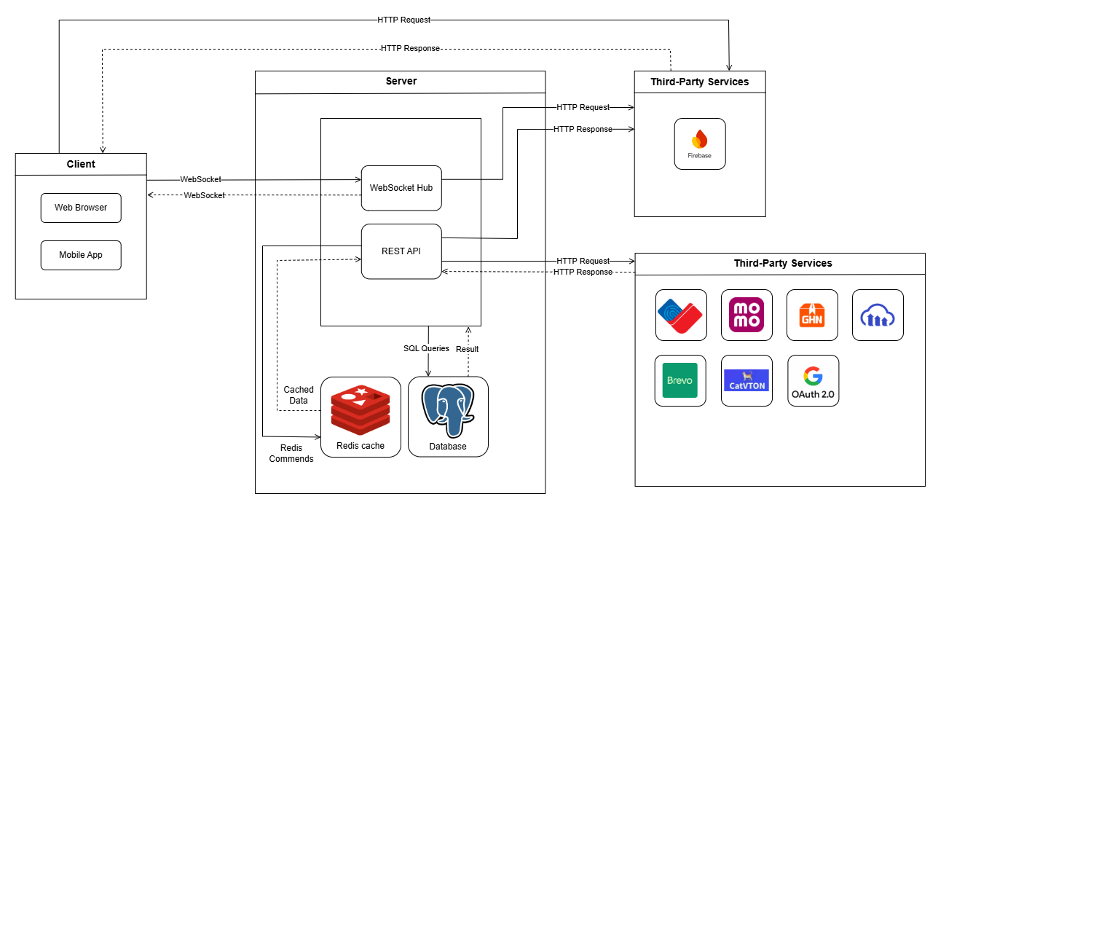

1.2 Package Diagram

1.2.1 Backend Package Diagram
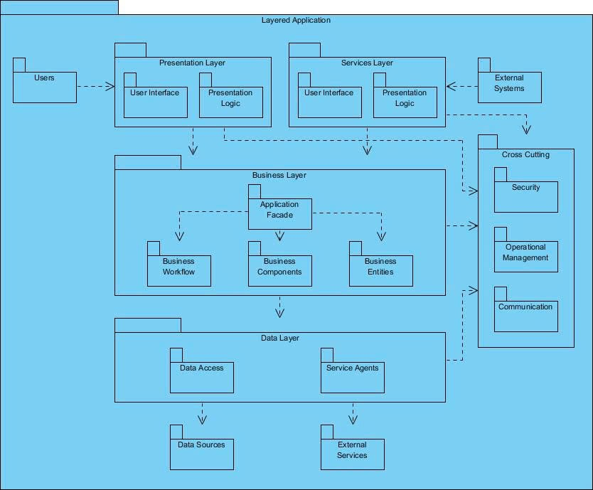
Package Descriptions
No | Package | Description
01 | controller | Receives REST requests, WebSocket messages and webhooks (MoMo, GHN), validates input, then calls the service layer
02 | dto | Request/response objects exchanged between client and server
03 | config | Configures beans, CORS, WebSocket and integration clients
04 | initializer | Seeds initial data when the application starts
05 | service | Declares the business service interfaces
06 | serviceImpl | Implements business logic: consignment, orders, wallet, platform fund, campaigns, chat...
07 | component | Shared components and scheduled jobs
08 | generator | Generates codes automatically (SKU, member code, order code...)
09 | mapper | Converts between entities and DTOs
10 | repository | Accesses the database through Spring Data JPA
11 | entity | Classes mapped to database tables
12 | client | Calls external systems: MoMo, GHN, FCM/Email, Google OAuth, background removal, AI service, cloud storage
13 | security | Handles authentication, JWT and role-based authorization
14 | exception | Defines exceptions and handles errors globally
15 | constant | Shared constants and enums
16 | util | Shared helper functions

1.2.2 Web Package Diagram
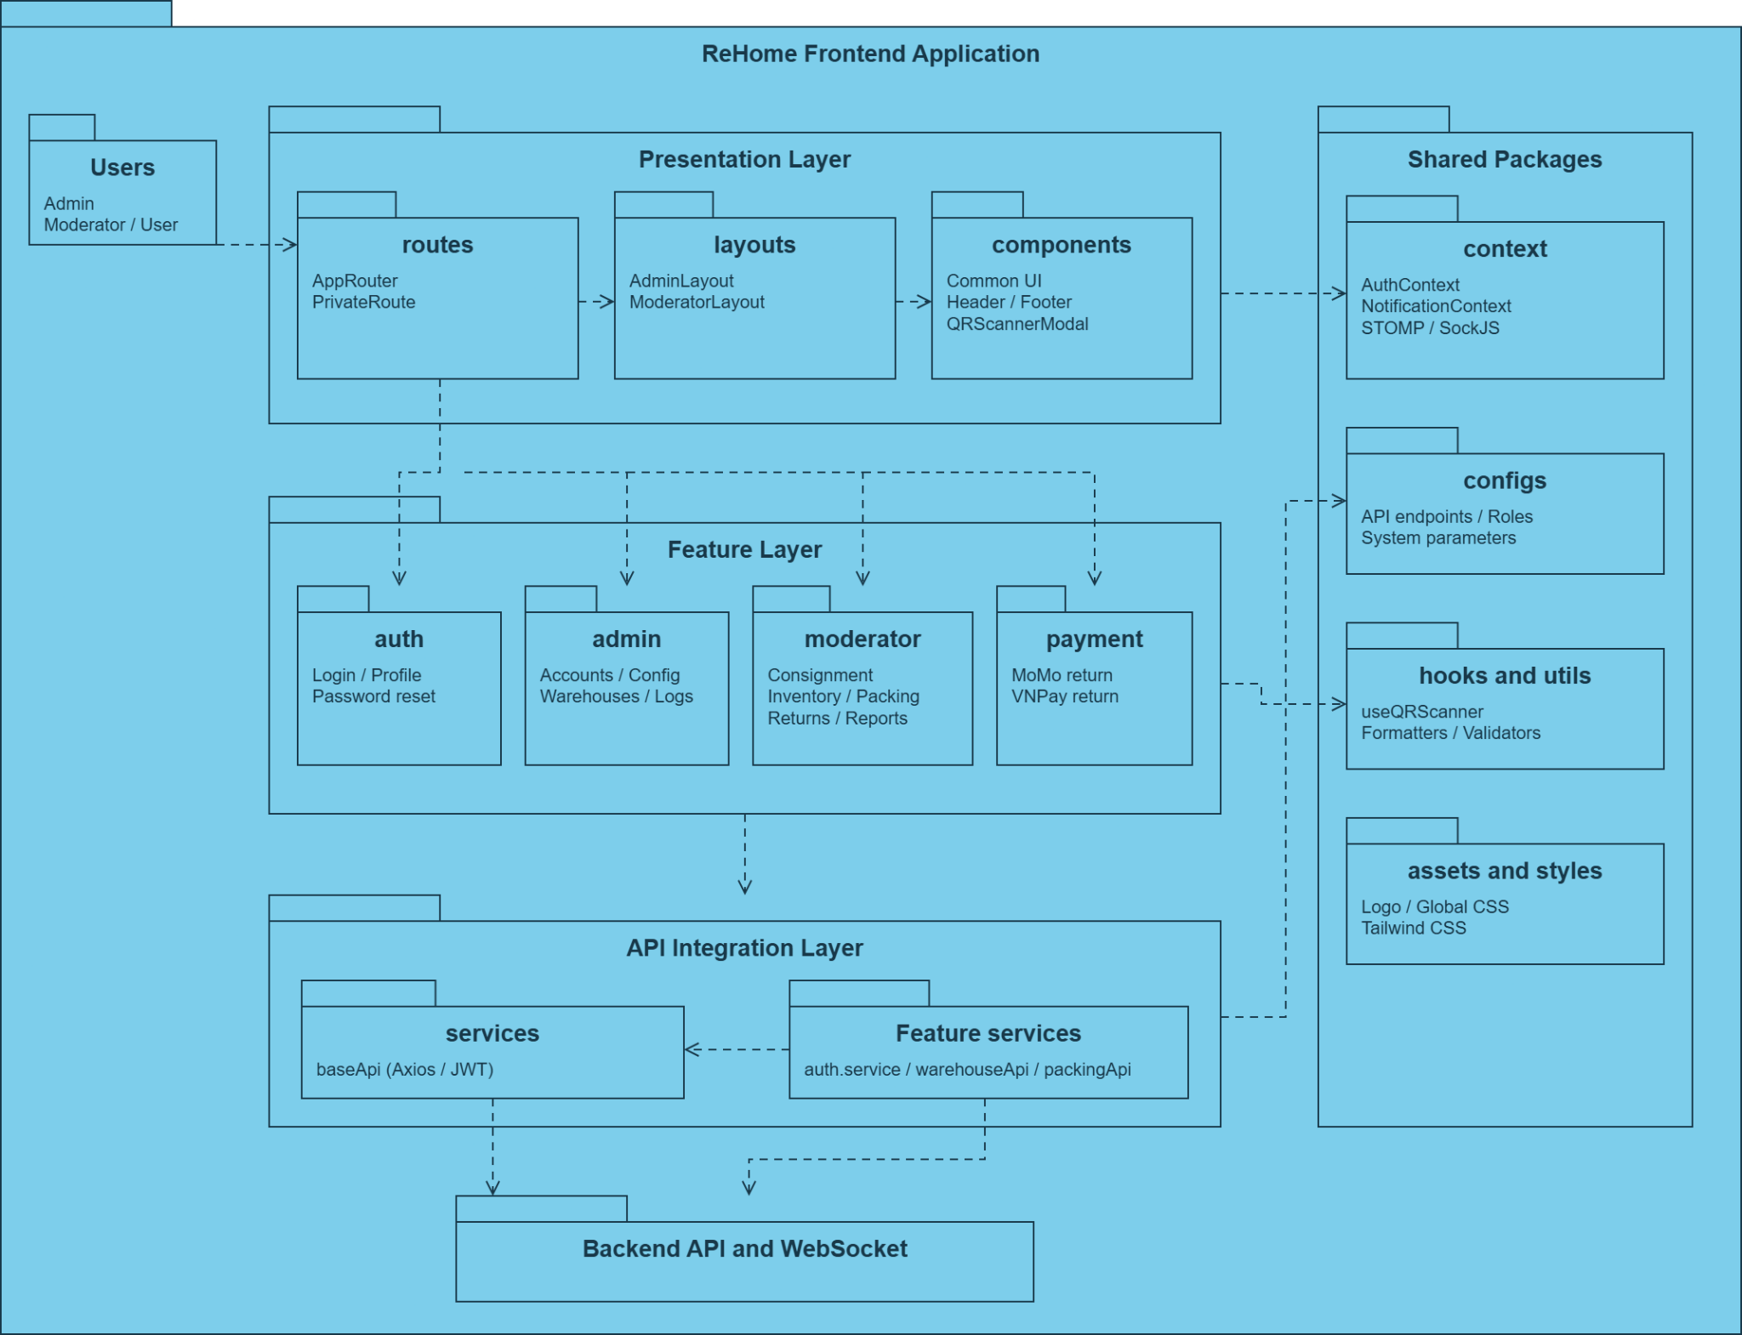
Package Descriptions

No | Package | Description
01 | routes | Defines routes in AppRouter; PrivateRoute checks authentication and role-based access permissions.
02 | layouts | Admin and moderator page layouts: AdminLayout and ModeratorLayout; organizes content and navigation.
03 | features/auth | Login, forgot-password, password-reset, and profile pages; auth.service handles authentication API requests.
04 | features/admin | Pages and components for managing accounts, moderators, warehouses, audit logs, settings, and the dashboard.
05 | features/moderator | Warehouse and consignment operations: receiving, inventory, packing, returns, catalog, verification, and violation reporting. Includes pages, components, hooks, models, services, config, and fixtures.
06 | features/payment | Pages that receive payment results returned by MoMo and VNPay.
07 | components | Shared UI components: header, footer, QRScannerModal, and common components including Button, Input, Modal, Table, Dropdown, Badge, and Logo.
08 | context | AuthContext stores authentication state; NotificationContext manages notifications through the API and STOMP/SockJS connections.
09 | services | baseApi provides a shared Axios instance, handles JWT tokens, stores user information, and configures interceptors for API requests.
10 | configs | Configures API base URLs and endpoints, roles, role-based routes, and system parameters.
11 | hooks | Reusable useQRScanner hook for QR code scanning.
12 | utils | Utilities for API calls, data formatting, and input validation in api.js, formatters.js, and validators.js.
13 | assets | Static UI assets, currently including the ReHome logo.
14 | styles | Global UI styling and CSS utility-class configuration through global.css and tailwind.css.

1.2.3 Mobile Package Diagram
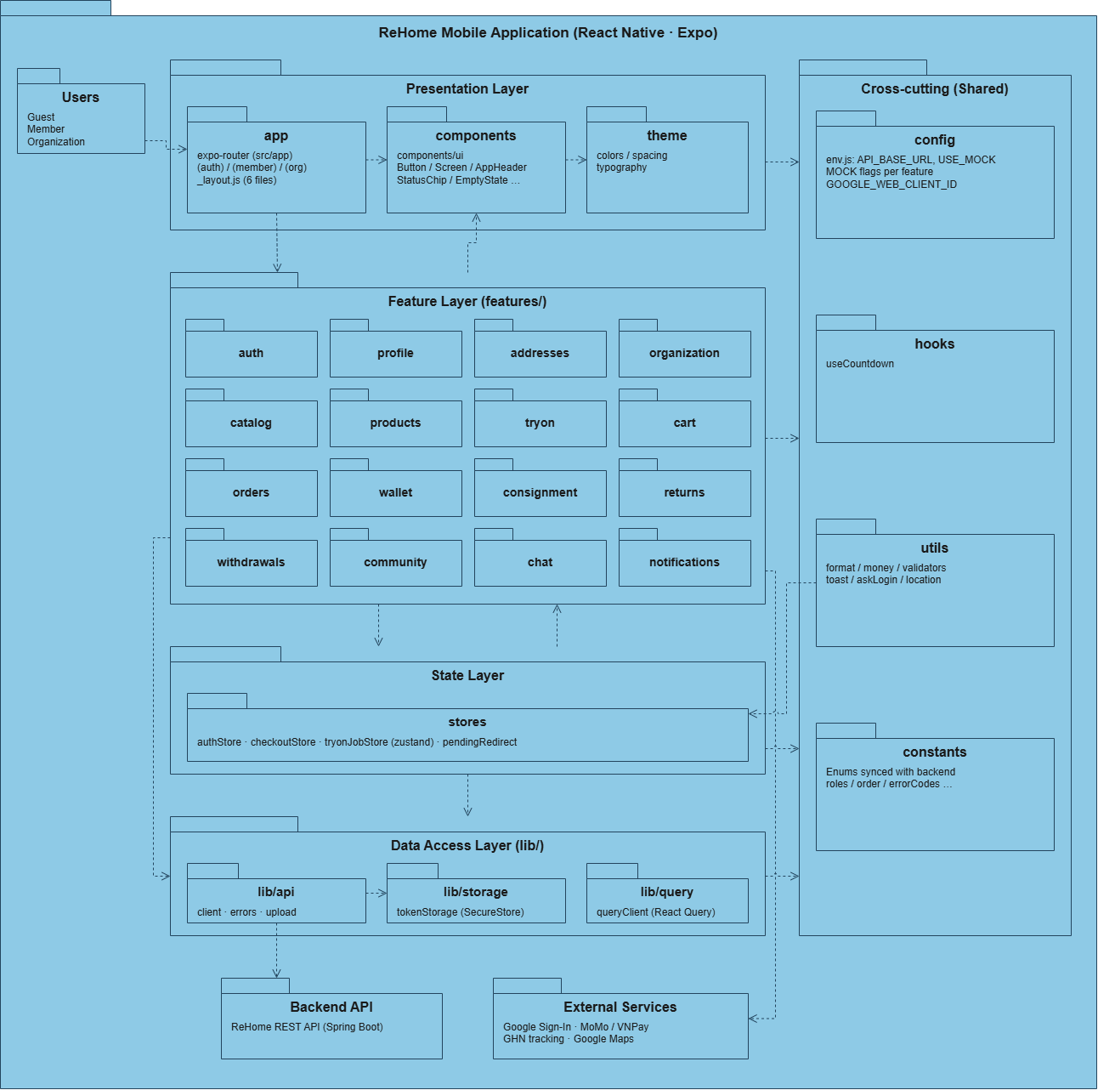
Package Descriptions

No | Package | Description
01 | Users | User groups of the mobile app: Guest (not signed in, browse only), Member (buys, consigns and returns items) and Organization (charity that receives donated items).
02 | app | Routing with Expo Router; each file is one screen. Three route groups: (auth) for sign-in, sign-up, OTP and password reset; (member) for the 4 main tabs plus shopping, consignment, wallet and return screens; (org) for organization registration. The root _layout.js wraps the QueryClientProvider, restores the session and redirects users by role.
03 | components | Shared UI components in components/ui: Button, Screen, AppHeader, StatusChip, SelectField, MoneyField, EmptyState, BootSplash, etc.
04 | theme | Design tokens: brand colors and status-label colors, spacing, border radius, fonts and text styles.
05 | auth | Sign in with email or Google, register as Member or Organization, OTP verification, and forgot, reset or change password.
06 | profile | Profile tab: view and edit personal information, avatar, QR member code and settings.
07 | addresses | Manage delivery addresses, with province and ward selection based on the GHN catalog.
08 | organization | Organization profile registration (information, legal representative, documents, warehouse location) and the profile status screen.
09 | catalog | Fetches categories and brands shared by other modules.
10 | products | Shopping home page, search and filters, product detail and similar products.
11 | tryon | AI virtual try-on: pick items, generate an image, view the result and the image gallery.
12 | cart | Shopping cart: add or remove items and a reminder banner for orders awaiting payment.
13 | orders | Checkout, payment (wallet, MoMo, VNPay), order list and detail, GHN shipment tracking, cancellation, delivery confirmation and reviews.
14 | wallet | Wallet balance, transaction history, consignment earnings and withdrawal requests.
15 | consignment | Consign new items, receipts, track items on consignment, price reductions, end-of-term decisions and re-consignment.
16 | returns | Return requests: create, list and view details, report GHN drop-off and choose how to receive the refund.
17 | withdrawals | Withdraw consigned items and handle degraded items.
18 | community | Browse organizations, campaigns and posts; follow organizations, report violations and find nearby organizations.
19 | chat | Conversation list and chat rooms with consignment locations or organizations.
20 | notifications | Notification list; tapping a notification opens the related screen.
21 | stores | Global state with zustand: authStore (session and role), checkoutStore (checkout in progress), tryonJobStore (background try-on jobs); pendingRedirect keeps the screen to return to after sign-in.
22 | lib/api | Axios client: attaches the access token, refreshes it automatically, converts errors into ApiError and reports session expiry through a callback; also contains the image upload module.
23 | lib/storage | Stores access and refresh tokens securely with expo-secure-store.
24 | lib/query | Configures @tanstack/react-query to cache server data.
25 | config | env.js: API base URL, mock switch with a MOCK flag per feature, and the Google client ID.
26 | hooks | Shared hooks; currently useCountdown (payment deadline and OTP countdown).
27 | utils | Utility functions: money, address and date formatting, validators, toast messages, sign-in prompt and location helpers.
28 | constants | Constants and enums kept in sync with the backend: roles, order, consignment, return and wallet statuses, error codes, etc.
29 | Backend API | ReHome REST API (Spring Boot). The app only calls it through lib/api.
30 | External Services | Google Sign-In is called from the app, which then sends the idToken to the backend. MoMo and VNPay payment pages open from a link returned by the backend. GHN shipment tracking and Google Maps directions open through Linking.

2. Database Design
Table Descriptions
No | Table | Description

3. Detailed Design

3.1 <Feature/Function Name1>

3.1.1 Class Diagram
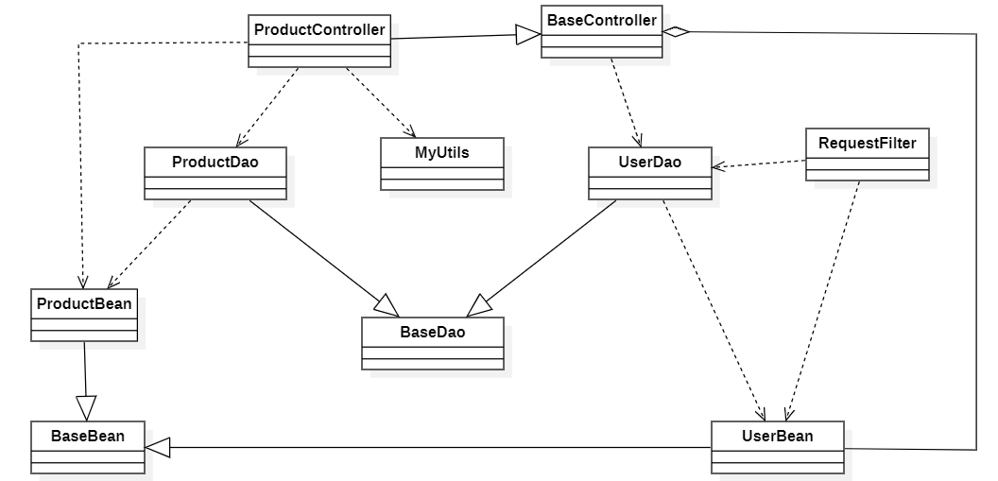
3.1.2 <Sequence Diagram Name1>
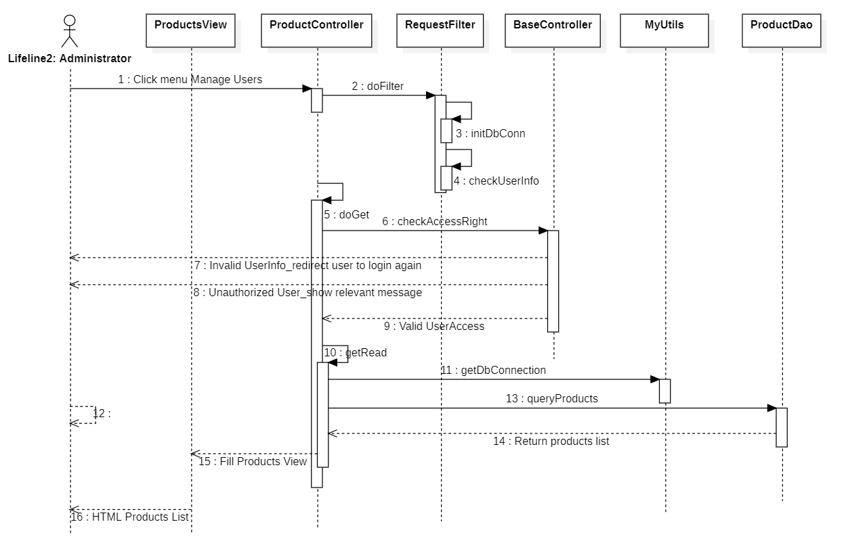

3.1.3 <Sequence Diagram Name2>

3.1.4 …

3.2 <Feature/Function Name2>
…

