REHOTEQ
AI EDUCATION CURRICULUM
―――――――――――――――――――――――

Comprehensive Teacher's Lesson Note
What is AI?
Junior Secondary 1 · First Term · Week 6

Field | Detail
Subject | AI Education and Digital Skills
Academic session | 2026/2027
Duration | 2 periods (40 to 45 minutes each, subject to the school timetable)
Document type | Comprehensive Teacher's Lesson Note
Curriculum status | Proposed curriculum for school pilot, review and consultation
Prepared by | Rehoteq Technologies (rehoteq.com)
Edition | First edition, November 2026

PROPOSED CURRICULUM NOTICE: This lesson note expands the Rehoteq AI Education Curriculum's proposed Junior Secondary 1, First Term, Week 6 scheme of work. It is offered for school pilot, review and consultation. It is not represented as an officially approved national syllabus, and it does not replace the current NERDC curriculum or any examination-board requirement.

1. Lesson Information
Field | Detail
Class | JSS 1
Subject | AI Education and Digital Skills
Term | First Term
Week | Week 6 of First Term
Topic | What is AI?
Duration | 2 periods (40 to 45 minutes each)

2. Learning Outcome
By the end of the lesson, learners can:
- Explain artificial intelligence in simple words: computers learning patterns from examples so they can help decide, predict or answer.
- Give at least four everyday examples of AI touches in Nigerian life: phone face unlock, voice assistants, payment fraud alerts, traffic or farm apps, school result prediction.
- Tell one thing AI does well and one thing a human still does better, and say why both matter.
- Use the key words of the week correctly in a sentence: artificial intelligence, pattern, data, predict.

3. Weekly Scheme Content
Period | Scheme content
Period 1 | Definition and everyday examples
Period 2 | AI spotting walk: list five AI touches
Weeks 11 to 13 of the term are reserved for examinations, marking and results. Do not introduce new content during those weeks.

4. Materials and Preparation
- A phone with face unlock or a voice assistant, for the demonstration moment (teacher's own device, used with care).
- Picture cards of five AI examples: a phone unlocking on a face, a fraud alert on a payment machine, a farm app on a tablet, a map showing a route, a voice assistant speaker.
- A wall chart with two columns: computer decides, human decides.
- Small exercise books or sheets for the AI spotting list.
No-lab fallback: the lesson is fully discussion based. The teacher acts the fraud alert on a drawn payment machine and mimes the voice assistant, and the AI spotting walk becomes a walk through the school compound listing any machine that appears to decide something: the bell, the borehole pump switch, the head teacher's laptop.

5. Period One: Introduce and Model
- Starter (5 minutes): ask learners how a phone knows its owner's face. Collect answers without correcting.
- Teach (10 minutes): define artificial intelligence simply: computers are shown many examples, they learn the patterns inside them, and then they use those patterns to answer, predict or decide. Compare with how a child learns to recognise a friend's face by seeing it many times.
- Model (10 minutes): walk through the five example cards. For each, ask what pattern the computer learned: what a face looks like, what a normal spending habit looks like, what a healthy crop looks like, what a fast route looks like, what a spoken question sounds like.
- Guided practice (10 minutes): learners fill the two-column chart with one item each: something a computer decides in their lives, and something a human must still decide, such as forgiving a friend or choosing a career.
- Check (5 minutes): oral drill: complete the sentence: AI learns from ___ and finds ___

6. Lesson Pictures
Show these pictures while teaching. Talk about each one before moving on, and ask learners to point to the same thing on the chart or the real machine.
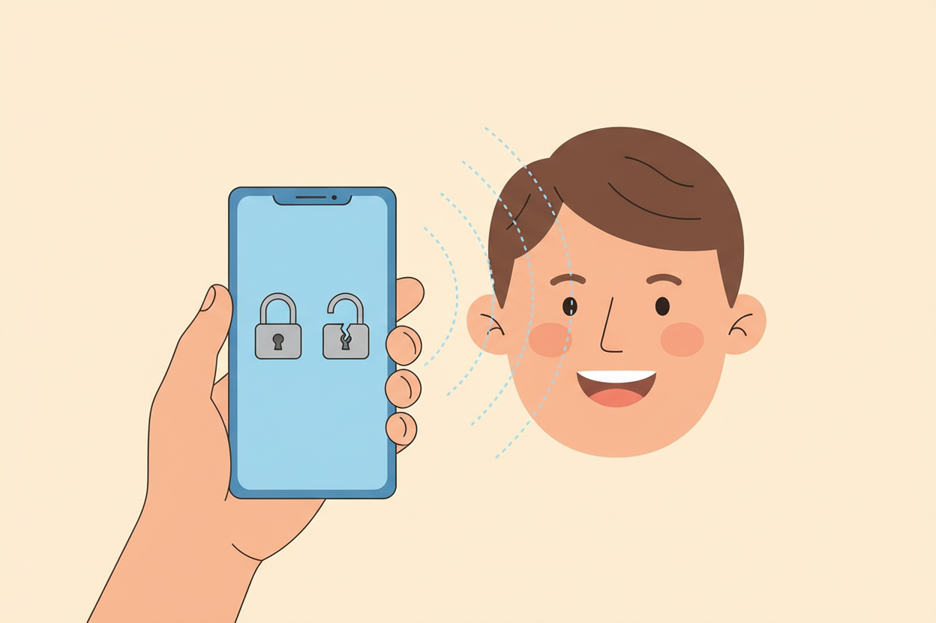
Picture 1. The phone studies the face in front of it, compares it with the pattern it learned, and opens only for the right person.
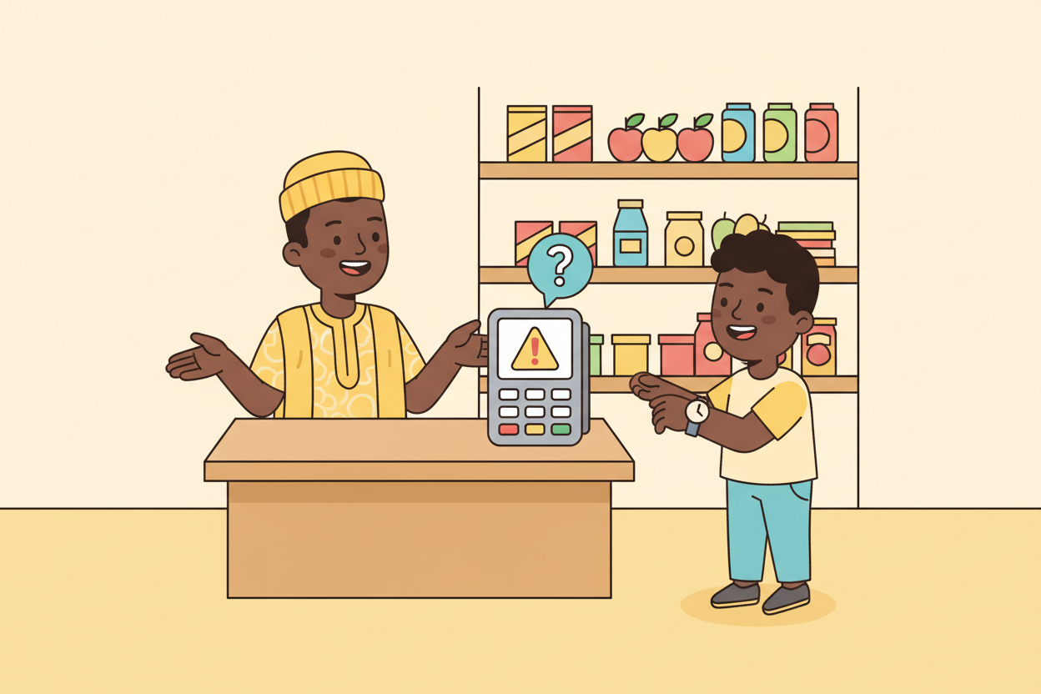
Picture 2. A payment machine can learn what normal spending looks like and raise an alert when a pattern looks wrong.
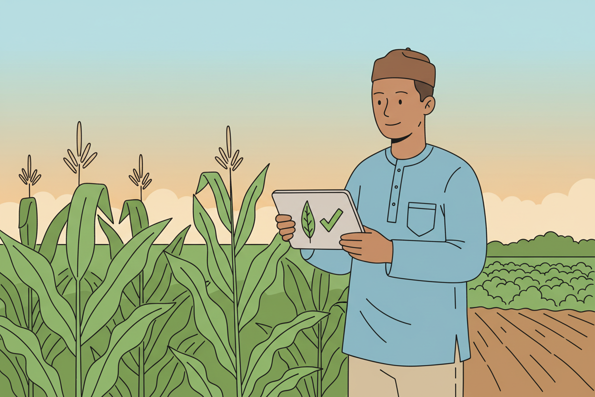
Picture 3. On the farm, a learning app can look at a leaf and tell which plant disease the pattern matches.
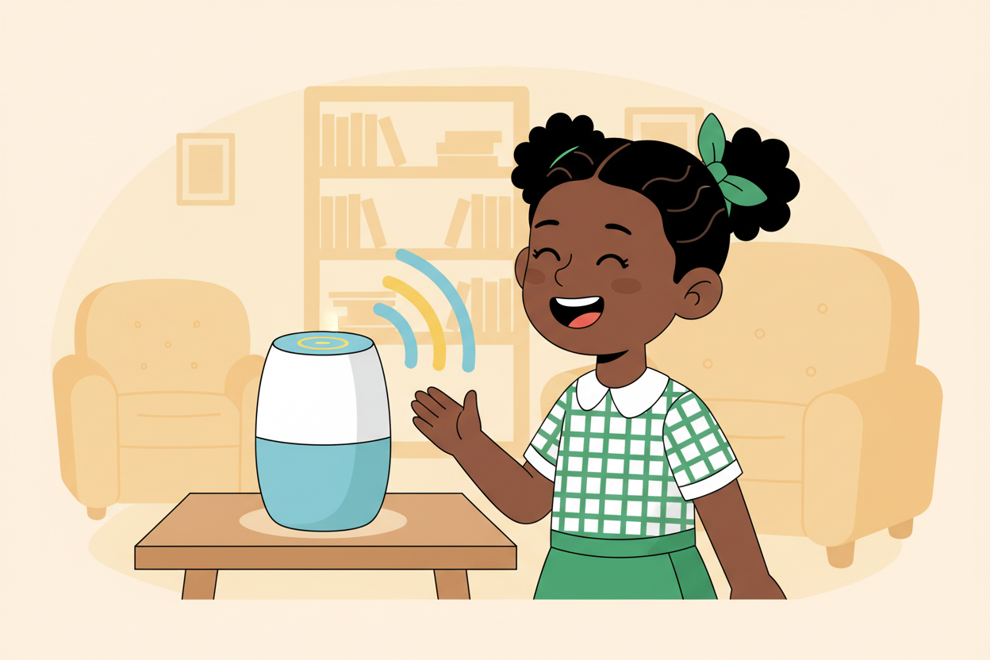
Picture 4. A voice assistant hears the sound pattern of a question and answers it aloud.

7. Period Two: Practise and Apply
- AI spotting walk (20 minutes): groups walk a fixed route through the school or around the pictures on the wall and list five AI touches they find or imagine, each with what pattern the machine learned. Groups without outdoor access work from the picture cards and the chart.
- Share and correct (10 minutes): each group reads its best two items; the class checks whether the pattern named is real. The teacher adds the truth where a claim is too big: AI does not feel or want, it matches patterns.
- Recap and write (10 minutes): learners write the definition in their own words and copy their favourite example.

8. Assessment and Evidence
- Evidence to collect: each group's five-item AI spotting list, and each learner's written definition.
Success looks like: every list names a real pattern the machine could learn, and every written definition mentions learning from examples or patterns.

9. Suggested Questions and Answer Guidance
1. What is artificial intelligence? Expected response: computer programs that learn patterns from many examples and use them to answer, predict or decide.
2. Mention three AI touches in Nigerian daily life. Expected response: any three of phone face unlock, payment fraud alerts, traffic route apps, farm disease apps, voice assistants, chat assistants.
3. Name one thing a human still does better than AI, with a reason. Expected response: any sensible example, such as understanding feelings, making fair choices or creating new ideas, because AI only matches patterns it has seen.
4. Where does AI get its knowledge? Expected response: from data, meaning many examples it is shown, not from living like a person.

10. Home Activity
Learners list two machines at home or in the neighbourhood that seem to decide something, such as a DSTV decoder suggesting programmes or a bank app sending an alert, and write what pattern each might have learned.

11. Inclusion
The lesson is oral and visual by design: learners who struggle with writing may draw their AI examples instead, and group reporters are rotated so every voice is heard. Picture cards are large and shown close to learners with low vision.

12. Safety and Privacy
No personal data is collected in this lesson: face unlock is demonstrated on the teacher's own device with the teacher's own face only, and learners never photograph one another. Discussion of fraud alerts uses invented examples, never a real person's story.

13. Teacher Reflection
After the lesson, note what worked, which parts confused the class, which pupils need follow-up, and one change for next time.
Reflection notes
__________________________________________________________________________________________

14. Curriculum Alignment and Document Status
This note expands the Rehoteq AI Education Curriculum, a proposed curriculum for school pilot, review and consultation; not an officially approved national syllabus. It does not replace the current NERDC curriculum or examination-board requirements, and schools remain responsible for checking current NERDC requirements and their own calendar before implementation.

Prepared by Rehoteq Technologies (rehoteq.com). First edition, November 2026.

