REHOTEQ
AI EDUCATION CURRICULUM
―――――――――――――――――――――――

Comprehensive Teacher's Lesson Note
Project and revision
Junior Secondary 1 · Third Term · Week 10

Field | Detail
Subject | AI Education and Digital Skills
Academic session | 2026/2027
Duration | 2 periods (40 to 45 minutes each, subject to the school timetable)
Document type | Comprehensive Teacher's Lesson Note
Curriculum status | Proposed curriculum for school pilot, review and consultation
Prepared by | Rehoteq Technologies (rehoteq.com)
Edition | First edition, November 2026

PROPOSED CURRICULUM NOTICE: This lesson note expands the Rehoteq AI Education Curriculum's proposed Junior Secondary 1, Third Term, Week 10 scheme of work. It is offered for school pilot, review and consultation. It is not represented as an officially approved national syllabus, and it does not replace the current NERDC curriculum or any examination-board requirement.

1. Lesson Information
Field | Detail
Class | JSS 1
Subject | AI Education and Digital Skills
Term | Third Term
Week | Week 10 of Third Term
Topic | Term project: design a simple solution with an algorithm, flowchart and pseudocode; plus term revision
Duration | 2 periods (40 to 45 minutes each)

2. Learning Outcome
By the end of the lesson, learners can:
- Plan a small project on paper: choose a problem, state inputs, steps and outputs.
- Produce an algorithm, a flowchart and pseudocode for the project, using Weeks 4 to 6.
- Apply the AI and digital-citizenship rules from Weeks 7 and 8 to their own work.
- Revise the term's topics using a self-made checklist.

3. Weekly Scheme Content
Period | Scheme content
Period 1 | Project planning: problem, inputs, steps, outputs
Period 2 | Build algorithm, flowchart and pseudocode; begin revision
Weeks 11 to 13 of the term are reserved for examinations, marking and results. Do not introduce new content during those weeks.

4. Materials and Preparation
- Project planning sheets: problem, who it helps, inputs, steps, outputs.
- Shape cards and pseudocode word cards from Weeks 5 and 6.
- This term's lesson notes for the revision checklist; no device needed.
No-lab fallback: paper project studio. Teams complete the planning sheet and all three artefacts (algorithm, flowchart, pseudocode) on paper and rehearse a two-minute pitch.

5. Period One: Introduce and Model
- Starter (5 minutes): recall the term's journey: algorithms, flowcharts, pseudocode, AI rules, digital citizenship. One project uses all of it.
- Choose and plan (20 minutes): teams pick one problem from a menu (a school-day helper, a canteen queue, a water-collection planner, a study-time planner) and complete the planning sheet.
- Check (15 minutes): each team reads its plan to another team, which checks the inputs and steps make sense; fix and finish.

6. Lesson Pictures
Show these pictures while teaching. Use each one to point back at the week it comes from before the class moves on.

Picture 1. Choose a real problem and plan it on paper first.
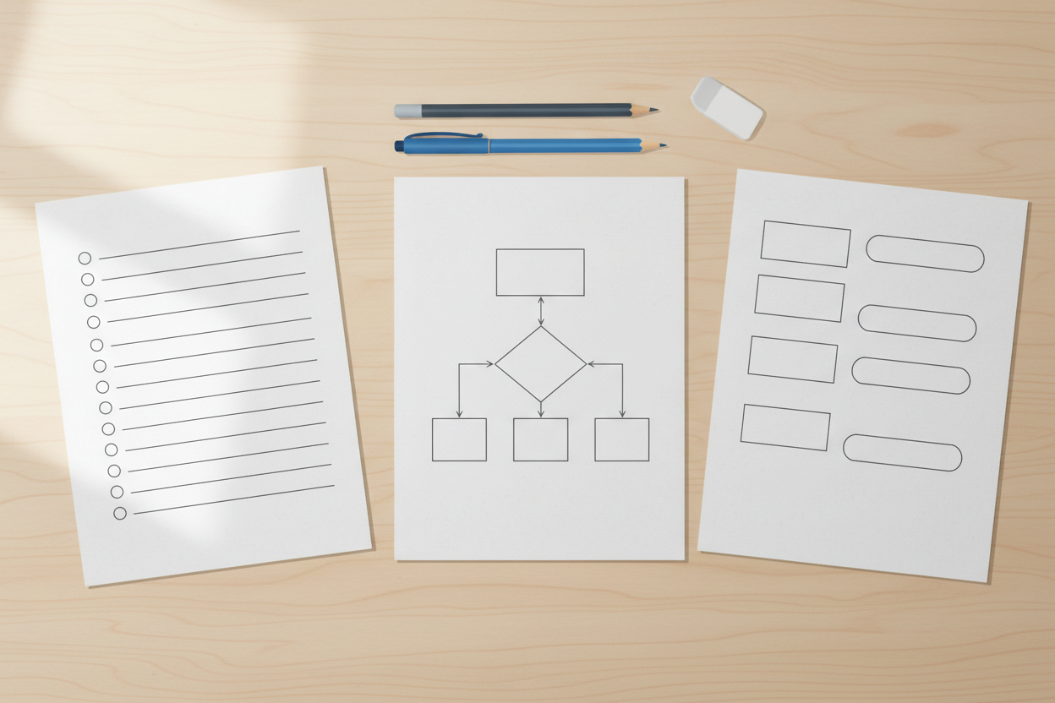
Picture 2. The three artefacts: algorithm list, flowchart, pseudocode.
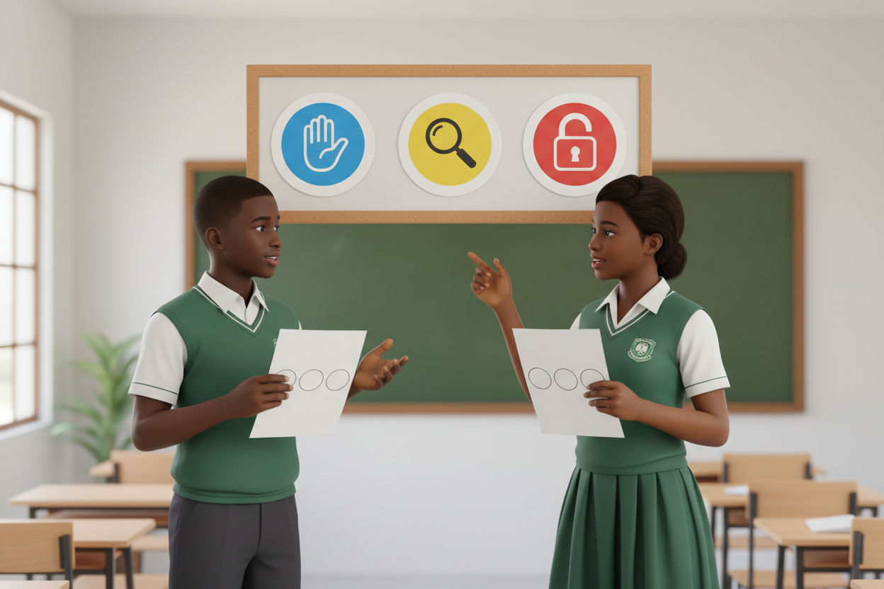
Picture 3. Our rules apply to our own work: honesty and privacy.

Picture 4. Revision checklist: tick the term's topics as you review.

7. Period Two: Practise and Apply
- Build the three artefacts (25 minutes): from the plan, teams write the algorithm list, draw the flowchart with all four symbols, and write the pseudocode with the fixed vocabulary.
- Two-minute pitches (15 minutes): each team presents problem, plan and artefacts; the class asks one question each and the AI and citizenship rules are checked explicitly.
- Revision checklist (5 minutes): learners start the self-made checklist of term topics to finish at home.

8. Assessment and Evidence
- Evidence to collect: each team's planning sheet, algorithm, flowchart, pseudocode and pitch notes.
Success looks like: all three artefacts match the plan and each other, all four flowchart symbols appear, the pseudocode vocabulary is correct, and the pitch passes the honesty and privacy check.

9. Suggested Questions and Answer Guidance
1. How do the three artefacts connect? Expected response: the algorithm lists the steps, the flowchart pictures them with decisions, the pseudocode writes them in structured words.
2. Where does your project need a decision (diamond)? Expected response: named, with its two branches.
3. How do the AI rules apply here? Expected response: say when AI helped, check anything an AI suggested, keep personal data out.
4. Which term topic do you most need to revise, and why? Expected response: named topic with a reason.

10. Home Activity
Learners finish the revision checklist at home and bring one improvement they would make to their team's project next term; no device needed.

11. Inclusion
Roles in the team cover planning, drawing, writing and presenting; artefacts may be drawn, arranged with cards or dictated. No colour-only cues.

12. Safety and Privacy
Projects stay school-appropriate; no personal data in any artefact; no device required.

13. Teacher Reflection
After the lesson, note what worked, which parts confused the class, which pupils need follow-up, and one change for next term.
Reflection notes
__________________________________________________________________________________________

14. Curriculum Alignment and Document Status
This note expands the Rehoteq AI Education Curriculum, a proposed curriculum for school pilot, review and consultation; not an officially approved national syllabus. It does not replace the current NERDC curriculum or examination-board requirements, and schools remain responsible for checking current NERDC requirements and their own calendar before implementation.

Prepared by Rehoteq Technologies (rehoteq.com). First edition, November 2026.

