REHOTEQ
AI EDUCATION CURRICULUM
―――――――――――――――――――――――

Comprehensive Teacher's Lesson Note
Sequences
Junior Secondary 1 · Second Term · Week 5

Field | Detail
Subject | AI Education and Digital Skills
Academic session | 2026/2027
Duration | 2 periods (40 to 45 minutes each, subject to the school timetable)
Document type | Comprehensive Teacher's Lesson Note
Curriculum status | Proposed curriculum for school pilot, review and consultation
Prepared by | Rehoteq Technologies (rehoteq.com)
Edition | First edition, November 2026

PROPOSED CURRICULUM NOTICE: This lesson note expands the Rehoteq AI Education Curriculum's proposed Junior Secondary 1, Second Term, Week 5 scheme of work. It is offered for school pilot, review and consultation. It is not represented as an officially approved national syllabus, and it does not replace the current NERDC curriculum or any examination-board requirement.

1. Lesson Information
Field | Detail
Class | JSS 1
Subject | AI Education and Digital Skills
Term | Second Term
Week | Week 5 of Second Term
Topic | Sequences: step-by-step programs; building a two-step story
Duration | 2 periods (40 to 45 minutes each)

2. Learning Outcome
By the end of the lesson, learners can:
- Define a sequence as steps in a fixed order.
- Predict what a given sequence will do before it runs.
- Reorder steps that are in the wrong order and explain the fix.
- Build and run a two-step story program with their sprite.

3. Weekly Scheme Content
Period | Scheme content
Period 1 | Step-by-step programs
Period 2 | Build a two-step story
Weeks 11 to 13 of the term are reserved for examinations, marking and results. Do not introduce new content during those weeks.

4. Materials and Preparation
- Computers with Scratch where available, one per pair; last week's saved projects as a starting point.
- Paper sequence cards: six blank coloured cards per team for ordering activities.
- A well-known sequence written on the board in pictures only: wake up, brush teeth, bathe, dress, eat, go to school.
No-lab fallback: the entire lesson runs on paper cards. Teams order the cards, act the sequence out, and reorder a deliberately wrong set; the computer version is only an extension.

5. Period One: Introduce and Model
- Starter (5 minutes): scramble the daily routine pictures on the board and let the class restore the correct order, shouting the fix each time.
- Teach (10 minutes): a sequence is a program's backbone: instructions run one after another, top to bottom, every time. In Scratch, blocks run in the order they are stacked.
- Model (10 minutes): open last week's three-block program. Predict, run, observe. Then insert a new step between two blocks and predict again: the new step changes everything after it.
- Error hunt (15 minutes): teams receive a deliberately wrong paper sequence (brush teeth after eating, say hello after moving off the stage) and must reorder it and explain each swap.

6. Lesson Pictures
Show these pictures while teaching. Use each one to point back at the week it comes from before the class moves on.
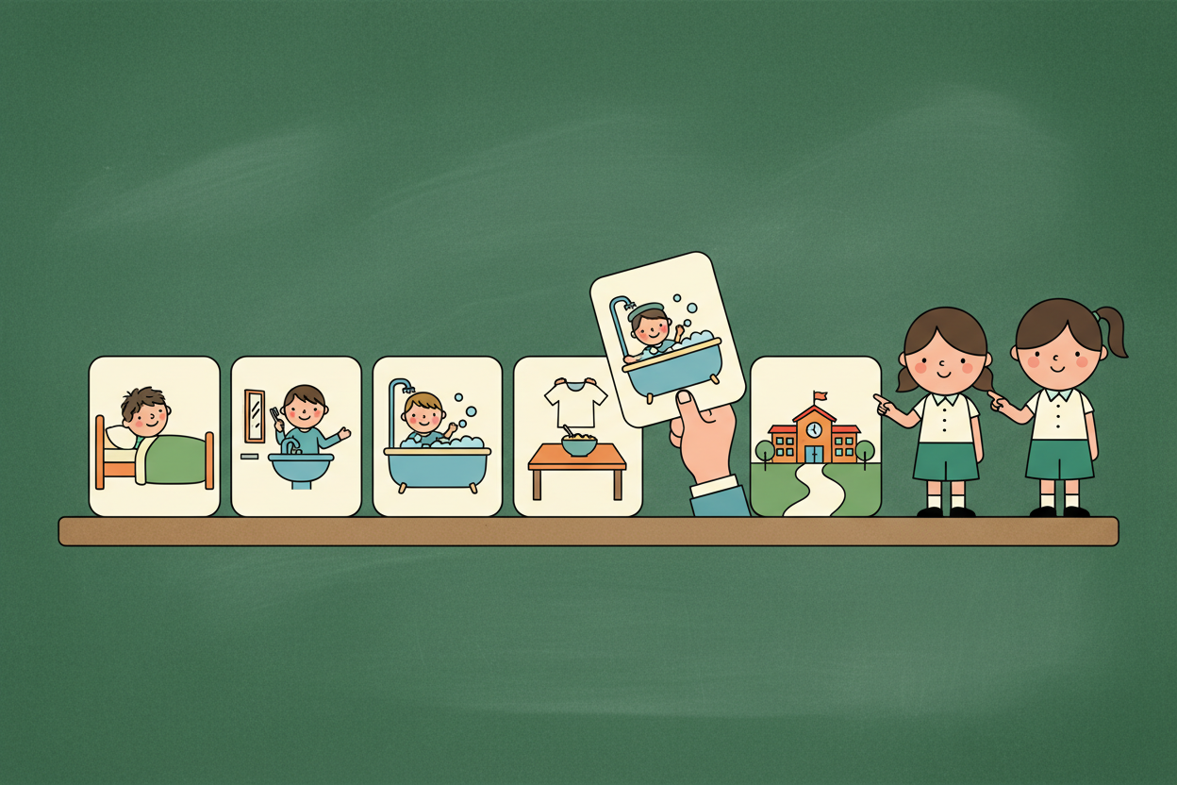
Picture 1. A sequence is steps in order: change the order and the day falls apart.
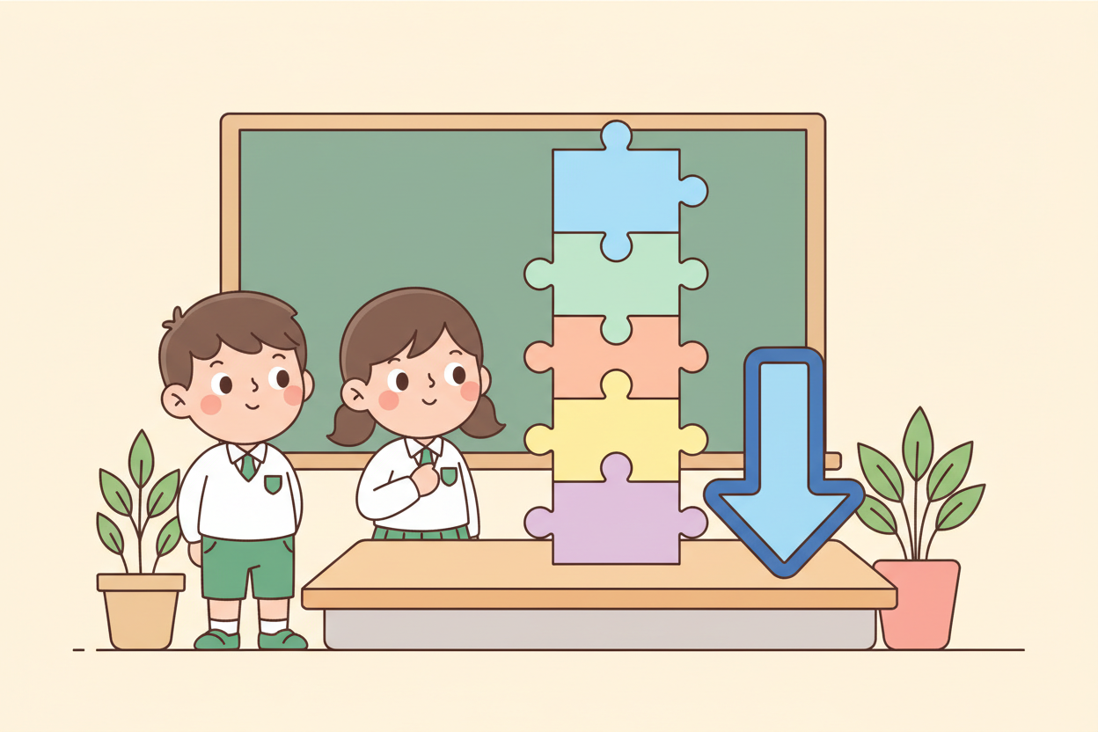
Picture 2. The computer follows the stack from top to bottom, every time.
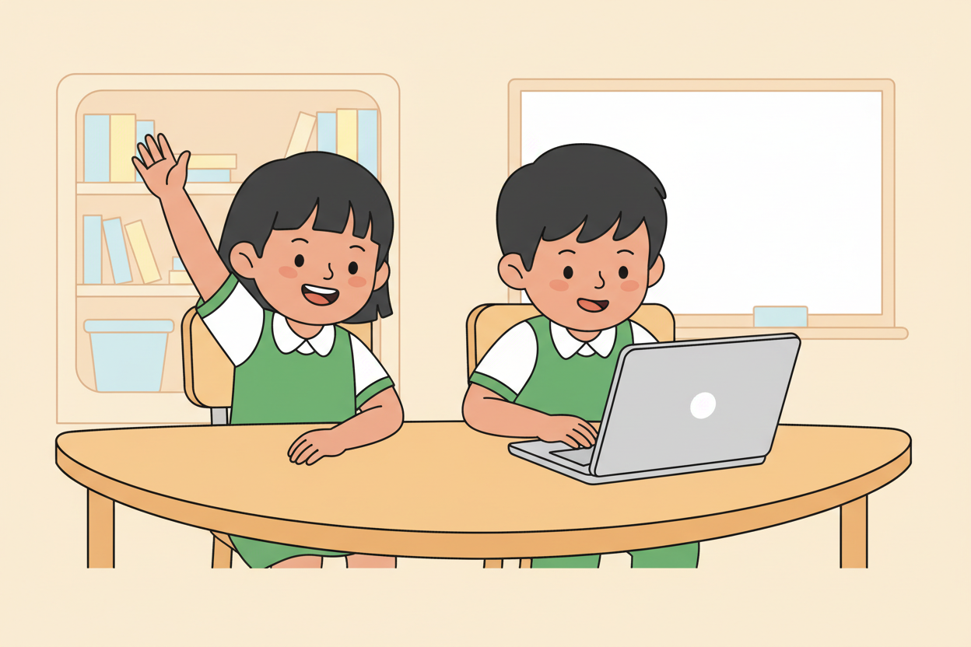
Picture 3. Predict first, run second: say what will happen before the flag is clicked.
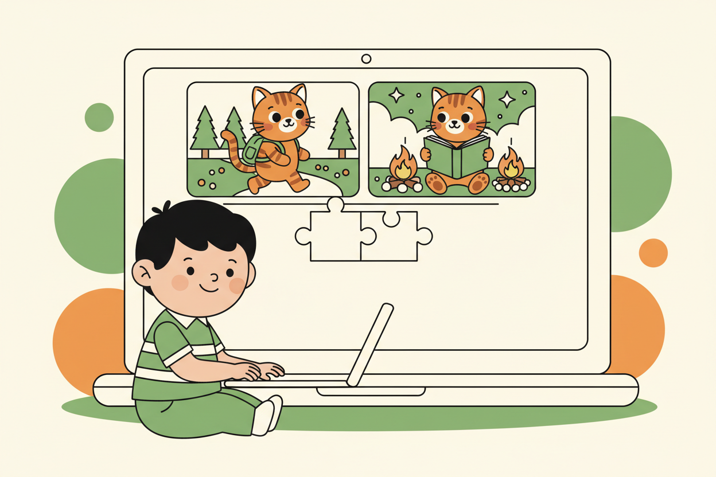
Picture 4. The two-step story: the sprite does step one, then step two, in that order.

7. Period Two: Practise and Apply
- Two-step story build (20 minutes): pairs program a story with exactly two events: the sprite does something, then does something else that depends on the first (walks to the door, then says 'I am home'; jumps, then cheers).
- Swap challenge (10 minutes): pairs swap computers or card layouts with a neighbouring pair, run the other pair's program, and say one thing they would change and why.
- Exit check (5 minutes): each learner writes the two steps of their story in order in their book.

8. Assessment and Evidence
- Evidence to collect: each pair's two-step story (saved project or card layout), one swap-review comment per pair, and each learner's written two steps.
Success looks like: stories run in a sensible order, predictions are made aloud before runs, and every swap comment names a real change rather than 'it is fine'.

9. Suggested Questions and Answer Guidance
1. What happens if you put the say block before the move block? Expected response: the sprite speaks first, then moves; the order of the story changes.
2. Why does a computer never skip a step or guess one? Expected response: it does exactly what the program says, nothing more.
3. Give one everyday task that fails if its steps are reordered. Expected response: any sensible example, such as wearing shoes before socks or pouring water before boiling.
4. How would you add a third step to your story? Expected response: snap or place one more card below the second, keeping the order sensible.

10. Home Activity
Learners write a three-step sequence for any household chore in their books and label the steps; no device is needed.

11. Inclusion
Card activities let every learner join physically: one learner places cards while another narrates. Prediction is oral first, written second, so slower writers still show understanding. Stories may use any sprite, including ones the learner draws themselves on paper.

12. Safety and Privacy
Stories stay school-appropriate and kind: no frightening scenes, no mocking classmates. Saved project names follow the class-week pattern with no personal details.

13. Teacher Reflection
After the lesson, note what worked, which parts confused the class, which pupils need follow-up, and one change for next term.
Reflection notes
__________________________________________________________________________________________

14. Curriculum Alignment and Document Status
This note expands the Rehoteq AI Education Curriculum, a proposed curriculum for school pilot, review and consultation; not an officially approved national syllabus. It does not replace the current NERDC curriculum or examination-board requirements, and schools remain responsible for checking current NERDC requirements and their own calendar before implementation.

Prepared by Rehoteq Technologies (rehoteq.com). First edition, November 2026.

