REHOTEQ
AI EDUCATION CURRICULUM
―――――――――――――――――――――――

Comprehensive Teacher's Lesson Note
AI ethics
Junior Secondary 1 · Third Term · Week 7

Field | Detail
Subject | AI Education and Digital Skills
Academic session | 2026/2027
Duration | 2 periods (40 to 45 minutes each, subject to the school timetable)
Document type | Comprehensive Teacher's Lesson Note
Curriculum status | Proposed curriculum for school pilot, review and consultation
Prepared by | Rehoteq Technologies (rehoteq.com)
Edition | First edition, November 2026

PROPOSED CURRICULUM NOTICE: This lesson note expands the Rehoteq AI Education Curriculum's proposed Junior Secondary 1, Third Term, Week 7 scheme of work. It is offered for school pilot, review and consultation. It is not represented as an officially approved national syllabus, and it does not replace the current NERDC curriculum or any examination-board requirement.

1. Lesson Information
Field | Detail
Class | JSS 1
Subject | AI Education and Digital Skills
Term | Third Term
Week | Week 7 of Third Term
Topic | Using AI helpers fairly and safely: honesty, privacy, bias and knowing when a human must decide
Duration | 2 periods (40 to 45 minutes each)

2. Learning Outcome
By the end of the lesson, learners can:
- Explain what an AI helper is and name everyday examples.
- State simple rules for honest and safe use: say when AI helped, never share personal details, check answers.
- Give one example of AI unfairness (bias) and one of a decision a human must make.
- Role-play choosing what is right to ask an AI helper and what is not.

3. Weekly Scheme Content
Period | Scheme content
Period 1 | What AI helpers are and fair-use rules
Period 2 | Bias, privacy and human decisions: role-play
Weeks 11 to 13 of the term are reserved for examinations, marking and results. Do not introduce new content during those weeks.

4. Materials and Preparation
- Rule cards with plain words: ASK FIRST, CHECK IT, KEEP IT PRIVATE, SAY WHEN AI HELPED, HUMANS DECIDE.
- The class's earlier work: the AI helper list from Term 2 and the fairness chart from the computing lesson.
- Pencils and paper; no device needed.
No-lab fallback: role-play circles. Teams act out short scenes (homework help, a photo of a friend, a health question) and hold up the rule card that applies; the class votes and discusses.

5. Period One: Introduce and Model
- Starter (5 minutes): name AI helpers the class already met (a voice assistant, an autocomplete, a picture maker). One word for all of them: they guess from patterns.
- Teach (10 minutes): five rules on the board: ASK FIRST before you use one for schoolwork, CHECK IT because AI can be confidently wrong, KEEP IT PRIVATE because names and photos are not for AI chats, SAY WHEN AI HELPED because honesty matters, HUMANS DECIDE for anything about people.
- Discuss (15 minutes): teams take one rule each and give one real example of keeping it and one of breaking it; the class judges each example.
- Write (10 minutes): each learner writes the two rules they will follow first, in their own words.

6. Lesson Pictures
Show these pictures while teaching. Use each one to point back at the week it comes from before the class moves on.
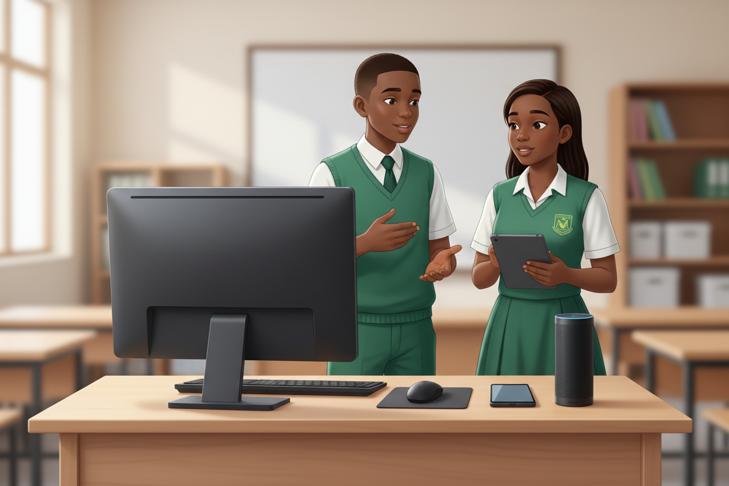
Picture 1. AI helpers guess from patterns: the helpers we already met.

Picture 2. Five rules for fair use, on the board.

Picture 3. Role-play: which rule fits this scene?

Picture 4. Humans decide: the teacher and pupils talking it through.

7. Period Two: Practise and Apply
- Role-play circles (25 minutes): each team acts one short scene (asking an AI to write a friend's homework; someone shares a classmate's photo with an AI chat; an AI ranks pupils for a prize) and the class holds up the rule that applies and explains it.
- Bias moment (10 minutes): the teacher shows two blank faces for a story and asks who the AI made the doctor and who the driver; discuss that AI copies patterns, including unfair ones, so humans must check.
- Close (5 minutes): the class signs the five rules as their AI charter for next term's projects.

8. Assessment and Evidence
- Evidence to collect: each team's role-play rule choice with one reason; each learner's two personal rules.
Success looks like: every learner can state at least two rules in their own words, every scene maps to the right rule, and the bias example is understood as patterns, not people.

9. Suggested Questions and Answer Guidance
1. Why must you say when AI helped? Expected response: honesty; the work should show your effort and where AI added to it.
2. Why not put a friend's photo into an AI chat? Expected response: private details are not yours to share and AI chats are not private.
3. What does bias mean here? Expected response: AI copied an unfair pattern from its examples.
4. Name one decision AI must never make alone. Expected response: any decision about people, a human decides.

10. Home Activity
Learners ask a grown-up at home which rule matters most to them and write the answer in one line; no device needed.

11. Inclusion
Rule cards may be read, signed or acted; role-plays may be voiced, gestured or mime. No colour-only cues.

12. Safety and Privacy
Scenes avoid frightening content and personal data; no child creates accounts or contacts any AI service at home.

13. Teacher Reflection
After the lesson, note what worked, which parts confused the class, which pupils need follow-up, and one change for next term.
Reflection notes
__________________________________________________________________________________________

14. Curriculum Alignment and Document Status
This note expands the Rehoteq AI Education Curriculum, a proposed curriculum for school pilot, review and consultation; not an officially approved national syllabus. It does not replace the current NERDC curriculum or examination-board requirements, and schools remain responsible for checking current NERDC requirements and their own calendar before implementation.

Prepared by Rehoteq Technologies (rehoteq.com). First edition, November 2026.

