REHOTEQ
AI EDUCATION CURRICULUM
――――――――――――――――――――――――――――――

Comprehensive Teacher's Lesson Note
Review and Device Rules
Primary 1 · Second Term · Week 1

Field | Detail
Subject | AI Education and Digital Skills
Academic session | 2026/2027
Duration | 2 periods (35 to 40 minutes each, subject to the school timetable)
Document type | Comprehensive Teacher's Lesson Note
Curriculum status | Proposed curriculum for school pilot, review and consultation
Prepared by | Rehoteq Technologies (rehoteq.com)
Edition | First edition, October 2026

PROPOSED CURRICULUM NOTICE: This lesson note expands the Rehoteq AI Education Curriculum's proposed Primary 1, Second Term, Week 1 scheme of work. It is offered for school pilot, review and consultation. It is not represented as an officially approved national syllabus, and it does not replace the current NERDC curriculum or any examination-board requirement.

1. Lesson Information
Field | Detail
Class | PRIMARY 1
Subject | AI Education and Digital Skills
Term | Second Term
Week | Week 1 of Second Term
Topic | Review and Device Rules
Duration | 2 periods (35 to 40 minutes each)

2. Learning Outcome
Learners can explain or demonstrate the key idea in 'Review and Device Rules' and apply it to a guided example.

3. Weekly Scheme Content
Period | Scheme content
Period 1 | Recall device names; safe-use rules
Period 2 | Picture quiz; demonstrate one safety rule
Weeks 11 to 13 of the term are reserved for examinations, marking and results. Do not introduce new content during those weeks.

4. Materials and Preparation
- Prepare simple locally available objects, picture cards or board drawings that illustrate the topic.
- Paper and pencils for recording. Use a shared device or offline demonstration only if available and appropriate. Prepare an equivalent no-device activity.
Low-resource option: The teacher can use ordinary classroom objects, hand-drawn cards and spoken instructions. No special equipment, electricity or internet is required.

5. Period One: Introduce and Model
- Starter: connect “Review and Device Rules” to learners’ home, school or community experiences. Ask 2–3 short questions and accept examples in familiar Nigerian contexts.
- Explain and model the first part of the scheme content: Period 1: Recall device names; safe-use rules Period 2: Picture quiz; demonstrate one safety rule. Use concrete examples, a drawing, a short demonstration or a think-aloud. Introduce key words and check understanding as you go.
- Guided practice: demonstrate one example, then invite learners to try a similar example with a partner or as a whole class. Correct misconceptions kindly and ask learners to explain how they reached an answer.

6. Lesson Pictures
The illustrations below are original Rehoteq sample pictures for this lesson. Each carries a text caption, and important information does not depend on colour alone. Teachers can show them on a screen, print them, or describe them on the board.
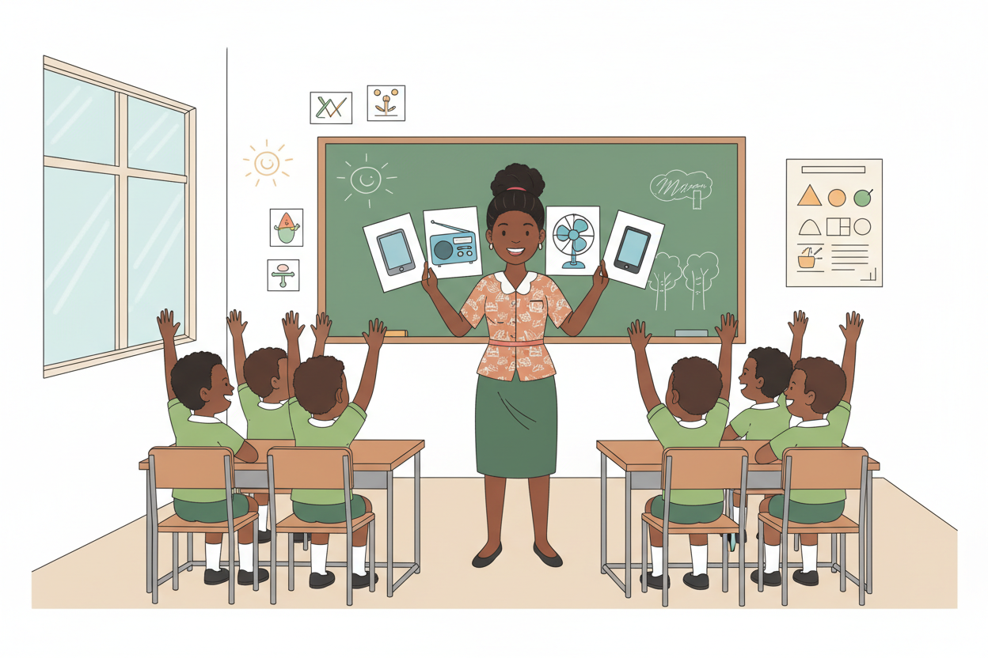
Picture 1. Name the device: the teacher holds up picture cards of a tablet, a radio, a fan and a phone, and the pupils call out each name.
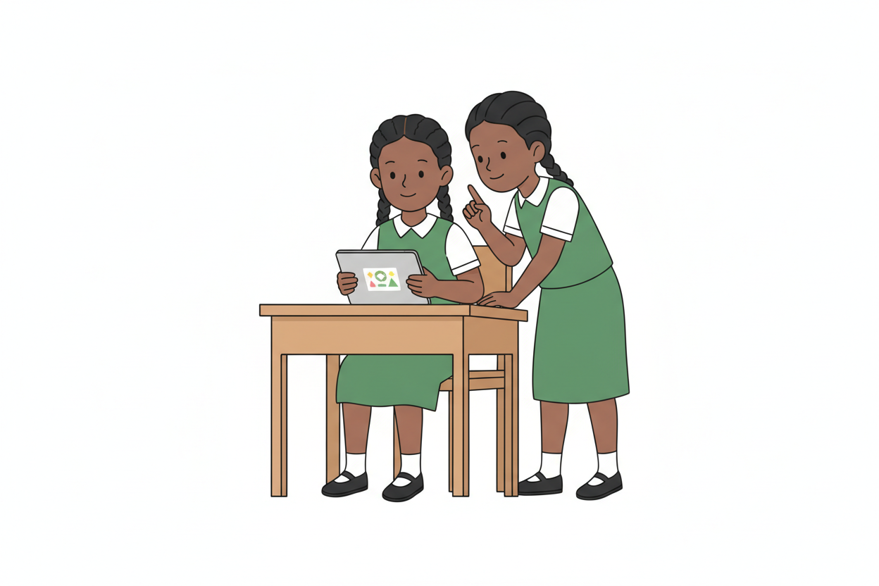
Picture 2. Safe use: clean hands, a gentle touch, and a friend who reminds you of the rules.
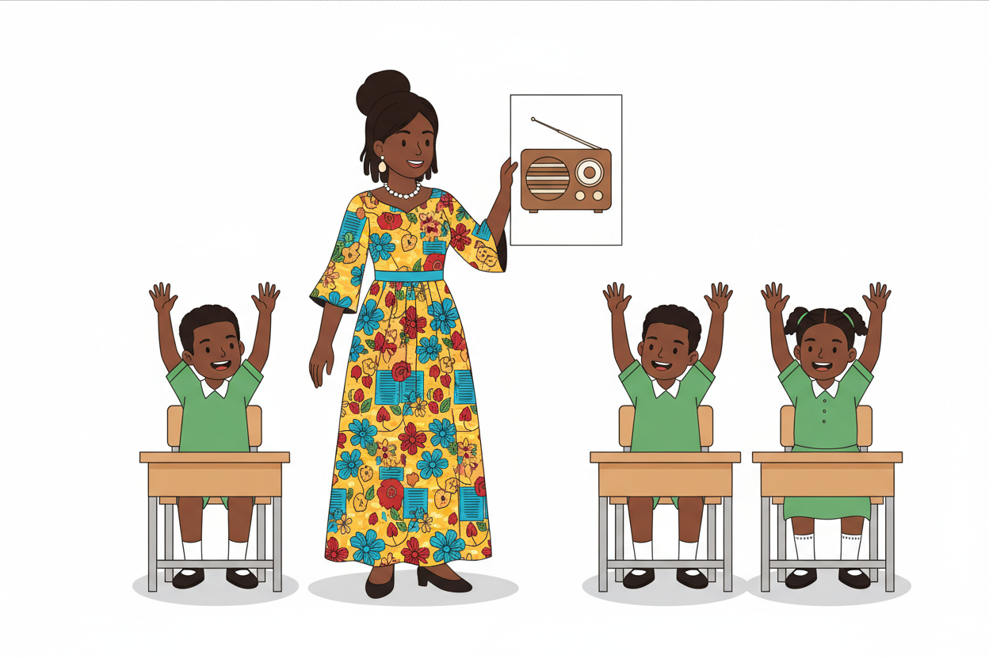
Picture 3. Picture quiz: which device is this? Raise your hand, say its name, and say one thing it does.
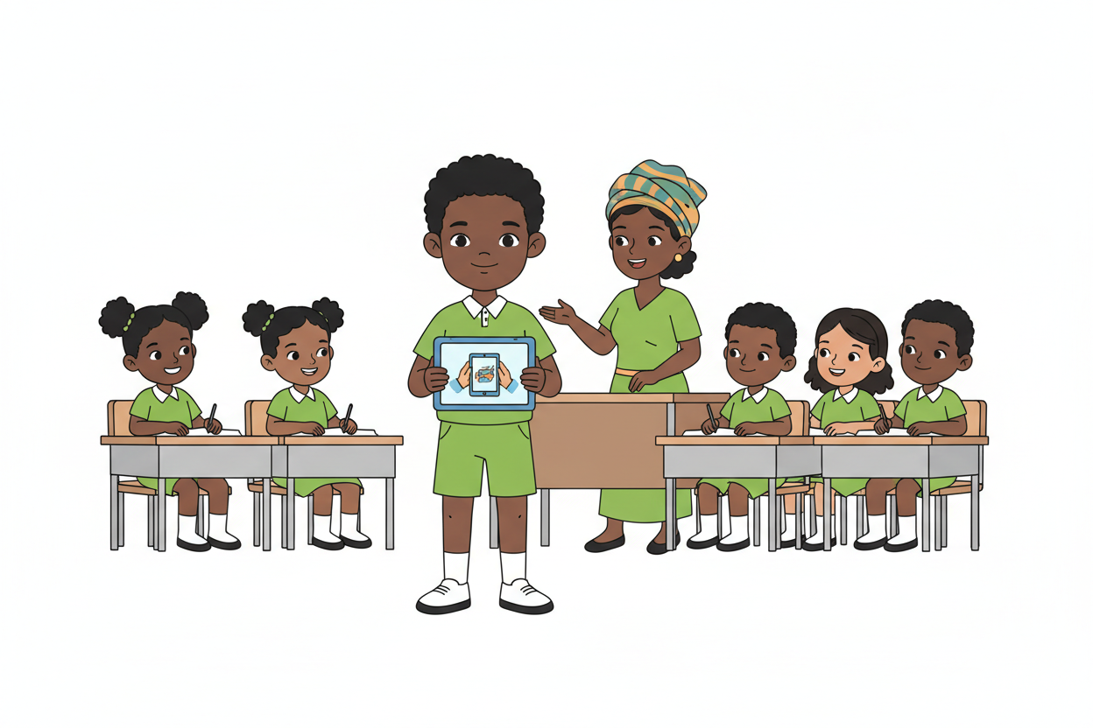
Picture 4. Show it: this pupil demonstrates one safety rule, carrying the tablet carefully with both hands.

7. Period Two: Practise and Apply
- Quick review: ask learners to recall the main idea from Period 1 using a question, object, picture or oral explanation.
- Application: learners complete a short sorting, matching, sequencing, drawing, role-play, discussion or practical task that directly reflects the weekly topic. Ask pairs/groups to share their reasoning.
- Consolidate: revisit the learning outcome, address common errors and have each learner show or say one thing learned. Keep the activity low-cost and offline-ready.

8. Assessment and Evidence
- Scheme evidence: Oral/written check, practical task or short exit ticket.
Ask learners to define or identify one key idea, complete one practical example, and explain their choice in a sentence or orally. Record observations for learners needing reteaching.

9. Suggested Questions and Answer Guidance
1. What is one important idea in “Review and Device Rules”? Expected response: an age-appropriate explanation or correct example drawn from the taught content.
2. Show or describe one example. Expected response: learner correctly identifies, demonstrates or applies the idea with no more prompting than appropriate for their level.
3. How can you use this safely or helpfully at home or school? Expected response: a relevant practical example that follows school and family safety rules.

10. Home Activity
Ask a family member to help the learner find or describe one everyday example related to “Review and Device Rules”. The learner may draw it or explain it orally in class. Do not require internet access, a personal device, photographs or paid materials.

11. Inclusion
Offer picture/object choices, peer support, oral responses, extra processing time and a simpler worked example; extend learners who are ready by asking them to create and explain a new example.

12. Safety and Privacy
Supervise all equipment; do not ask learners to share personal data or upload identifiable images; follow school rules for devices and online tools. Use paper-based alternatives by default when uncertain.

13. Teacher Reflection
(1) learners who met the outcome, (2) the misconception that appeared most often, and (3) one adjustment for the next lesson.
Reflection notes
__________________________________________________________________________________________

14. Curriculum Alignment and Document Status
Source note: The weekly topic, outcome, period allocations and assessment evidence in this note are drawn from the Rehoteq AI Education Curriculum Weekly Schemes of Work for Primary 1 to 6, Session 2026/2027. The lesson procedures are suggested teacher-support material, not verbatim official curriculum. This note does not replace checking the current official NERDC curriculum or the school's approved assessment requirements. Keep the 'proposed curriculum' label until formal approval and alignment are confirmed.

© 2026 Rehoteq Technologies, free for non-commercial educational use with attribution. rehoteq.com

