REHOTEQ
AI EDUCATION CURRICULUM
―――――――――――――――――――――――

Comprehensive Teacher's Lesson Note
Spreadsheets Basics
Junior Secondary 1 · Second Term · Week 2

Field | Detail
Subject | AI Education and Digital Skills
Academic session | 2026/2027
Duration | 2 periods (40 to 45 minutes each, subject to the school timetable)
Document type | Comprehensive Teacher's Lesson Note
Curriculum status | Proposed curriculum for school pilot, review and consultation
Prepared by | Rehoteq Technologies (rehoteq.com)
Edition | First edition, November 2026

PROPOSED CURRICULUM NOTICE: This lesson note expands the Rehoteq AI Education Curriculum's proposed Junior Secondary 1, Second Term, Week 2 scheme of work. It is offered for school pilot, review and consultation. It is not represented as an officially approved national syllabus, and it does not replace the current NERDC curriculum or any examination-board requirement.

1. Lesson Information
Field | Detail
Class | JSS 1
Subject | AI Education and Digital Skills
Term | Second Term
Week | Week 2 of Second Term
Topic | Spreadsheets: cells, rows, simple formulas; entering survey data and totalling it
Duration | 2 periods (40 to 45 minutes each)

2. Learning Outcome
By the end of the lesson, learners can:
- Name the parts of a spreadsheet: cell, row, column, and the active cell.
- Enter labels and numbers into the correct cells.
- Write a simple SUM formula to total a column of numbers.
- Enter the class survey data from first term into a grid and total it.

3. Weekly Scheme Content
Period | Scheme content
Period 1 | Cells, rows and simple formulas
Period 2 | Enter survey data and total it
Weeks 11 to 13 of the term are reserved for examinations, marking and results. Do not introduce new content during those weeks.

4. Materials and Preparation
- One computer per small group where available, with any spreadsheet program (LibreOffice Calc is free; a phone spreadsheet app also works).
- A printed or drawn empty grid on chart paper, one per group, for the unplugged version.
- The class survey tally table from first term, Week 9, copied onto the board.
- Practice data on a card: five favourite fruits and how many pupils chose each.
No-lab fallback: use the drawn grid. Learners write values into cells by hand and add each column with pencil arithmetic; the teacher shows that the SUM formula would do the same adding on a real computer.

5. Period One: Introduce and Model
- Starter (5 minutes): show the class a market woman's price list copied on the board in a grid and ask why a table is easier than a long list of sentences.
- Teach (10 minutes): define the grid: columns run down (named by position), rows run across, and a cell is one box where a row meets a column. The active cell is the one selected now. Draw a 4 by 4 grid on the board and have pupils point and name cells.
- Model (10 minutes): enter the fruit data live (or on the board grid): labels in the first column, numbers in the second. Then show the total: write the numbers in the column and add them; on a computer, show that typing a SUM command in the cell below the numbers makes the machine add them automatically, and that changing one number updates the total.
- Guided practice (15 minutes): pairs enter the practice card data on paper grids; groups with computers enter it in the spreadsheet and use the SUM formula, then change one number and watch the total move.

6. Lesson Pictures
Show these pictures while teaching. Use each one to point back at the week it comes from before the class moves on.

Picture 1. A spreadsheet is a grid of cells: this one box, highlighted, is the active cell.

Picture 2. On a computer, the same grid lives on the screen, and one team shares one machine.

Picture 3. Enter the numbers down a column, then add the column: that is a total.
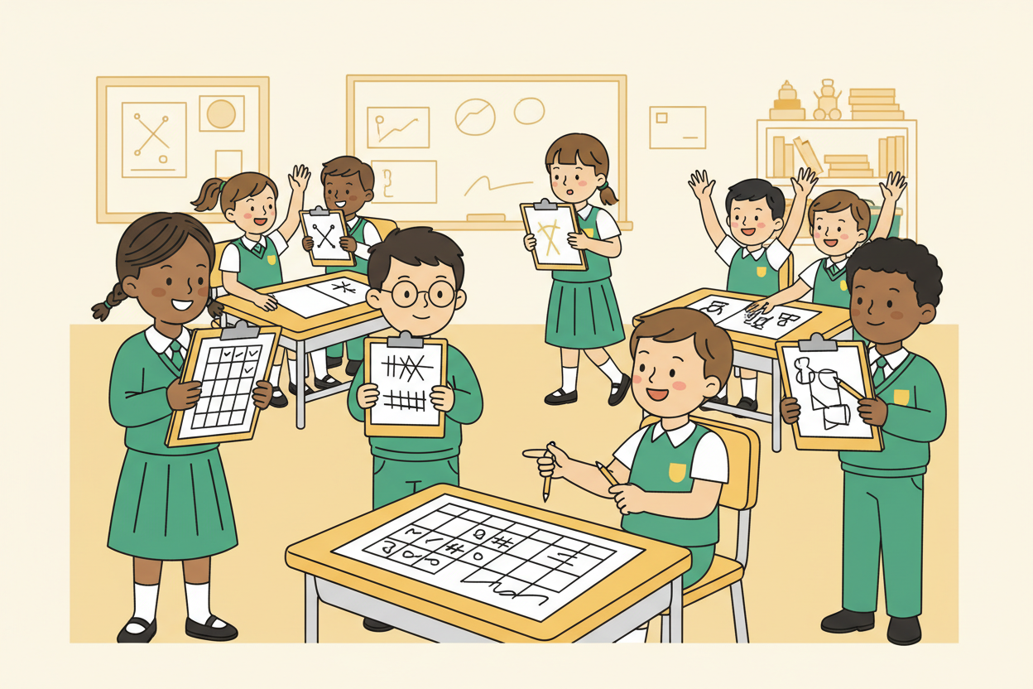
Picture 4. The survey data from first term goes straight into the grid, ready to total.

7. Period Two: Practise and Apply
- Survey entry (15 minutes): each group copies the first-term survey tally into their grid: one row per option, the tally count as the number, then totals the column with SUM (or by hand on paper).
- Check and discuss (10 minutes): groups compare totals; the class checks the grand total against the number of pupils surveyed in first term and explains any gap.
- Challenge (10 minutes): add a new row for a new option a classmate suggests, enter its count, and watch the total change.
- Close (5 minutes): quick oral check: point at a cell and ask pupils to name what it holds.

8. Assessment and Evidence
- Evidence to collect: one completed grid per group (paper or computer), with the total row filled and correct.
Success looks like: every group's grid has labels and numbers in the right cells, the column total is correct, and the group can point to any cell and say what it holds.

9. Suggested Questions and Answer Guidance
1. What is the difference between a row and a column? Expected response: a row runs across the sheet; a column runs down it.
2. Why is a spreadsheet better than a written list for the survey? Expected response: the machine adds and updates totals automatically, and everything stays in neat cells.
3. What happens to a SUM total if one number below it changes? Expected response: the total updates immediately.
4. Name one real Nigerian job where a spreadsheet is useful, and what it would hold. Expected response: any sensible example, such as a shopkeeper's sales or a school's fees record.

10. Home Activity
Learners draw a 5-row grid at home and fill it with the ages (in years) of five family members or neighbours, writing the total row; they bring the grid next week for charting.

11. Inclusion
Grid work needs no reading speed: learners point and write. Weak writers dictate entries to a partner. The unplugged grid is the default so every learner completes the same task; computer groups simply do it faster.

12. Safety and Privacy
Survey data stays anonymous: only counts, never names, go into the grid. No pupil's personal information (age beyond their own family task at home, phone numbers) is entered into any device.

13. Teacher Reflection
After the lesson, note what worked, which parts confused the class, which pupils need follow-up, and one change for next term.
Reflection notes
__________________________________________________________________________________________

14. Curriculum Alignment and Document Status
This note expands the Rehoteq AI Education Curriculum, a proposed curriculum for school pilot, review and consultation; not an officially approved national syllabus. It does not replace the current NERDC curriculum or examination-board requirements, and schools remain responsible for checking current NERDC requirements and their own calendar before implementation.

Prepared by Rehoteq Technologies (rehoteq.com). First edition, November 2026.

