REHOTEQ
AI EDUCATION CURRICULUM
―――――――――――――――――――――――

Comprehensive Teacher's Lesson Note
Digital citizenship
Junior Secondary 1 · Third Term · Week 8

Field | Detail
Subject | AI Education and Digital Skills
Academic session | 2026/2027
Duration | 2 periods (40 to 45 minutes each, subject to the school timetable)
Document type | Comprehensive Teacher's Lesson Note
Curriculum status | Proposed curriculum for school pilot, review and consultation
Prepared by | Rehoteq Technologies (rehoteq.com)
Edition | First edition, November 2026

PROPOSED CURRICULUM NOTICE: This lesson note expands the Rehoteq AI Education Curriculum's proposed Junior Secondary 1, Third Term, Week 8 scheme of work. It is offered for school pilot, review and consultation. It is not represented as an officially approved national syllabus, and it does not replace the current NERDC curriculum or any examination-board requirement.

1. Lesson Information
Field | Detail
Class | JSS 1
Subject | AI Education and Digital Skills
Term | Third Term
Week | Week 8 of Third Term
Topic | Being a good digital citizen: kindness online, privacy, screen balance and asking a grown-up
Duration | 2 periods (40 to 45 minutes each)

2. Learning Outcome
By the end of the lesson, learners can:
- Explain digital citizenship: how we behave towards people when we use phones, computers and the internet.
- State the class online rules: be kind, keep private things private, balance screen time, ask a grown-up when unsure.
- Sort everyday online situations into kind or unkind, safe or unsafe.
- Make a class digital citizenship charter for next term.

3. Weekly Scheme Content
Period | Scheme content
Period 1 | What digital citizenship means
Period 2 | Situations, sorting and the class charter
Weeks 11 to 13 of the term are reserved for examinations, marking and results. Do not introduce new content during those weeks.

4. Materials and Preparation
- Situation cards with plain words and a small icon each: a kind message, an unkind comment, a stranger asking for a photo, a game that never ends.
- Two sorting trays or labelled boxes: KIND and NOT KIND, SAFE and NOT SAFE.
- Paper for the class charter; no device needed.
No-lab fallback: corner sorting. Learners read or hear a situation card and walk to the corner that matches the safe or kind choice, then explain their choice in one sentence.

5. Period One: Introduce and Model
- Starter (5 minutes): remind the class of last week's AI rules. Today we widen them: how we treat people on phones and computers too.
- Teach (10 minutes): digital citizenship means the same good manners online as in person: we speak kindly, we keep private things private, we balance screen time with play and rest, and we ask a grown-up when something feels strange.
- Read and sort (15 minutes): the teacher reads situation cards aloud; learners vote with thumbs and say why each is kind or unkind, safe or unsafe.
- Write (10 minutes): each learner writes one promise for the class charter in their own words.

6. Lesson Pictures
Show these pictures while teaching. Use each one to point back at the week it comes from before the class moves on.

Picture 1. Private stays private: what we share and what we keep.
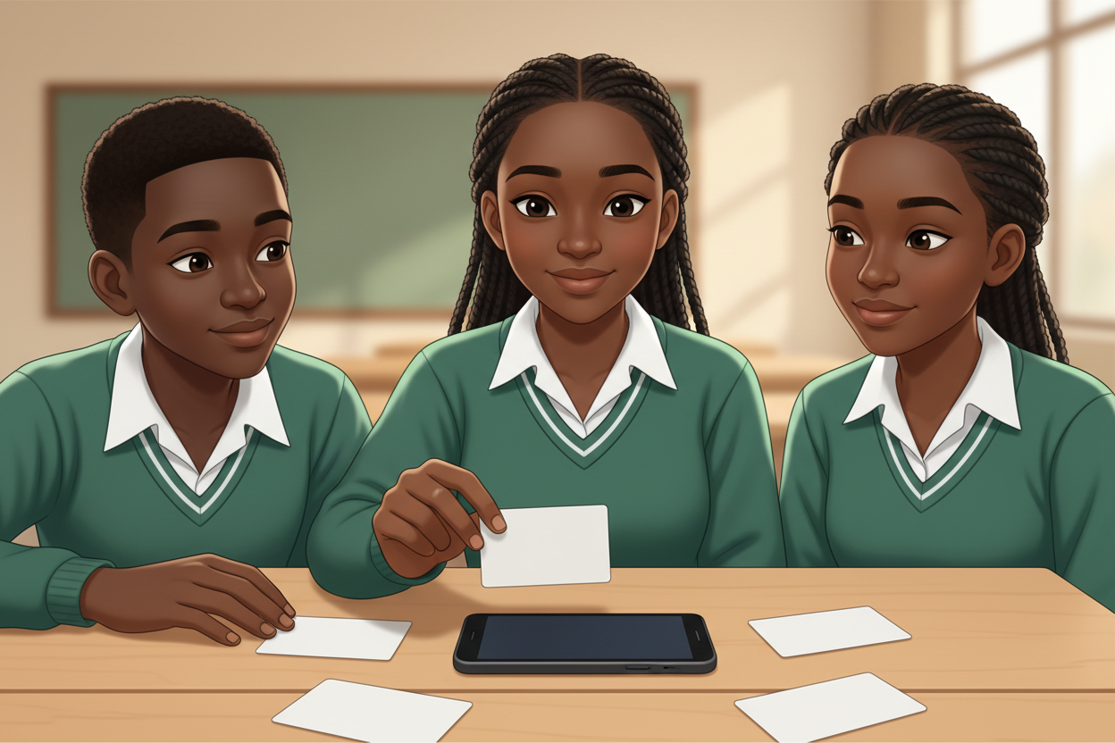
Picture 2. Keep personal details away from strangers and apps.

Picture 3. Kind words build people up, online and in person.

Picture 4. Unsure? Ask a grown-up you trust.

7. Period Two: Practise and Apply
- Corner sorting (25 minutes): eight situation cards; learners walk to the corner that matches the safe and kind choice and defend it in one sentence.
- Charter drafting (10 minutes): the class combines their promises into five charter lines; the teacher writes them large.
- Signing and display (5 minutes): every learner signs the charter; it goes on the wall beside the AI rules.

8. Assessment and Evidence
- Evidence to collect: each learner's charter promise and one corner-sorting explanation.
Success looks like: every learner explains at least one situation correctly with a reason, and the charter reflects the class's own words.

9. Suggested Questions and Answer Guidance
1. Why is an unkind comment worse online than you might think? Expected response: many people can see it and it stays.
2. What counts as private information? Expected response: full name, address, phone, photos of people, passwords.
3. What do you do when something online feels strange? Expected response: stop and tell a grown-up you trust.
4. Why balance screen time? Expected response: bodies and friendships need movement, rest and face-to-face time too.

10. Home Activity
Learners tell a grown-up at home one rule from the charter and write down the grown-up's own online rule; no device needed.

11. Inclusion
Situation cards may be read aloud, shown as icons or acted; sorting can be done by pointing, moving or voting with thumbs. No colour-only cues.

12. Safety and Privacy
Scenarios stay age-appropriate and non-frightening; no real personal data is used in examples; no child goes online during the lesson.

13. Teacher Reflection
After the lesson, note what worked, which parts confused the class, which pupils need follow-up, and one change for next term.
Reflection notes
__________________________________________________________________________________________

14. Curriculum Alignment and Document Status
This note expands the Rehoteq AI Education Curriculum, a proposed curriculum for school pilot, review and consultation; not an officially approved national syllabus. It does not replace the current NERDC curriculum or examination-board requirements, and schools remain responsible for checking current NERDC requirements and their own calendar before implementation.

Prepared by Rehoteq Technologies (rehoteq.com). First edition, November 2026.

