REHOTEQ
AI EDUCATION CURRICULUM
―――――――――――――――――――――――

Comprehensive Teacher's Lesson Note
Pseudocode
Junior Secondary 1 · Third Term · Week 6

Field | Detail
Subject | AI Education and Digital Skills
Academic session | 2026/2027
Duration | 2 periods (40 to 45 minutes each, subject to the school timetable)
Document type | Comprehensive Teacher's Lesson Note
Curriculum status | Proposed curriculum for school pilot, review and consultation
Prepared by | Rehoteq Technologies (rehoteq.com)
Edition | First edition, November 2026

PROPOSED CURRICULUM NOTICE: This lesson note expands the Rehoteq AI Education Curriculum's proposed Junior Secondary 1, Third Term, Week 6 scheme of work. It is offered for school pilot, review and consultation. It is not represented as an officially approved national syllabus, and it does not replace the current NERDC curriculum or any examination-board requirement.

1. Lesson Information
Field | Detail
Class | JSS 1
Subject | AI Education and Digital Skills
Term | Third Term
Week | Week 6 of Third Term
Topic | Pseudocode: steps in structured plain words; turning flowcharts into pseudocode
Duration | 2 periods (40 to 45 minutes each)

2. Learning Outcome
By the end of the lesson, learners can:
- Explain pseudocode as plain, structured words that describe a program without a specific programming language.
- Write short pseudocode with START, INPUT, IF...THEN...ELSE, REPEAT and STOP.
- Turn a flowchart from last week into pseudocode and back.
- Explain why pseudocode helps people plan before they code.

3. Weekly Scheme Content
Period | Scheme content
Period 1 | Steps in structured plain words
Period 2 | Turn two flowcharts into pseudocode
Weeks 11 to 13 of the term are reserved for examinations, marking and results. Do not introduce new content during those weeks.

4. Materials and Preparation
- Pseudocode word cards: START, STOP, INPUT, IF, THEN, ELSE, REPEAT, END REPEAT, one set per team.
- Last week's school-day flowcharts and the class's cooking algorithms.
- Lined paper and pencils; the word cards can also be drawn by hand.
No-lab fallback: word-card sentences. Teams arrange the word cards into pseudocode sentences on the desk and read them aloud; no computer needed.

5. Period One: Introduce and Model
- Starter (5 minutes): read last week's flowchart aloud as a story. Now tell the same story in short, numbered plain sentences: that is pseudocode.
- Teach (10 minutes): pseudocode uses a small fixed vocabulary: START begins, INPUT asks for a value, IF...THEN...ELSE decides, REPEAT...END REPEAT repeats, STOP ends. It is not a real language; it is a plan anyone can read.
- Model (10 minutes): write the school-day morning as pseudocode on the board: START, walk to school, IF the gate is open THEN enter ELSE wait, REPEAT lessons until break, END REPEAT, STOP.
- Word-card practice (15 minutes): teams build three pseudocode sentences with the cards and read them aloud; the class checks the vocabulary and order.

6. Lesson Pictures
Show these pictures while teaching. Use each one to point back at the week it comes from before the class moves on.

Picture 1. The flowchart becomes a story: short numbered plain sentences.
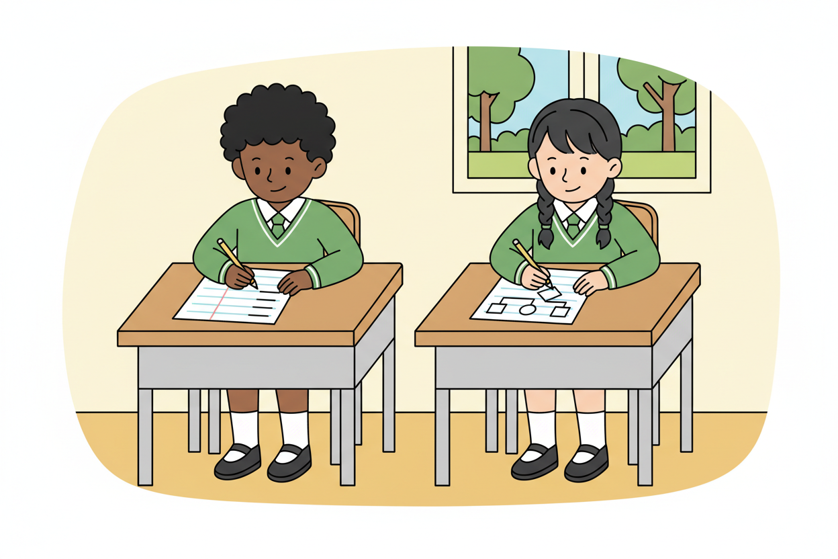
Picture 2. A small fixed vocabulary: begin, ask, decide, repeat, stop.
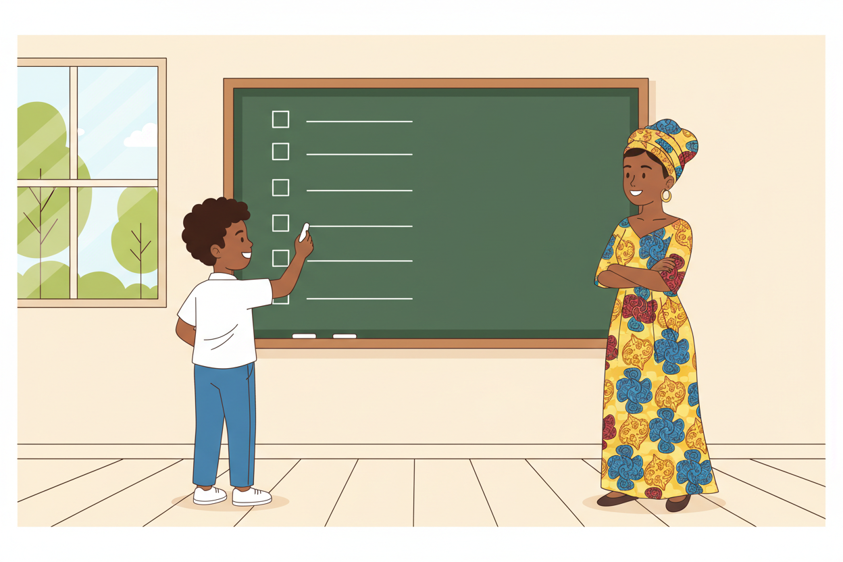
Picture 3. Pseudocode on the board: the school day in plain structured words.
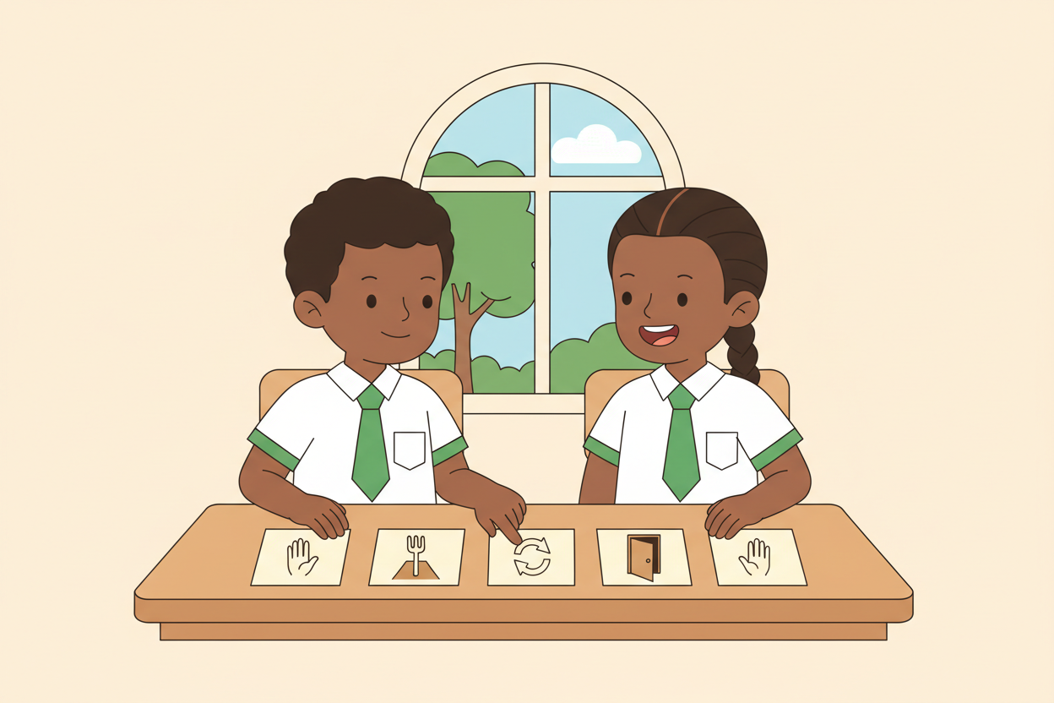
Picture 4. Word cards become sentences: build, read, check.

7. Period Two: Practise and Apply
- Turn two flowcharts into pseudocode (25 minutes): pairs take the school-day flowchart and one more (the cooking algorithm or their game), and write each as pseudocode with the fixed vocabulary.
- Swap and read (10 minutes): pairs exchange pseudocode and read it as a story, marking any step that is unclear; writers fix the marks.
- Close (5 minutes): the class agrees why planning in pseudocode beats starting to code straight away.

8. Assessment and Evidence
- Evidence to collect: each pair's two pseudocode listings and one swap note.
Success looks like: pseudocode uses the fixed vocabulary in the right order, matches the flowchart it came from, and reads cleanly as a story.

9. Suggested Questions and Answer Guidance
1. Is pseudocode a language a computer can run? Expected response: no; it is a plan for people, translated into a real language later.
2. What does REPEAT...END REPEAT match in a flowchart or program? Expected response: a loop.
3. Why write pseudocode before coding? Expected response: it catches mistakes in the plan while fixing them is still cheap.
4. Where did your IF...THEN...ELSE come from? Expected response: a diamond in the flowchart, named.

10. Home Activity
Learners write the pseudocode for one home routine in five lines using at least one IF and bring it; no device needed.

11. Inclusion
Word cards may be arranged, dictated or signed; the fixed vocabulary is spoken, written and gestured. Pseudocode may be read aloud by any team member. No colour-only cues.

12. Safety and Privacy
Pseudocode examples stay school-appropriate and kind; no personal details enter any listing.

13. Teacher Reflection
After the lesson, note what worked, which parts confused the class, which pupils need follow-up, and one change for next term.
Reflection notes
__________________________________________________________________________________________

14. Curriculum Alignment and Document Status
This note expands the Rehoteq AI Education Curriculum, a proposed curriculum for school pilot, review and consultation; not an officially approved national syllabus. It does not replace the current NERDC curriculum or examination-board requirements, and schools remain responsible for checking current NERDC requirements and their own calendar before implementation.

Prepared by Rehoteq Technologies (rehoteq.com). First edition, November 2026.

