REHOTEQ
AI EDUCATION CURRICULUM
―――――――――――――――――――――――

Comprehensive Teacher's Lesson Note
The Operating System
Junior Secondary 1 · First Term · Week 3

Field | Detail
Subject | AI Education and Digital Skills
Academic session | 2026/2027
Duration | 2 periods (40 to 45 minutes each, subject to the school timetable)
Document type | Comprehensive Teacher's Lesson Note
Curriculum status | Proposed curriculum for school pilot, review and consultation
Prepared by | Rehoteq Technologies (rehoteq.com)
Edition | First edition, November 2026

PROPOSED CURRICULUM NOTICE: This lesson note expands the Rehoteq AI Education Curriculum's proposed Junior Secondary 1, First Term, Week 3 scheme of work. It is offered for school pilot, review and consultation. It is not represented as an officially approved national syllabus, and it does not replace the current NERDC curriculum or any examination-board requirement.

1. Lesson Information
Field | Detail
Class | JSS 1
Subject | AI Education and Digital Skills
Term | First Term
Week | Week 3 of First Term
Topic | The Operating System
Duration | 2 periods (40 to 45 minutes each)

2. Learning Outcome
By the end of the lesson, learners can:
- Explain what an operating system is: the main program that starts the computer and manages everything on it, and name at least three examples: Windows, Linux, Android, macOS, Chrome OS.
- Describe four jobs of the operating system: starting the machine, managing memory, managing files, and connecting devices such as printers and speakers.
- Point to the parts of a desktop screen: wallpaper, icons, taskbar, and open a folder on a real machine or in a guided demonstration.
- Use the key words of the week correctly in a sentence: operating system, boot, desktop, icon, file, folder.

3. Weekly Scheme Content
Period | Scheme content
Period 1 | What an operating system is, examples, and its four main jobs
Period 2 | The desktop: icons, taskbar, files and folders; guided hands-on or demonstration
Weeks 11 to 13 of the term are reserved for examinations, marking and results. Do not introduce new content during those weeks.

4. Materials and Preparation
- One working computer with an operating system the teacher can start in front of the class; test the start-up before the lesson so the wait is not wasted.
- A printed or drawn desktop screenshot poster with blank callout lines for icons and taskbar.
- Paper file and folder cut-outs in three colours, plus a cardboard pocket folder for the sorting game.
- A phone with an operating system learners already know (Android), for the comparison moment.
No-lab fallback: the whole lesson runs from the poster and the paper cut-outs, with the teacher narrating the start-up while pointing at the screen poster. If one machine exists, use it as a demonstration only, two pupils at a time at the end.

5. Period One: Introduce and Model
- Starter (5 minutes): ask learners what happens between pressing the power button and seeing pictures on the screen. Collect guesses on the board.
- Teach (10 minutes): define the operating system as the manager program that wakes the computer, gives every part its job and lets other programs work. Name the examples learners meet daily, including the one inside their phones.
- Model (10 minutes): demonstrate a real start-up, narrating each stage: power, memory check, operating system loading, desktop appearing. Point out the four jobs as they happen.
- Guided practice (10 minutes): pupils label the desktop poster in turns: wallpaper, icons, taskbar. The class agrees or corrects each label.
- Check (5 minutes): oral drill with two quick questions: what loads first, and what appears last.

6. Lesson Pictures
Show these pictures while teaching. Talk about each one before moving on, and ask learners to point to the same thing on the poster or the real screen.

Picture 1. The desktop appears when the operating system has finished loading: pictures to click and a row of tools along the bottom.
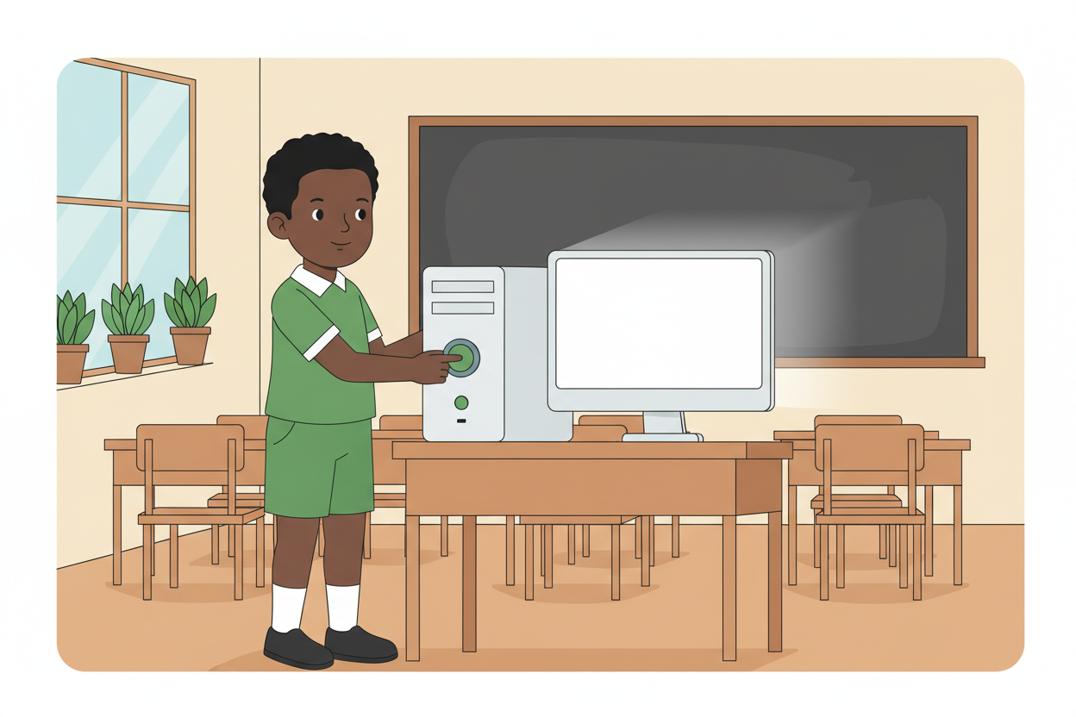
Picture 2. Booting: one press on the power button, and the operating system begins its work before anything shows on the screen.
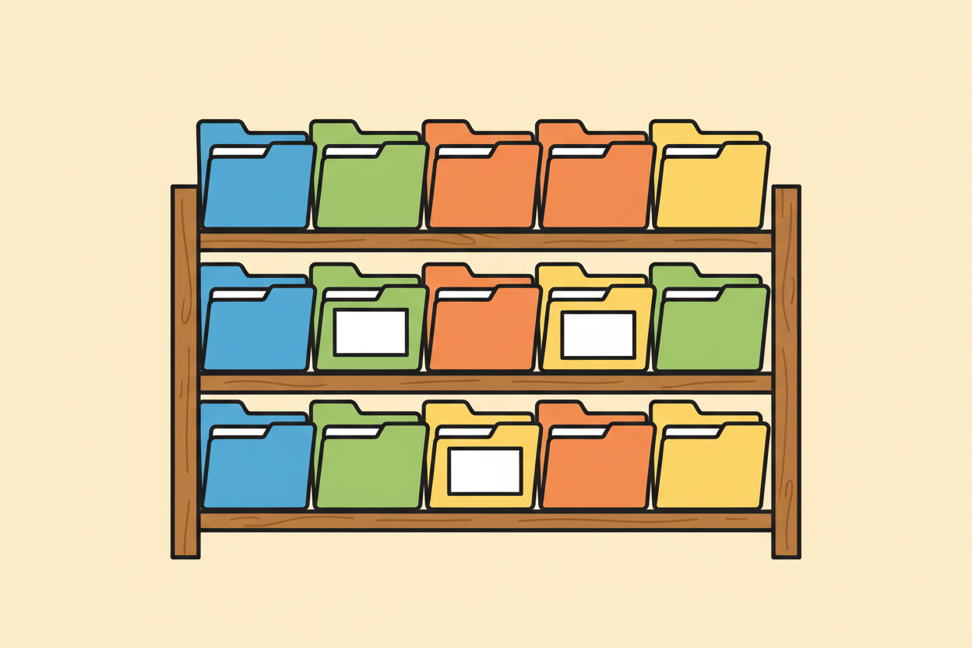
Picture 3. Files and folders: the operating system keeps our work in folders, the way a careful student keeps exercise books by subject.
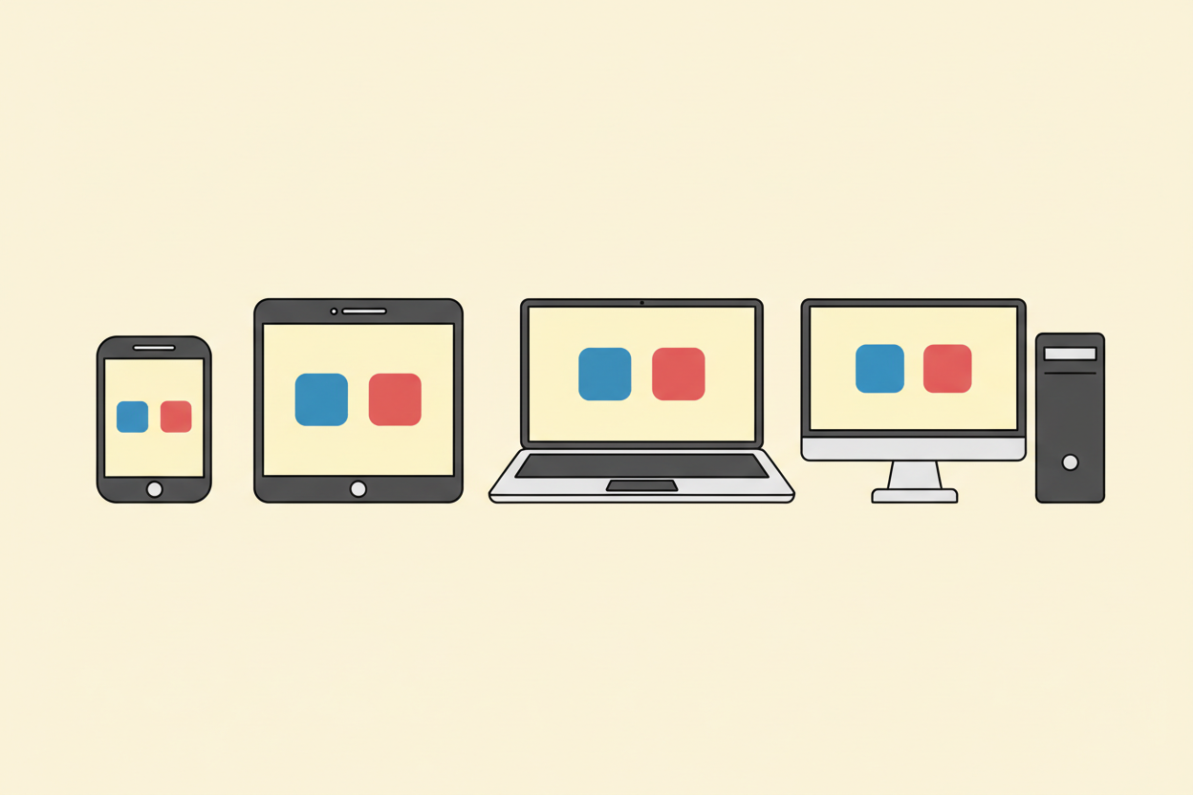
Picture 4. One idea, many machines: phones, tablets, laptops and desktops all carry an operating system inside.

7. Period Two: Practise and Apply
- Folder game (15 minutes): each group receives paper cut-outs representing school subjects and sorts them into coloured folder pockets, then explains why a folder keeps related files together.
- Demonstration round (10 minutes): two pupils at a time open a folder on the real machine or phone while the rest watch; every pupil gets a turn or the teacher rotates across two lessons.
- Recap and write (10 minutes): pupils write the four jobs of the operating system in their notes and draw a small desktop with three icons.

8. Assessment and Evidence
- Evidence to collect: each group's sorted folder pockets; each pupil's written four-job list and desktop sketch.
Success looks like: every pupil names at least three operating systems and at least three of the four jobs without prompting, and every group sorts all subject cut-outs into sensible folders.

9. Suggested Questions and Answer Guidance
1. What is an operating system? Expected response: the main program that starts the computer and manages its memory, files and devices so other programs can work.
2. Mention three examples of operating systems. Expected response: any three of Windows, Linux, macOS, Android, Chrome OS; accept iOS.
3. What is the difference between a file and a folder? Expected response: a file holds one piece of work, and a folder holds many files together.
4. Why does a phone also have an operating system? Expected response: because the phone is a small computer that also needs a manager to start it and run its apps.

10. Home Activity
Learners ask an adult at home which operating system the family phone or computer uses, and note its name. They also list two things the device does the moment it is switched on, such as showing the time or asking for a password.

11. Inclusion
Learners who read slowly work with picture cards instead of written labels, and the folder game uses colours and shapes so reading is never the gate. During the demonstration round, a confident peer stands beside each turn so no learner faces the machine alone.

12. Safety and Privacy
Only the teacher plugs in or powers equipment, and cables stay tidy where pupils walk. The demonstration account carries no personal files, and pupils never type or share passwords during class. Nothing from the lesson goes online.

13. Teacher Reflection
After the lesson, note what worked, which parts confused the class, which pupils need follow-up, and one change for next time.
Reflection notes
__________________________________________________________________________________________

14. Curriculum Alignment and Document Status
This note expands the Rehoteq AI Education Curriculum, a proposed curriculum for school pilot, review and consultation; not an officially approved national syllabus. It does not replace the current NERDC curriculum or examination-board requirements, and schools remain responsible for checking current NERDC requirements and their own calendar before implementation.

Prepared by Rehoteq Technologies (rehoteq.com). First edition, November 2026.

