REHOTEQ
AI EDUCATION CURRICULUM
―――――――――――――――――――――――

Comprehensive Teacher's Lesson Note
Word Processing
Junior Secondary 1 · First Term · Week 4

Field | Detail
Subject | AI Education and Digital Skills
Academic session | 2026/2027
Duration | 2 periods (40 to 45 minutes each, subject to the school timetable)
Document type | Comprehensive Teacher's Lesson Note
Curriculum status | Proposed curriculum for school pilot, review and consultation
Prepared by | Rehoteq Technologies (rehoteq.com)
Edition | First edition, November 2026

PROPOSED CURRICULUM NOTICE: This lesson note expands the Rehoteq AI Education Curriculum's proposed Junior Secondary 1, First Term, Week 4 scheme of work. It is offered for school pilot, review and consultation. It is not represented as an officially approved national syllabus, and it does not replace the current NERDC curriculum or any examination-board requirement.

1. Lesson Information
Field | Detail
Class | JSS 1
Subject | AI Education and Digital Skills
Term | First Term
Week | Week 4 of First Term
Topic | Word Processing
Duration | 2 periods (40 to 45 minutes each)

2. Learning Outcome
By the end of the lesson, learners can:
- Name word processing as writing, changing and arranging text on a computer, and name at least two word processing programs.
- Create, type, format and save a short document: change text size, make text bold or italic, centre a heading, and save the file in a folder.
- Produce a neat one-page composition with a centred title and three short paragraphs, then check it for mistakes before printing or showing it.
- Use the key words of the week correctly in a sentence: word processor, document, format, save, file.

3. Weekly Scheme Content
Period | Scheme content
Period 1 | Create, format and save a document
Period 2 | Produce a one-page composition
Weeks 11 to 13 of the term are reserved for examinations, marking and results. Do not introduce new content during those weeks.

4. Materials and Preparation
- Computers with a word processor, one per pair where possible; otherwise one demonstration machine.
- A printed sample composition on paper, one per group, to serve as the model the class copies.
- A typed mistakes sheet: the same short paragraph printed with three deliberate errors for the class to find.
- A wall chart of the word processor window, with the toolbar, the typing area and the save button marked.
No-lab fallback: run the lesson as a paper simulation. Learners write and rearrange sentence strips on paper, the teacher demonstrates formatting by cutting and pasting the strips, and the save step is acted out with a folder. The real-machine round happens whenever a machine is available.

5. Period One: Introduce and Model
- Starter (5 minutes): show the printed sample composition and ask how the writer could change the title without rewriting the whole page. Lead the class to the idea of editing on a computer.
- Teach (10 minutes): define a word processor and name the common programs. Walk through the window on the chart: toolbar at the top, typing area in the middle, save button to keep the work.
- Model (10 minutes): on the demonstration machine or by narration, type a heading, centre it, make it bold, type two lines of body text, change the text size, and save the file into the class folder. Say each step aloud as you do it.
- Guided practice (10 minutes): in pairs, learners find the three deliberate errors on the mistakes sheet: a missing capital, a repeated word and a wrong spelling. Each pair circles them and suggests the fix.
- Check (5 minutes): oral drill: name the three steps in order: type, format, save.

6. Lesson Pictures
Show these pictures while teaching. Talk about each one before moving on, and ask learners to point to the same thing on the chart or the real machine.

Picture 1. A word processing document on screen: the heading lines at the top, the body lines below, and the toolbar above them.
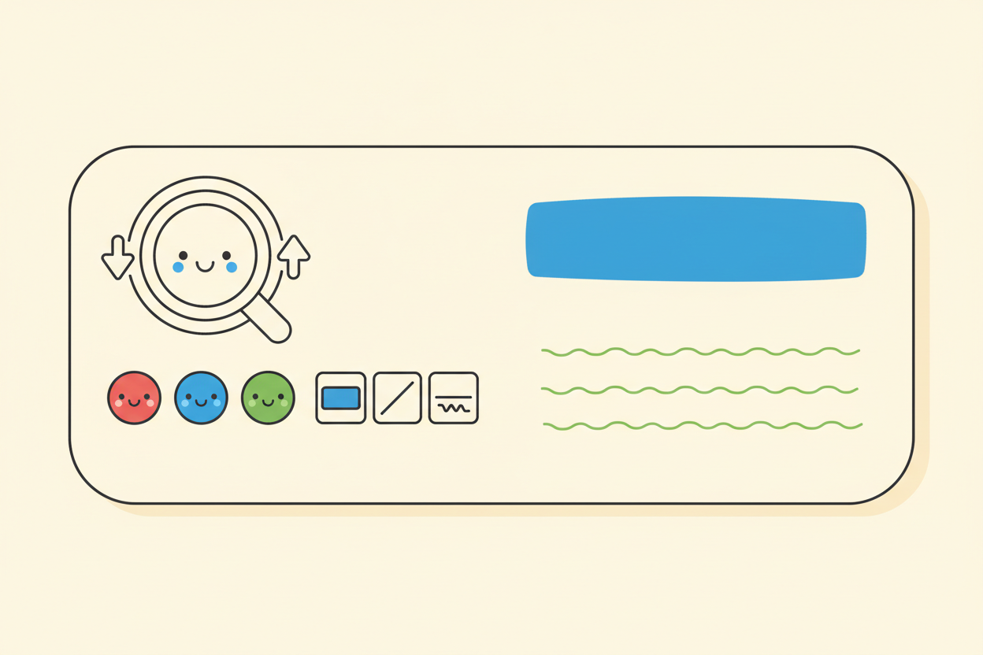
Picture 2. Formatting tools: change the size, the colour and the style of text so the heading stands out.

Picture 3. Save your work: one click keeps the document safe in its folder so it can be opened again later.
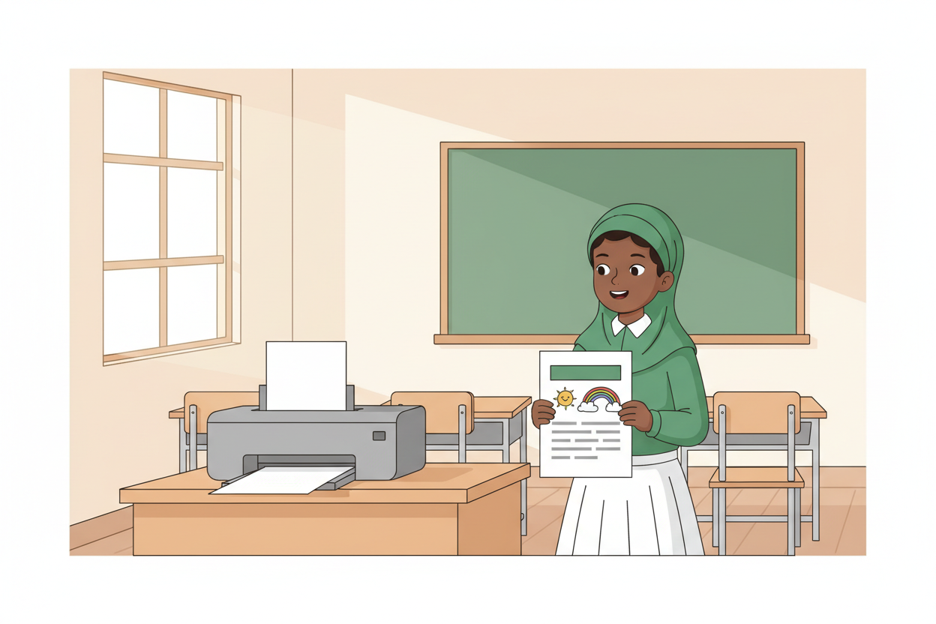
Picture 4. The finished page: a neat one-page composition with a centred title, printed and read.

7. Period Two: Practise and Apply
- Writing round (20 minutes): each pair types or writes a one-page composition titled with a topic the class chooses, such as My School or Market Day. Heading centred and bold, three short paragraphs. Pairs without a machine write neatly on paper and format with pencil rules: underline the title and frame it.
- Peer check (10 minutes): pairs swap work and hunt for the three error types practised in Period 1, then return the page for correction.
- Save and show (5 minutes): finished documents are saved into the class folder, or paper pages are filed in the class work box. Two pairs read their compositions aloud.

8. Assessment and Evidence
- Evidence to collect: each pair's saved document or filed paper page, and the corrected mistakes sheet.
Success looks like: every document has a centred bold title, at least three short paragraphs, and a saved copy in the class folder; every mistakes sheet shows the three errors found and corrected.

9. Suggested Questions and Answer Guidance
1. What is word processing? Expected response: writing, changing and arranging text on a computer using a word processor.
2. Name the steps for keeping a document so you can open it tomorrow. Expected response: save the document into a folder, and give the file a clear name.
3. How do you make a heading stand out? Expected response: make it larger, bold, and centre it; a colour change is also acceptable.
4. Why check your work before printing? Expected response: printing repeats every mistake on paper, and checking catches errors such as spelling and missing capitals first.

10. Home Activity
Learners find one short notice or letter at home or in the market, read it, and note two things the writer did to make it easy to read, such as a clear title or short paragraphs.

11. Inclusion
Learners who type slowly may write one paragraph while a partner types the rest, and the pair reads aloud together. Learners with low vision sit nearest the demonstration screen and receive the sample composition in large print.

12. Safety and Privacy
Keyboards and mice are handled with clean, dry hands; no food or drink near the machines. Learners type only their own compositions and never open or change another pupil's saved file. The class folder is shared work space: respect every file in it.

13. Teacher Reflection
After the lesson, note what worked, which parts confused the class, which pupils need follow-up, and one change for next time.
Reflection notes
__________________________________________________________________________________________

14. Curriculum Alignment and Document Status
This note expands the Rehoteq AI Education Curriculum, a proposed curriculum for school pilot, review and consultation; not an officially approved national syllabus. It does not replace the current NERDC curriculum or examination-board requirements, and schools remain responsible for checking current NERDC requirements and their own calendar before implementation.

Prepared by Rehoteq Technologies (rehoteq.com). First edition, November 2026.

