REHOTEQ
AI EDUCATION CURRICULUM
―――――――――――――――――――――――

Comprehensive Teacher's Lesson Note
Conditions (If and Then)
Junior Secondary 1 · Second Term · Week 8

Field | Detail
Subject | AI Education and Digital Skills
Academic session | 2026/2027
Duration | 2 periods (40 to 45 minutes each, subject to the school timetable)
Document type | Comprehensive Teacher's Lesson Note
Curriculum status | Proposed curriculum for school pilot, review and consultation
Prepared by | Rehoteq Technologies (rehoteq.com)
Edition | First edition, November 2026

PROPOSED CURRICULUM NOTICE: This lesson note expands the Rehoteq AI Education Curriculum's proposed Junior Secondary 1, Second Term, Week 8 scheme of work. It is offered for school pilot, review and consultation. It is not represented as an officially approved national syllabus, and it does not replace the current NERDC curriculum or any examination-board requirement.

1. Lesson Information
Field | Detail
Class | JSS 1
Subject | AI Education and Digital Skills
Term | Second Term
Week | Week 8 of Second Term
Topic | Conditions: decisions in programs; the gate-keeper challenge
Duration | 2 periods (40 to 45 minutes each)

2. Learning Outcome
By the end of the lesson, learners can:
- Explain a condition as a question a program asks before it acts.
- Build a program with one if-then decision.
- Predict what a simple condition will do for a given input.
- Add the otherwise branch (else) to a condition.

3. Weekly Scheme Content
Period | Scheme content
Period 1 | Decisions: if and then
Period 2 | Gate-keeper challenge
Weeks 11 to 13 of the term are reserved for examinations, marking and results. Do not introduce new content during those weeks.

4. Materials and Preparation
- Computers with Scratch where available, one per pair; a class door or a taped line on the floor as the gate.
- Paper decision cards: a question card (with a fork drawn on it) plus two action cards (yes path and no path), one set per team.
- The class's Week 7 score variables.
No-lab fallback: the human gate. One learner plays the gate-keeper with a question card; classmates walk up and take the yes or no path. Teams then write their own question and two action cards and swap with another team to test.

5. Period One: Introduce and Model
- Starter (5 minutes): every morning we decide: if it is raining, take the umbrella, otherwise do not. Programs make the same kind of decision.
- Teach (10 minutes): a condition is a yes-or-no question the program checks. If the answer is yes, the program runs the steps inside; otherwise it runs the other steps (or skips them).
- Model (10 minutes): build a simple check: if the sprite touches the edge, it turns around; otherwise it moves forward. Run it and watch the decision happen each step.
- Spot decisions (15 minutes): teams find three decisions in familiar apps (a phone asks if the answer is correct before showing a green tick; a bank checks if the balance covers the withdrawal).

6. Lesson Pictures
Show these pictures while teaching. Use each one to point back at the week it comes from before the class moves on.
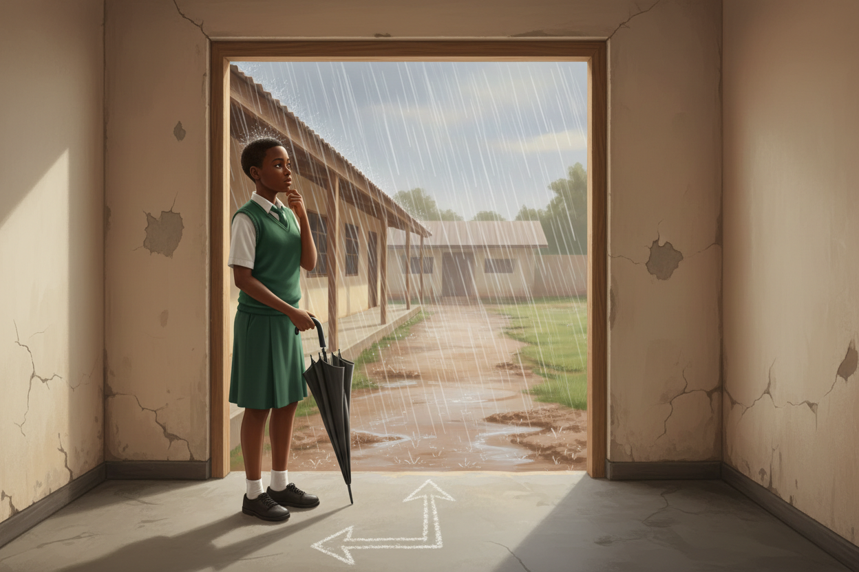
Picture 1. Every morning we decide: if rain, take an umbrella; otherwise, walk on.

Picture 2. A condition is a question with two paths: yes and no.

Picture 3. The sprite checks the edge every step: touch, turn; clear, move.

Picture 4. The gate-keeper challenge: answer the question and take your path.

7. Period Two: Practise and Apply
- Gate-keeper challenge (25 minutes): pairs build a gate: the sprite moves toward a door; if a condition is true (a key is pressed, the sprite touches a colour, the score reaches five) the door opens, otherwise it stays shut. Pairs choose their own condition.
- Add the otherwise (10 minutes): each pair adds the else branch and predicts both outcomes before running.
- Close (5 minutes): each pair reads out its condition as a sentence: if, then, otherwise.

8. Assessment and Evidence
- Evidence to collect: each pair's gate program (or decision-card set) and one prediction note covering both outcomes.
Success looks like: conditions are written as clear if-then-otherwise sentences, predictions cover both branches, and programs run without the class needing to fix the logic first.

9. Suggested Questions and Answer Guidance
1. What question does your condition ask, and what happens on each answer? Expected response: a clear yes-no question with a different action on each branch.
2. What happens if the otherwise branch is empty? Expected response: the program does nothing extra when the answer is no; the step is simply skipped.
3. Where does a bank app use a condition? Expected response: checking whether the balance is enough before paying out.
4. Can a condition check something that changes while the program runs? Expected response: yes; the check is made fresh each time the program reaches it.

10. Home Activity
Learners write one if-then sentence about home (if the bucket is full, stop pouring) and one about school, in their books; no device needed.

11. Inclusion
The human gate is a full-body version of the concept and works for every learner; the gate-keeper role rotates so several learners take the decision role. Question cards may be answered with pointing or gesture for learners who prefer it. Card teams use the same rubric.

12. Safety and Privacy
No condition may single out a learner (no 'if it is Amaka, then' rules). Programs avoid startling sounds and flashing; saved projects carry no personal details.

13. Teacher Reflection
After the lesson, note what worked, which parts confused the class, which pupils need follow-up, and one change for next term.
Reflection notes
__________________________________________________________________________________________

14. Curriculum Alignment and Document Status
This note expands the Rehoteq AI Education Curriculum, a proposed curriculum for school pilot, review and consultation; not an officially approved national syllabus. It does not replace the current NERDC curriculum or examination-board requirements, and schools remain responsible for checking current NERDC requirements and their own calendar before implementation.

Prepared by Rehoteq Technologies (rehoteq.com). First edition, November 2026.

