REHOTEQ
AI EDUCATION CURRICULUM
―――――――――――――――――――――――

Comprehensive Teacher's Lesson Note
Flowcharts
Junior Secondary 1 · Third Term · Week 5

Field | Detail
Subject | AI Education and Digital Skills
Academic session | 2026/2027
Duration | 2 periods (40 to 45 minutes each, subject to the school timetable)
Document type | Comprehensive Teacher's Lesson Note
Curriculum status | Proposed curriculum for school pilot, review and consultation
Prepared by | Rehoteq Technologies (rehoteq.com)
Edition | First edition, November 2026

PROPOSED CURRICULUM NOTICE: This lesson note expands the Rehoteq AI Education Curriculum's proposed Junior Secondary 1, Third Term, Week 5 scheme of work. It is offered for school pilot, review and consultation. It is not represented as an officially approved national syllabus, and it does not replace the current NERDC curriculum or any examination-board requirement.

1. Lesson Information
Field | Detail
Class | JSS 1
Subject | AI Education and Digital Skills
Term | Third Term
Week | Week 5 of Third Term
Topic | Flowcharts: drawing steps as connected shapes before writing any code
Duration | 2 periods (40 to 45 minutes each)

2. Learning Outcome
By the end of the lesson, learners can:
- Name the four basic flowchart symbols: oval (start/stop), rectangle (a step), diamond (a decision) and arrows (the order).
- Read a simple flowchart aloud as a list of steps.
- Draw a flowchart for a familiar school or home task.
- Explain why programmers draw flowcharts before they code.

3. Weekly Scheme Content
Period | Scheme content
Period 1 | Flowchart symbols and reading them
Period 2 | Draw flowcharts for familiar tasks
Weeks 11 to 13 of the term are reserved for examinations, marking and results. Do not introduce new content during those weeks.

4. Materials and Preparation
- Large blank shape cards: ovals, rectangles, diamonds and paper arrows, one set per team.
- Chalkboard and rulers; plain paper for drawing.
- Last week's algorithm lists (the school-day and cooking algorithms).
No-lab fallback: shape cards on the floor or desks. Teams lay out a flowchart as a picture path with the cards and walk a classmate through it; no computer needed.

5. Period One: Introduce and Model
- Starter (5 minutes): recall last week's algorithm list for the school morning. Now the class draws the same steps as boxes and arrows: that picture is a flowchart.
- Teach (10 minutes): the four symbols. An oval starts or stops, a rectangle is a step, a diamond asks a yes/no question, arrows show which way to go next. Draw each on the board large, blank shapes only.
- Reading practice (15 minutes): the teacher draws a short flowchart for crossing the road; teams read it aloud as steps, following the arrows in order.
- Symbol card game (10 minutes): teams receive mixed shape cards and build one flowchart on the desk for the cooking algorithm from Week 3.

6. Lesson Pictures
Show these pictures while teaching. Use each one to point back at the week it comes from before the class moves on.

Picture 1. The four symbols: oval to start or stop, rectangle for a step, diamond for a decision, arrows for the order.

Picture 2. Reading a flowchart: follow the arrows and say the steps aloud.
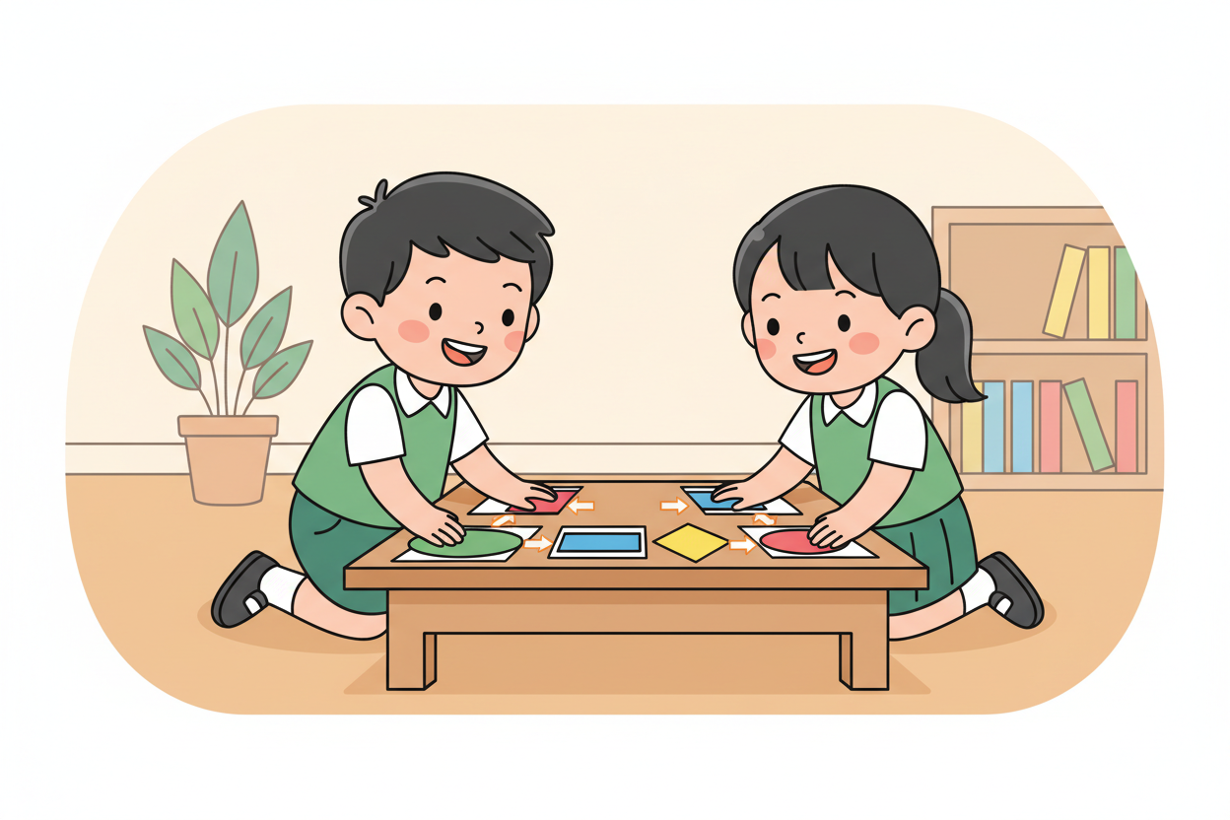
Picture 3. Building with shape cards: the cooking algorithm as a picture path.

Picture 4. Drawing your own: ruler, shapes, arrows, in order.

7. Period Two: Practise and Apply
- Draw two flowcharts (25 minutes): pairs draw one for a school task and one for a home task, using all four symbols at least once and labelled with plain words.
- Walk the chart (10 minutes): pairs exchange flowcharts and read each other's aloud as steps; readers mark anything unclear and writers fix it.
- Close (5 minutes): the class agrees that a flowchart is a plan you can check before you code.

8. Assessment and Evidence
- Evidence to collect: each pair's two flowcharts and one swap note.
Success looks like: correct symbols in the right order, at least one diamond with a yes/no branch, and a chart another pair can read aloud without stopping.

9. Suggested Questions and Answer Guidance
1. Which symbol asks a question? Expected response: the diamond.
2. What do the arrows do? Expected response: show the order, which step follows which.
3. Where does a flowchart begin and end? Expected response: at ovals, start and stop.
4. Why draw before coding? Expected response: mistakes in the plan are cheaper to fix on paper than in a program.

10. Home Activity
Learners draw the flowchart for one home routine on paper and bring it; no device needed.

11. Inclusion
Shape cards may be placed, dictated or signed; flowcharts may be drawn, described or assembled from cards. No colour-only cues.

12. Safety and Privacy
Scissors are used only with adult supervision when cutting shape cards; examples stay school-appropriate.

13. Teacher Reflection
After the lesson, note what worked, which parts confused the class, which pupils need follow-up, and one change for next term.
Reflection notes
__________________________________________________________________________________________

14. Curriculum Alignment and Document Status
This note expands the Rehoteq AI Education Curriculum, a proposed curriculum for school pilot, review and consultation; not an officially approved national syllabus. It does not replace the current NERDC curriculum or examination-board requirements, and schools remain responsible for checking current NERDC requirements and their own calendar before implementation.

Prepared by Rehoteq Technologies (rehoteq.com). First edition, November 2026.

