REHOTEQ
AI EDUCATION CURRICULUM
――――――――――――――――――――――――――――――

Comprehensive Teacher's Lesson Note
Following Instructions
Primary 1 · First Term · Week 3

Field | Detail
Subject | AI Education and Digital Skills
Academic session | 2026/2027
Duration | 2 periods (35 to 40 minutes each, subject to the school timetable)
Document type | Comprehensive Teacher's Lesson Note
Curriculum status | Proposed curriculum for school pilot, review and consultation
Prepared by | Rehoteq Technologies (rehoteq.com)
Edition | First edition, October 2026

PROPOSED CURRICULUM NOTICE: This lesson note expands the Rehoteq AI Education Curriculum's proposed Primary 1, First Term, Week 3 scheme of work. It is offered for school pilot, review and consultation. It is not represented as an officially approved national syllabus, and it does not replace the current NERDC curriculum or any examination-board requirement.

1. Introduction
Instructions tell us what to do and how to do it. We follow instructions when a teacher asks us to open a book, when a parent asks us to put away our school bag, or when we follow steps in a classroom activity.
In computing and artificial intelligence, instructions are important because computers and other devices perform tasks according to instructions, rules or programs. In this lesson, pupils will begin with simple, everyday instructions and learn to follow and give clear directions.
The lesson uses movement, classroom objects, pictures and games. No computer or internet connection is required.

2. Learning Objectives
By the end of the lesson, pupils should be able to:
1. Explain what an instruction means in simple words.
2. Recognise a clear, one-step instruction.
3. Follow simple instructions given by the teacher.
4. Give a simple instruction to a classmate.
5. Explain why instructions should be clear.
6. Arrange or perform a simple activity according to instructions.
7. Practise safe and respectful behaviour when following directions.

3. Key Vocabulary
Term | Meaning
Instruction | A direction that tells someone what to do.
One-step instruction | A direction asking someone to do one action.
Action | Something a person or object does.
Sequence | The order in which actions happen.
Clear | Easy to understand.
Follow | To do what an instruction asks, when it is safe and appropriate.

4. Teaching and Learning Materials
- Exercise books and pencils.
- A school bag, ruler, book or other familiar classroom object.
- Picture cards showing simple actions.
- Chalkboard or whiteboard.
- Paper arrows or direction cards, if available.
- Open, safe classroom space for a movement activity.
Low-resource option: The teacher can use ordinary classroom objects and spoken instructions. No special equipment, electricity or internet is required.

5. Sample Pictures
The illustrations below are original Rehoteq sample pictures for this lesson. Each carries a text caption, and important information does not depend on colour alone.

Picture 1. A teacher gives an instruction: "Open your book." The pupil listens before acting.
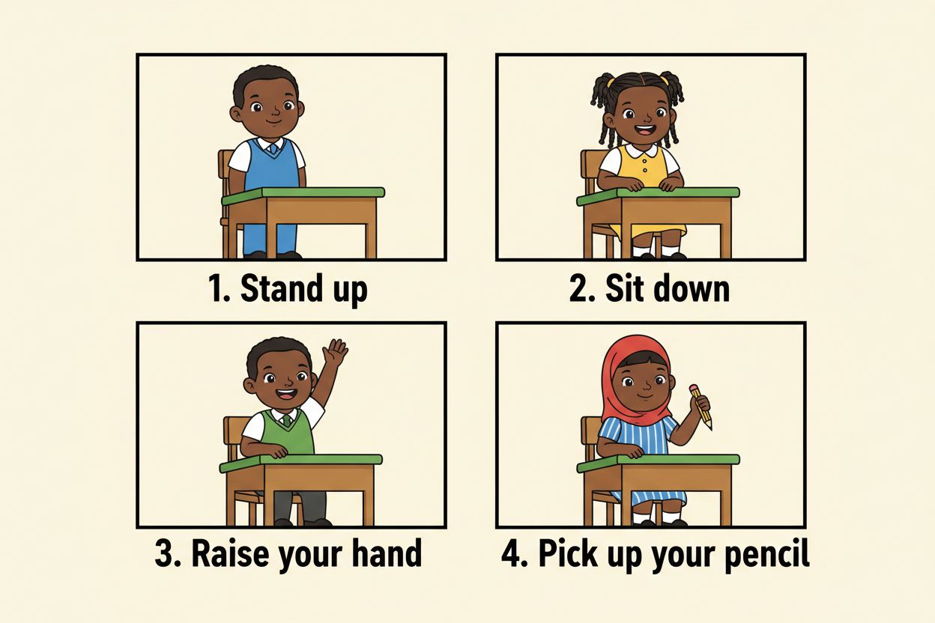
Picture 2. One-step instructions: stand up, sit down, raise your hand, pick up your pencil. Each picture shows one action.

Picture 3. A sequence of instructions, numbered 1, 2 and 3: pick up the book, open the book, point to the picture.
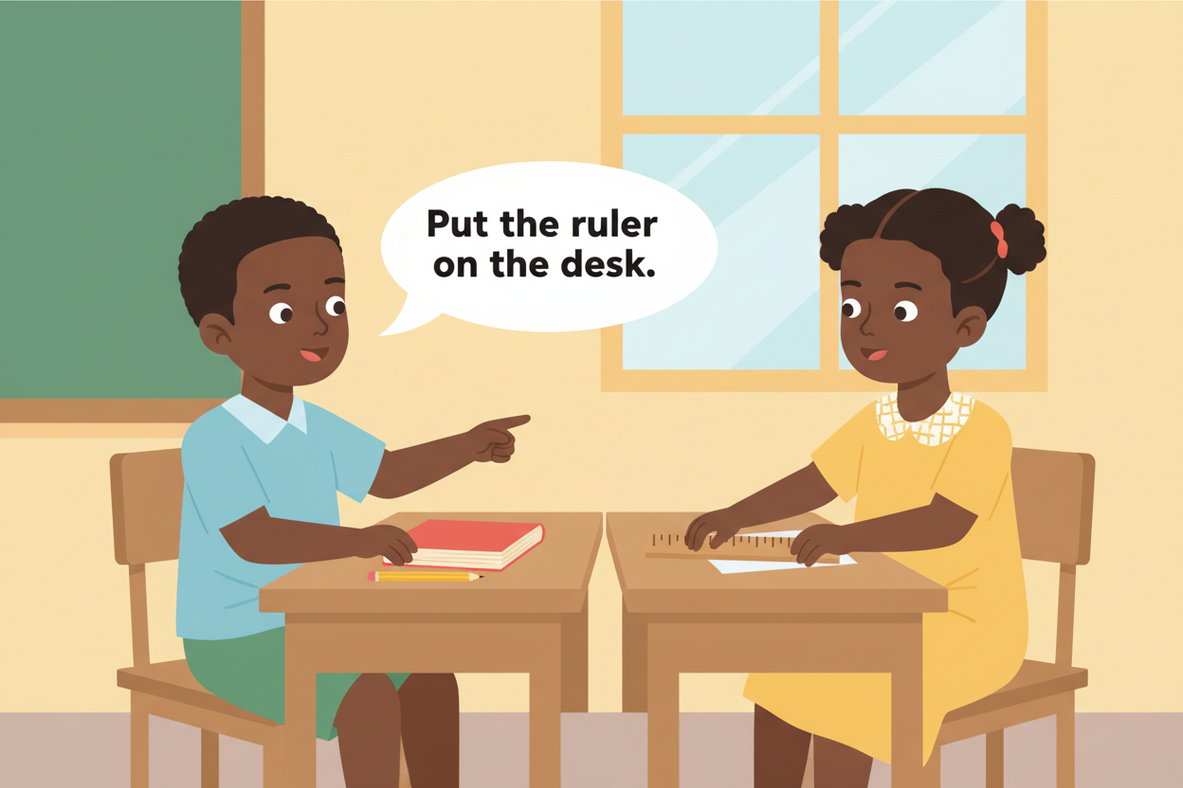
Picture 4. Giving a clear direction: "Put the ruler on the desk." The instruction names the object and the place.
Picture accessibility: Use large images, high-contrast labels and short captions. Do not rely on colour alone to communicate an instruction.

6. Period One: Meaning of an Instruction and One-Step Instructions
Duration: 35 to 40 minutes.

A. Introduction (5 minutes)
Greet the pupils and ask:
- What does your teacher ask you to do when the lesson begins?
- What do you do when someone asks you to open your book?
- Have you ever followed directions to find a classroom or office?
Allow pupils to respond. Explain that a direction telling us what to do is called an instruction.

B. Teacher explanation (8 minutes)
An instruction tells us to do something.
Examples include:
- Stand up.
- Sit down.
- Raise your hand.
- Open your book.
- Pick up your pencil.
- Close your bag.
Explain that each example asks the pupil to perform one main action. Such an instruction is called a one-step instruction.
Demonstrate each action slowly. Ask pupils to listen before acting.
Connect the concept to technology: a computer program contains instructions that tell a computer what actions to perform. A computer does not understand every spoken direction automatically; it needs suitable instructions or software designed to process them.

C. Demonstration (7 minutes)
Give one instruction at a time.
Examples:
1. Stand up.
2. Sit down.
3. Raise your hand.
4. Touch your desk.
5. Point to the door.
After each action, pause and check that pupils understand what to do.
Ask:
- What did I ask you to do?
- Which action did you perform?
- Was the instruction clear?
Correct misunderstandings kindly. Do not rush pupils who need more time.

D. Activity: Listen and Do (10 minutes)
Instructions for the teacher:
1. Ask pupils to stand or sit where they have enough space.
2. Explain that they should listen to the full instruction before acting.
3. Give one simple instruction at a time.
4. Invite pupils to perform the action.
5. Ask volunteers to give one-step instructions to the class.
Suggested instructions:
- Clap your hands once.
- Raise your right hand.
- Point to your book.
- Touch your desk gently.
- Sit down quietly.
Safety rule: Use only safe actions. Do not ask pupils to run, climb furniture, touch electrical equipment or perform actions that could cause injury.

E. Oral recap (5 minutes)
Ask:
1. What is an instruction?
2. Give one example of a one-step instruction.
3. What should you do before following an instruction?
4. Why should an instruction be clear?
Expected responses: An instruction tells someone what to do. Examples include "Sit down" and "Open your book." Pupils should listen, understand and check that the instruction is safe and appropriate.
Period One learning evidence: Each pupil should follow at least one one-step instruction correctly and give or explain one clear instruction. Give additional picture prompts to pupils who need support.

7. Period Two: Following and Giving Clear Instructions
Duration: 35 to 40 minutes.

A. Revision (5 minutes)
Revise the meaning of an instruction. Ask two pupils to demonstrate one-step instructions.
Remind pupils that good instructions are clear and that we should follow only instructions that are safe and appropriate.

B. Teacher explanation (7 minutes)
A clear instruction tells someone exactly what action to perform.
Compare these examples:
Clear: "Put your pencil on the desk."
Unclear: "Put it over there."
The first instruction identifies the object and tells the pupil where to place it. The second may confuse the listener because "it" and "over there" are not specific.
Explain that a person giving an instruction should use words that the listener can understand.

C. Demonstration: Make the Instruction Clear (5 minutes)
Place a book, ruler and pencil on a desk.
Give the instruction: "Move that."
Ask pupils whether they know exactly which object to move or where to put it.
Then say: "Place the ruler beside the book."
Explain that the second instruction gives more information.
Invite pupils to suggest other clear instructions using familiar classroom objects.

D. Group activity: Give and Follow (12 minutes)
Materials: A book, pencil, ruler, school bag or picture cards.
Steps:
1. Divide pupils into pairs or small groups.
2. Give each group two or three familiar objects.
3. One pupil gives a clear, safe instruction.
4. Another pupil listens and performs the action.
5. Pupils swap roles.
6. The teacher observes whether the instruction is understandable and whether the action matches it.
Suggested instructions:
- Put the book on the desk.
- Place the pencil beside the ruler.
- Pick up the school bag.
- Point to the picture of a computer.
- Close your exercise book.
Offline alternative: Use hand-drawn picture cards and let pupils point to the action described by the teacher.

E. Connection to computers and AI (3 minutes)
Explain in simple language:
Computers perform tasks using instructions and programs. If instructions are missing or unclear, a task may not produce the expected result.
Give a simple example: if a computer game is programmed to move a character one step forward, the character follows that programmed instruction. The computer does not decide to perform an unrelated action unless the program or system allows it.
Explain that computers and AI systems have different capabilities, but both depend on suitable input, instructions or system design to perform tasks.

F. Lesson conclusion (3 minutes)
Ask pupils to complete these sentences:
- An instruction tells us what to ______.
- "Raise your hand" is an example of a ______ instruction.
- A good instruction should be ______.
- Before following an instruction, I should check that it is ______.
Expected answers: do; one-step; clear; safe.

8. Assessment
The teacher may use oral questions, a short written exercise or a practical task.

Part A: Oral or written questions
1. What is an instruction?
2. Give two examples of one-step instructions.
3. What makes an instruction clear?
4. What should you do if you do not understand an instruction?
5. Give one example of an instruction that is unsafe to follow.
6. Why do computers need instructions or programs?

Part B: Identify the instruction
Ask pupils to identify which statements are instructions.
1. "Open your book."
2. "The sky is blue."
3. "Raise your hand."
4. "A pencil is used for writing."
5. "Put the ruler on the desk."
Answers: 1, 3 and 5 are instructions.

Part C: Practical assessment
Ask each pupil to:
- Follow one safe, one-step instruction.
- Give one clear instruction to a classmate.
- Explain what action the instruction asks the listener to perform.

Suggested answer guide
1. A direction telling someone what to do.
2. Examples: "Sit down" and "Open your book."
3. It tells the listener what action to perform in understandable words.
4. Ask the teacher or another trusted adult to explain it.
5. Examples: "Touch an exposed wire" or "Climb onto a desk."
6. Instructions or programs tell computers what tasks to perform.
Accept other reasonable examples.

9. Homework
Task: Draw and Write Three Instructions
Ask pupils to draw three small pictures showing safe actions and write or dictate one instruction for each picture.
Examples:
- Open your book.
- Raise your hand.
- Put your pencil on the desk.
Pupils who need support may draw one picture and explain the instruction orally.
Important: Pupils do not need to own any device for this homework. The optional activity below uses only spoken language at home.

Optional home activity: With a trusted adult, identify one safe instruction used at home and explain what action it asks someone to perform. No device purchase or internet access is required.

10. Differentiation and Inclusion

For pupils who need more support
- Use short instructions and demonstrate each action.
- Give one instruction at a time.
- Use picture cards and familiar objects.
- Allow additional response time and oral answers.

For pupils ready for an extra challenge
- Ask them to explain why a vague instruction may cause confusion.
- Invite them to improve an unclear instruction.
- Let them give a short sequence of two safe instructions, while retaining one-step instructions as the core objective.

For pupils with mobility, hearing, vision or communication needs
- Offer actions that can be completed while seated.
- Use visual cards, gestures or written directions where appropriate.
- Repeat instructions clearly and check understanding.
- Accept pointing, signing, assisted movement or verbal responses as appropriate.

11. Safety and Responsible Behaviour
Teach pupils these rules:
1. Listen carefully before acting.
2. Ask for help if an instruction is confusing.
3. Do not follow instructions that could hurt you or someone else.
4. Never touch exposed wires or unsafe electrical equipment.
5. Tell a trusted adult if someone asks you to do something unsafe or secretive.
6. Be respectful when giving instructions to classmates.
7. Do not share private information or passwords when using digital devices.
Explain that following instructions does not mean obeying every request. Safety and appropriate adult guidance are important.

12. Teacher Preparation Checklist
Before the lesson, the teacher should:
☐ Review the lesson objectives and vocabulary.
☐ Prepare familiar classroom objects.
☐ Prepare or draw the sample instruction pictures.
☐ Clear enough space for safe movement.
☐ Plan seated alternatives for movement activities.
☐ Prepare oral and practical assessment questions.
☐ Ensure pupils have an offline way to participate.
☐ Review the safety rules before starting the activity.

13. Lesson Evaluation
After teaching, the teacher should complete the following:
Number of pupils present: ________________________________________
Number of pupils who met the objectives: ________________________________________
Objectives that need revision:
__________________________________________________________________________________________
Activities pupils found most helpful:
__________________________________________________________________________________________
Difficulties encountered:
__________________________________________________________________________________________
Follow-up support required:
__________________________________________________________________________________________
Teacher's name / signature: ________________________________________
Date: ________________________________________

14. Curriculum Alignment and Document Status
This lesson note follows the Rehoteq AI Education Curriculum's proposed Primary 1, First Term, Week 3 scheme of work.
The weekly scheme specifies:
- Period 1: Meaning of an instruction; one-step instructions.
- Period 2: Follow and give clear instructions.
- Assessment: Oral or written check, practical task or short exit ticket.
The expanded activities are suggested teaching approaches. Teachers may adapt them to suit their pupils, available resources and approved school timetable.
Status: Proposed Rehoteq curriculum for school pilot, review and consultation. It is not represented as an officially approved national syllabus. Before adoption, schools should check the current official NERDC curriculum, their own calendar and any examination-board requirements.

Prepared by: Rehoteq Technologies
© 2026 Rehoteq Technologies. Free for non-commercial educational use with attribution. Branding and copyright statement to be confirmed before publication.
End of lesson note

