REHOTEQ
AI EDUCATION CURRICULUM
―――――――――――――――――――――――

Comprehensive Teacher's Lesson Note
Charts
Junior Secondary 1 · Second Term · Week 3

Field | Detail
Subject | AI Education and Digital Skills
Academic session | 2026/2027
Duration | 2 periods (40 to 45 minutes each, subject to the school timetable)
Document type | Comprehensive Teacher's Lesson Note
Curriculum status | Proposed curriculum for school pilot, review and consultation
Prepared by | Rehoteq Technologies (rehoteq.com)
Edition | First edition, November 2026

PROPOSED CURRICULUM NOTICE: This lesson note expands the Rehoteq AI Education Curriculum's proposed Junior Secondary 1, Second Term, Week 3 scheme of work. It is offered for school pilot, review and consultation. It is not represented as an officially approved national syllabus, and it does not replace the current NERDC curriculum or any examination-board requirement.

1. Lesson Information
Field | Detail
Class | JSS 1
Subject | AI Education and Digital Skills
Term | Second Term
Week | Week 3 of Second Term
Topic | Charts: bar and pie charts; charting the survey data two ways
Duration | 2 periods (40 to 45 minutes each)

2. Learning Outcome
By the end of the lesson, learners can:
- Say what a bar chart and a pie chart each show best.
- Draw a simple bar chart from the survey grid on graph paper or a drawn grid.
- Read a pie chart and explain what the slices mean.
- Choose which chart suits a given question and justify the choice.

3. Weekly Scheme Content
Period | Scheme content
Period 1 | Bar and pie charts
Period 2 | Chart the survey two ways
Weeks 11 to 13 of the term are reserved for examinations, marking and results. Do not introduce new content during those weeks.

4. Materials and Preparation
- Chart paper or graph paper, one sheet per group; rulers and colouring pencils.
- A round paper plate or drawn circle per group for the hand-drawn pie chart.
- The completed survey grids from Week 2, plus the teacher's large model grid on the board.
- Where a computer is available, the spreadsheet's chart button demonstrated once for the class.
No-lab fallback: this whole week is drawn by hand on paper. The computer chart is only a demonstration; every learner produces their charts on paper.

5. Period One: Introduce and Model
- Starter (5 minutes): hold up two pictures: last term's tally table and a drawn bar chart of the same data. Ask which tells the story faster and why.
- Teach bar charts (10 minutes): a bar chart compares amounts: the taller the bar, the more. Model drawing one on the board from the survey grid: label line, equal-width bars, gaps between bars, countable height.
- Teach pie charts (10 minutes): a pie chart shows parts of one whole: the whole circle is everyone surveyed; each slice is one group's share. Model cutting the circle roughly by share using the survey numbers (for example, half the class chose one fruit, so half the circle).
- Compare (10 minutes): ask which chart answers 'which fruit is most popular?' fastest (bar) and which shows 'what share of the class?' (pie). Note both are correct; they answer different questions.

6. Lesson Pictures
Show these pictures while teaching. Use each one to point back at the week it comes from before the class moves on.

Picture 1. A bar chart compares amounts: the tallest bar is the biggest number.
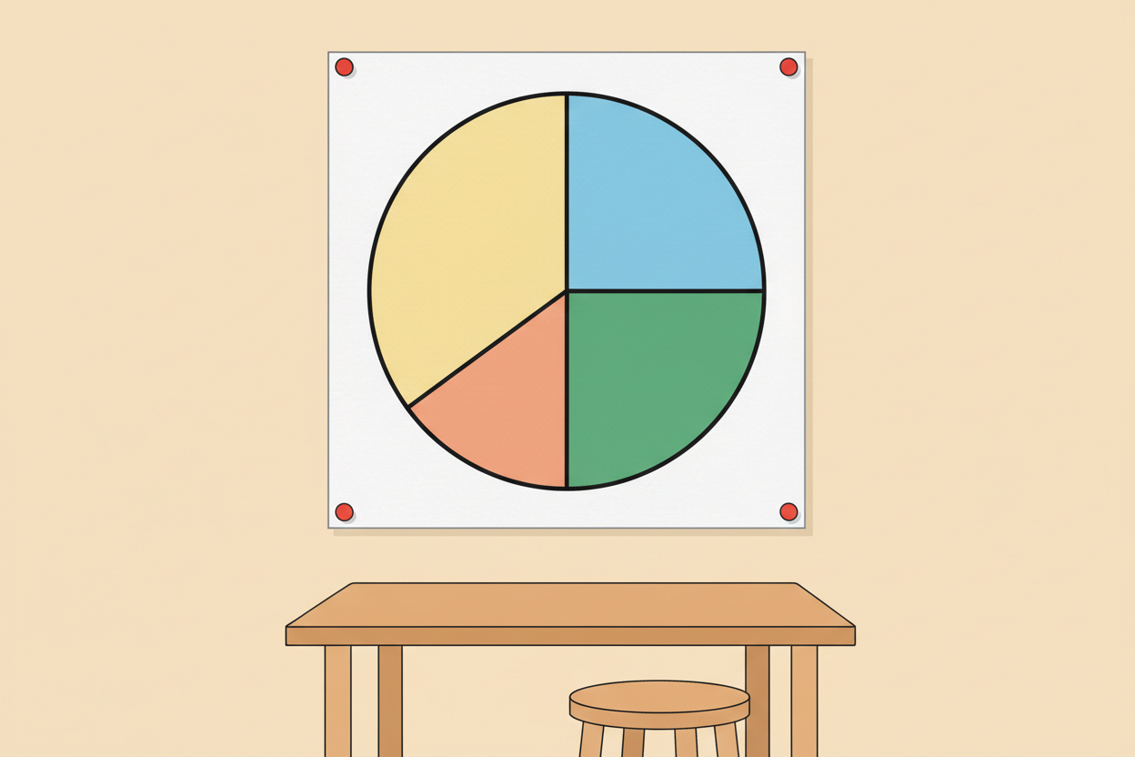
Picture 2. A pie chart shows shares of one whole: each slice is one group's part of everyone.
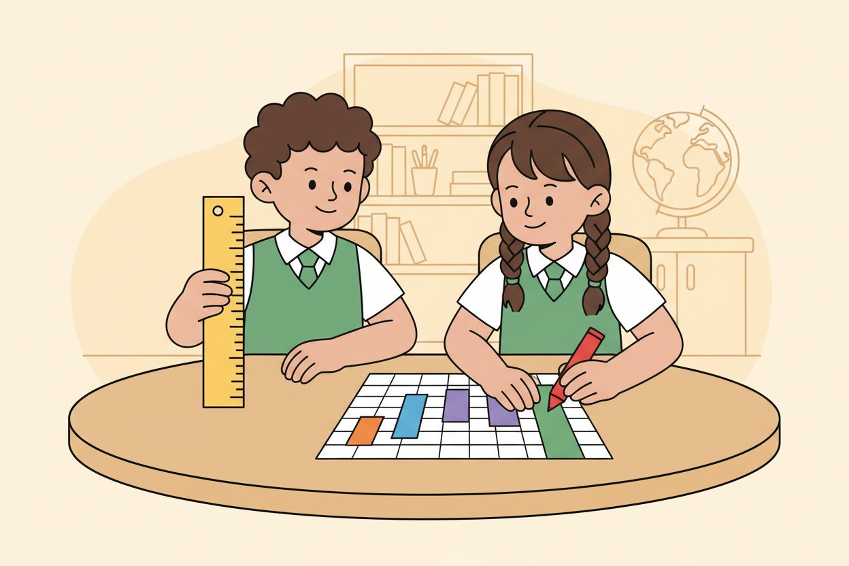
Picture 3. Drawing the bar chart from the survey grid, bar by bar.

Picture 4. The same survey, drawn two ways: the numbers did not change, the view did.

7. Period Two: Practise and Apply
- Bar chart build (15 minutes): each group draws the survey data as a bar chart on graph paper, then colours the bars differently.
- Pie chart build (15 minutes): each group draws the same data as a pie chart on their circle, dividing slices by share (a strip-folding method is shown: fold a paper strip marked into the total count and mark the circle at each fold).
- Gallery check (10 minutes): groups hang both charts; the class walks past and answers two questions from each pair of charts: which is biggest, and what share does it take?
- Close (5 minutes): one-line exit answer: which chart would you use to show your family's weekly spending, and why?

8. Assessment and Evidence
- Evidence to collect: each group's two charts, and each learner's one-line exit answer.
Success looks like: bar heights match the numbers, pie slices roughly match the shares, every chart has a title line, and exit answers pick a chart with a reason.

9. Suggested Questions and Answer Guidance
1. When is a bar chart the better choice? Expected response: when comparing amounts across different groups or options.
2. When is a pie chart the better choice? Expected response: when showing how one whole is shared into parts.
3. Your survey says 12 of 40 pupils chose mango. How would that slice look? Expected response: a bit under one third of the circle.
4. A chart with no title or labels: what problem does that cause? Expected response: nobody can tell what it shows; it fails to communicate.

10. Home Activity
Learners ask five people at home which chore they dislike most, tally it, and draw a bar chart of the five answers on any paper; charts come in next week and are hung as homework charts.

11. Inclusion
Colour is never the only carrier of meaning: bar heights and slice sizes carry the data, and learners label each bar and slice with words as well as colour. Learners who struggle with rulers may use a strip of paper as a straight edge. Fast finishers extend their pie chart to 24 hour-uses of their day.

12. Safety and Privacy
No pupil data leaves the room: charts show counts and option names only, never pupils' names or photos. Scissors are not needed; folding replaces cutting.

13. Teacher Reflection
After the lesson, note what worked, which parts confused the class, which pupils need follow-up, and one change for next term.
Reflection notes
__________________________________________________________________________________________

14. Curriculum Alignment and Document Status
This note expands the Rehoteq AI Education Curriculum, a proposed curriculum for school pilot, review and consultation; not an officially approved national syllabus. It does not replace the current NERDC curriculum or examination-board requirements, and schools remain responsible for checking current NERDC requirements and their own calendar before implementation.

Prepared by Rehoteq Technologies (rehoteq.com). First edition, November 2026.

