REHOTEQ
AI EDUCATION CURRICULUM
―――――――――――――――――――――――

Comprehensive Teacher's Lesson Note
E-waste
Junior Secondary 1 · Third Term · Week 9

Field | Detail
Subject | AI Education and Digital Skills
Academic session | 2026/2027
Duration | 2 periods (40 to 45 minutes each, subject to the school timetable)
Document type | Comprehensive Teacher's Lesson Note
Curriculum status | Proposed curriculum for school pilot, review and consultation
Prepared by | Rehoteq Technologies (rehoteq.com)
Edition | First edition, November 2026

PROPOSED CURRICULUM NOTICE: This lesson note expands the Rehoteq AI Education Curriculum's proposed Junior Secondary 1, Third Term, Week 9 scheme of work. It is offered for school pilot, review and consultation. It is not represented as an officially approved national syllabus, and it does not replace the current NERDC curriculum or any examination-board requirement.

1. Lesson Information
Field | Detail
Class | JSS 1
Subject | AI Education and Digital Skills
Term | Third Term
Week | Week 9 of Third Term
Topic | Electronic waste: what it is, why it harms people and the environment, and how we handle old gadgets responsibly
Duration | 2 periods (40 to 45 minutes each)

2. Learning Outcome
By the end of the lesson, learners can:
- Define e-waste: discarded phones, computers, cables, batteries and other electronics.
- Explain three dangers of dumping e-waste: poisonous substances, fire risk and polluted soil or water.
- List responsible choices: repair, reuse, donate, take to a collection point; never burn or open batteries.
- Plan one e-waste action for the class or home.

3. Weekly Scheme Content
Period | Scheme content
Period 1 | What e-waste is and why it is dangerous
Period 2 | Responsible choices and a class e-waste plan
Weeks 11 to 13 of the term are reserved for examinations, marking and results. Do not introduce new content during those weeks.

4. Materials and Preparation
- Real or pictured examples of old electronics: a dead phone, worn-out cables, an old keyboard, spent AA batteries (sealed, handled by the teacher only).
- Sorting cards: REPAIR, REUSE, DONATE, RECYCLE POINT, DANGER.
- Paper and pencils for the class plan; no device needed.
No-lab fallback: card sorting and drawing. Teams sort example cards into the responsible choices and draw one e-waste danger with its safe alternative; the class plans its collection drive.

5. Period One: Introduce and Model
- Starter (5 minutes): hold up or describe an old phone and worn-out cables. Where do broken electronics in Nigeria go? Many end up dumped or burned. That is e-waste.
- Teach (10 minutes): electronics contain useful metals but also poisons: lead in old screens and batteries, mercury in some lamps, chemicals that can leak into soil and water. Burning cables releases toxic smoke. Batteries can catch fire if crushed or opened.
- Discuss (15 minutes): teams map what happens to a dead phone on its last day at home: dump, drawer, burn, or hand-in? Each team defends the safest path.
- Sort (10 minutes): teams place example cards under REPAIR, REUSE, DONATE, RECYCLE POINT or DANGER and read out their reasons.

6. Lesson Pictures
Show these pictures while teaching. Use each one to point back at the week it comes from before the class moves on.
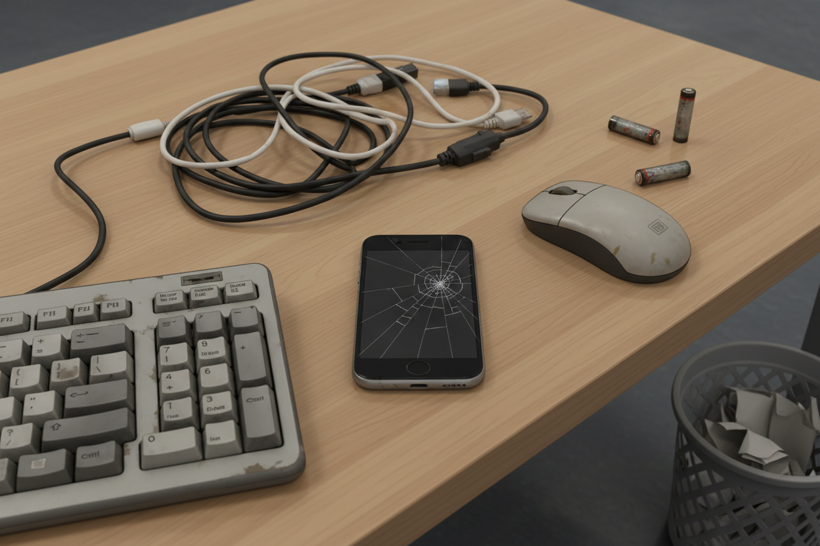
Picture 1. E-waste: phones, cables, keyboards and batteries at the end of their life.
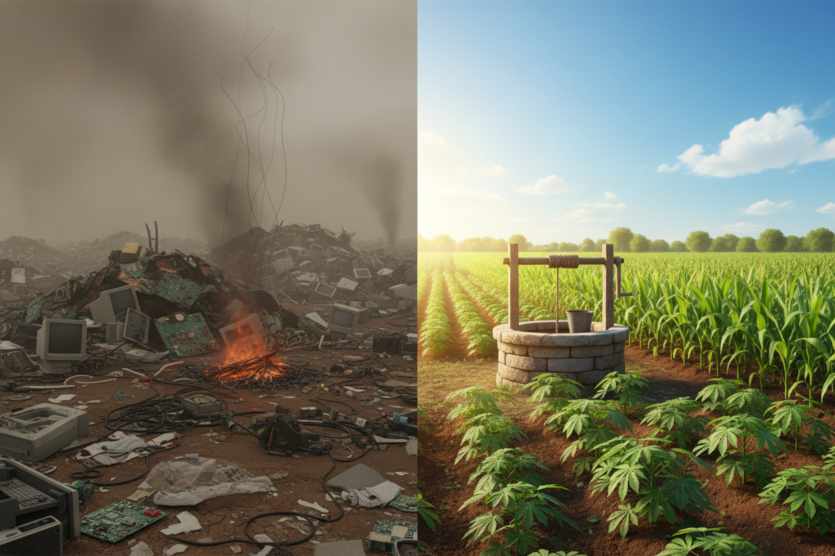
Picture 2. Dumping and burning harm soil, water and air.

Picture 3. Repair and reuse give devices a second life.
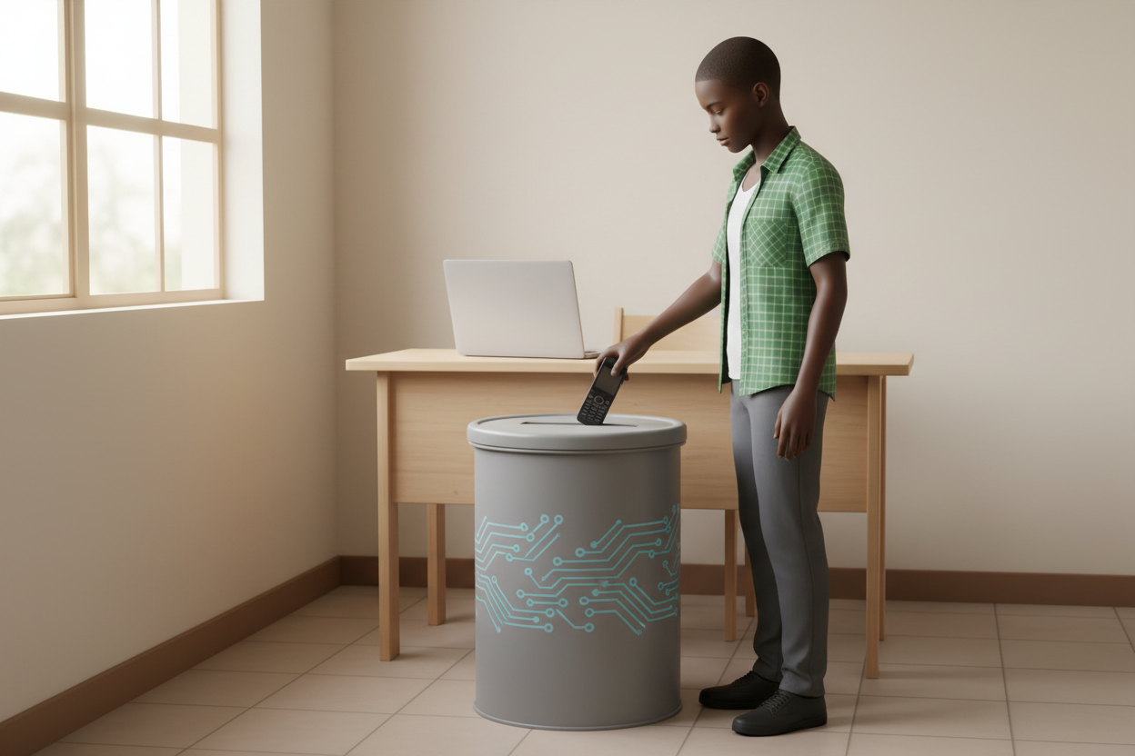
Picture 4. Hand it in: a collection point for old electronics.

7. Period Two: Practise and Apply
- Responsible choices (25 minutes): teams build a decision path for four items (old phone, tangled cable, spent batteries, working but slow laptop) using the five card types, then present it in two minutes.
- Class plan (10 minutes): the class chooses one action, for example a termly e-waste box at the school office taken to a collection point, and writes the steps and who does what.
- Close (5 minutes): recap the dangers and the rule: never burn, never open, never dump; hand in instead.

8. Assessment and Evidence
- Evidence to collect: each team's decision path for the four items and the written class plan.
Success looks like: dangers named correctly (poison, fire, pollution), every item mapped to a responsible choice with a reason, and a concrete class action with owners.

9. Suggested Questions and Answer Guidance
1. Why can burning cables poison people? Expected response: toxic smoke and chemicals settle in air, soil and water.
2. What is the safest thing to do with spent batteries? Expected response: hand them in sealed at a collection point; never crush, open or burn them.
3. Name two responsible choices for a working but old laptop. Expected response: repair or reuse or donate.
4. Who should handle broken screens or opened devices? Expected response: adults or trained technicians, never pupils.

10. Home Activity
Learners list every old or dead electronic item at home with a grown-up and bring the list; no device is opened and nothing is bought.

11. Inclusion
Card sorting may be done by placing, pointing or calling out; every role in the class plan has a speaking, writing or organizing option. No colour-only cues.

12. Safety and Privacy
Batteries and broken devices are handled by the teacher only; no device is opened, burned or dismantled; electrical safety rules stated plainly.

13. Teacher Reflection
After the lesson, note what worked, which parts confused the class, which pupils need follow-up, and one change for next term.
Reflection notes
__________________________________________________________________________________________

14. Curriculum Alignment and Document Status
This note expands the Rehoteq AI Education Curriculum, a proposed curriculum for school pilot, review and consultation; not an officially approved national syllabus. It does not replace the current NERDC curriculum or examination-board requirements, and schools remain responsible for checking current NERDC requirements and their own calendar before implementation.

Prepared by Rehoteq Technologies (rehoteq.com). First edition, November 2026.

