REHOTEQ
AI EDUCATION CURRICULUM
―――――――――――――――――――――――

Comprehensive Teacher's Lesson Note
Variables
Junior Secondary 1 · Second Term · Week 7

Field | Detail
Subject | AI Education and Digital Skills
Academic session | 2026/2027
Duration | 2 periods (40 to 45 minutes each, subject to the school timetable)
Document type | Comprehensive Teacher's Lesson Note
Curriculum status | Proposed curriculum for school pilot, review and consultation
Prepared by | Rehoteq Technologies (rehoteq.com)
Edition | First edition, November 2026

PROPOSED CURRICULUM NOTICE: This lesson note expands the Rehoteq AI Education Curriculum's proposed Junior Secondary 1, Second Term, Week 7 scheme of work. It is offered for school pilot, review and consultation. It is not represented as an officially approved national syllabus, and it does not replace the current NERDC curriculum or any examination-board requirement.

1. Lesson Information
Field | Detail
Class | JSS 1
Subject | AI Education and Digital Skills
Term | Second Term
Week | Week 7 of Second Term
Topic | Variables: labelled boxes that remember; the score box game
Duration | 2 periods (40 to 45 minutes each)

2. Learning Outcome
By the end of the lesson, learners can:
- Explain a variable as a labelled box that stores one value that can change.
- Create a variable in a program and give it a starting value.
- Change a variable's value while a program runs and observe the effect.
- Use a variable to keep score in a simple game.

3. Weekly Scheme Content
Period | Scheme content
Period 1 | Labelled boxes
Period 2 | Score box game
Weeks 11 to 13 of the term are reserved for examinations, marking and results. Do not introduce new content during those weeks.

4. Materials and Preparation
- Computers with Scratch where available, one per pair; one empty carton or box and sticky labels for the physical model.
- Paper variable cards: blank labelled rectangles (name on top, value inside), one set per team.
- The class's Week 6 dance programs.
No-lab fallback: the physical box. The teacher writes a number on a slip, puts it in the labelled box, and the class updates the slip each time the game scores; the paper variable cards work the same way.

5. Period One: Introduce and Model
- Starter (5 minutes): hold up an empty labelled box. Write a number on a slip, drop it in, then change the number on a new slip and swap. Ask: the box never moved, only what is inside changed.
- Teach (10 minutes): a variable is a named box the program remembers: it holds one value, and the value can change while the program runs. Names must be clear: score, not x.
- Model (10 minutes): create a score variable, set it to zero at the start, then add one each time a key is pressed. Run it, press the key, watch the value change on screen.
- Spot the change (15 minutes): teams list three things a phone remembers that change during the day (battery level, unread messages, volume), and say what each value started at.

6. Lesson Pictures
Show these pictures while teaching. Use each one to point back at the week it comes from before the class moves on.

Picture 1. A labelled box: the box stays, the value inside changes.
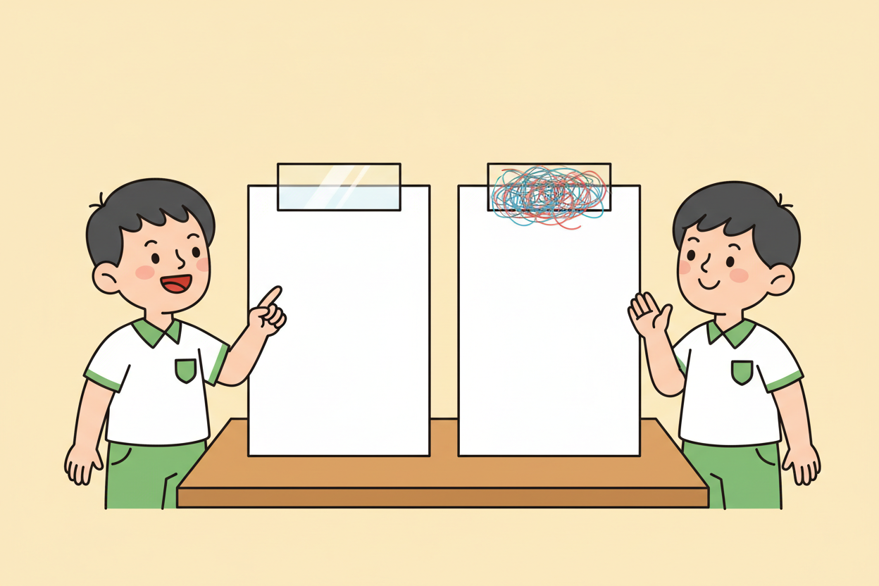
Picture 2. A clear name beats a vague one: score tells us what the box holds.

Picture 3. Start at zero, change as the game goes: the number on screen follows the box.

Picture 4. The score box game: every correct answer makes the box grow.

7. Period Two: Practise and Apply
- Score box game (25 minutes): pairs add a score variable to any simple program: set to zero at the start, change by one when something happens (a key press, a click, a correct answer in a question sprite).
- Test and predict (10 minutes): pairs predict what the score shows after three events, run, and check. Then reset and try a change of two at a time.
- Close (5 minutes): each pair names its variable and says in one sentence why the name fits.

8. Assessment and Evidence
- Evidence to collect: each pair's program with its variable (or paper variable card set), and one prediction note per pair.
Success looks like: variables start at a sensible value, names describe what they hold, and predictions match what actually appears most of the time.

9. Suggested Questions and Answer Guidance
1. Why start score at zero instead of an empty box? Expected response: the program needs a definite value to work with; zero is the fair starting count.
2. What is wrong with naming a variable x? Expected response: the name tells the reader nothing; a clear name explains the program.
3. Give one thing on a phone that behaves like a variable. Expected response: any sensible example with a value that changes, such as battery level or volume.
4. How would you make the score go up by five each time? Expected response: change the add-one step to add-five, or repeat the add-one step five times.

10. Home Activity
Learners draw one labelled box for something that changes at home (water level in a bucket, number of eggs, airtime balance) and write two values it might hold; no device is needed.

11. Inclusion
The physical box makes the idea visible and touchable for every learner: one learner names the variable, another holds the box, a third swaps slips. Screen readers of the value are read aloud by a partner so all learners track the number. Card teams use the same rubric.

12. Safety and Privacy
Variable names stay kind and school-appropriate; no learner's name is used as a score label in a way that ranks people. Saved projects carry no personal details.

13. Teacher Reflection
After the lesson, note what worked, which parts confused the class, which pupils need follow-up, and one change for next term.
Reflection notes
__________________________________________________________________________________________

14. Curriculum Alignment and Document Status
This note expands the Rehoteq AI Education Curriculum, a proposed curriculum for school pilot, review and consultation; not an officially approved national syllabus. It does not replace the current NERDC curriculum or examination-board requirements, and schools remain responsible for checking current NERDC requirements and their own calendar before implementation.

Prepared by Rehoteq Technologies (rehoteq.com). First edition, November 2026.

