REHOTEQ
AI EDUCATION CURRICULUM
―――――――――――――――――――――――

Comprehensive Teacher's Lesson Note
Loops
Junior Secondary 1 · Second Term · Week 6

Field | Detail
Subject | AI Education and Digital Skills
Academic session | 2026/2027
Duration | 2 periods (40 to 45 minutes each, subject to the school timetable)
Document type | Comprehensive Teacher's Lesson Note
Curriculum status | Proposed curriculum for school pilot, review and consultation
Prepared by | Rehoteq Technologies (rehoteq.com)
Edition | First edition, November 2026

PROPOSED CURRICULUM NOTICE: This lesson note expands the Rehoteq AI Education Curriculum's proposed Junior Secondary 1, Second Term, Week 6 scheme of work. It is offered for school pilot, review and consultation. It is not represented as an officially approved national syllabus, and it does not replace the current NERDC curriculum or any examination-board requirement.

1. Lesson Information
Field | Detail
Class | JSS 1
Subject | AI Education and Digital Skills
Term | Second Term
Week | Week 6 of Second Term
Topic | Loops: repeats; the dance loop challenge
Duration | 2 periods (40 to 45 minutes each)

2. Learning Outcome
By the end of the lesson, learners can:
- Explain what a loop does: it repeats a set of steps so we do not stack the same block many times.
- Spot repeats in everyday activities and in a given program.
- Build a program that uses one loop to repeat a set of moves.
- Adjust the number of repeats and predict the change.

3. Weekly Scheme Content
Period | Scheme content
Period 1 | Repeats
Period 2 | Dance loop challenge
Weeks 11 to 13 of the term are reserved for examinations, marking and results. Do not introduce new content during those weeks.

4. Materials and Preparation
- Computers with Scratch where available, one per pair; a drum or clap pattern for the rhythm starter.
- Paper loop cards: a repeat card (a card drawn as a loop-shaped arrow) plus plain move cards, one set per team.
- The class's saved two-step stories from Week 5.
No-lab fallback: paper cards. Teams build a loop card wrapped around three move cards and act it out; changing the repeat count changes the dance.

5. Period One: Introduce and Model
- Starter (5 minutes): clap a simple pattern four times, then ask how many times you clapped and whether anyone got tired of hearing the same instruction. Introduce the shortcut word: repeat.
- Teach (10 minutes): a loop tells the program to repeat a group of steps a set number of times (or forever). Show last week's story where a step was repeated by stacking it four times, then replace the stack with one loop block: same result, fewer blocks.
- Model (10 minutes): build a walk-and-turn loop on the board or computer: repeat four times, move ten steps, turn fifteen degrees. Predict the shape the sprite walks in before running (a rough square or circle), then run and check.
- Counting challenge (15 minutes): teams predict how far the sprite travels if the loop count changes from four to ten, then test.

6. Lesson Pictures
Show these pictures while teaching. Use each one to point back at the week it comes from before the class moves on.

Picture 1. Clap the pattern four times: the same small step, repeated, makes the whole dance.

Picture 2. A loop block wraps the same steps: one card instead of a tall stack.
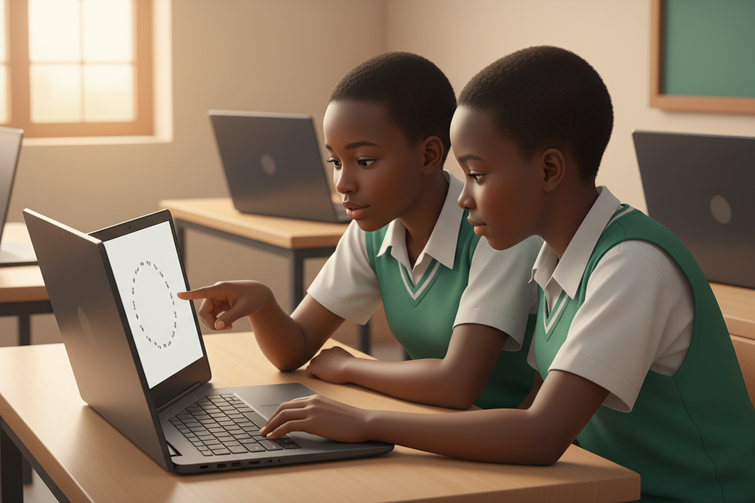
Picture 3. Change the count, change the path: predict before you run.
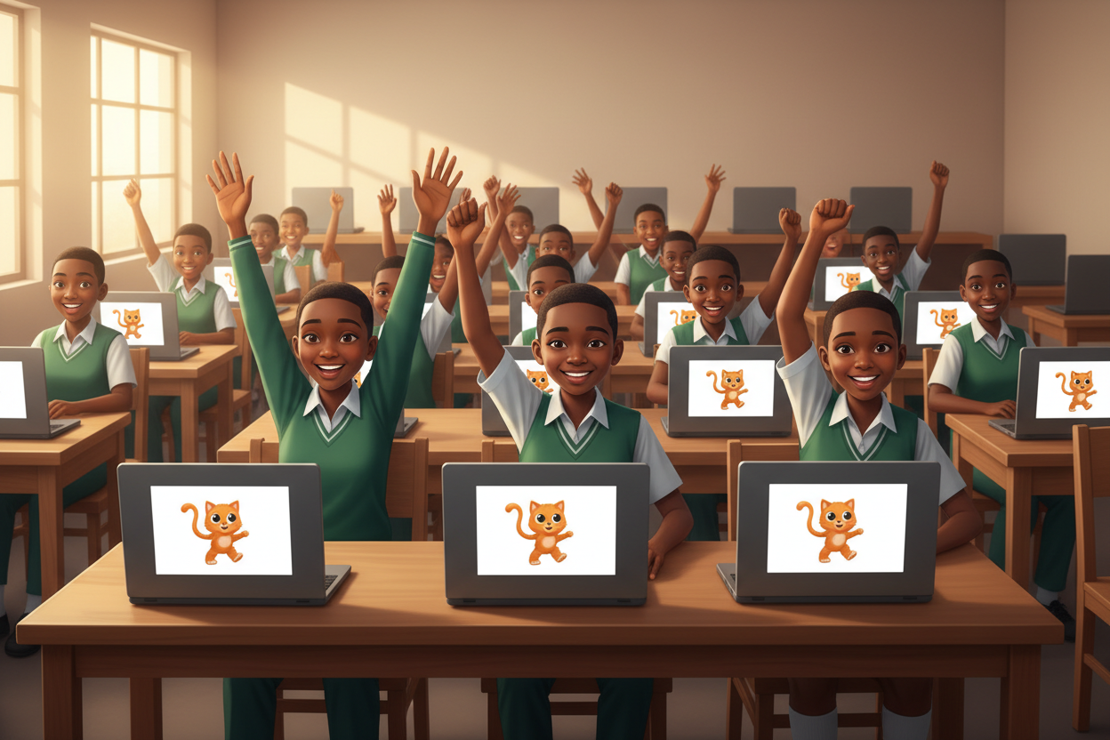
Picture 4. The dance loop challenge: everyone's sprite dances to its own repeat count.

7. Period Two: Practise and Apply
- Dance loop challenge (25 minutes): pairs build a dancing sprite: inside one loop, the sprite moves, turns, changes colour or costume, then waits. Each pair sets its own repeat count; the class votes for the best dance at the end.
- Change and predict (10 minutes): each pair changes only the repeat count, predicts the new result aloud, runs, and confirms.
- Close (5 minutes): name one loop learners met this week and one loop they think a phone runs every day.

8. Assessment and Evidence
- Evidence to collect: each pair's dance program (or paper loop layout), and each pair's prediction note.
Success looks like: programs use ONE loop block instead of stacked repeats, predictions come before runs, and the class can explain why the loop is the shorter way.

9. Suggested Questions and Answer Guidance
1. Why is a loop better than stacking the same block ten times? Expected response: shorter, easier to read, and one change updates every repeat.
2. What happens if you put a move outside the loop instead of inside? Expected response: it runs once before (or after) the repeats instead of every time.
3. Where might a loop run in a bank app? Expected response: checking each transaction in turn, repeating until all are checked.
4. What would make a loop run forever, and is that ever useful? Expected response: no end condition; useful for things like a clock display or game background animation.

10. Home Activity
Learners count one repeated action at home (for example, how many times a gate swings or how many times they stir food) and write the action and its count in their books as a loop sentence: repeat, action, count.

11. Inclusion
Dance loops can be clapped, tapped or acted without sound or screen: hearing-impaired learners follow the visual pattern, and every team presents its dance physically if it prefers. Card teams are graded by the same rubric.

12. Safety and Privacy
Programs stay kind: no flashing that could distress, no frightening sounds. Volume is kept low on shared computers, and saved projects carry no personal details.

13. Teacher Reflection
After the lesson, note what worked, which parts confused the class, which pupils need follow-up, and one change for next term.
Reflection notes
__________________________________________________________________________________________

14. Curriculum Alignment and Document Status
This note expands the Rehoteq AI Education Curriculum, a proposed curriculum for school pilot, review and consultation; not an officially approved national syllabus. It does not replace the current NERDC curriculum or examination-board requirements, and schools remain responsible for checking current NERDC requirements and their own calendar before implementation.

Prepared by Rehoteq Technologies (rehoteq.com). First edition, November 2026.

