REHOTEQ
AI EDUCATION CURRICULUM
―――――――――――――――――――――――

Comprehensive Teacher's Lesson Note
Scratch game
Junior Secondary 1 · Third Term · Week 3

Field | Detail
Subject | AI Education and Digital Skills
Academic session | 2026/2027
Duration | 2 periods (40 to 45 minutes each, subject to the school timetable)
Document type | Comprehensive Teacher's Lesson Note
Curriculum status | Proposed curriculum for school pilot, review and consultation
Prepared by | Rehoteq Technologies (rehoteq.com)
Edition | First edition, November 2026

PROPOSED CURRICULUM NOTICE: This lesson note expands the Rehoteq AI Education Curriculum's proposed Junior Secondary 1, Third Term, Week 3 scheme of work. It is offered for school pilot, review and consultation. It is not represented as an officially approved national syllabus, and it does not replace the current NERDC curriculum or any examination-board requirement.

1. Lesson Information
Field | Detail
Class | JSS 1
Subject | AI Education and Digital Skills
Term | Third Term
Week | Week 3 of Third Term
Topic | Scratch game: build and share a game; play-testing classmates' games
Duration | 2 periods (40 to 45 minutes each)

2. Learning Outcome
By the end of the lesson, learners can:
- Combine sequence, loops, variables and conditions in a small game.
- Build a playable game with a clear goal and a score.
- Play-test a classmate's game politely and give one useful comment.
- Fix the first bug a play-tester finds.

3. Weekly Scheme Content
Period | Scheme content
Period 1 | Build and share a game
Period 2 | Play-test classmates' games
Weeks 11 to 13 of the term are reserved for examinations, marking and results. Do not introduce new content during those weeks.

4. Materials and Preparation
- Computers with Scratch where available, one per pair; the class's Week 10 Term 2 counting games as starting points.
- A play-test feedback slip per tester: one star, one wish, one bug found.
- Paper game boards for the unplugged version: a grid, a counter, a score box.
No-lab fallback: the paper game. Teams build a board game with one rule card (a condition), one repeat rule (a loop) and a score box (a variable); other teams play it and give feedback.

5. Period One: Introduce and Model
- Starter (5 minutes): name a game you play and what makes you keep playing it. A game is a goal plus rules plus a score.
- Build (25 minutes): pairs build a small game: a sprite the player moves, something to catch or avoid, a score that changes, and one condition that ends or celebrates (score reaches ten).
- Share check (10 minutes): each pair states its goal in one sentence and shows the score working before the play-test.

6. Lesson Pictures
Show these pictures while teaching. Use each one to point back at the week it comes from before the class moves on.
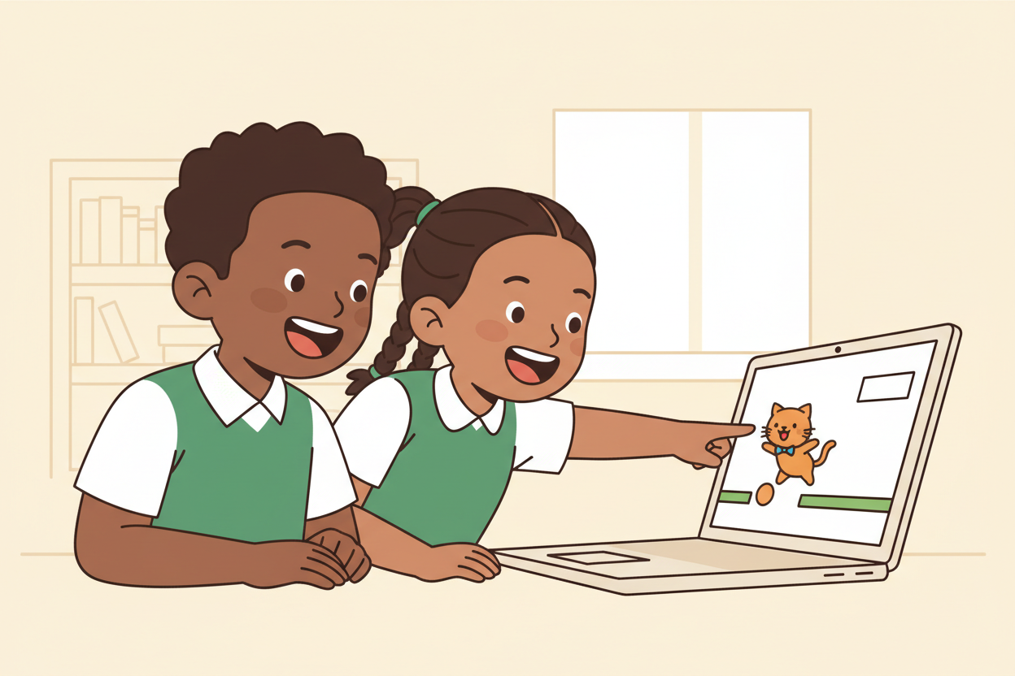
Picture 1. A game is a goal, rules and a score: say your goal in one sentence.
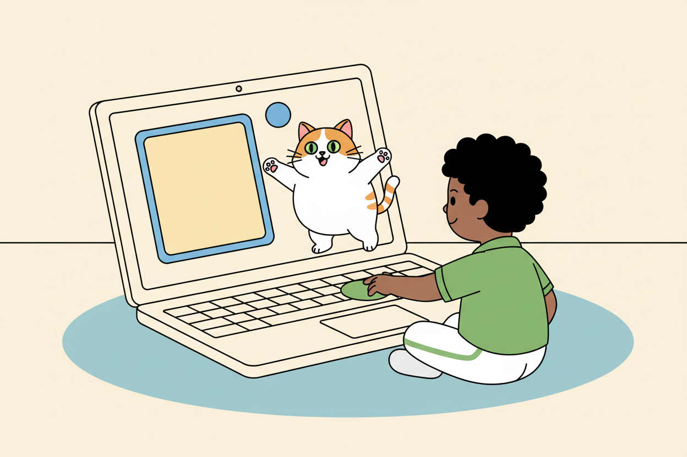
Picture 2. Build the score first: every catch must count.
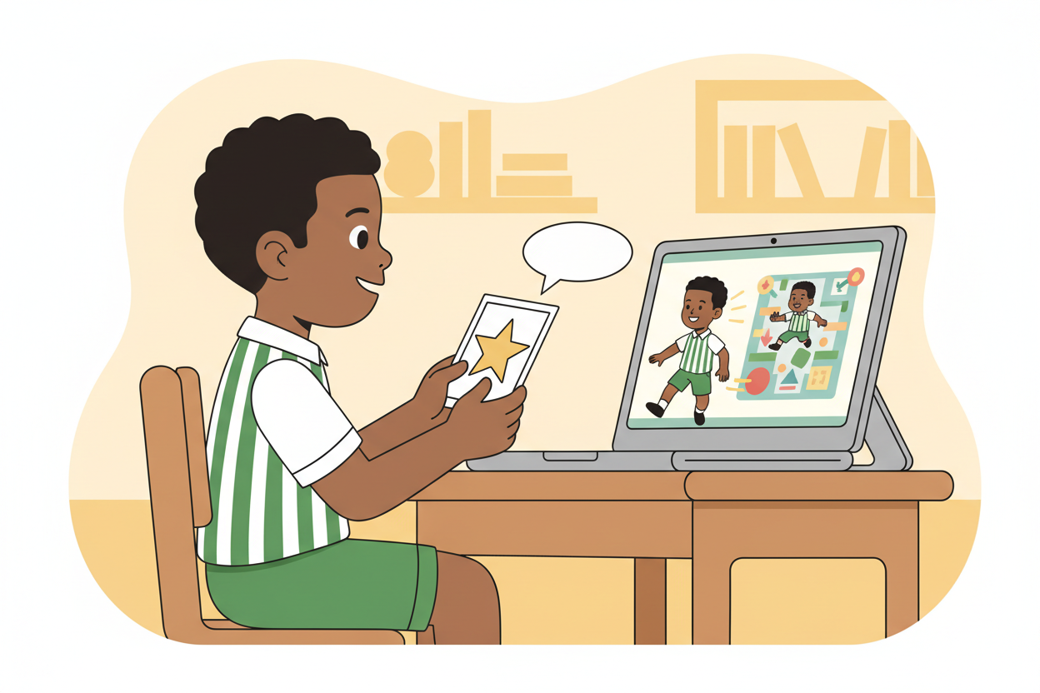
Picture 3. Play-test kindly: one star, one wish, one bug found.
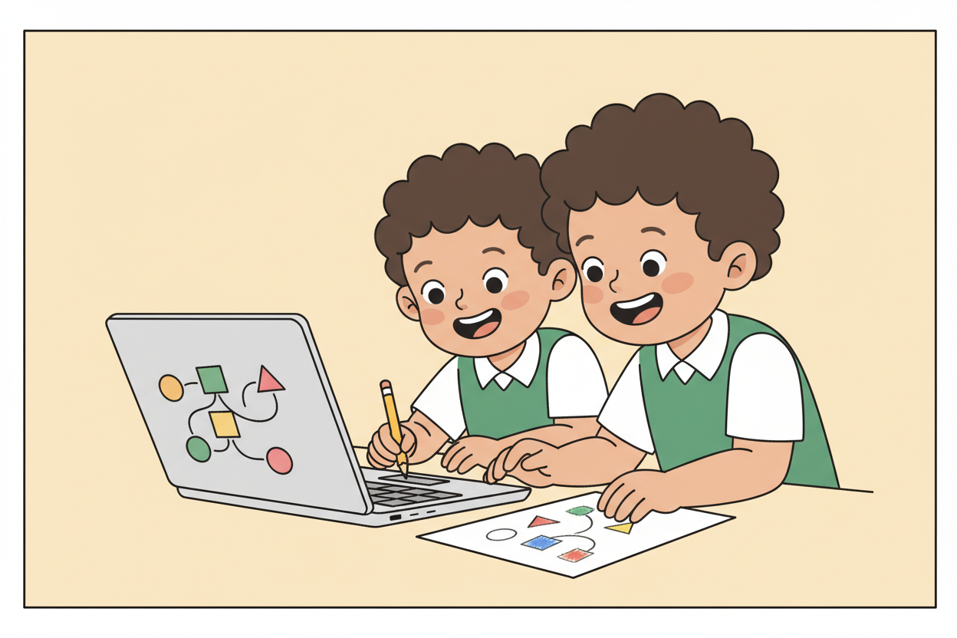
Picture 4. Fix the first bug and try again: builders improve by testing.

7. Period Two: Practise and Apply
- Play-test carousel (25 minutes): pairs swap seats and play each other's games, filling one feedback slip per game: one star, one wish, one bug found.
- Fix round (10 minutes): builders read their slips and fix the first bug found, then re-run.
- Close (5 minutes): the class names what good feedback sounded like today.

8. Assessment and Evidence
- Evidence to collect: each pair's game (or paper board), its one-sentence goal, and the feedback slips it wrote.
Success looks like: games have a working score and a stated goal, feedback slips are kind and specific, and at least the first bug is fixed the same day.

9. Suggested Questions and Answer Guidance
1. What is your game's goal, in one sentence? Expected response: a clear aim stated by the pair.
2. Which part of your game is a loop? Expected response: the repeated part, named.
3. Why does the score need to start at a set value? Expected response: the game must be fair and countable from a known start.
4. What made a bug easy or hard to fix? Expected response: a sensible reason tied to where the bug sat in the program.

10. Home Activity
No new homework: learners rest after building. Optional: teach someone at home one rule of your game and note what they asked.

11. Inclusion
Paper-board games are full participants in the carousel; feedback may be written, dictated or signed. Seated or standing play-testing are both fine. No game may mock a person or group.

12. Safety and Privacy
Games avoid startling sounds and flashing; sprites and themes stay kind. Projects carry no personal details.

13. Teacher Reflection
After the lesson, note what worked, which parts confused the class, which pupils need follow-up, and one change for next term.
Reflection notes
__________________________________________________________________________________________

14. Curriculum Alignment and Document Status
This note expands the Rehoteq AI Education Curriculum, a proposed curriculum for school pilot, review and consultation; not an officially approved national syllabus. It does not replace the current NERDC curriculum or examination-board requirements, and schools remain responsible for checking current NERDC requirements and their own calendar before implementation.

Prepared by Rehoteq Technologies (rehoteq.com). First edition, November 2026.

