REHOTEQ
AI EDUCATION CURRICULUM
―――――――――――――――――――――――

Comprehensive Teacher's Lesson Note
Collecting Data for Machines
Junior Secondary 1 · First Term · Week 9

Field | Detail
Subject | AI Education and Digital Skills
Academic session | 2026/2027
Duration | 2 periods (40 to 45 minutes each, subject to the school timetable)
Document type | Comprehensive Teacher's Lesson Note
Curriculum status | Proposed curriculum for school pilot, review and consultation
Prepared by | Rehoteq Technologies (rehoteq.com)
Edition | First edition, November 2026

PROPOSED CURRICULUM NOTICE: This lesson note expands the Rehoteq AI Education Curriculum's proposed Junior Secondary 1, First Term, Week 9 scheme of work. It is offered for school pilot, review and consultation. It is not represented as an officially approved national syllabus, and it does not replace the current NERDC curriculum or any examination-board requirement.

1. Lesson Information
Field | Detail
Class | JSS 1
Subject | AI Education and Digital Skills
Term | First Term
Week | Week 9 of First Term
Topic | Collecting data: where the examples a machine learns from come from
Duration | 2 periods (40 to 45 minutes each)

2. Learning Outcome
By the end of the lesson, learners can:
- Explain data in simple words: recorded facts and examples, such as counts, measurements or labelled pictures.
- Collect a small set of data correctly by counting and recording with tallies.
- Organise the class's collected data into a simple table and read one pattern from it.
- Say why good data matters for AI: bad or unfair examples teach a machine the wrong patterns.

3. Weekly Scheme Content
Period | Scheme content
Period 1 | What is data and how do we collect it
Period 2 | Class data collection: tally, table and one pattern
Weeks 11 to 13 of the term are reserved for examinations, marking and results. Do not introduce new content during those weeks.

4. Materials and Preparation
- The board tally chart template: three columns for question, tally marks and total.
- One exercise book or sheet per pair for recording.
- A wall chart showing a simple tally-to-table example (or the teacher draws it live on the board).
- Chalk and the chalkboard table prepared before class: item, tally, total.
No-lab fallback: the lesson is fully pen-and-paper. If tally marks are new to some learners, drill five-bar gate tallies on the board first: four strokes and a crossing fifth.

5. Period One: Introduce and Model
- Starter (5 minutes): ask how a market woman knows which goods to buy more of. Lead the class to: she remembers what sells, in other words she uses recorded experience, which is data.
- Teach (10 minutes): define data: recorded facts and examples. Give three forms: counts, measurements and labelled examples. Connect: Week 6 taught that AI learns patterns from data, so good data is the food of every machine that learns.
- Model (10 minutes): on the board, collect a mini dataset live: ask five learners their shoe size, tally each answer, total the tallies, and read one pattern aloud, such as which size is most common.
- Guided practice (15 minutes): pairs copy the mini dataset into their books as a neat table with item, tally and total columns.

6. Lesson Pictures
Show these pictures while teaching. Talk about each one before moving on, and connect it to the class's own tally work.

Picture 1. Data begins as recorded facts: every answer gets one mark, and the marks add up to a count.
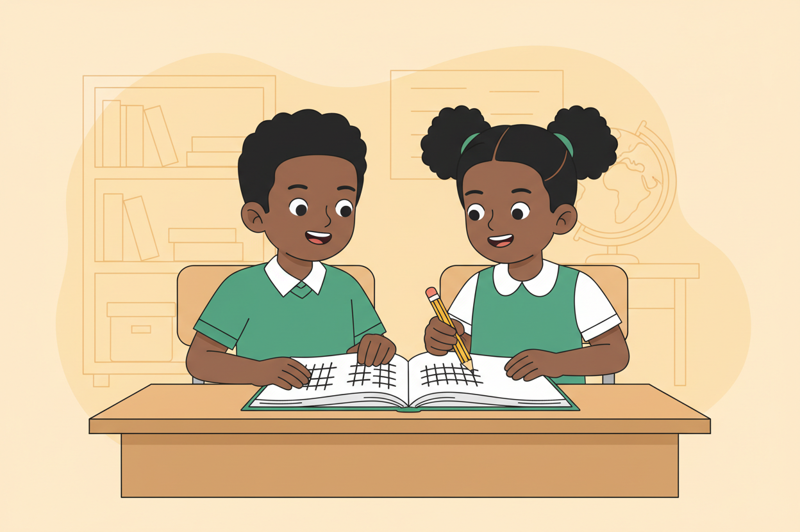
Picture 2. Pair recording: one asks, one records, and both check the count at the end.
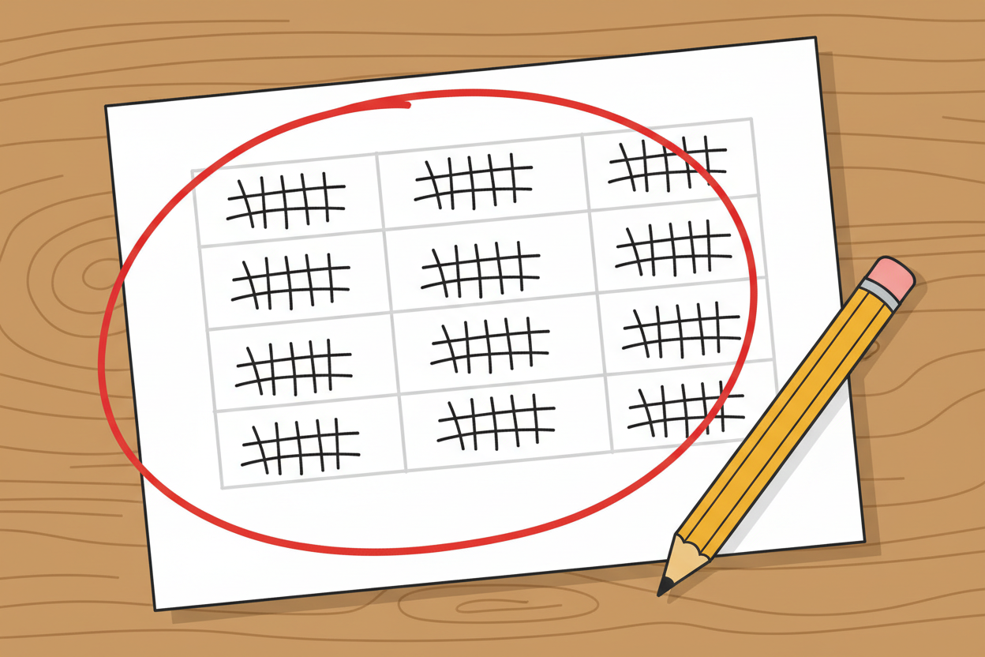
Picture 3. A completed table is easier to read than a memory: the biggest total jumps out as the pattern.

Picture 4. Machines are taught the same way: someone collects many good examples first, then the machine learns from them.

7. Period Two: Practise and Apply
- Class data collection (20 minutes): the class chooses one safe question together, such as favourite local fruit or how learners travel to school. Each pair interviews four classmates, records with tallies, and totals.
- Combine and read (15 minutes): the teacher collects each pair's totals on the board table, and the class reads the biggest and smallest groups aloud: the pattern.
- Recap and write (10 minutes): learners write the definition of data and one sentence: what could go wrong if the data collected were wrong or one-sided.

8. Assessment and Evidence
- Evidence to collect: each pair's completed tally table, and each learner's one written sentence on bad data.
Success looks like: tallies are accurate against the class totals on the board, and the written sentences name a real consequence of poor data.

9. Suggested Questions and Answer Guidance
1. What is data? Expected response: recorded facts and examples, such as counts, measurements or labelled pictures.
2. How did our class collect its data today? Expected response: asking classmates questions, recording answers as tally marks, and totalling the tallies.
3. What pattern did we find in our class data? Expected response: the group with the largest total, named correctly from the board table.
4. Why does a machine need good data? Expected response: it learns patterns from the examples it is given, so wrong or one-sided examples teach it wrong or unfair patterns.

10. Home Activity
Learners count one thing at home, such as the types of fruit in the kitchen or shoes by the door, record it as a tally table, and bring it to next class. No photographs of people or homes are needed.

11. Inclusion
All recording is on paper in pairs with rotated roles, so learners who write slowly can still take part fully. Tables show counts only, and learners may draw a small picture beside each row instead of writing its name.

12. Safety and Privacy
All recording is on paper; no learner's name, age or personal details are collected or displayed. The interview question is agreed in class so no learner is asked anything private, and any learner may pass on a question without giving a reason.

13. Teacher Reflection
After the lesson, note what worked, which parts confused the class, which pupils need follow-up, and one change for next time.
Reflection notes
__________________________________________________________________________________________

14. Curriculum Alignment and Document Status
This note expands the Rehoteq AI Education Curriculum, a proposed curriculum for school pilot, review and consultation; not an officially approved national syllabus. It does not replace the current NERDC curriculum or examination-board requirements, and schools remain responsible for checking current NERDC requirements and their own calendar before implementation.

Prepared by Rehoteq Technologies (rehoteq.com). First edition, November 2026.

