REHOTEQ
AI EDUCATION CURRICULUM
―――――――――――――――――――――――

Comprehensive Teacher's Lesson Note
Algorithms
Junior Secondary 1 · Third Term · Week 4

Field | Detail
Subject | AI Education and Digital Skills
Academic session | 2026/2027
Duration | 2 periods (40 to 45 minutes each, subject to the school timetable)
Document type | Comprehensive Teacher's Lesson Note
Curriculum status | Proposed curriculum for school pilot, review and consultation
Prepared by | Rehoteq Technologies (rehoteq.com)
Edition | First edition, November 2026

PROPOSED CURRICULUM NOTICE: This lesson note expands the Rehoteq AI Education Curriculum's proposed Junior Secondary 1, Third Term, Week 4 scheme of work. It is offered for school pilot, review and consultation. It is not represented as an officially approved national syllabus, and it does not replace the current NERDC curriculum or any examination-board requirement.

1. Lesson Information
Field | Detail
Class | JSS 1
Subject | AI Education and Digital Skills
Term | Third Term
Week | Week 4 of Third Term
Topic | Algorithms: definition and everyday examples; the cooking algorithm
Duration | 2 periods (40 to 45 minutes each)

2. Learning Outcome
By the end of the lesson, learners can:
- Define an algorithm as a precise step-by-step set of instructions to finish a task.
- Give everyday examples of algorithms and spot what makes one work.
- Write the algorithm for a familiar cooking task in clear ordered steps.
- Test a classmate's algorithm by following it exactly and reporting what breaks.

3. Weekly Scheme Content
Period | Scheme content
Period 1 | Definition; everyday examples
Period 2 | Write the algorithm for cooking a meal
Weeks 11 to 13 of the term are reserved for examinations, marking and results. Do not introduce new content during those weeks.

4. Materials and Preparation
- A simple recipe card (a familiar local dish, no brand names), one per pair; paper and pencils.
- Instruction cards for the robot-teacher game: one learner is the robot who obeys instructions exactly.
- The class's flowchart vocabulary is next week; this week stays with numbered steps.
No-lab fallback: the whole week is unplugged. The robot-teacher game and the cooking algorithm need only paper and a willing robot.

5. Period One: Introduce and Model
- Starter (5 minutes): the robot-teacher game. One learner is the robot; the class gives instructions to make the robot walk from the door to their seat. Every ambiguous instruction is obeyed literally, and the class laughs and fixes it.
- Teach (10 minutes): an algorithm is a precise, ordered set of steps that finishes a task. Precise means no guessing: each step says exactly what to do. Everyday algorithms: the steps for washing hands, for boarding a bus, for charging a phone.
- Spot and sort (15 minutes): teams put three everyday routines in order and mark any step that is vague (add some water: how much?).

6. Lesson Pictures
Show these pictures while teaching. Use each one to point back at the week it comes from before the class moves on.
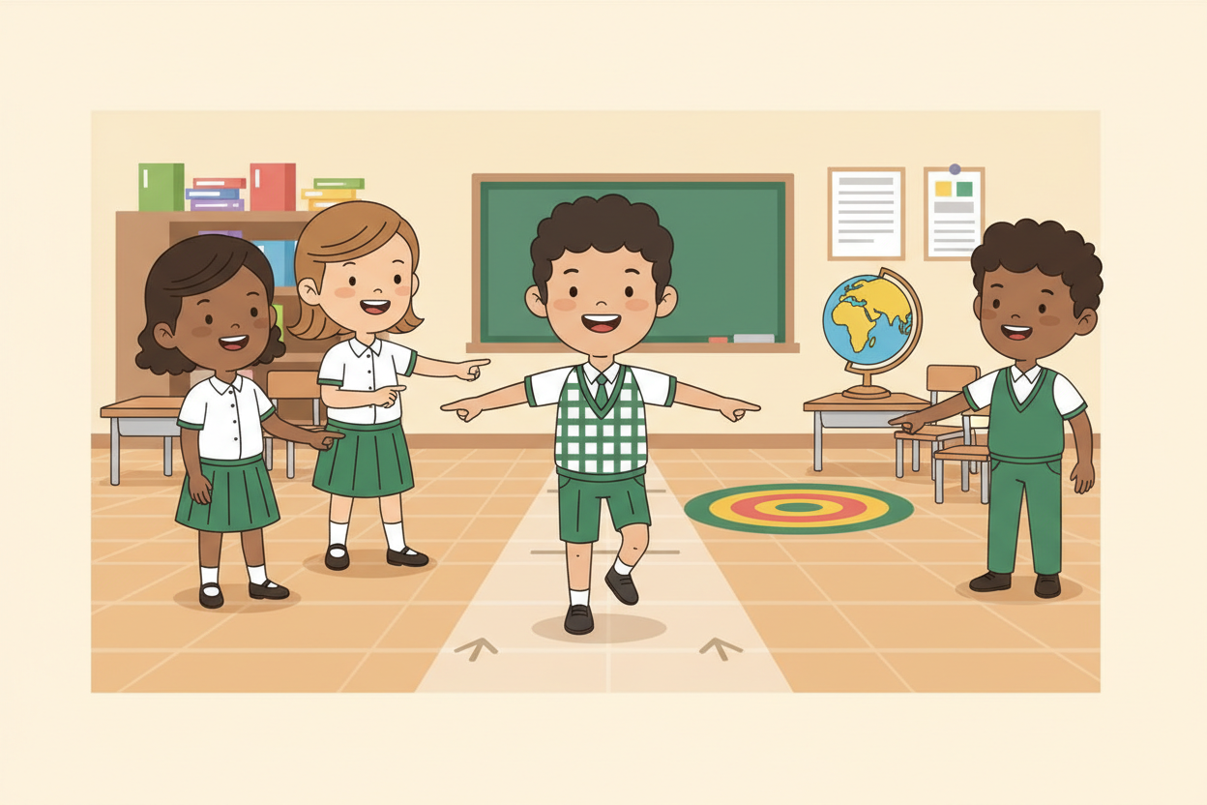
Picture 1. The robot obeys every word: say exactly what to do.

Picture 2. Every day runs on algorithms: hands, buses, phones.
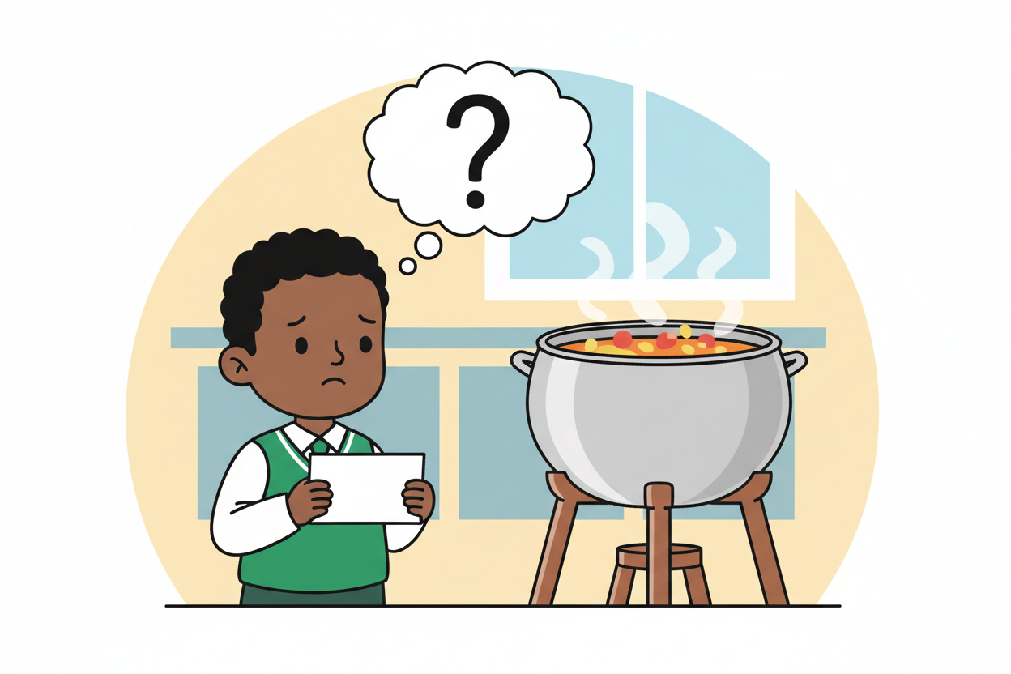
Picture 3. Vague steps break algorithms: how much water, exactly?
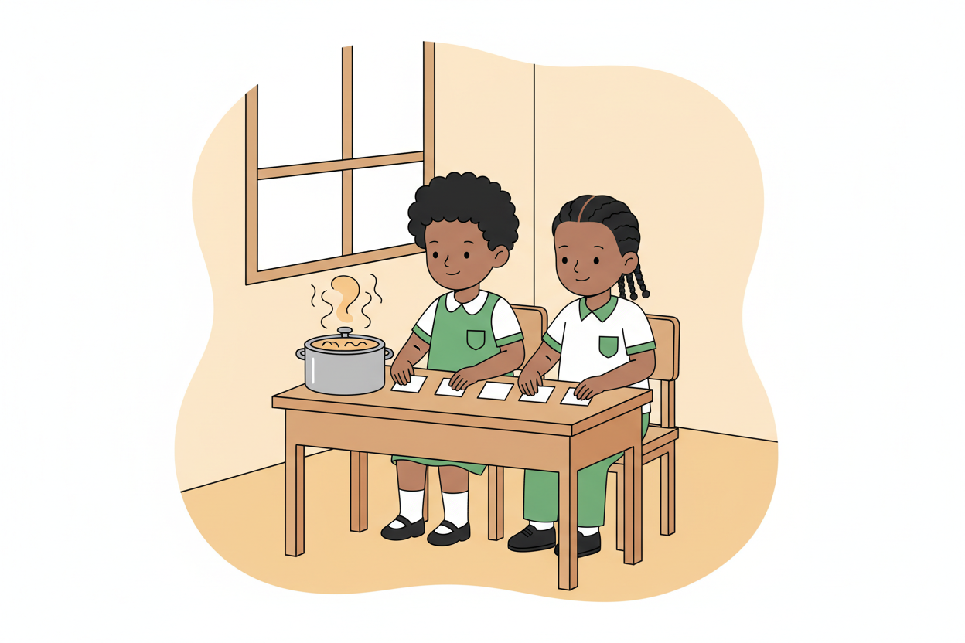
Picture 4. Write the meal algorithm, then follow it exactly.

7. Period Two: Practise and Apply
- Cooking algorithm (25 minutes): pairs write the algorithm for cooking a simple familiar meal: exact quantities (three cups), exact actions (stir until it thickens), exact order. The teacher supplies the known recipe as a reference.
- Swap and test (15 minutes): pairs swap algorithms and follow them exactly as written; any step that fails or confuses is marked. Pairs get their algorithms back and fix the marked steps.
- Close (5 minutes): the class agrees on what makes an algorithm good: precise, ordered, and finishable by someone who has never seen the task.

8. Assessment and Evidence
- Evidence to collect: each pair's cooking algorithm (written and corrected) and one test note from the swapping pair.
Success looks like: algorithms are numbered, precise (no 'some' or 'a bit'), and survive a strict follow-through with at most small fixes.

9. Suggested Questions and Answer Guidance
1. What makes an instruction precise? Expected response: it says exactly what to do, with amounts and order, so no guessing is needed.
2. Why does order matter? Expected response: some steps depend on earlier ones; the wrong order changes or spoils the result.
3. Give one everyday algorithm and its first step. Expected response: any sensible routine with a sensible first step.
4. How is an algorithm different from a program? Expected response: an algorithm is the plan; a program is the plan written in a language a computer can run.

10. Home Activity
Learners write the algorithm for one home task in five steps (sweeping the compound, washing a plate, fetching water) and bring it; no device needed.

11. Inclusion
Instructions may be given, written or signed; the robot obeys any clear signal the class agrees on, including gestures. Reading aloud is shared so no learner is put on the spot alone. No colour-only cues in any card.

12. Safety and Privacy
Cooking stays on paper: no heat, knives or real food handling. Robot-walking routes are checked for obstacles before the game starts.

13. Teacher Reflection
After the lesson, note what worked, which parts confused the class, which pupils need follow-up, and one change for next term.
Reflection notes
__________________________________________________________________________________________

14. Curriculum Alignment and Document Status
This note expands the Rehoteq AI Education Curriculum, a proposed curriculum for school pilot, review and consultation; not an officially approved national syllabus. It does not replace the current NERDC curriculum or examination-board requirements, and schools remain responsible for checking current NERDC requirements and their own calendar before implementation.

Prepared by Rehoteq Technologies (rehoteq.com). First edition, November 2026.

