REHOTEQ
AI EDUCATION CURRICULUM
―――――――――――――――――――――――

Comprehensive Teacher's Lesson Note
Scratch: Interface
Junior Secondary 1 · Second Term · Week 4

Field | Detail
Subject | AI Education and Digital Skills
Academic session | 2026/2027
Duration | 2 periods (40 to 45 minutes each, subject to the school timetable)
Document type | Comprehensive Teacher's Lesson Note
Curriculum status | Proposed curriculum for school pilot, review and consultation
Prepared by | Rehoteq Technologies (rehoteq.com)
Edition | First edition, November 2026

PROPOSED CURRICULUM NOTICE: This lesson note expands the Rehoteq AI Education Curriculum's proposed Junior Secondary 1, Second Term, Week 4 scheme of work. It is offered for school pilot, review and consultation. It is not represented as an officially approved national syllabus, and it does not replace the current NERDC curriculum or any examination-board requirement.

1. Lesson Information
Field | Detail
Class | JSS 1
Subject | AI Education and Digital Skills
Term | Second Term
Week | Week 4 of Second Term
Topic | Scratch interface: stage, sprites and blocks; a first animation
Duration | 2 periods (40 to 45 minutes each)

2. Learning Outcome
By the end of the lesson, learners can:
- Name the three main parts of Scratch: the stage, the sprite list and the blocks palette.
- Move and turn a sprite on the stage.
- Snap three blocks into a small program and run it.
- Explain in their own words what a block of code does.

3. Weekly Scheme Content
Period | Scheme content
Period 1 | Stage, sprites and blocks
Period 2 | Explore with a first animation
Weeks 11 to 13 of the term are reserved for examinations, marking and results. Do not introduce new content during those weeks.

4. Materials and Preparation
- One computer per pair where available, with Scratch (offline app or scratch.mit.edu in a browser).
- Printed block cards: large blank puzzle-piece shapes in three colours (motion, looks, events) for the unplugged version.
- Board drawing of the Scratch window divided into the three areas.
No-lab fallback: the class runs the same lesson with paper block cards. Learners snap cards in order on the desk and one learner 'runs' the program by acting it out while the class checks the order.

5. Period One: Introduce and Model
- Starter (5 minutes): play 'teacher the robot': the teacher only follows exactly spoken step commands, showing why instructions must be exact and ordered.
- Tour (10 minutes): on the board (or one projected computer), name the three areas: the stage is where things happen, sprites are the characters, and blocks are the instructions you snap together. Emphasise the colour groups: blue blocks move things, purple blocks change how things look.
- Model (10 minutes): snap together, out loud and in order: when the green flag is clicked, move ten steps, say hello for two seconds. Run it. Change the number to fifty and run again. Learners predict before each run.
- Hands-on (15 minutes): pairs open Scratch, find each area, and rebuild the three-block program. Early finishers add a turn block.

6. Lesson Pictures
Show these pictures while teaching. Use each one to point back at the week it comes from before the class moves on.

Picture 1. The stage is where the action happens; the sprite stands on it.

Picture 2. Blocks are the instructions: each coloured shape is one command you snap together.
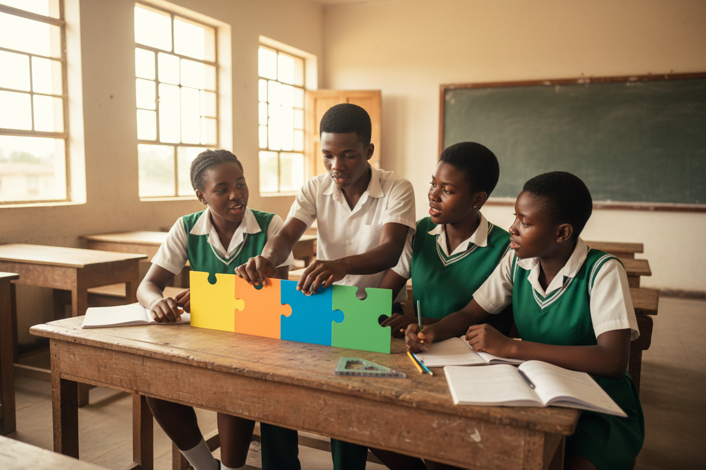
Picture 3. Planning on paper first: laying the blocks in order before touching the computer.
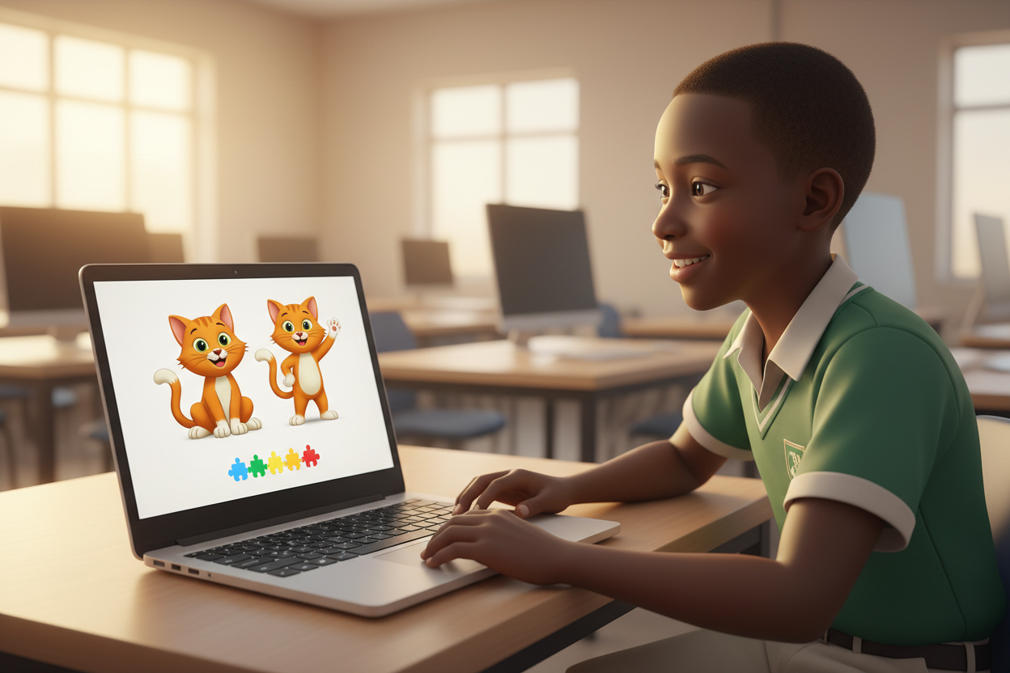
Picture 4. The first animation runs: two frames of the same character, one small program.

7. Period Two: Practise and Apply
- First animation (25 minutes): pairs build a two-step story: their sprite walks forward, turns, and says something for two seconds. Encourage changing the sprite's costume for a simple animation effect.
- Unplugged group (parallel): teams lay paper block cards for the same two-step story; the teacher checks the order before they 'run' it by acting.
- Show and tell (10 minutes): three pairs run their animations; the class names the three blocks each pair used.
- Save and close (5 minutes): each pair saves their project with the school's naming pattern (class week surname, no personal photos).

8. Assessment and Evidence
- Evidence to collect: each pair's saved project (or photographed card layout), plus the show-and-tell observation notes.
Success looks like: every pair can point to stage, sprite and blocks and name them, and every built program runs without error when the flag is clicked.

9. Suggested Questions and Answer Guidance
1. What is the difference between the stage and a sprite? Expected response: the stage is the background scene; the sprite is the character that acts on it.
2. Why must blocks snap in order? Expected response: the computer follows instructions top to bottom; a wrong order gives a wrong result.
3. What does changing the number in a move block change? Expected response: how far the sprite moves.
4. Name one real thing a program and a recipe have in common. Expected response: both are ordered steps that must be followed exactly to get the result.

10. Home Activity
Learners write the three blocks of their animation in their books as coloured shapes and label each with what it does; no computer is needed at home.

11. Inclusion
Pairs pair a confident user with a newer one and swap driver seats halfway. The paper-card version is a full alternative, not a lesser one: unplugged teams present the same way. Learners with limited hand mobility may direct a partner verbally.

12. Safety and Privacy
Projects are saved with class-and-week names only, never a pupil's full name or photo as the sprite. No accounts are created online: schools using Scratch offline avoid sign-ups entirely, per the curriculum's no-child-accounts rule.

13. Teacher Reflection
After the lesson, note what worked, which parts confused the class, which pupils need follow-up, and one change for next term.
Reflection notes
__________________________________________________________________________________________

14. Watch the Lesson Video
This week's lesson video is online at https://rehoteq.com/videos/Rehoteq_JSS1_T2_W4_Scratch_Interface.mp4. Learners can scan the code below on a phone to watch it.
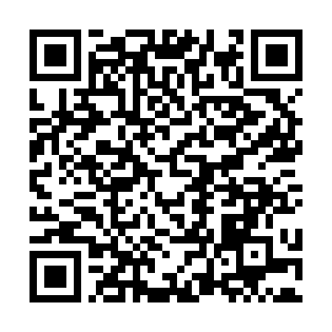
Scan to watch the Week 4 Scratch interface video.

15. Curriculum Alignment and Document Status
This note expands the Rehoteq AI Education Curriculum, a proposed curriculum for school pilot, review and consultation; not an officially approved national syllabus. It does not replace the current NERDC curriculum or examination-board requirements, and schools remain responsible for checking current NERDC requirements and their own calendar before implementation.

Prepared by Rehoteq Technologies (rehoteq.com). First edition, November 2026.

