REHOTEQ
AI EDUCATION CURRICULUM
―――――――――――――――――――――――

Comprehensive Teacher's Lesson Note
Number systems
Junior Secondary 1 · Second Term · Week 9

Field | Detail
Subject | AI Education and Digital Skills
Academic session | 2026/2027
Duration | 2 periods (40 to 45 minutes each, subject to the school timetable)
Document type | Comprehensive Teacher's Lesson Note
Curriculum status | Proposed curriculum for school pilot, review and consultation
Prepared by | Rehoteq Technologies (rehoteq.com)
Edition | First edition, November 2026

PROPOSED CURRICULUM NOTICE: This lesson note expands the Rehoteq AI Education Curriculum's proposed Junior Secondary 1, Second Term, Week 9 scheme of work. It is offered for school pilot, review and consultation. It is not represented as an officially approved national syllabus, and it does not replace the current NERDC curriculum or any examination-board requirement.

1. Lesson Information
Field | Detail
Class | JSS 1
Subject | AI Education and Digital Skills
Term | Second Term
Week | Week 9 of Second Term
Topic | Number systems: counting in twos; binary and the computer
Duration | 2 periods (40 to 45 minutes each)

2. Learning Outcome
By the end of the lesson, learners can:
- Explain that computers store everything as on or off signals, counted in twos.
- Count in twos using a binary place pattern and read small binary numbers.
- Convert small numbers between ones-and-twos counting and ordinary digits.
- Explain why the same count can look different in different number systems.

3. Weekly Scheme Content
Period | Scheme content
Period 1 | Counting in twos
Period 2 | Binary on paper
Weeks 11 to 13 of the term are reserved for examinations, marking and results. Do not introduce new content during those weeks.

4. Materials and Preparation
- Counters or bottle tops, at least twenty per team; one plain card per team divided into four boxes.
- A lamp or torch for the on-off demonstration; the Week 8 decision cards for the link to conditions.
- Paper and pencils; printed binary pattern cards where available.
No-lab fallback: counters on paper boxes. Each box holds at most one counter; a filled box counts as on, an empty one as off, and the team reads the total by adding the box values.

5. Period One: Introduce and Model
- Starter (5 minutes): count aloud in ones, then ask how many different digits we need. Introduce the idea that another way of counting needs fewer symbols.
- Teach (10 minutes): computers only know two states, on and off (a lamp on or off). Everything inside a computer, from letters to pictures, is stored as patterns of on and off, and counting with on and off is counting in twos.
- Model (10 minutes): on the board draw four boxes worth one, two, four, eight from left to right (write the values above the boxes). Show how a filled box adds its value: two filled boxes make three, five or other totals.
- Guided practice (15 minutes): teams use bottle tops to build totals of three, five and six in the boxes, then read what each other's layout says.

6. Lesson Pictures
Show these pictures while teaching. Use each one to point back at the week it comes from before the class moves on.

Picture 1. A lamp has two states: on or off. Two signals are enough to count with.
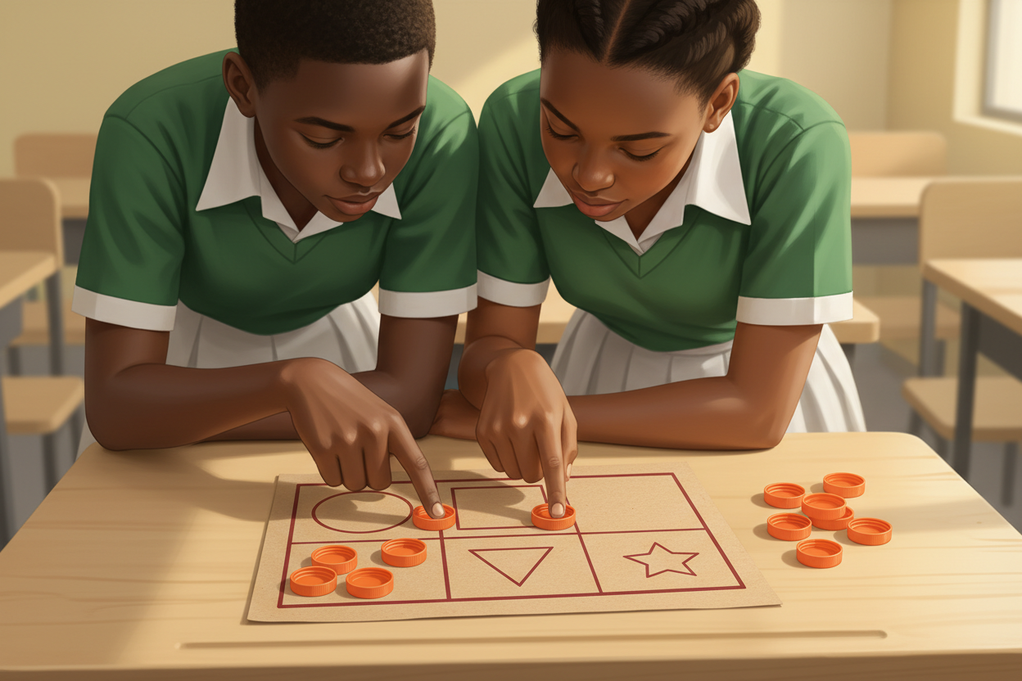
Picture 2. Four boxes, one counter each: fill the boxes to make the total.

Picture 3. Same total, different counting: the layout says the number.

Picture 4. Inside every computer, letters and pictures ride on patterns of on and off.

7. Period Two: Practise and Apply
- Binary on paper (25 minutes): teams receive target totals and build them with counters in the four boxes, then write the pattern (filled or empty per box) and swap with another team to read.
- The big idea (10 minutes): as a class, follow how a letter typed on a keyboard becomes a pattern of on and off inside the machine; connect to Week 8: the computer checks states and decides.
- Close (5 minutes): each team says one thing it now knows about how computers store information that it did not know before today.

8. Assessment and Evidence
- Evidence to collect: each team's counter layouts for the target totals and its written patterns.
Success looks like: teams can build a given total in the boxes, read another team's pattern correctly, and explain the on-off idea in their own words.

9. Suggested Questions and Answer Guidance
1. Why do computers count in twos? Expected response: a circuit is either on or off, so two states are what the machine can hold reliably.
2. What does an empty box contribute? Expected response: nothing; only a filled box adds its value.
3. Is the number itself different, or only the way we write it? Expected response: the number is the same; only the counting system differs.
4. Where else might on-off patterns appear in daily life? Expected response: light switches, a series of lamps, a row of flags up or down.

10. Home Activity
Learners make two rows of five marks for on and off at home (a switched-on lamp row and a switched-off lamp row) and bring the sheet back; no device or purchase needed.

11. Inclusion
Counters are handled, so the work is touch-first for every learner; teams may count aloud, sign the totals or point. No colour-only cues: filled versus empty is a position and object cue. Card teams use the same rubric.

12. Safety and Privacy
Small counters stay on the desk and are counted back at the end of each activity. The lamp demonstration uses a safe classroom lamp, never an open flame or mains wiring.

13. Teacher Reflection
After the lesson, note what worked, which parts confused the class, which pupils need follow-up, and one change for next term.
Reflection notes
__________________________________________________________________________________________

14. Curriculum Alignment and Document Status
This note expands the Rehoteq AI Education Curriculum, a proposed curriculum for school pilot, review and consultation; not an officially approved national syllabus. It does not replace the current NERDC curriculum or examination-board requirements, and schools remain responsible for checking current NERDC requirements and their own calendar before implementation.

Prepared by Rehoteq Technologies (rehoteq.com). First edition, November 2026.

