REHOTEQ
AI EDUCATION CURRICULUM
―――――――――――――――――――――――

Comprehensive Teacher's Lesson Note
AI in Nigerian Services
Junior Secondary 1 · First Term · Week 7

Field | Detail
Subject | AI Education and Digital Skills
Academic session | 2026/2027
Duration | 2 periods (40 to 45 minutes each, subject to the school timetable)
Document type | Comprehensive Teacher's Lesson Note
Curriculum status | Proposed curriculum for school pilot, review and consultation
Prepared by | Rehoteq Technologies (rehoteq.com)
Edition | First edition, November 2026

PROPOSED CURRICULUM NOTICE: This lesson note expands the Rehoteq AI Education Curriculum's proposed Junior Secondary 1, First Term, Week 7 scheme of work. It is offered for school pilot, review and consultation. It is not represented as an officially approved national syllabus, and it does not replace the current NERDC curriculum or any examination-board requirement.

1. Lesson Information
Field | Detail
Class | JSS 1
Subject | AI Education and Digital Skills
Term | First Term
Week | Week 7 of First Term
Topic | AI in Nigerian services: banks, farms, transport and health
Duration | 2 periods (40 to 45 minutes each)

2. Learning Outcome
By the end of the lesson, learners can:
- Name at least three Nigerian services that use artificial intelligence and what each uses it for.
- Explain how AI helps a bank protect customers' money, in one or two sentences.
- Explain how AI helps a farmer or a hospital worker do a job faster or safer.
- Sort a mixed list of tasks into computer-decides and human-decides, and justify each choice.

3. Weekly Scheme Content
Period | Scheme content
Period 1 | Tour of AI in Nigerian banks, farms, transport and health
Period 2 | Service matching game and human-in-the-loop discussion
Weeks 11 to 13 of the term are reserved for examinations, marking and results. Do not introduce new content during those weeks.

4. Materials and Preparation
- The six service cards used in the matching game (bank fraud alert, farm app, ride/traffic app, hospital scan helper, customer service chat, weather advisory for farmers). Cards can be hand-drawn.
- A wall chart titled Our services with three columns: the service, what the computer learned, what the human still checks.
- Marker board and chalk for the sorting task.
No-lab fallback: run the matching game on the board. Write the six service names on one side and what each computer learned on the other in mixed order, and let teams draw lines to match them. The hospital example is told as a story with the chart, no projector needed.

5. Period One: Introduce and Model
- Starter (5 minutes): ask where learners have seen a machine help an adult work: the market, the bank, the farm, the clinic. Collect on the board.
- Teach (12 minutes): tour the four services with the chart. Bank: the computer learns what normal spending looks like for a customer and stops or alerts on spending that does not fit, while a human officer confirms. Farm: apps that read leaf photos and match plant diseases, and weather advisories that help farmers plan planting. Transport: maps that learn road patterns and suggest faster routes, and ride apps that match riders and passengers. Health: computer helpers that flag anything unusual on a scan or record, always with a doctor or nurse making the final call.
- Model (8 minutes): take one service, walk the full chain on the board: data collected, pattern learned, decision suggested, human confirms. Use the bank example and act it: pupil is the computer, teacher is the bank officer.
- Guided practice (10 minutes): in pairs, learners pick one service and draw its chain in four boxes in their books.
- Check (5 minutes): oral quiz: what does the computer do in each chain, and what does the human do?

6. Lesson Pictures
Show these pictures while teaching. Talk about each one before moving on, and ask learners to name a place in Nigeria where they have seen the same thing.
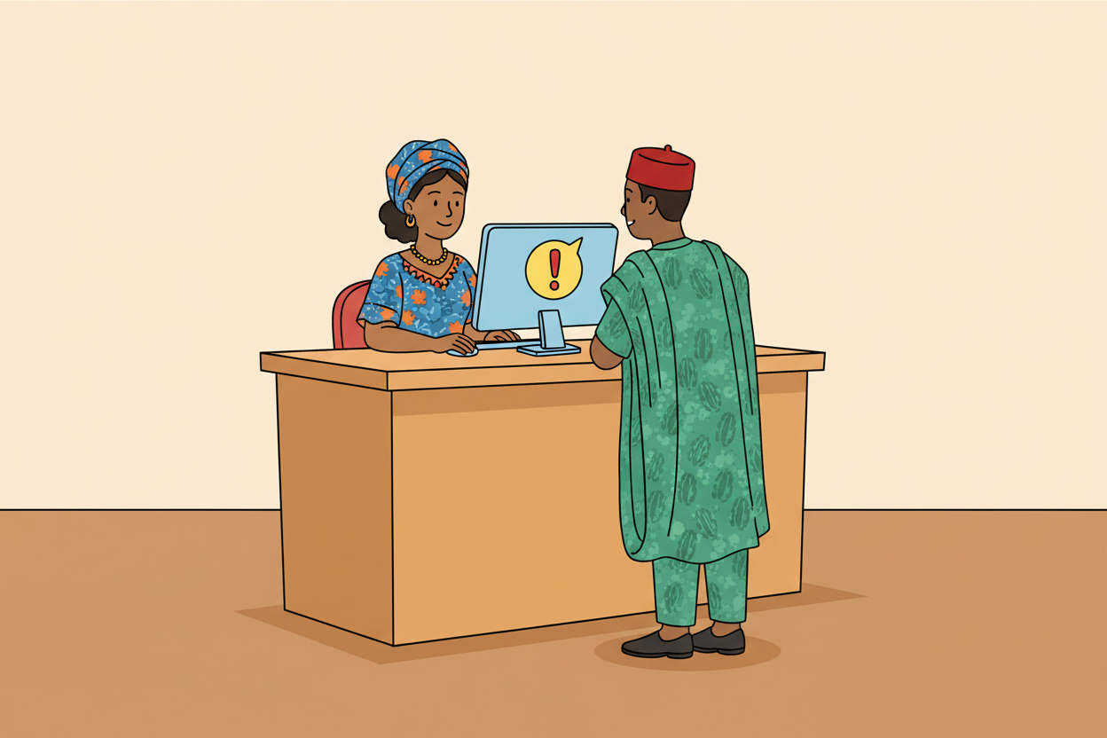
Picture 1. In a bank, a learning system watches spending patterns and can raise an alert when something does not fit, while a human officer confirms what happens next.
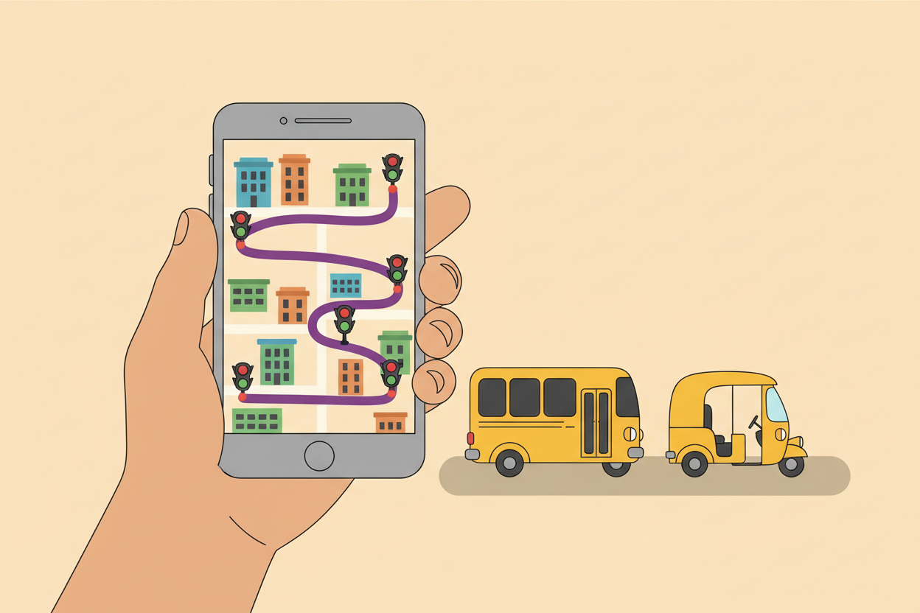
Picture 2. Transport apps learn road patterns and can suggest a faster route across town.
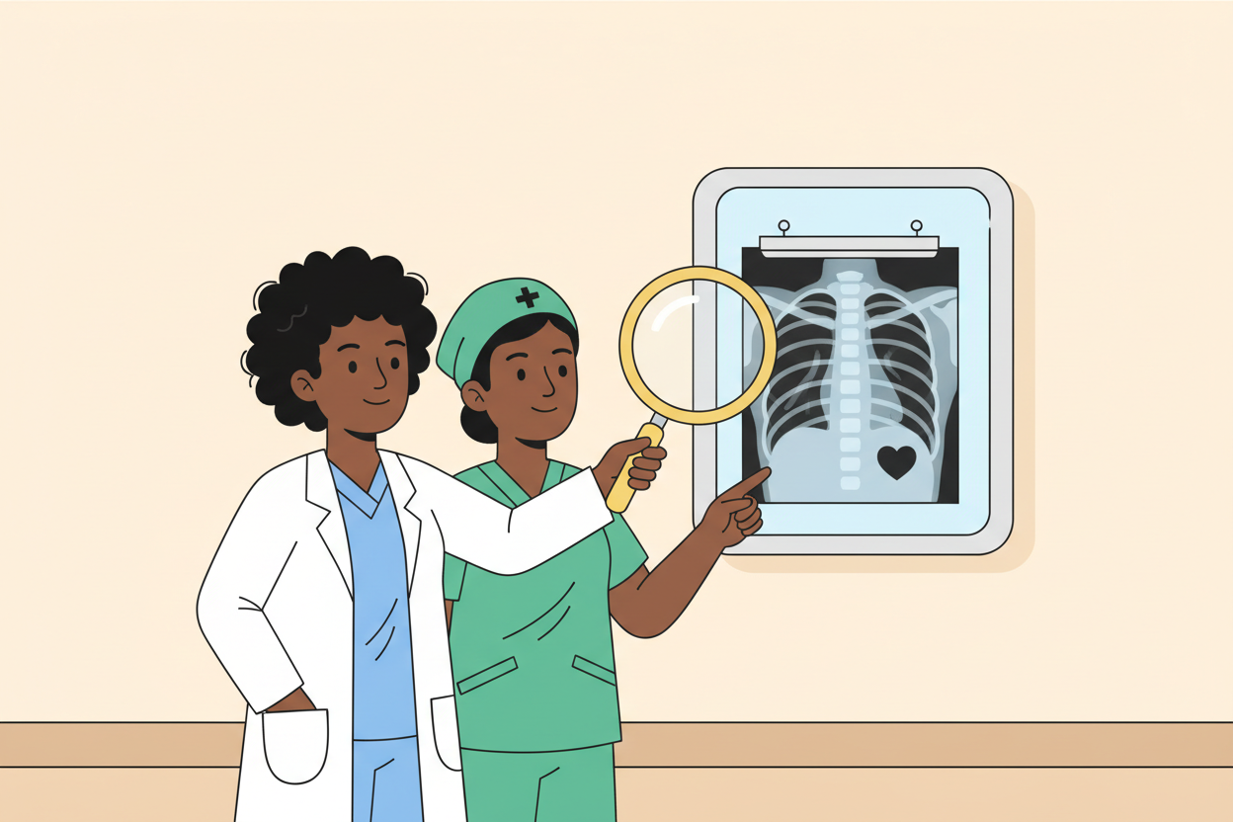
Picture 3. In clinics, a computer helper can point at anything unusual on a scan, and the doctor or nurse still makes the final decision.
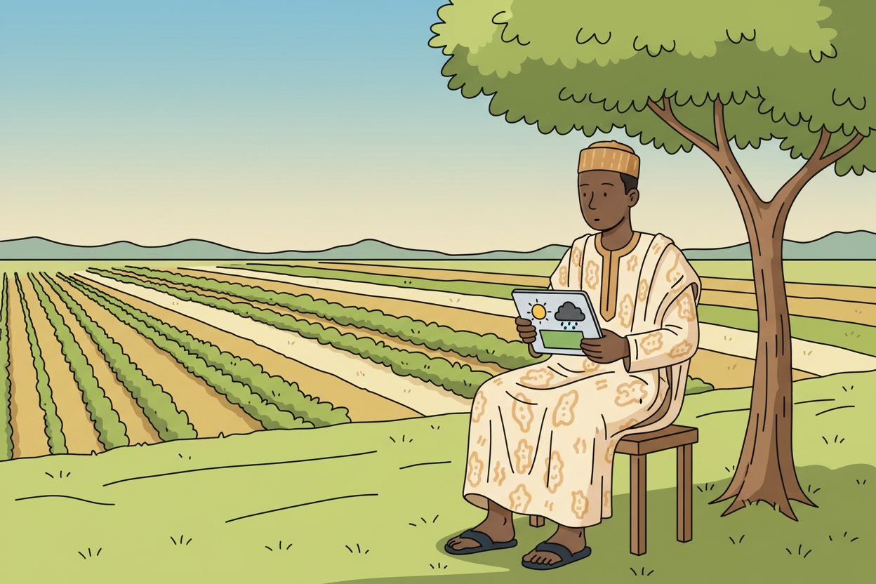
Picture 4. Farmer advice services combine weather and field patterns so planting and harvest days are planned better.

7. Period Two: Practise and Apply
- Service matching game (15 minutes): teams match the six service cards to what each computer learned, then defend one match aloud.
- Human in the loop (10 minutes): using the bank and health examples, the class lists on the chart what only the human should confirm, and why: fairness, feelings, final responsibility.
- Write and recap (15 minutes): each learner writes two sentences: one AI help they would like to see in a service their family uses, and one reason a human must still check it.

8. Assessment and Evidence
- Evidence to collect: each pair's four-box service chain drawing, and each learner's two written sentences.
Success looks like: chains show both a learned pattern and a human check, and the written sentences name a real service.

9. Suggested Questions and Answer Guidance
1. Name three Nigerian services that use AI and what each uses it for. Expected response: any three sensible services from the lesson with a matching use, such as banks for fraud alerts, farms for disease spotting, transport for route suggestions, clinics for scan checks.
2. How does a bank's AI help protect customers' money? Expected response: it learns what a customer's normal spending looks like and alerts or blocks spending that does not fit, and a bank officer confirms.
3. Why must a doctor still check the computer's finding? Expected response: because the computer only suggests based on patterns, and the doctor's training and judgement decide what is true for this patient.
4. Give one task a computer does better and one a human does better in a bank. Expected response: computer: watching thousands of transactions quickly; human: understanding a customer's real situation and making the final call.

10. Home Activity
Learners ask one adult at home which bank, farm or health service they use that sends alerts or advice, and write one sentence on what the alert might have learned from.

11. Inclusion
All examples are oral, drawn or on cards, so learners who write slowly can still lead the matching game. Pair learners so stronger readers support others, and keep cards large and close for learners with low vision.

12. Safety and Privacy
No real customer records, health records or personal details are discussed or shown: all examples are invented. Remind learners never to share their parents' account details, phone numbers or photos with any app without an adult's permission.

13. Teacher Reflection
After the lesson, note what worked, which parts confused the class, which pupils need follow-up, and one change for next time.
Reflection notes
__________________________________________________________________________________________

14. Curriculum Alignment and Document Status
This note expands the Rehoteq AI Education Curriculum, a proposed curriculum for school pilot, review and consultation; not an officially approved national syllabus. It does not replace the current NERDC curriculum or examination-board requirements, and schools remain responsible for checking current NERDC requirements and their own calendar before implementation.

Prepared by Rehoteq Technologies (rehoteq.com). First edition, November 2026.

