REHOTEQ
AI EDUCATION CURRICULUM
―――――――――――――――――――――――

Comprehensive Teacher's Lesson Note
Classification: Sorting Things into Groups
Junior Secondary 1 · First Term · Week 8

Field | Detail
Subject | AI Education and Digital Skills
Academic session | 2026/2027
Duration | 2 periods (40 to 45 minutes each, subject to the school timetable)
Document type | Comprehensive Teacher's Lesson Note
Curriculum status | Proposed curriculum for school pilot, review and consultation
Prepared by | Rehoteq Technologies (rehoteq.com)
Edition | First edition, November 2026

PROPOSED CURRICULUM NOTICE: This lesson note expands the Rehoteq AI Education Curriculum's proposed Junior Secondary 1, First Term, Week 8 scheme of work. It is offered for school pilot, review and consultation. It is not represented as an officially approved national syllabus, and it does not replace the current NERDC curriculum or any examination-board requirement.

1. Lesson Information
Field | Detail
Class | JSS 1
Subject | AI Education and Digital Skills
Term | First Term
Week | Week 8 of First Term
Topic | Classification: how machines sort things into groups
Duration | 2 periods (40 to 45 minutes each)

2. Learning Outcome
By the end of the lesson, learners can:
- Explain classification in simple words: putting things into groups based on what they look like or how they behave.
- Give the class's own sorting activity as an example of how a machine learns to classify: first many labelled examples, then a new item.
- Classify a new example correctly using features, and say which features mattered.
- Name one thing that can go wrong when examples are poor, and what it would cause.

3. Weekly Scheme Content
Period | Scheme content
Period 1 | Features and grouping: the class sorts real items
Period 2 | Classify like a machine: labelling examples, then a surprise item
Weeks 11 to 13 of the term are reserved for examinations, marking and results. Do not introduce new content during those weeks.

4. Materials and Preparation
- A bag of everyday items for sorting: bottle top, leaf, stone, button, piece of cloth, pen cap, small tin, seed, paper clip, plastic spoon. Twenty to thirty items total.
- Two or three large labelled sorting trays or paper circles: one per group.
- A chalkboard table with three columns: item, its features, its group.
- A surprise-item envelope holding one new object the class has not seen, such as a key or a bottle opener.
No-lab fallback: the activity is fully hands-on with everyday objects, no computer needed. If items are scarce, use drawn cards instead: ten simple object drawings the teacher cuts out beforehand.

5. Period One: Introduce and Model
- Starter (5 minutes): hold up two items, a leaf and a stone, and ask what makes them different. Collect feature words on the board.
- Teach (10 minutes): define classification: sorting things into groups by their features. Connect it to yesterday's AI definition: a machine classifies by learning which features belong to which group from many examples.
- Model (10 minutes): sort three items on the board table: write the item, list its features, state its group. Say the rule aloud each time: look at the features, then choose the group.
- Guided practice (15 minutes): each group receives the item bag and sorts all items into two or three groups of its choice, then reports: group name, which features decided it.

6. Lesson Pictures
Show these pictures while teaching. Talk about each one before moving on, and ask learners to add one more example of their own.
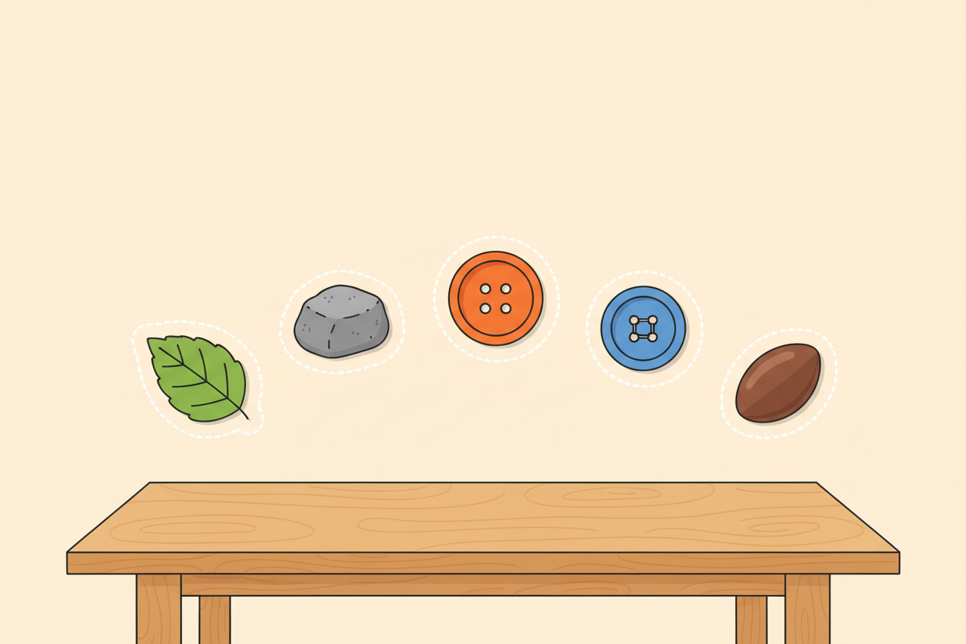
Picture 1. Sorting starts with looking closely: shape, colour, size and feel are the features that decide each group.
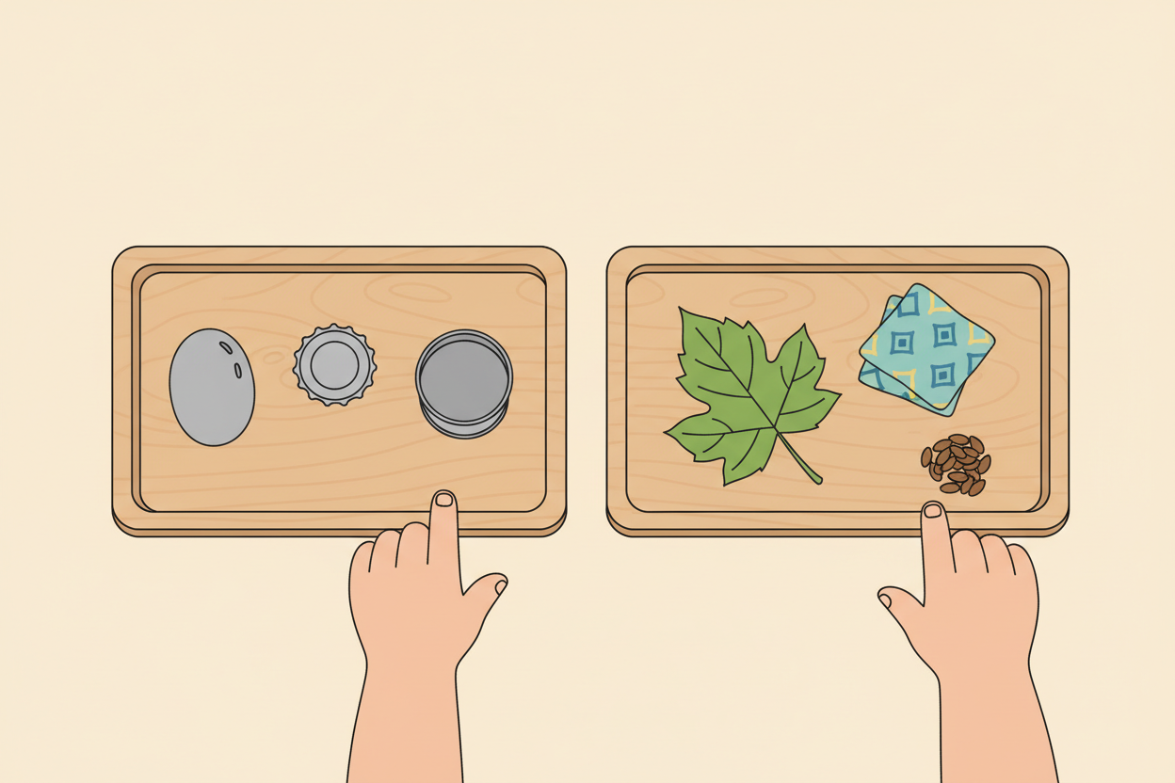
Picture 2. Items land in labelled groups: hard and shiny in one tray, soft and natural in another.
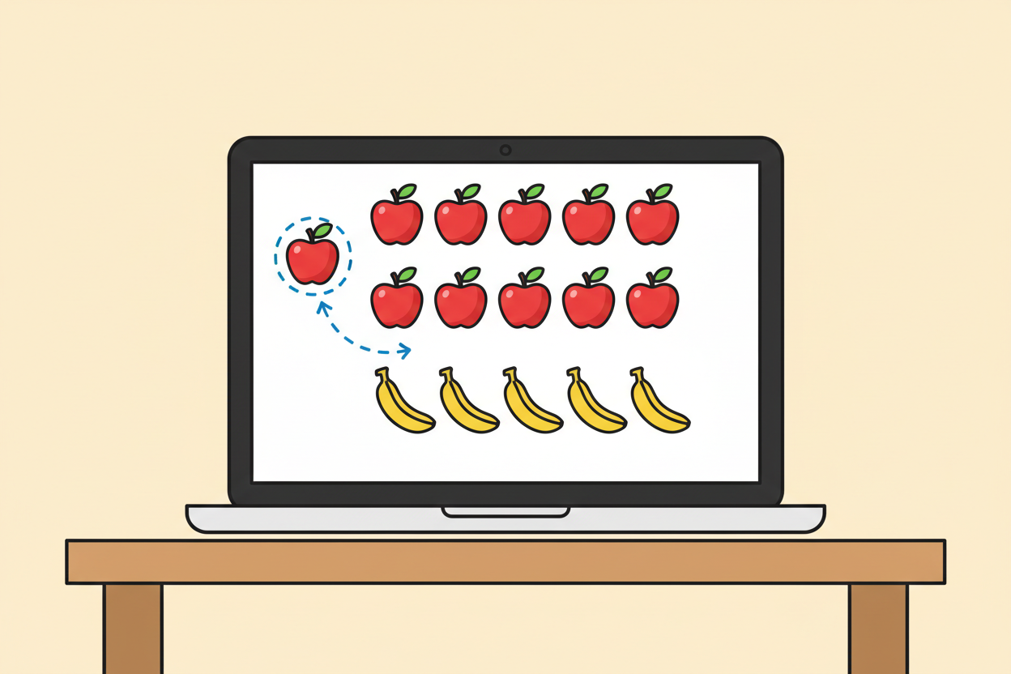
Picture 3. A machine classifies the same way: it has seen many labelled examples and matches the new one to the closest pattern.
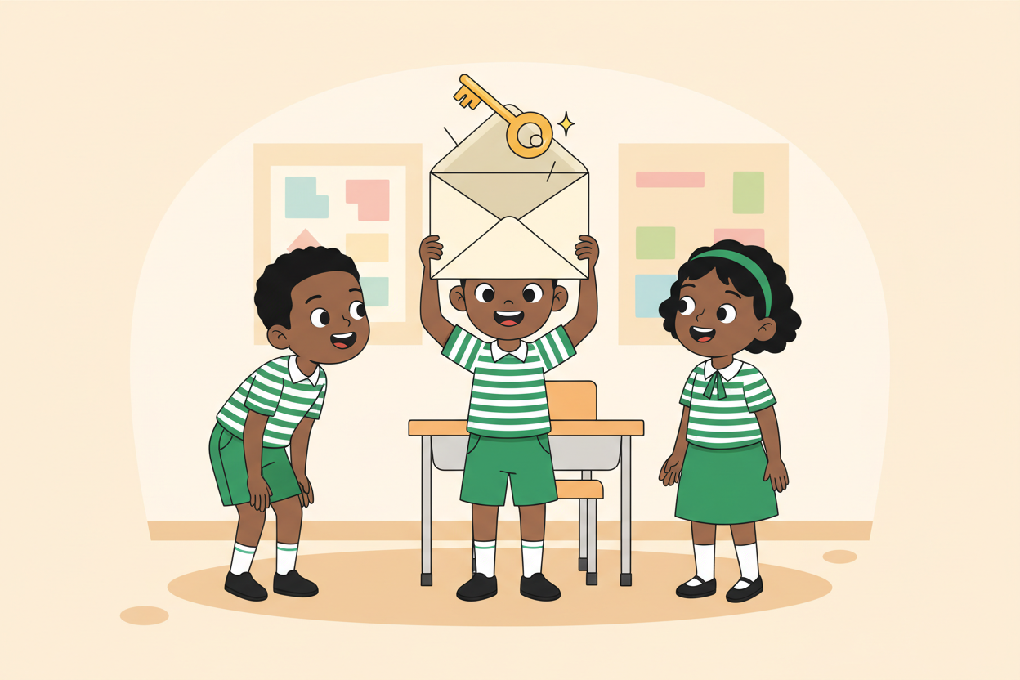
Picture 4. A surprise item is the real test: the class must name its features first, then the group.

7. Period Two: Practise and Apply
- Labelling round (15 minutes): each group re-labels its sorted items, one label per item, as if teaching a machine: item name plus group. This mirrors the labelled examples a machine needs.
- Surprise test (15 minutes): the teacher reveals the surprise item. Groups write its features, then predict which group it belongs in, and defend the prediction with the features. The class compares answers.
- Recap and write (10 minutes): learners write the definition of classification and one sentence on what a machine needs before it can classify: many labelled examples.

8. Assessment and Evidence
- Evidence to collect: each group's labelled item list, and each group's surprise-item prediction with its features.
Success looks like: predictions are defended with named features, and every labelled list is complete for the group's items.

9. Suggested Questions and Answer Guidance
1. What is classification? Expected response: sorting things into groups based on their features.
2. What did your group use to decide its groups? Expected response: named features such as shape, hardness, material or size.
3. A machine has never seen your surprise item. How can it still classify it? Expected response: it compares the item's features with the patterns it learned from many labelled examples.
4. What can go wrong if the examples a machine learns from are poor? Expected response: it learns the wrong patterns and classifies new things wrongly, for example unfair or silly groupings.

10. Home Activity
Learners sort five things in their homes into two groups and write the features that decided each group, ready to show next class.

11. Inclusion
Sorting is done in mixed-ability groups with rotated reporters, so every learner handles and describes at least one item. Learners who struggle with writing may dictate labels to a groupmate or draw them. Items are large enough to handle safely.

12. Safety and Privacy
Handle items hygienically: wash hands after the activity and wipe trays. Never use sharp, broken or dirty objects as sorting items, and no learner's personal belongings are photographed or recorded.

13. Teacher Reflection
After the lesson, note what worked, which parts confused the class, which pupils need follow-up, and one change for next time.
Reflection notes
__________________________________________________________________________________________

14. Curriculum Alignment and Document Status
This note expands the Rehoteq AI Education Curriculum, a proposed curriculum for school pilot, review and consultation; not an officially approved national syllabus. It does not replace the current NERDC curriculum or examination-board requirements, and schools remain responsible for checking current NERDC requirements and their own calendar before implementation.

Prepared by Rehoteq Technologies (rehoteq.com). First edition, November 2026.

