REHOTEQ
AI EDUCATION CURRICULUM
―――――――――――――――――――――――

Comprehensive Teacher's Lesson Note
Internet and Email
Junior Secondary 1 · First Term · Week 5

Field | Detail
Subject | AI Education and Digital Skills
Academic session | 2026/2027
Duration | 2 periods (40 to 45 minutes each, subject to the school timetable)
Document type | Comprehensive Teacher's Lesson Note
Curriculum status | Proposed curriculum for school pilot, review and consultation
Prepared by | Rehoteq Technologies (rehoteq.com)
Edition | First edition, November 2026

PROPOSED CURRICULUM NOTICE: This lesson note expands the Rehoteq AI Education Curriculum's proposed Junior Secondary 1, First Term, Week 5 scheme of work. It is offered for school pilot, review and consultation. It is not represented as an officially approved national syllabus, and it does not replace the current NERDC curriculum or any examination-board requirement.

1. Lesson Information
Field | Detail
Class | JSS 1
Subject | AI Education and Digital Skills
Term | First Term
Week | Week 5 of First Term
Topic | Internet and Email
Duration | 2 periods (40 to 45 minutes each)

2. Learning Outcome
By the end of the lesson, learners can:
- Explain the internet as a worldwide network of connected computers, and give three things Nigerians use it for every day.
- Name the parts of an email message: the address, the subject line, the message body, and the send button.
- Demonstrate safe browsing habits: visiting sites a trusted adult names, not sharing personal details, and asking before clicking anything new.
- Use the key words of the week correctly in a sentence: internet, browser, website, email, address, subject, attachment.

3. Weekly Scheme Content
Period | Scheme content
Period 1 | Browsing safely; sending mail
Period 2 | Compose and send a practice mail
Weeks 11 to 13 of the term are reserved for examinations, marking and results. Do not introduce new content during those weeks.

4. Materials and Preparation
- One connected computer or phone the teacher may use for a live demonstration, tested before the lesson.
- A wall chart of an email window with its parts marked: address lines, subject line, message area and send button.
- Paper envelopes and letter slips for the unplug-the-post comparison game.
- A printed list of three class-approved websites the demonstration will visit.
No-lab fallback: the lesson runs as a role-play. Paper envelopes become email messages: learners write a recipient name on the front and a subject on the slip inside, the teacher plays the postman, and the class discusses what would make a message reach the wrong person. The live demonstration replaces the role-play whenever a connection exists.

5. Period One: Introduce and Model
- Starter (5 minutes): ask learners who has seen an adult send a message or check a result online. Build the idea that the internet is a worldwide road network for information.
- Teach (10 minutes): define the internet, the browser as the vehicle that travels on it, and a website as a place it reaches. Use three Nigerian examples: checking a school result, paying a bill, watching a lesson video.
- Model (10 minutes): on the demonstration machine, open the browser, type the address of an approved website, and show the page loading. Then open the mail window and point out the address, subject and body areas on the chart and the screen.
- Guided practice (10 minutes): with the paper-envelope game, each learner addresses a letter to a classmate with a clear subject line; the class votes which envelopes would clearly reach their owners.
- Check (5 minutes): oral drill: name the four parts of an email message in order.

6. Lesson Pictures
Show these pictures while teaching. Talk about each one before moving on, and ask learners to point to the same thing on the chart or the real machine.

Picture 1. The browser carries us across the internet to a website, the way a bus carries us along a road to a destination.
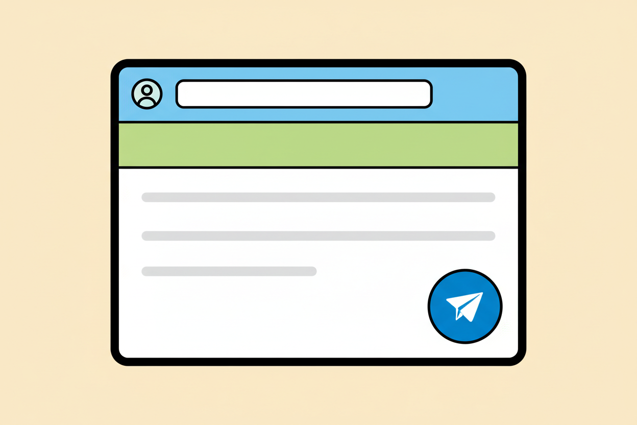
Picture 2. An email has four parts: who it goes to, what it is about, the message itself, and the send button.

Picture 3. Safe browsing: visit only the places a trusted adult names, and ask before clicking anything new.

Picture 4. From paper post to email: a letter once took days; an email travels the world in seconds.

7. Period Two: Practise and Apply
- Practice-mail round (20 minutes): with paper slips where no machine is free, each learner composes a practice mail to a classmate: a recipient line, a subject line and a two-sentence message about the school's inter-house sports. Where one connected machine exists, two pupils at a time compose and send a real practice mail to the teacher's class address.
- Safety sorting (10 minutes): the teacher reads short situations aloud, such as a message asking for a home address, and the class votes share or do not share with a reason.
- Recap and write (10 minutes): learners copy the four parts of an email and two safety rules into their notes.

8. Assessment and Evidence
- Evidence to collect: each learner's composed practice-mail slip, and the class vote results recorded by the teacher.
Success looks like: every practice mail carries a clear recipient, a subject and a two-sentence message; during safety sorting, learners give a reason, not only a vote.

9. Suggested Questions and Answer Guidance
1. What is the internet? Expected response: a worldwide network of connected computers that share information.
2. What is a browser? Expected response: the program we use to visit websites on the internet.
3. Mention the parts of an email message. Expected response: the recipient address, the subject line, the message body and the send button; accept attachments as a fifth part.
4. A message asks you to send your home address. What do you do? Expected response: do not share it, close or report the message, and tell a trusted adult.

10. Home Activity
Learners ask an adult at home to show them one email they have received, and note what the subject line said and whether it was easy to understand.

11. Inclusion
Learners who read slowly may dictate their practice-mail message to a partner, and the safety situations are read aloud twice at a gentle pace. Roles in the role-play are rotated so every learner plays both sender and postman.

12. Safety and Privacy
Learners use only the class-approved websites on the printed list and never enter names, phone numbers, addresses or photographs into any site. No learner creates an account during this lesson, and the practice mail goes only to the teacher's class address.

13. Teacher Reflection
After the lesson, note what worked, which parts confused the class, which pupils need follow-up, and one change for next time.
Reflection notes
__________________________________________________________________________________________

14. Curriculum Alignment and Document Status
This note expands the Rehoteq AI Education Curriculum, a proposed curriculum for school pilot, review and consultation; not an officially approved national syllabus. It does not replace the current NERDC curriculum or examination-board requirements, and schools remain responsible for checking current NERDC requirements and their own calendar before implementation.

Prepared by Rehoteq Technologies (rehoteq.com). First edition, November 2026.

