REHOTEQ
AI EDUCATION CURRICULUM
―――――――――――――――――――――――

Comprehensive Teacher's Lesson Note
Recap
Junior Secondary 1 · Third Term · Week 1

Field | Detail
Subject | AI Education and Digital Skills
Academic session | 2026/2027
Duration | 2 periods (40 to 45 minutes each, subject to the school timetable)
Document type | Comprehensive Teacher's Lesson Note
Curriculum status | Proposed curriculum for school pilot, review and consultation
Prepared by | Rehoteq Technologies (rehoteq.com)
Edition | First edition, November 2026

PROPOSED CURRICULUM NOTICE: This lesson note expands the Rehoteq AI Education Curriculum's proposed Junior Secondary 1, Third Term, Week 1 scheme of work. It is offered for school pilot, review and consultation. It is not represented as an officially approved national syllabus, and it does not replace the current NERDC curriculum or any examination-board requirement.

1. Lesson Information
Field | Detail
Class | JSS 1
Subject | AI Education and Digital Skills
Term | Third Term
Week | Week 1 of Third Term
Topic | Recap: reviewing second term's work; the quiz relay
Duration | 2 periods (40 to 45 minutes each)

2. Learning Outcome
By the end of the lesson, learners can:
- Recall the key ideas of second term: spreadsheets, charts, Scratch basics, sequences, loops, variables, conditions and number systems.
- Use the term's vocabulary correctly in short answers.
- Work in a team to answer revision questions under time pressure.
- Identify their own strong and weak topics and say what they will revise.

3. Weekly Scheme Content
Period | Scheme content
Period 1 | Review of second term
Period 2 | Quiz relay
Weeks 11 to 13 of the term are reserved for examinations, marking and results. Do not introduce new content during those weeks.

4. Materials and Preparation
- One blank page per learner for the self-check; the class's saved programs from Weeks 5 to 9 of last term.
- Quiz relay cards: one question card per station (ten stations cover the term's ten weeks), one answer sheet per team.
- Counters and paper cards from last term for learners who prefer to demonstrate answers physically.
No-lab fallback: the relay runs on paper stations around the classroom; teams rotate, answer, and the teacher reveals the agreed answer at each station.

5. Period One: Introduce and Model
- Starter (5 minutes): without books, list in one minute as many second-term topics as you can remember.
- Review (20 minutes): walk quickly through the term: spreadsheets hold data in rows and columns, charts turn data into pictures, Scratch has five block groups, sequences run top to bottom, loops repeat, variables remember, conditions decide, and computers count in twos. Learners check their own starter list.
- Self-check (15 minutes): each learner writes one topic they feel strong in and one they want to revise, and hands the page in; the teacher uses these to set the relay's pace.

6. Lesson Pictures
Show these pictures while teaching. Use each one to point back at the week it comes from before the class moves on.
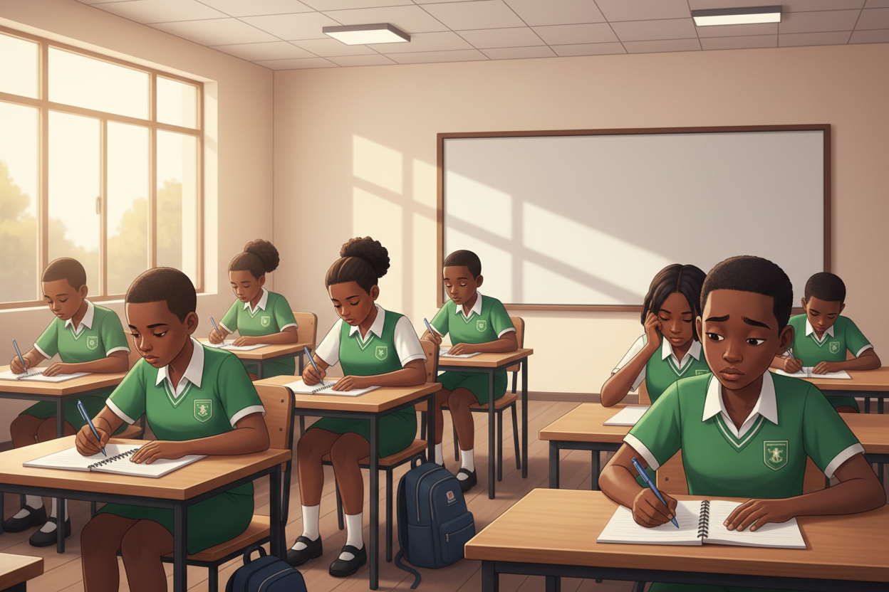
Picture 1. First, remember on your own: one minute, no books, just your memory.

Picture 2. The whole term on one board: from spreadsheets to counting in twos.

Picture 3. Strong topic, revision topic: know where you stand.

Picture 4. The quiz relay: ten stations, one team, keep moving.

7. Period Two: Practise and Apply
- Quiz relay (25 minutes): ten stations, one question each, one at a time per team; teams move station to station and write one answer per station. Stations cover spreadsheets, charts, Scratch blocks, sequences, loops, variables, conditions, number systems, project work and vocabulary.
- Reveal and correct (15 minutes): the teacher reads each station's agreed answer; teams correct their own sheets and circle the stations they missed.
- Close (5 minutes): each team names the topic it wants the most practice in during third term.

8. Assessment and Evidence
- Evidence to collect: each learner's self-check page and each team's relay answer sheet.
Success looks like: learners can name and briefly explain at least six of the term's ten topics, and their self-checks identify real gaps.

9. Suggested Questions and Answer Guidance
1. Which topic did you circle most often in your team, and why? Expected response: a topic named with a reason tied to its work.
2. What does a variable do? Expected response: it remembers one value that can change while the program runs.
3. How does a condition work? Expected response: the program checks a yes-no question and acts on each answer.
4. Why do computers count in twos? Expected response: circuits hold only on or off, so counting uses two states.

10. Home Activity
Learners revisit one station they missed and write the correct answer in their books in a full sentence; no device needed.

11. Inclusion
Relay stations are reachable from a seated position on request; answers may be written, dictated to a teammate or shown with the paper cards. The self-check is private between learner and teacher. Station questions avoid colour-only cues.

12. Safety and Privacy
The relay stays a game: no public scoring of individuals, no teasing over missed stations. Movement between stations is walked, never run.

13. Teacher Reflection
After the lesson, note what worked, which parts confused the class, which pupils need follow-up, and one change for next term.
Reflection notes
__________________________________________________________________________________________

14. Curriculum Alignment and Document Status
This note expands the Rehoteq AI Education Curriculum, a proposed curriculum for school pilot, review and consultation; not an officially approved national syllabus. It does not replace the current NERDC curriculum or examination-board requirements, and schools remain responsible for checking current NERDC requirements and their own calendar before implementation.

Prepared by Rehoteq Technologies (rehoteq.com). First edition, November 2026.

