REHOTEQ
AI EDUCATION CURRICULUM
―――――――――――――――――――――――――

Comprehensive Teacher's Lesson Note
Computer and Society
Junior Secondary 1 · First Term · Week 1

Field | Detail
Subject | AI Education and Digital Skills
Academic session | 2026/2027
Duration | 2 periods (40 to 45 minutes each, subject to the school timetable)
Document type | Comprehensive Teacher's Lesson Note
Curriculum status | Proposed curriculum for school pilot, review and consultation
Prepared by | Rehoteq Technologies (rehoteq.com)
Edition | First edition, November 2026

PROPOSED CURRICULUM NOTICE: This lesson note expands the Rehoteq AI Education Curriculum's proposed Junior Secondary 1, First Term, Week 1 scheme of work. It is offered for school pilot, review and consultation. It is not represented as an officially approved national syllabus, and it does not replace the current NERDC curriculum or any examination-board requirement.

1. Lesson Information
Field | Detail
Class | JSS 1
Subject | AI Education and Digital Skills
Term | First Term
Week | Week 1 of First Term
Topic | Computer and Society
Duration | 2 periods (40 to 45 minutes each)

2. Learning Outcome
By the end of the lesson, learners can:
- Give a short, correct history of computing: from counting sticks and the abacus, through early mechanical and electronic machines, to today's computers, phones and smart devices.
- Mention at least four places computers are used in Nigeria today: school, bank, hospital, market, airport, government office.
- Explain two ways computers help people in those places, and name one risk or problem they can cause.
- Use the key words of the week correctly in a sentence.

3. Weekly Scheme Content
Period | Scheme content
Period 1 | Brief history of computing; computers in Nigeria today
Period 2 | Uses of computers in school, bank, hospital and market
Weeks 11 to 13 of the term are reserved for examinations, marking and results. Do not introduce new content during those weeks.

4. Materials and Preparation
- Flashcards or printed pictures of old and new devices: abacus, counting stones, old room-sized computer, desktop computer, laptop, smartphone, POS machine, ATM.
- A timeline drawn on cardboard or the board, with spaces for learners to pin pictures.
- Manila paper, markers, cellotape and scissors for the matching activity.
- A working computer, tablet or teacher's phone for demonstration only if available and appropriate. Prepare an equivalent picture-based demonstration.
Low-resource option: The whole lesson works with hand-drawn device cards, a board timeline and spoken examples. No special equipment, electricity or internet is required.

5. Period One: Introduce and Model
- Starter (5 minutes): ask learners where they have seen a machine that works like a computer in their community. Expect answers such as bank ATM, POS machine at a shop, school office, hospital reception, phone at home. Write their answers on the board.
- Teach the brief history (15 minutes): draw the timeline on the board and walk through it with the flashcards: (1) early people counted with sticks, stones and fingers; (2) the abacus, one of the first counting tools, was used for trade; (3) around the 1800s inventors such as Charles Babbage designed mechanical machines that could calculate; (4) the 1900s brought huge electronic computers filled with vacuum tubes and later transistors; (5) computers became small and personal, and today they live inside phones, cars, POS machines and bank systems. Keep it a story, not dates to memorise.
- Connect to Nigeria (10 minutes): explain that early computers came to Nigeria through banks, universities and government offices, and today they run everyday services: bank transfers, POS payments, school records, hospital files and market payments. Ask learners to give one example they know.
- Key words (5 minutes): computer, device, data, information, society. Give each word a one-line meaning and one local example, and check understanding as you go.
- Check (5 minutes): show the cards in mixed order and ask learners to place them on the timeline from oldest to newest.

6. Lesson Pictures
Display each picture as the matching part of the lesson is taught, and read the caption aloud. Ask learners what they see before you explain.
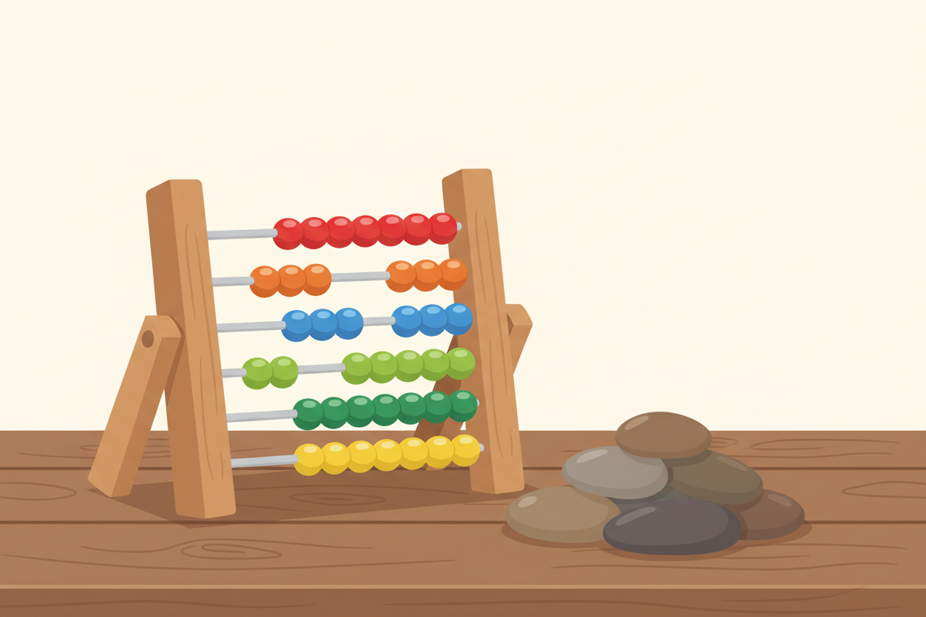
Picture 1. Long ago: people counted trade with an abacus and counting stones.
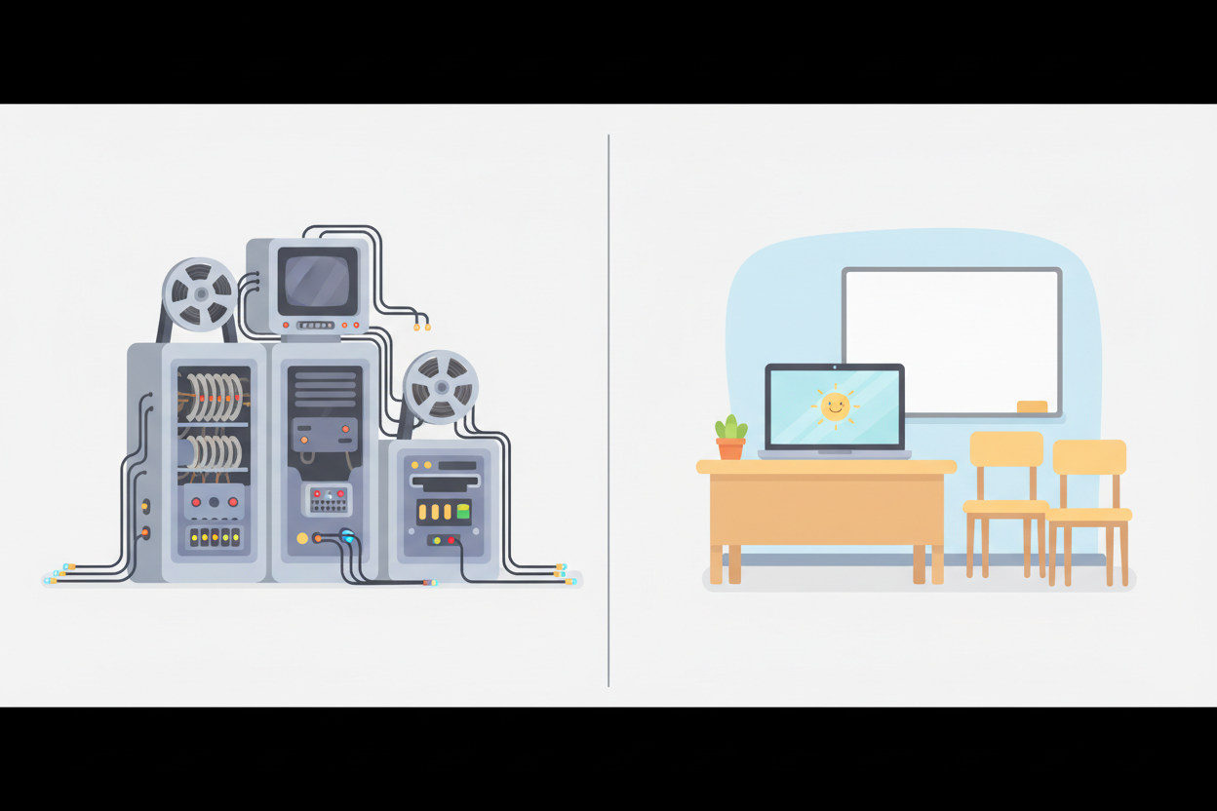
Picture 2. The machines grew: from a huge early computer to the laptop on a teacher's desk.
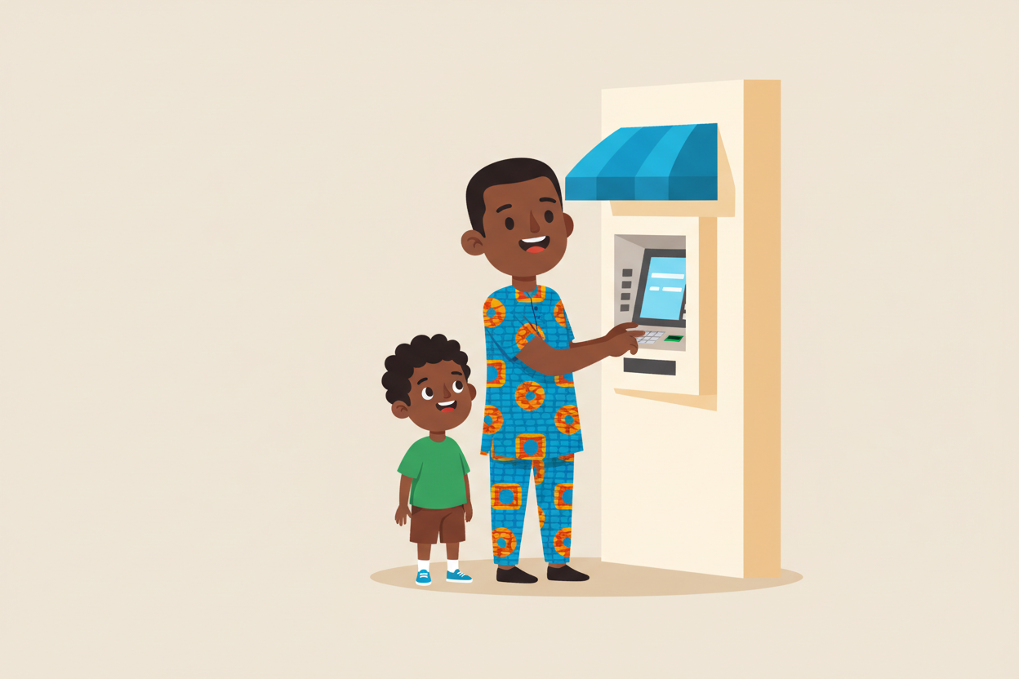
Picture 3. At the bank: computers and the ATM keep our money safe and moving.
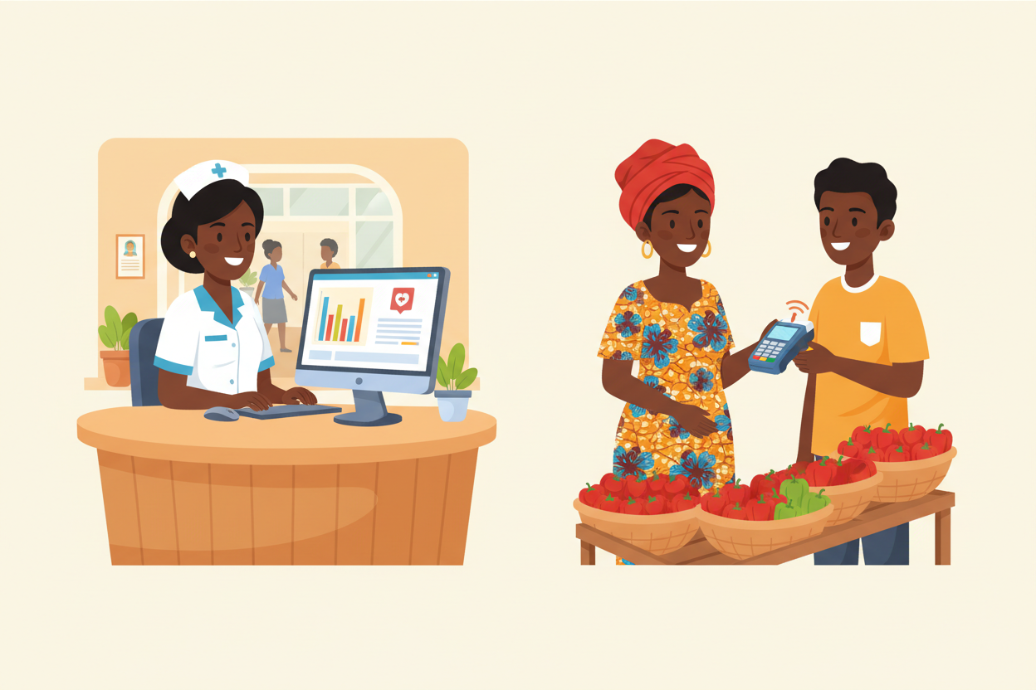
Picture 4. At the hospital and the market: computers help nurses and traders every day.
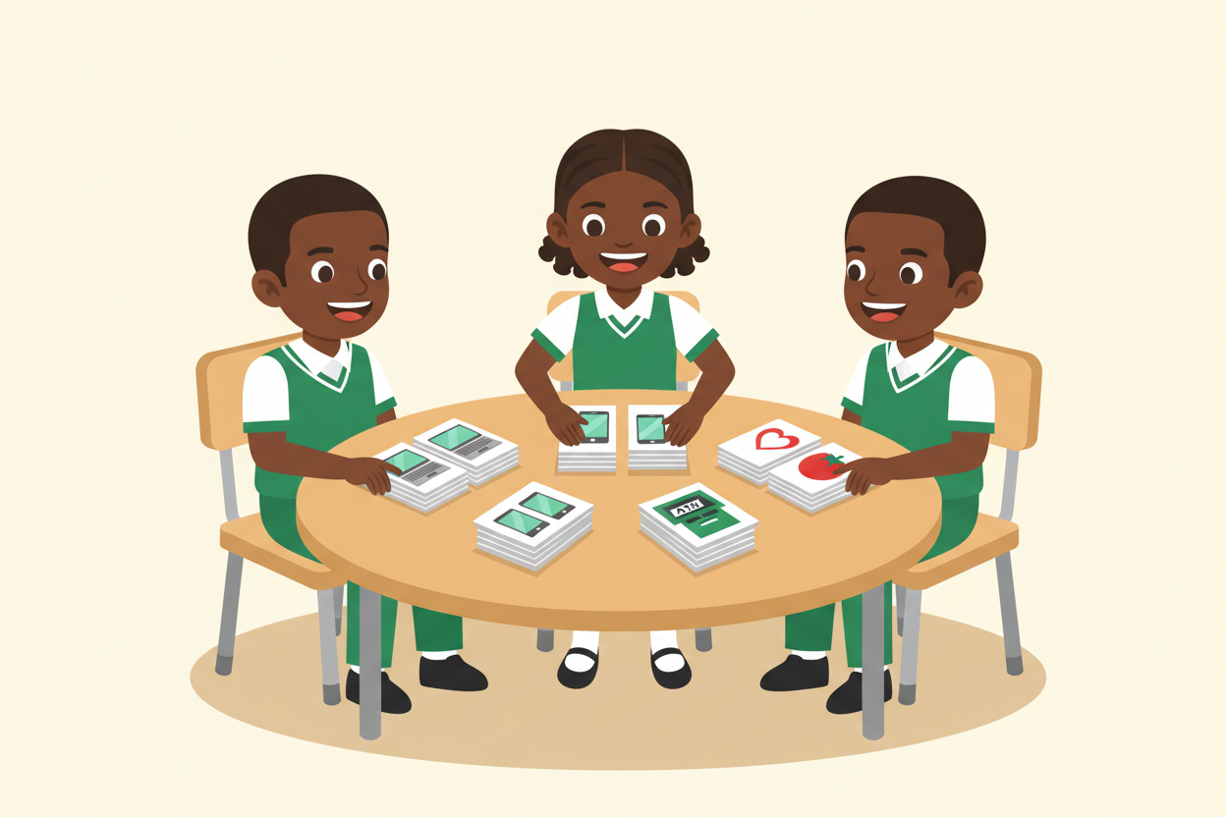
Picture 5. Matching work: the group sorts device cards into the places they are used.

7. Period Two: Practise and Apply
- Group task (25 minutes): divide the class into four groups: school, bank, hospital and market. Each group receives manila paper and a set of device cards. Their work: draw or write the place, then stick or list every way a computer or smart device helps there, and one problem it can cause (for example a bank fraud alert, a wrong hospital record, a market transfer that fails).
- Presentation (15 minutes): each group presents for two minutes. The class may add one more use for each place. Correct misconceptions kindly and ask learners to explain how they reached their answers.
- Wrap-up (5 minutes): agree a class list of at least four places and two benefits and two risks of computers in society. Copy it into exercise books.

8. Assessment and Evidence
- Scheme evidence: oral check, the group matching task and a short exit ticket.
Ask each learner to name one device from the history, one place a computer is used in Nigeria, and one sentence on why it helps people there. Record observations for learners needing reteaching.

9. Suggested Questions and Answer Guidance
1. What is a computer? Expected response: an electronic device that accepts data, works on it, and gives information we can use, such as a phone, laptop or POS machine.
2. Which counting tool did traders use before modern computers? Expected response: the abacus (accept counting sticks or stones).
3. Mention three places computers are used in Nigeria today. Expected response: any three of school, bank, hospital, market, airport, government office.
4. Give one way computers help a bank and one problem they can bring. Expected response: they keep money records and make transfers fast; they can also be used for fraud, so people must be careful.

10. Home Activity
Ask a family member where they use a computer, phone or POS machine in their work or business. The learner writes or draws two examples in the exercise book and brings them to the next class. Do not require internet access, a personal device, photographs or paid materials.

11. Inclusion
Use large, clear cards and point at each picture while speaking for learners who hear or see best through demonstration. Seat learners who need support beside confident peers in the group task. Accept oral answers, drawings or role-play in place of writing where a learner finds writing hard. Allow Pidgin, Hausa, Yoruba or Igbo explanations to support understanding, then build the English key words on them.

12. Safety and Privacy
Learners must not share personal information such as home address, phone number, bank details or passwords during the discussion of bank and market examples. Remind them that the POS and fraud examples are for learning, and that any real transfer or payment is always handled by an adult. Supervised demonstration only, on a device the teacher controls.

13. Teacher Reflection
After the lesson, note what worked and what to improve next time.
Reflection notes
__________________________________________________________________________________________

14. Curriculum Alignment and Document Status
Source note: The weekly topic, outcome, period allocations and assessment evidence in this note are drawn from the Rehoteq AI Education Curriculum Weekly Schemes of Work for Junior Secondary 1 to Senior Secondary 3, Session 2026/2027. The lesson procedures are suggested teacher-support material, not verbatim official curriculum. This note does not replace checking the current official NERDC curriculum or the school's approved assessment requirements. Keep the 'proposed curriculum' label until formal approval and alignment are confirmed.

© 2026 Rehoteq Technologies, free for non-commercial educational use with attribution. rehoteq.com

