REHOTEQ
AI EDUCATION CURRICULUM
――――――――――――――――――――――――――――――

Comprehensive Teacher's Lesson Note
Patterns Around Us
Primary 1 · First Term · Week 4

Field | Detail
Subject | AI Education and Digital Skills
Academic session | 2026/2027
Duration | 2 periods (35 to 40 minutes each, subject to the school timetable)
Document type | Comprehensive Teacher's Lesson Note
Curriculum status | Proposed curriculum for school pilot, review and consultation
Prepared by | Rehoteq Technologies (rehoteq.com)
Edition | First edition, October 2026

PROPOSED CURRICULUM NOTICE: This lesson note expands the Rehoteq AI Education Curriculum's proposed Primary 1, First Term, Week 4 scheme of work. It is offered for school pilot, review and consultation. It is not represented as an officially approved national syllabus, and it does not replace the current NERDC curriculum or any examination-board requirement.

1. Introduction
Patterns are things that repeat in a regular way. We can see patterns in colours, shapes, clothes, floor tiles, beads, plants and many other things around us.
For example, red, blue, red, blue is a repeating colour pattern. A circle, square, circle, square is a repeating shape pattern.
Learning about patterns helps children observe carefully, recognise similarities, predict what comes next and solve simple problems. These skills are also useful in computing and artificial intelligence because computers can be designed to recognise patterns in information.
In this lesson, pupils will identify repeating colours and shapes, predict the next item in a pattern, complete pattern cards and explain the rule they followed.

2. Learning Objectives
By the end of the lesson, pupils should be able to:
1. Explain what a pattern is in simple words.
2. Identify repeating patterns in colours and shapes.
3. Recognise the rule in a simple repeating pattern.
4. Predict the next item in a pattern.
5. Complete simple colour and shape patterns.
6. Create a repeating pattern using drawings or classroom objects.
7. Explain the pattern rule using simple words.

3. Key Vocabulary
Term | Meaning
Pattern | A design or arrangement that follows a rule.
Repeat | To happen or appear again.
Shape | The form of an object, such as a circle, square or triangle.
Colour | The appearance of an object, such as red, blue, yellow or green.
Sequence | Items arranged in a particular order.
Rule | The idea that explains how a pattern continues.
Predict | To say what is likely to come next by looking at what has already happened.

4. Teaching and Learning Materials
The teacher may use:
- Coloured pencils or crayons.
- Paper shapes cut from coloured paper.
- Picture cards showing circles, squares and triangles.
- Bottle tops or other safe classroom objects in different colours.
- Chalkboard or whiteboard.
- Pattern worksheets.
- Classroom objects such as books, pencils and rulers.
Low-resource option: Draw shapes on the board and use chalk marks, locally available safe objects or hand-drawn cards. Pupils do not need a computer, tablet, internet connection or purchased learning materials.

5. Sample Pictures
The illustrations below are original Rehoteq sample pictures for this lesson. Each carries a text caption, and important information does not depend on colour alone.
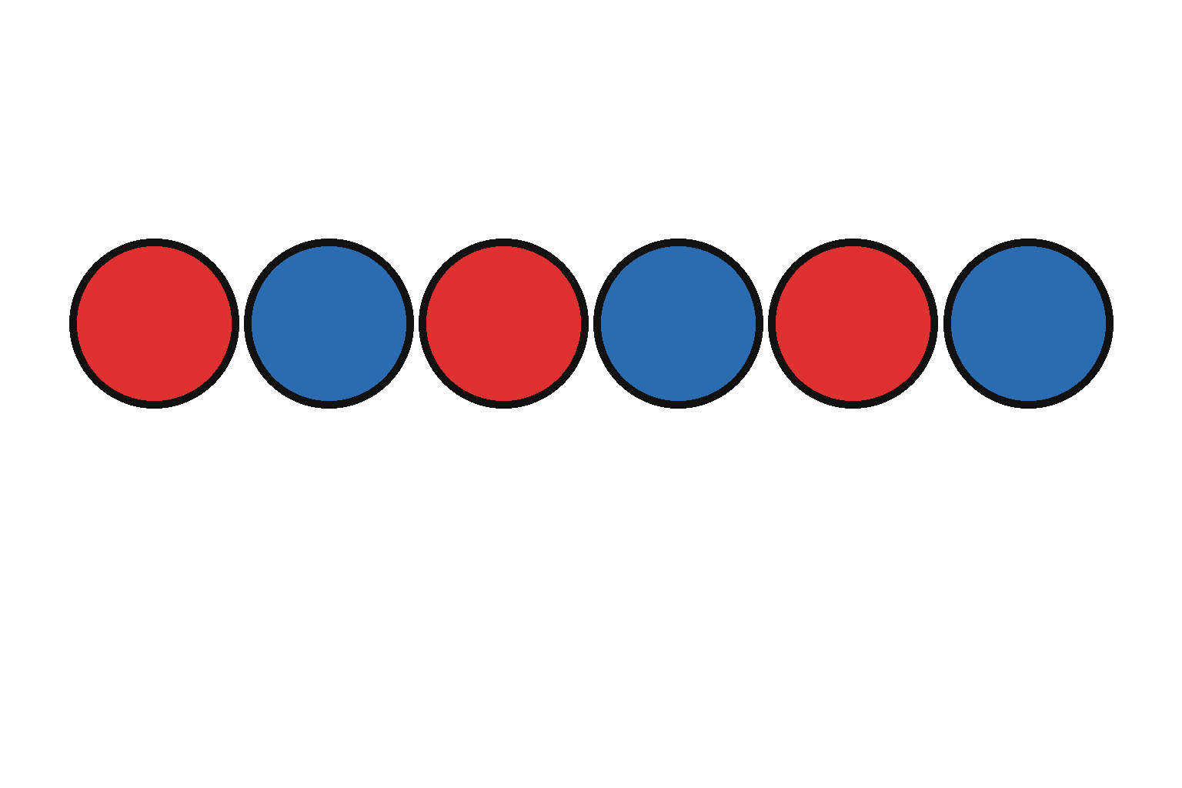
Picture 1. Red, blue, red, blue. The colours repeat.
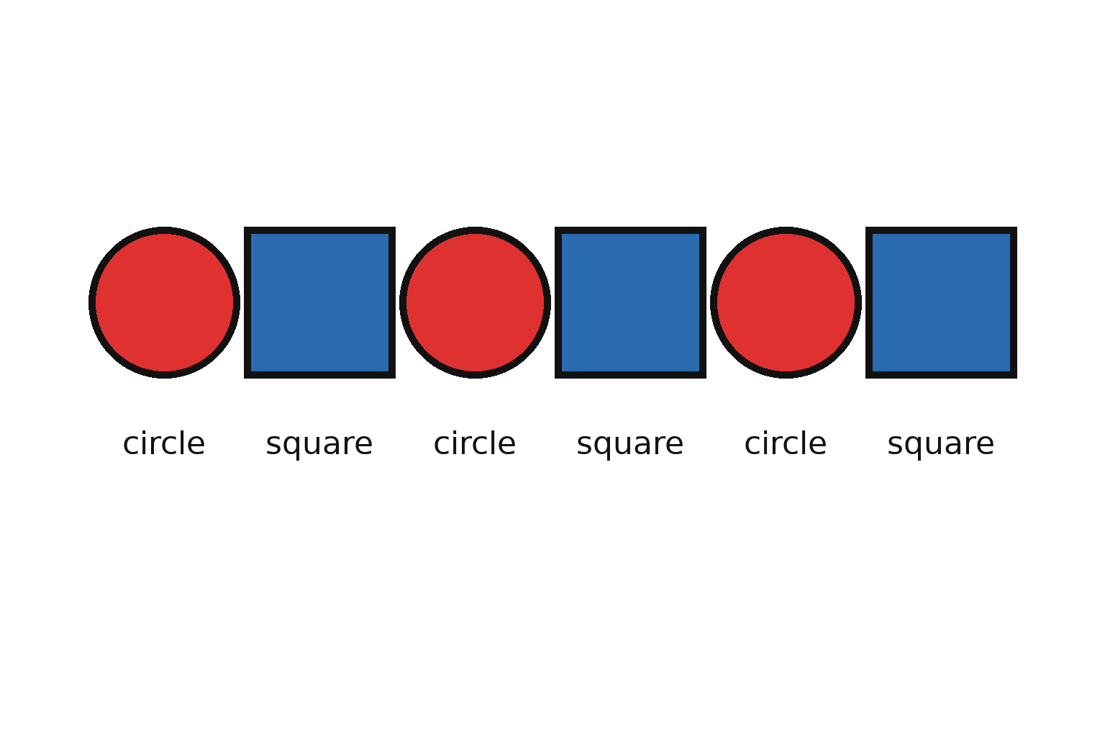
Picture 2. A repeating shape pattern: circle, square, circle, square, circle, square.

Picture 3. Find what comes next: yellow star, green star, yellow star, green star. Which colour comes next?
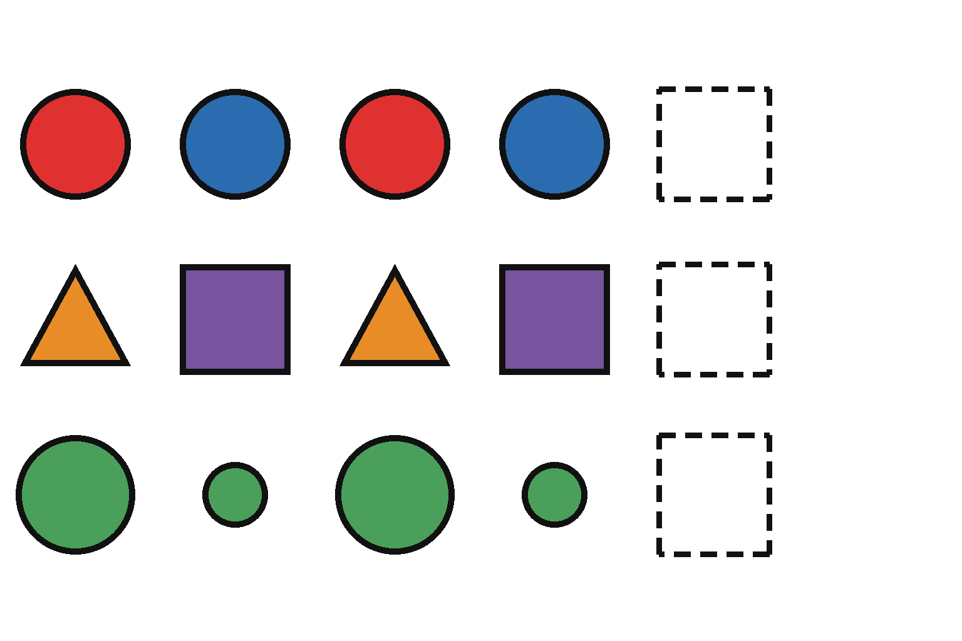
Picture 4. Complete the pattern: each row is missing its last item.
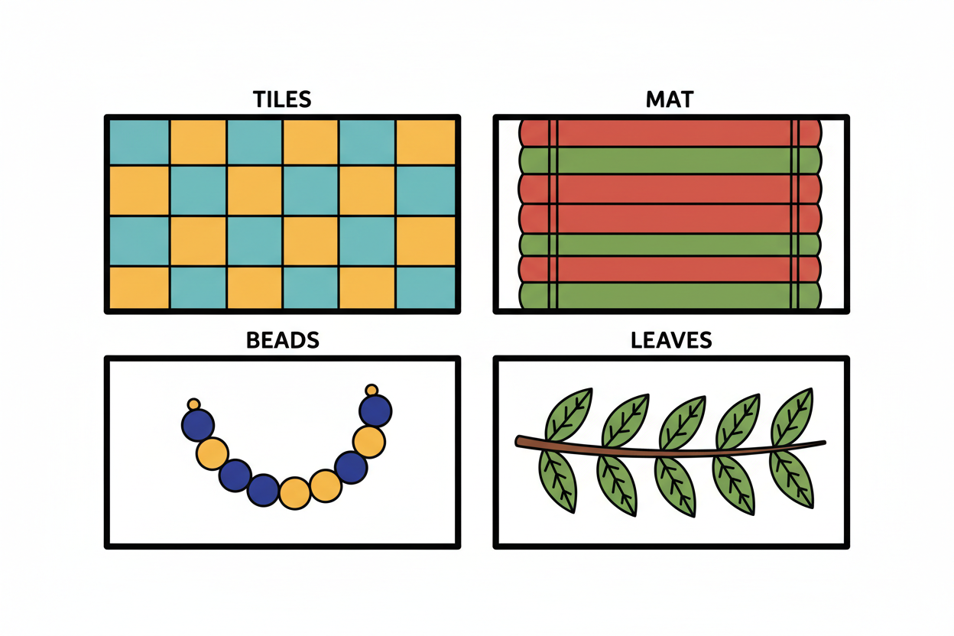
Picture 5. Patterns around us: floor tiles, a woven mat, beads and leaves can all show repeating designs.
Picture accessibility: Use clear outlines, large shapes, captions and high contrast. Do not rely on colour alone; use shape differences and labels so pupils who have difficulty distinguishing colours can still complete the activities.

6. Period One: Repeating Colours and Shapes
Duration: 35 to 40 minutes.

A. Introduction (5 minutes)
Greet the pupils and ask them to look around the classroom.
Ask:
- Have you seen floor tiles with the same design repeating?
- Have you seen beads arranged in different colours?
- Can you name two shapes?
- What colours can you see in the classroom?
Allow pupils to share examples. Explain that when colours or shapes follow a rule and repeat, they can form a pattern.

B. Teacher explanation (8 minutes)
Write the following sequence on the board:
Red – Blue – Red – Blue – Red – Blue
Ask pupils what they notice.
Explain that red and blue take turns appearing. The colours repeat in the same order.
Next, draw:
Circle – Square – Circle – Square – Circle – Square
Explain that the circle and square repeat in the same order.
Introduce the word rule. The rule tells us how the pattern works.
For the first example, the rule is “red, then blue, repeat.”
For the second example, the rule is “circle, then square, repeat.”
Explain that not every row of objects is a pattern. A repeating pattern follows a rule that helps us know what should come next.

C. Guided demonstration (7 minutes)
Draw these patterns on the board:
1. Yellow – Green – Yellow – Green.
2. Circle – Triangle – Circle – Triangle.
3. Red – Red – Blue – Red – Red – Blue.
Ask pupils to identify what repeats.
Expected responses:
1. Yellow and green repeat.
2. Circle and triangle repeat.
3. Two red items followed by one blue item repeat.
For the third example, explain that patterns can have rules involving more than two items. Keep the main focus on simple patterns that pupils can understand.

D. Activity: Clap the Pattern (5 minutes)
Tell pupils that patterns can involve actions as well as pictures.
Demonstrate:
Clap – Tap desk – Clap – Tap desk
Ask pupils to repeat the actions in the same order.
Try another safe sequence:
Stand – Sit – Stand – Sit
Pupils who cannot perform a movement can point to action cards or participate using hand movements.
Explain that the actions follow a repeating rule.

E. Guided practice (10 minutes)
Ask pupils to complete these patterns orally or on paper.
Pattern A: Red, blue, red, blue, ______.
Pattern B: Circle, square, circle, square, ______.
Pattern C: Triangle, triangle, circle, triangle, triangle, circle, ______.
Invite pupils to explain how they found the answer.
Expected answers:
- Pattern A: Red.
- Pattern B: Circle.
- Pattern C: Triangle.
Encourage pupils to look at the whole sequence rather than guessing.

F. Oral recap (5 minutes)
Ask:
1. What is a pattern?
2. What does it mean when something repeats?
3. What is the rule in a red-blue-red-blue pattern?
4. What shape comes after circle-square-circle-square?
Expected answers:
- A pattern is an arrangement that follows a rule.
- Repeating means appearing again in the same order.
- Red, then blue, repeating.
- A circle.

7. Period Two: Complete Pattern Cards and Explain the Rule
Duration: 35 to 40 minutes.

A. Revision (5 minutes)
Revise the meaning of a pattern. Draw a simple colour or shape sequence and ask pupils to identify what comes next.
Remind pupils to look for what repeats before answering.

B. Teacher explanation (7 minutes)
Explain that completing a pattern means adding the item that comes next according to its rule.
Demonstrate:
Circle – Square – Circle – Square – ______
Ask pupils to look at the first four shapes. The circle and square repeat in that order.
Therefore, the next shape is a circle.
Demonstrate another example:
Red – Red – Blue – Red – Red – Blue – ______
Explain that the rule is two red items followed by one blue item. The next item is red.
Teach pupils to use three steps:
1. Look carefully at the items.
2. Find what repeats.
3. Add the next item according to the rule.

C. Activity: Complete the Pattern Cards (12 minutes)
Materials: Pattern cards, pencils, crayons or drawings on the board.
Give pupils the following tasks.
Card 1: Colours
Red – Blue – Red – Blue – ______
Answer: Red.
Card 2: Shapes
Circle – Square – Circle – Square – ______
Answer: Circle.
Card 3: Shapes
Triangle – Circle – Triangle – Circle – ______
Answer: Triangle.
Card 4: Three-item pattern
Red – Red – Blue – Red – Red – Blue – ______
Answer: Red.
Card 5: Colour and shape
Red circle – Blue square – Red circle – Blue square – ______
Answer: Red circle.
Teacher instructions:
1. Demonstrate the first card together.
2. Let pupils attempt the remaining cards individually or in pairs.
3. Ask pupils to draw or select the missing item.
4. Invite pupils to explain the rule in simple words.
5. Correct errors by asking pupils to compare the repeated groups.
Offline alternative: Draw the pattern cards on the chalkboard. Pupils can copy them into exercise books or answer orally.

D. Activity: Make Your Own Pattern (8 minutes)
Ask each pupil to create one repeating pattern using shapes, colours or safe classroom objects.
Examples:
- Red, blue, red, blue.
- Circle, square, circle, square.
- Pencil, book, pencil, book.
Ask pupils to:
1. Show the pattern to a partner.
2. Ask the partner what comes next.
3. Explain the rule.
Accept different patterns as long as the rule is consistent and the next item can be predicted.

E. Connection to computing and AI (3 minutes)
Explain that computers can be programmed to follow rules and that some AI systems are designed to find patterns in data, pictures, sounds or other information.
For example, a computer may be programmed to recognise a repeating sequence of shapes. An AI system might learn patterns from many examples, but it can also make mistakes.
Emphasise that finding patterns is one foundation for later learning about computing and artificial intelligence. A simple repeating pattern activity is not itself an AI system.

F. Lesson conclusion (3 minutes)
Ask pupils to complete these statements:
- A pattern follows a ______.
- To complete a pattern, I look for what ______.
- In circle-square-circle-square, the next shape is a ______.
- I can make a pattern using colours and ______.
Expected answers: rule; repeats; circle; shapes.

8. Assessment

Part A: Oral or written questions
1. What is a pattern?
2. What is a rule in a pattern?
3. Complete: Red, blue, red, blue, ______.
4. Complete: Circle, square, circle, square, ______.
5. Complete: Triangle, triangle, circle, triangle, triangle, circle, ______.
6. Explain the rule in this pattern: Red, red, blue, red, red, blue.
7. Draw your own repeating pattern.

Part B: Find the missing item
Question 1
Circle – Square – Circle – ______
Answer: Square.
Question 2
Yellow – Green – Yellow – Green – ______
Answer: Yellow.
Question 3
Triangle – Circle – Triangle – Circle – ______
Answer: Triangle.

Part C: Practical assessment
Ask pupils to:
- Identify a repeating pattern.
- Add the next item.
- Explain the rule using simple words.
Suggested assessment criteria:
- Identifies what repeats.
- Selects the correct next item.
- Explains the rule.
- Participates in creating a pattern.
Use the school's approved assessment policy. Accept oral, drawn or practical responses from pupils who need support with writing.

9. Homework
Task: Find and Draw Patterns Around You
Ask pupils to find one example of a pattern they have seen at home or in their community.
They should draw the pattern in their exercise book and explain what repeats.
Possible examples:
- Repeating floor tiles.
- Colours on a woven mat.
- Beads arranged in repeating colours.
- A pattern made with pencils and books.
If pupils cannot find a real-life example, they may create their own pattern using drawings.
No photographs, internet access or purchased materials are required.

10. Differentiation and Inclusion

For pupils who need more support
- Begin with two-item patterns.
- Use large, clearly separated shapes.
- Demonstrate the repeated group before asking pupils to complete it.
- Allow pupils to point to the answer rather than write it.
- Repeat instructions as needed.

For pupils ready for an extra challenge
- Introduce a three-item repeating pattern.
- Ask pupils to create a pattern and let a partner solve it.
- Ask pupils to explain how they checked that their answer follows the rule.

For pupils with colour-vision or visual difficulties
- Use shapes, labels, textures or symbols in addition to colour.
- Provide large-print pattern cards.
- Read the sequence aloud.
- Use raised or tactile shapes where available.

For pupils with motor difficulties
- Let pupils point, speak or choose from answer cards.
- Provide assistance with drawing or cutting when necessary.
- Avoid making fast physical movements a requirement for success.

11. Safety and Responsible Use
1. Use classroom objects carefully.
2. Do not put small objects in the mouth.
3. Do not run or push others during action-pattern games.
4. Share learning materials fairly.
5. Respect different answers and explain mistakes kindly.
6. Ask for help when instructions or pattern cards are confusing.
7. Remember that computers and AI systems can make mistakes when recognising patterns.

12. Teacher Preparation Checklist
Before the lesson, the teacher should:
☐ Review the lesson objectives and key vocabulary.
☐ Prepare colour and shape examples.
☐ Draw or print pattern cards.
☐ Prepare an offline classroom activity.
☐ Check that pictures and colours are clear and accessible.
☐ Prepare the assessment questions and answer guide.
☐ Plan support for pupils who need additional help.
☐ Ensure all activities use safe materials.

13. Lesson Evaluation
After teaching, the teacher should complete the following:
Number of pupils present: ________________________________________
Number of pupils who met the objectives: ________________________________________
Objectives that need revision:
__________________________________________________________________________________________
Activities pupils found most helpful:
__________________________________________________________________________________________
Difficulties encountered:
__________________________________________________________________________________________
Follow-up support required:
__________________________________________________________________________________________
Teacher's name / signature: ________________________________________
Date: ________________________________________

14. Curriculum Alignment and Document Status
This lesson note follows the Rehoteq AI Education Curriculum's proposed Primary 1, First Term, Week 4 scheme of work:
The weekly scheme specifies:
- Period 1: Repeating colours and shapes; finding the next item.
- Period 2: Complete pattern cards; explain the rule.
- Assessment: Oral or written check, practical task or short exit ticket.
The lesson expands the weekly scheme into suggested teaching activities. Teachers may adjust examples, timing and materials to suit pupils' needs and the school's approved timetable.
Status: Proposed Rehoteq curriculum for school pilot, review and consultation. It is not represented as an officially approved national syllabus. Before adoption, schools should check the current official NERDC curriculum, their own calendar and any examination-board requirements.

Prepared by: Rehoteq Technologies
© 2026 Rehoteq Technologies. Free for non-commercial educational use with attribution. Branding and copyright statement to be confirmed before publication.
End of lesson note

