REHOTEQ
AI EDUCATION CURRICULUM
―――――――――――――――――――――――

Comprehensive Teacher's Lesson Note
Project and revision
Junior Secondary 1 · Second Term · Week 10

Field | Detail
Subject | AI Education and Digital Skills
Academic session | 2026/2027
Duration | 2 periods (40 to 45 minutes each, subject to the school timetable)
Document type | Comprehensive Teacher's Lesson Note
Curriculum status | Proposed curriculum for school pilot, review and consultation
Prepared by | Rehoteq Technologies (rehoteq.com)
Edition | First edition, November 2026

PROPOSED CURRICULUM NOTICE: This lesson note expands the Rehoteq AI Education Curriculum's proposed Junior Secondary 1, Second Term, Week 10 scheme of work. It is offered for school pilot, review and consultation. It is not represented as an officially approved national syllabus, and it does not replace the current NERDC curriculum or any examination-board requirement.

1. Lesson Information
Field | Detail
Class | JSS 1
Subject | AI Education and Digital Skills
Term | Second Term
Week | Week 10 of Second Term
Topic | Term 2 project: the counting game; revision of Weeks 1 to 9
Duration | 2 periods (40 to 45 minutes each)

2. Learning Outcome
By the end of the lesson, learners can:
- Combine sequence, loops, variables and conditions in one small project.
- Plan a project on paper before building it.
- Test a project and fix what does not work.
- Explain the project to others using the right vocabulary.

3. Weekly Scheme Content
Period | Scheme content
Period 1 | Revision Weeks 1 to 9
Period 2 | Project: the counting game
Weeks 11 to 13 of the term are reserved for examinations, marking and results. Do not introduce new content during those weeks.

4. Materials and Preparation
- Computers with Scratch where available, one per pair; the class's saved programs from Weeks 5 to 9.
- One planning sheet per pair: a page divided into plan, build, test and show.
- Counters and the paper cards from Weeks 6 to 9 for the unplugged version.
No-lab fallback: the counting machine on paper. Teams draw their counting machine (a loop, a variable box and one condition) and act it out; other teams press the pretend button and check the counting is right.

5. Period One: Introduce and Model
- Revision (20 minutes): quick rounds covering Weeks 1 to 9: name the five block groups, spot the loop, read a variable box, say a condition aloud, count a small number in twos.
- Plan (15 minutes): pairs choose one challenge: a counting game (each press adds to the score; when the score reaches five, the sprite celebrates) or a dance loop that changes when the count hits a number. They sketch the plan first: what repeats, what is remembered, what is checked.

6. Lesson Pictures
Show these pictures while teaching. Use each one to point back at the week it comes from before the class moves on.
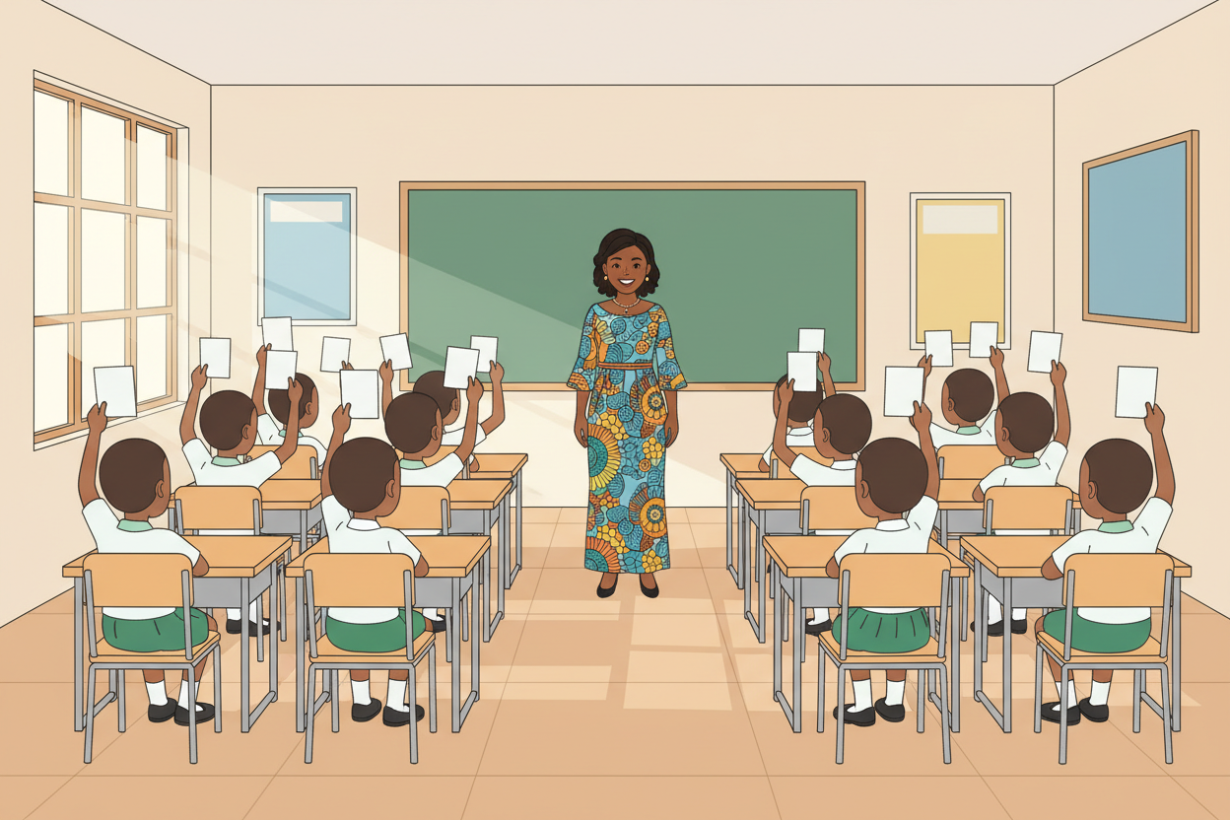
Picture 1. Revision first: the whole term in one quick quiz round.
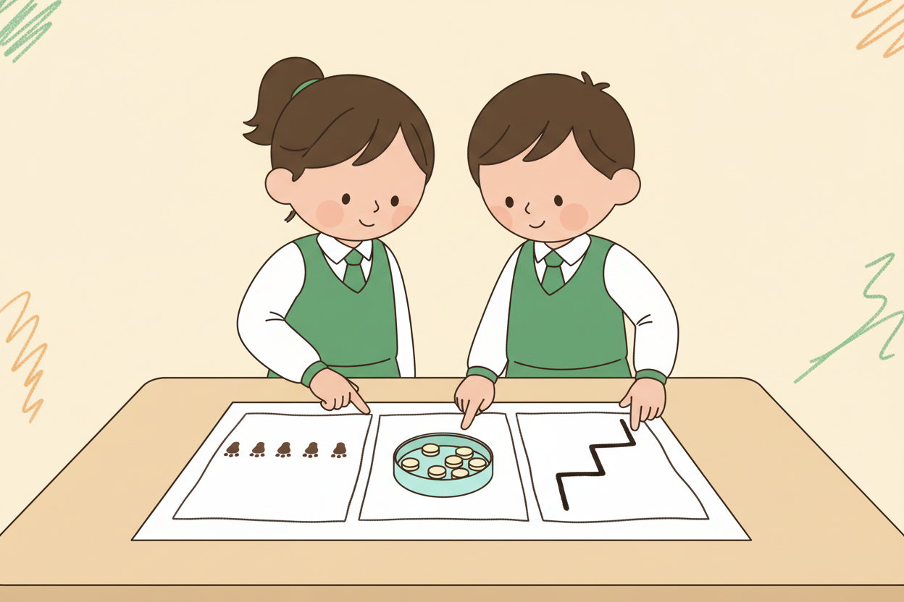
Picture 2. Plan before build: sketch what repeats, what is remembered, what is checked.
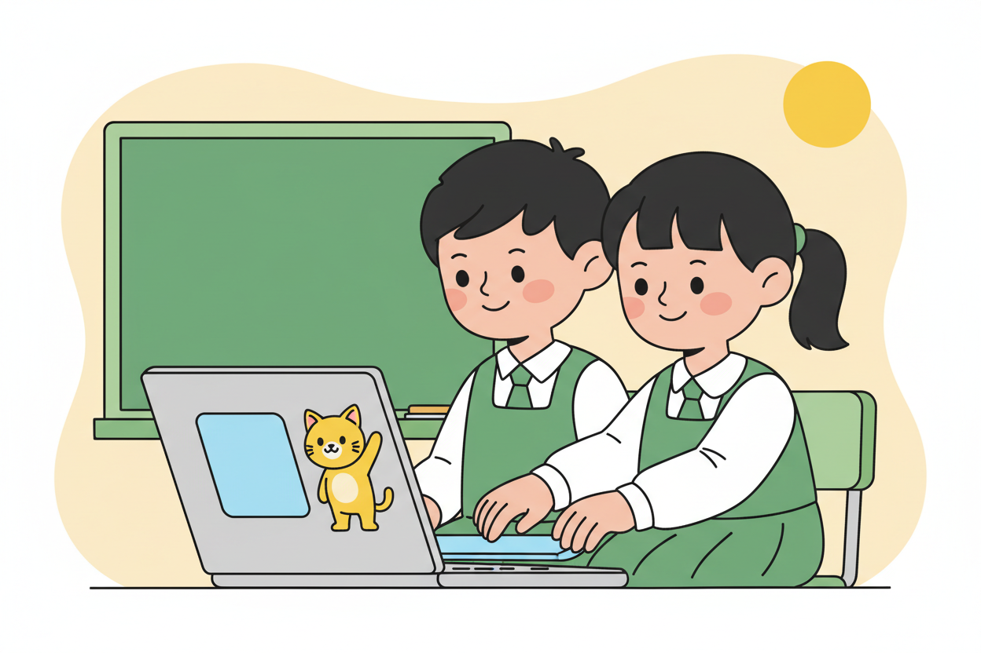
Picture 3. Build and test: every press of the button must count exactly right.
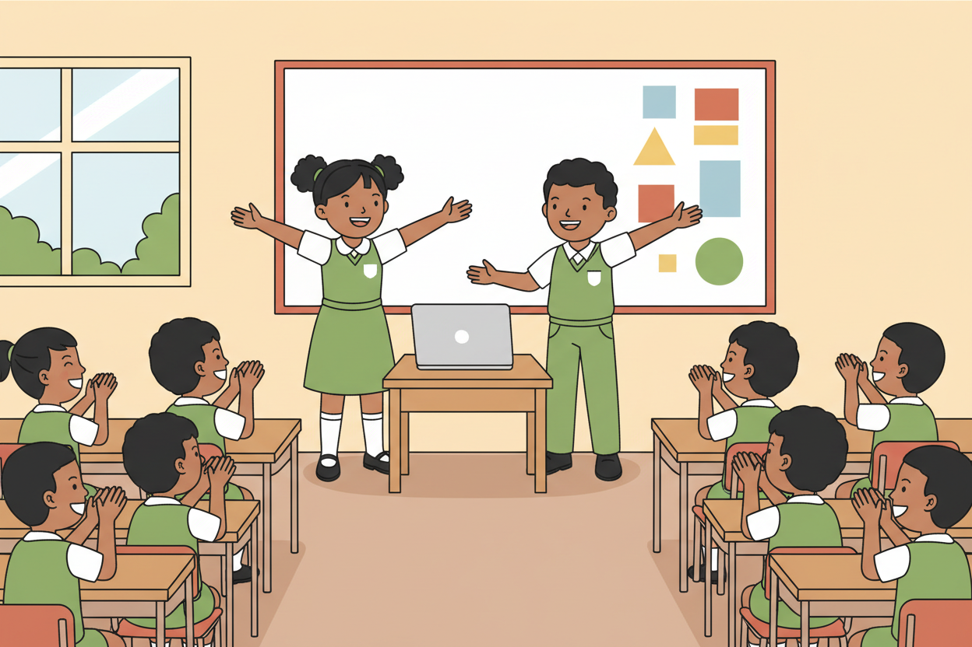
Picture 4. Show time: every pair explains its machine in its own words.

7. Period Two: Practise and Apply
- Build and test (25 minutes): pairs build the project, testing as they go: does the loop repeat the right moves, does the variable change, does the condition fire at the right moment?
- Show (10 minutes): each pair shows its project and explains it in one sentence per idea: sequence, loop, variable, condition.
- Close (5 minutes): the class names what it wants to learn next term (presentations and Scratch games come in Term 3).

8. Assessment and Evidence
- Evidence to collect: each pair's planning sheet, its finished project (or drawn machine), and its show explanation.
Success looks like: plans come before builds, projects use at least a loop and a variable, and explanations use the term's vocabulary correctly.

9. Suggested Questions and Answer Guidance
1. Which part of your project uses a loop, and why? Expected response: the part that repeats, named clearly.
2. What does your variable remember? Expected response: the count or score, with its starting value.
3. What does your condition check? Expected response: a clear yes-no question and both outcomes.
4. What would you add next term if you had one more week? Expected response: any sensible extension stated in the project's terms.

10. Home Activity
No new homework this week: learners rest after the project. Optional: teach one loop or variable idea from this term to someone at home and note what they asked.

11. Inclusion
Projects may be built on computers, with cards, or acted out; the show may be a spoken, signed or drawn explanation. Every team gets the same rubric with an acknowledgment of its chosen form. No learner is scored on equipment they did not have.

12. Safety and Privacy
Programs and demonstrations stay kind and inclusive; no flashing or loud sounds. Planning sheets and projects carry no personal details.

13. Teacher Reflection
After the lesson, note what worked, which parts confused the class, which pupils need follow-up, and one change for next term.
Reflection notes
__________________________________________________________________________________________

14. Curriculum Alignment and Document Status
This note expands the Rehoteq AI Education Curriculum, a proposed curriculum for school pilot, review and consultation; not an officially approved national syllabus. It does not replace the current NERDC curriculum or examination-board requirements, and schools remain responsible for checking current NERDC requirements and their own calendar before implementation.

Prepared by Rehoteq Technologies (rehoteq.com). First edition, November 2026.

