REHOTEQ
AI EDUCATION CURRICULUM
―――――――――――――――――――――――

Comprehensive Teacher's Lesson Note
Recap: Welcome Back
Junior Secondary 1 · Second Term · Week 1

Field | Detail
Subject | AI Education and Digital Skills
Academic session | 2026/2027
Duration | 2 periods (40 to 45 minutes each, subject to the school timetable)
Document type | Comprehensive Teacher's Lesson Note
Curriculum status | Proposed curriculum for school pilot, review and consultation
Prepared by | Rehoteq Technologies (rehoteq.com)
Edition | First edition, November 2026

PROPOSED CURRICULUM NOTICE: This lesson note expands the Rehoteq AI Education Curriculum's proposed Junior Secondary 1, Second Term, Week 1 scheme of work. It is offered for school pilot, review and consultation. It is not represented as an officially approved national syllabus, and it does not replace the current NERDC curriculum or any examination-board requirement.

1. Lesson Information
Field | Detail
Class | JSS 1
Subject | AI Education and Digital Skills
Term | Second Term
Week | Week 1 of Second Term
Topic | Recap of first term: quiz on first term, team quiz
Duration | 2 periods (40 to 45 minutes each)

2. Learning Outcome
By the end of the lesson, learners can:
- Answer recall questions from Weeks 1 to 10 of first term with growing confidence.
- Work in a team to agree and submit one shared answer.
- Identify their own two strongest and two weakest first-term topics.
- Set one simple goal for second term.

3. Weekly Scheme Content
Period | Scheme content
Period 1 | Quiz on first term
Period 2 | Team quiz
Weeks 11 to 13 of the term are reserved for examinations, marking and results. Do not introduce new content during those weeks.

4. Materials and Preparation
- Two sets of numbered question cards covering first-term Weeks 1 to 10 (teacher-made from the term's lesson notes).
- One answer sheet per pair, chalk or marker for the scoreboard.
- Learners' first-term exercise books, kept from last term, for their own reference after the quiz.
No-lab fallback: the whole recap is paper-based by design. No computer is needed this week.

5. Period One: Introduce and Model
- Welcome and starter (5 minutes): greet the class and remind them of the term ahead: spreadsheets, charts, and Scratch programming, all built on first-term foundations.
- Rules (5 minutes): explain the individual quiz: 10 questions, one per first-term week, answered alone, no books open. Mark together at the end.
- Individual quiz (20 minutes): read each question aloud twice; learners write answers. Questions span computer and society, system unit, operating system, word processing, internet and email, AI, AI in Nigerian services, classification, collecting data, and the term project.
- Mark and discuss (10 minutes): swap books, mark together, and let pupils raise any question they disagreed with; re-teach the one most-missed item on the board.
- Close (5 minutes): each learner writes their two strongest and two weakest topics on the back of their sheet.

6. Lesson Pictures
Show these pictures while teaching. Use each one to point back at the week it comes from before the class moves on.

Picture 1. Welcome back: a new term starts from what the class already knows.
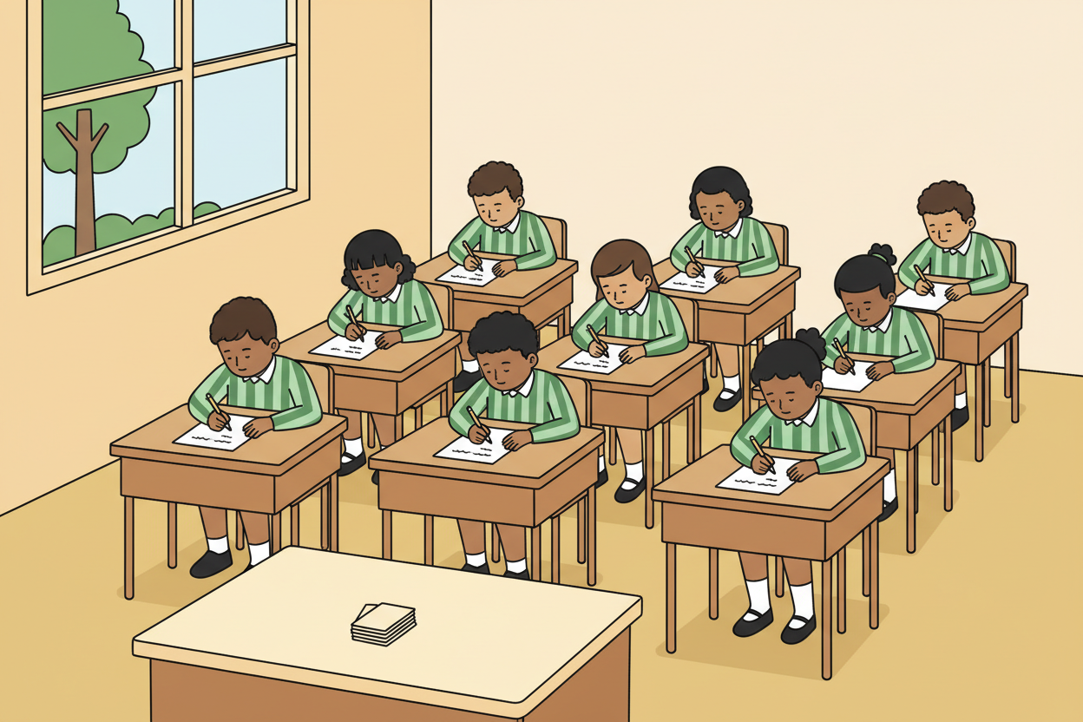
Picture 2. The individual quiz: ten questions, one from each week of first term.
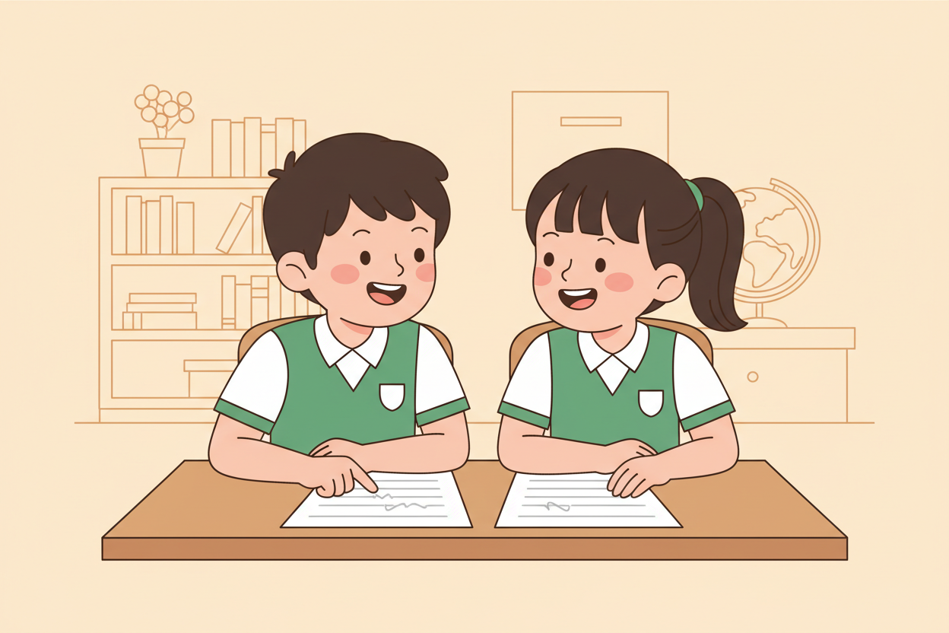
Picture 3. The team quiz: pairs and groups agree one answer together.
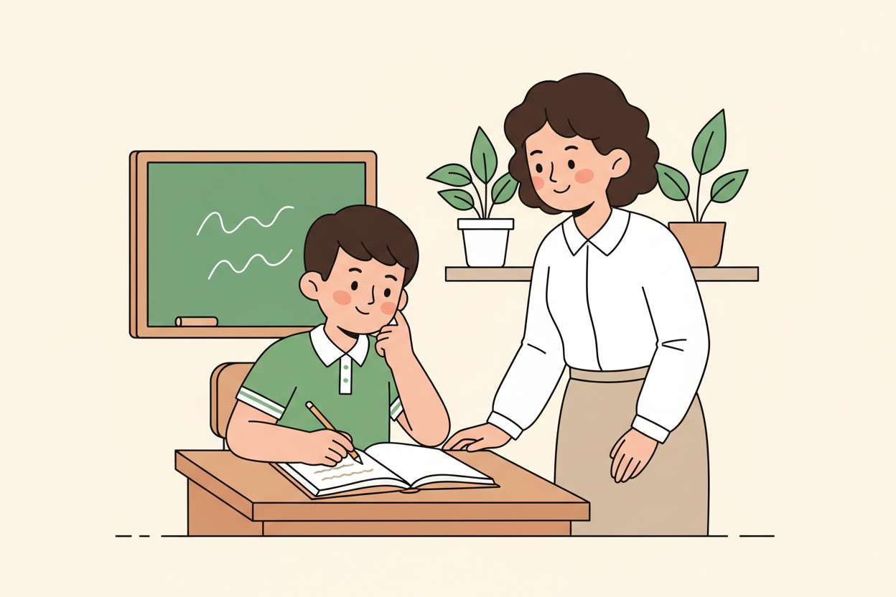
Picture 4. After the quiz, every learner names what they know well and what to improve.

7. Period Two: Practise and Apply
- Team quiz (25 minutes): mixed-ability teams of four answer 10 further questions, one per topic. Each team writes ONE agreed answer per question; a team may pool knowledge before writing.
- Scoreboard and speed round (10 minutes): post team scores; the fastest correct team answers a bonus question about the project week.
- Goal setting (10 minutes): each learner writes one simple second-term goal (for example, learn to make a chart, or finish every Scratch challenge).

8. Assessment and Evidence
- Evidence to collect: each learner's marked individual quiz sheet, one team answer sheet per team, and each learner's written goal.
Success looks like: most pupils score above half on the individual quiz, teams reach agreement without one member doing all the writing, and every learner's goal is about their own learning, not a wish.

9. Suggested Questions and Answer Guidance
1. Which first-term topic did your team find easiest, and why? Expected response: any topic named with a reason tied to what was taught.
2. What is the difference between system software and an operating system's job? Expected response: the operating system IS the main system software; it manages the hardware and runs other programs.
3. Name one AI feature you met in first term and where it lives. Expected response: any correct example, such as a bank fraud alert in a banking app or a spam filter in email.
4. Why do machines need many labelled examples before they can classify new things? Expected response: because they learn patterns from examples; few or one-sided examples give wrong rules.

10. Home Activity
Learners show their goal to someone at home and keep the marked quiz sheet in their folder; the first spelling-and-meaning check of ten first-term key words happens at the start of next week's lesson.

11. Inclusion
Teams are mixed-ability and the teacher assigns the writer role to a different member each round so nobody is left out. Learners who write slowly may give answers orally to their team's writer. The quiz is read aloud twice so weak readers are not penalised.

12. Safety and Privacy
No pupil's individual score is read aloud or posted. Team scores are fine; personal results stay between the pupil and the teacher.

13. Teacher Reflection
After the lesson, note what worked, which parts confused the class, which pupils need follow-up, and one change for next term.
Reflection notes
__________________________________________________________________________________________

14. Curriculum Alignment and Document Status
This note expands the Rehoteq AI Education Curriculum, a proposed curriculum for school pilot, review and consultation; not an officially approved national syllabus. It does not replace the current NERDC curriculum or examination-board requirements, and schools remain responsible for checking current NERDC requirements and their own calendar before implementation.

Prepared by Rehoteq Technologies (rehoteq.com). First edition, November 2026.

