REHOTEQ
AI EDUCATION CURRICULUM
――――――――――――――――――――――――――――――

Comprehensive Teacher's Lesson Note
Getting to Know Technology
Primary 1 · First Term · Week 1

Field | Detail
Subject | AI Education and Digital Skills
Academic session | 2026/2027
Duration | 2 periods (35 to 40 minutes each, subject to the school timetable)
Document type | Comprehensive Teacher's Lesson Note
Curriculum status | Proposed curriculum for school pilot, review and consultation
Prepared by | Rehoteq Technologies (rehoteq.com)
Edition | First edition, October 2026

PROPOSED CURRICULUM NOTICE: This lesson note expands the Rehoteq AI Education Curriculum's proposed Primary 1, First Term, Week 1 scheme of work. It is offered for school pilot, review and consultation. It is not represented as an officially approved national syllabus, and it does not replace the current NERDC curriculum or any examination-board requirement.

1. Lesson Information
Field | Detail
Class | PRIMARY 1
Subject | AI Education and Digital Skills
Term | First Term
Week | Week 1 of First Term
Topic | Getting to Know Technology
Duration | 2 periods (35 to 40 minutes each)

2. Learning Outcome
Learners can explain or demonstrate the key idea in 'Getting to Know Technology' and apply it to a guided example.

3. Weekly Scheme Content
Period | Scheme content
Period 1 | Meaning of technology; familiar tools
Period 2 | Identify everyday tools; sort tools by use
Weeks 11 to 13 of the term are reserved for examinations, marking and results. Do not introduce new content during those weeks.

4. Materials and Preparation
- Prepare simple locally available objects, picture cards or board drawings that illustrate the topic.
- Paper and pencils for recording. Use a shared device or offline demonstration only if available and appropriate. Prepare an equivalent no-device activity.
Low-resource option: The teacher can use ordinary classroom objects, hand-drawn cards and spoken instructions. No special equipment, electricity or internet is required.

5. Sample Pictures
The illustrations below are original Rehoteq sample pictures for this lesson. Each carries a text caption, and important information does not depend on colour alone. Teachers may also draw these objects on the chalkboard or bring the real objects to class.
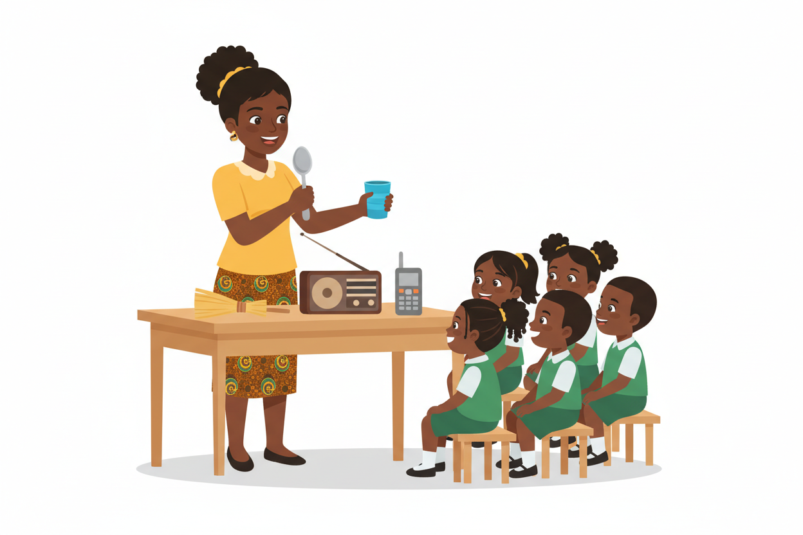
Picture 1. The teacher shows familiar tools people use every day: a spoon, a cup, a broom, a radio and a small phone. Technology means tools people make to help them work.
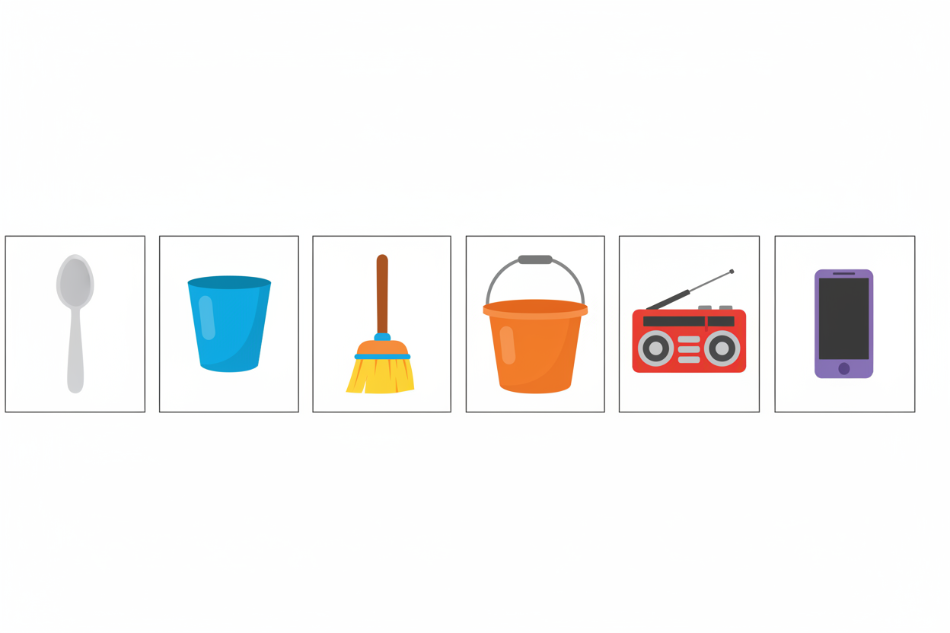
Picture 2. Six everyday tools in order: spoon, cup, broom, bucket, radio and phone. Each object sits in its own box so learners can point and name them one by one.
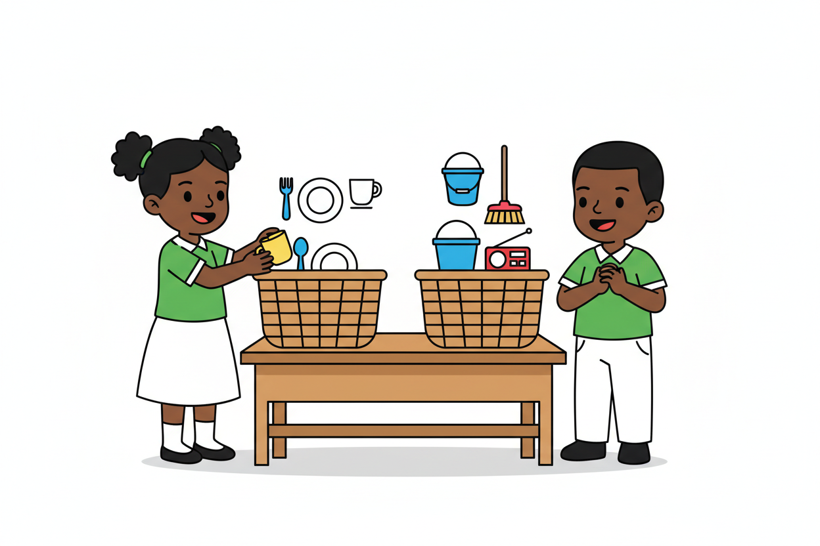
Picture 3. Two pupils sort objects into two baskets by what each tool is used for. One basket holds things we eat with, the other holds things we clean and listen with.
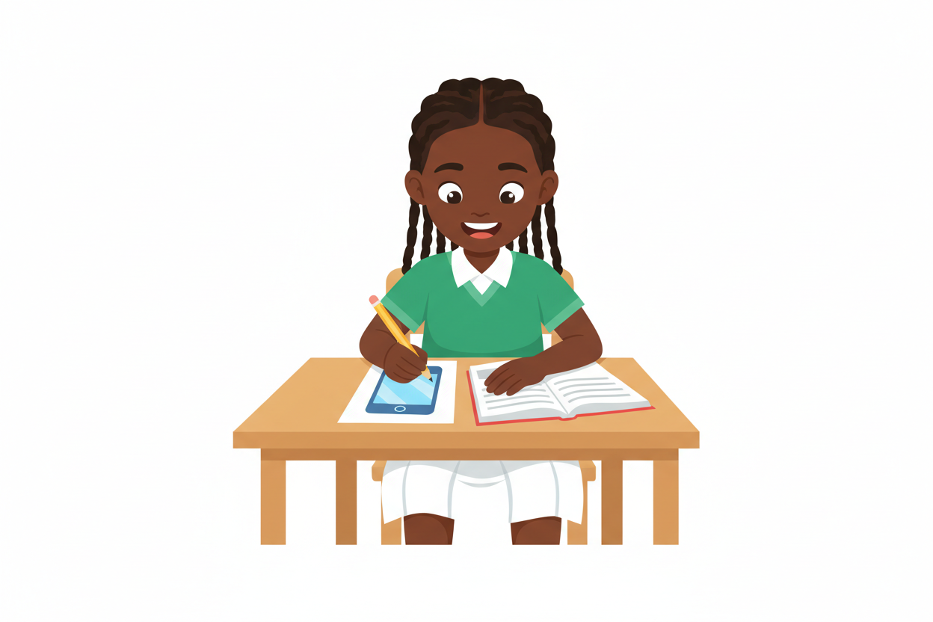
Picture 4. A learner draws her favourite everyday tool in her exercise book. Drawing and naming a tool is a simple home activity with no device needed.

6. Period One: Introduce and Model
- Starter: connect “Getting to Know Technology” to learners’ home, school or community experiences. Ask 2–3 short questions and accept examples in familiar Nigerian contexts.
- Explain and model the first part of the scheme content: Period 1: Meaning of technology; familiar tools Period 2: Identify everyday tools; sort tools by use. Use concrete examples, a drawing, a short demonstration or a think-aloud. Introduce key words and check understanding as you go.
- Guided practice: demonstrate one example, then invite learners to try a similar example with a partner or as a whole class. Correct misconceptions kindly and ask learners to explain how they reached an answer.

7. Period Two: Practise and Apply
- Quick review: ask learners to recall the main idea from Period 1 using a question, object, picture or oral explanation.
- Application: learners complete a short sorting, matching, sequencing, drawing, role-play, discussion or practical task that directly reflects the weekly topic. Ask pairs/groups to share their reasoning.
- Consolidate: revisit the learning outcome, address common errors and have each learner show or say one thing learned. Keep the activity low-cost and offline-ready.

8. Assessment and Evidence
- Scheme evidence: Oral/written check, practical task or short exit ticket.
Ask learners to define or identify one key idea, complete one practical example, and explain their choice in a sentence or orally. Record observations for learners needing reteaching.

9. Suggested Questions and Answer Guidance
1. What is one important idea in “Getting to Know Technology”? Expected response: an age-appropriate explanation or correct example drawn from the taught content.
2. Show or describe one example. Expected response: learner correctly identifies, demonstrates or applies the idea with no more prompting than appropriate for their level.
3. How can you use this safely or helpfully at home or school? Expected response: a relevant practical example that follows school and family safety rules.

10. Home Activity
Ask a family member to help the learner find or describe one everyday example related to “Getting to Know Technology”. The learner may draw it or explain it orally in class. Do not require internet access, a personal device, photographs or paid materials.

11. Inclusion
Offer picture/object choices, peer support, oral responses, extra processing time and a simpler worked example; extend learners who are ready by asking them to create and explain a new example.

12. Safety and Privacy
Supervise all equipment; do not ask learners to share personal data or upload identifiable images; follow school rules for devices and online tools. Use paper-based alternatives by default when uncertain.

13. Teacher Reflection
(1) learners who met the outcome, (2) the misconception that appeared most often, and (3) one adjustment for the next lesson.
Reflection notes
__________________________________________________________________________________________

14. Watch the Lesson Video
This week comes with a one-minute lesson video, narrated by a Nigerian female voice. Pupils can watch it on any phone with internet. Scan the code below with a phone camera, or visit rehoteq.com and open the Primary 1 lesson note library.

Scan this QR code with a phone camera to watch the Week 1 lesson video on rehoteq.com.

15. Curriculum Alignment and Document Status
Source note: The weekly topic, outcome, period allocations and assessment evidence in this note are drawn from the Rehoteq AI Education Curriculum Weekly Schemes of Work for Primary 1 to 6, Session 2026/2027. The lesson procedures are suggested teacher-support material, not verbatim official curriculum. This note does not replace checking the current official NERDC curriculum or the school's approved assessment requirements. Keep the 'proposed curriculum' label until formal approval and alignment are confirmed.

© 2026 Rehoteq Technologies, free for non-commercial educational use with attribution. rehoteq.com

