REHOTEQ
AI EDUCATION CURRICULUM
―――――――――――――――――――――――

Comprehensive Teacher's Lesson Note
Presentations
Junior Secondary 1 · Third Term · Week 2

Field | Detail
Subject | AI Education and Digital Skills
Academic session | 2026/2027
Duration | 2 periods (40 to 45 minutes each, subject to the school timetable)
Document type | Comprehensive Teacher's Lesson Note
Curriculum status | Proposed curriculum for school pilot, review and consultation
Prepared by | Rehoteq Technologies (rehoteq.com)
Edition | First edition, November 2026

PROPOSED CURRICULUM NOTICE: This lesson note expands the Rehoteq AI Education Curriculum's proposed Junior Secondary 1, Third Term, Week 2 scheme of work. It is offered for school pilot, review and consultation. It is not represented as an officially approved national syllabus, and it does not replace the current NERDC curriculum or any examination-board requirement.

1. Lesson Information
Field | Detail
Class | JSS 1
Subject | AI Education and Digital Skills
Term | Third Term
Week | Week 2 of Third Term
Topic | Presentations: slide design and delivery; the three-slide deck
Duration | 2 periods (40 to 45 minutes each)

2. Learning Outcome
By the end of the lesson, learners can:
- Describe what makes a good slide: few words, clear pictures, one idea per slide.
- Plan a three-slide presentation: tell them, show them, invite them.
- Build a three-slide deck with an approved tool or on paper.
- Present to the class with a clear voice and eyes on the audience.

3. Weekly Scheme Content
Period | Scheme content
Period 1 | Slide design and delivery
Period 2 | Build and present a three-slide deck
Weeks 11 to 13 of the term are reserved for examinations, marking and results. Do not introduce new content during those weeks.

4. Materials and Preparation
- A projector or the teacher's laptop where available; presentation software or paper flip cards, one set per pair.
- The planning template: three blank frames labelled by position (first, middle, last) with room for one picture idea and three short words.
- A timer or the classroom clock for the two-minute delivery practice.
No-lab fallback: paper flip cards. Each pair makes three large flip cards and presents by turning them; the same design and delivery rules apply.

5. Period One: Introduce and Model
- Starter (5 minutes): the teacher shows one overloaded slide (many sentences crammed) and one clean slide (one picture, few words). The class votes which one they would rather watch.
- Teach (10 minutes): a good slide is one idea, few words, a clear picture, big text. A good delivery is a clear voice, eyes on the audience, and standing still enough to be seen.
- Model (10 minutes): build a three-slide plan aloud for a topic the class knows: slide one tells what the talk is about, slide two shows the main idea with a picture, slide three invites a question or a next step.
- Design rules practice (15 minutes): pairs redesign a bad slide on paper into a good one and explain their changes in two sentences.

6. Lesson Pictures
Show these pictures while teaching. Use each one to point back at the week it comes from before the class moves on.
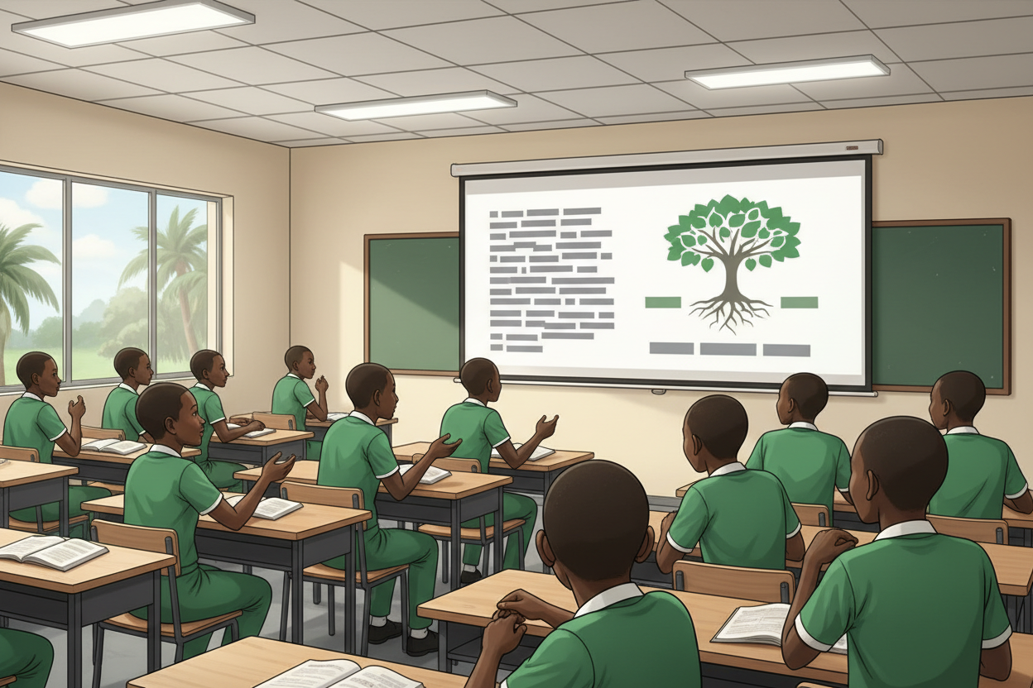
Picture 1. Crowded slide or clean slide: the class chooses.

Picture 2. One idea, few words, clear picture: the three rules of a good slide.
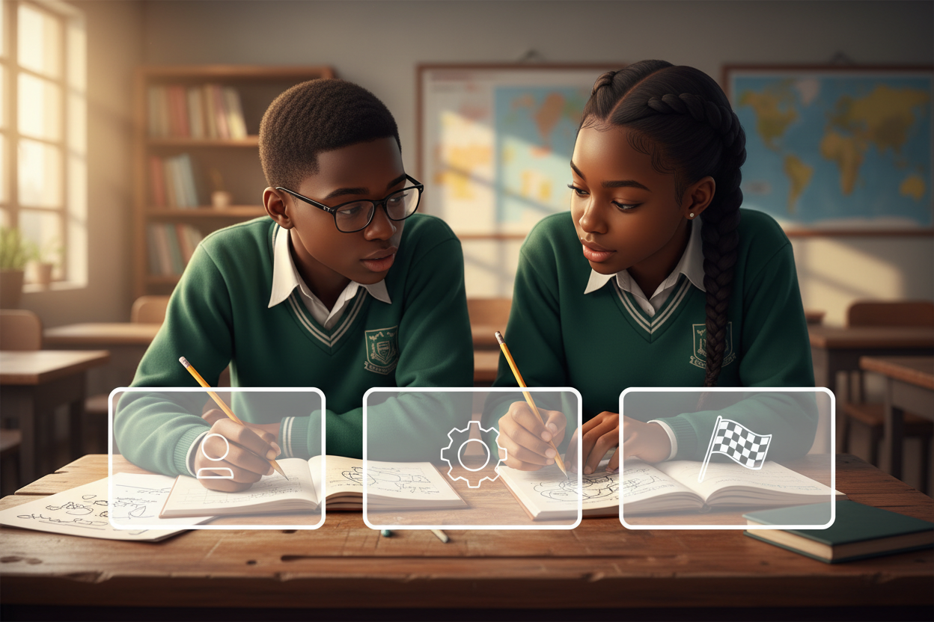
Picture 3. Three slides: tell them, show them, invite them.

Picture 4. Deliver with a clear voice and eyes up: two minutes is enough.

7. Period Two: Practise and Apply
- Build and present (25 minutes): pairs choose a small topic (their Week 10 project, a school club, a favourite subject), build three slides or flip cards, and practise once before presenting to another pair.
- Present (15 minutes): volunteers present to the class; the audience gives one star (what worked) and one wish (what to improve) per presentation.
- Close (5 minutes): the class agrees on the top three design rules to keep for future presentations.

8. Assessment and Evidence
- Evidence to collect: each pair's three-slide plan and deck (or flip cards), and one practice run observed.
Success looks like: decks follow the three design rules, delivery runs about two minutes, and every pair gives and receives one star and one wish.

9. Suggested Questions and Answer Guidance
1. Why only a few words on a slide? Expected response: the audience listens to the speaker; the slide supports, it does not repeat everything.
2. What are the three slides of your deck for? Expected response: tell, show, invite, in that order.
3. What does a good delivery look and sound like? Expected response: clear voice, eyes on the audience, steady posture.
4. How would you help a nervous presenter? Expected response: practise together, stand beside them, keep the audience kind.

10. Home Activity
Learners watch one short presentation at home or remember one from assembly and note one thing the presenter did well; no device or purchase needed.

11. Inclusion
Flip-card presenters use the same rubric; presentations may be delivered seated, with a partner, or with a signed introduction. The audience gives feedback kindly and in turn. Slides avoid flashing and colour-only meaning.

12. Safety and Privacy
Presentation topics stay school-appropriate; no personal addresses, phone numbers or family details appear on slides. Screens are checked for glare before each presentation.

13. Teacher Reflection
After the lesson, note what worked, which parts confused the class, which pupils need follow-up, and one change for next term.
Reflection notes
__________________________________________________________________________________________

14. Curriculum Alignment and Document Status
This note expands the Rehoteq AI Education Curriculum, a proposed curriculum for school pilot, review and consultation; not an officially approved national syllabus. It does not replace the current NERDC curriculum or examination-board requirements, and schools remain responsible for checking current NERDC requirements and their own calendar before implementation.

Prepared by Rehoteq Technologies (rehoteq.com). First edition, November 2026.

