REHOTEQ
AI EDUCATION CURRICULUM
―――――――――――――――――――――――

Comprehensive Teacher's Lesson Note
System Unit and Peripherals
Junior Secondary 1 · First Term · Week 2

Field | Detail
Subject | AI Education and Digital Skills
Academic session | 2026/2027
Duration | 2 periods (40 to 45 minutes each, subject to the school timetable)
Document type | Comprehensive Teacher's Lesson Note
Curriculum status | Proposed curriculum for school pilot, review and consultation
Prepared by | Rehoteq Technologies (rehoteq.com)
Edition | First edition, November 2026

PROPOSED CURRICULUM NOTICE: This lesson note expands the Rehoteq AI Education Curriculum's proposed Junior Secondary 1, First Term, Week 2 scheme of work. It is offered for school pilot, review and consultation. It is not represented as an officially approved national syllabus, and it does not replace the current NERDC curriculum or any examination-board requirement.

1. Lesson Information
Field | Detail
Class | JSS 1
Subject | AI Education and Digital Skills
Term | First Term
Week | Week 2 of First Term
Topic | System Unit and Peripherals
Duration | 2 periods (40 to 45 minutes each)

2. Learning Outcome
By the end of the lesson, learners can:
- Name the main parts of a complete computer set-up: system unit, monitor, keyboard, mouse, and at least one printer or speaker, and say what each part is for.
- Describe the system unit as the part that does the thinking and keeping, and name at least three parts inside it: processor, memory and storage.
- Sort common devices into input devices, output devices and devices that do both, and give one reason for each sorting.
- Use the key words of the week correctly in a sentence: system unit, peripheral, input, output, processor, memory, storage.

3. Weekly Scheme Content
Period | Scheme content
Period 1 | The system unit: what it looks like outside, what lives inside it (processor, memory, storage, power supply)
Period 2 | Peripherals: input devices, output devices, and devices that do both
Weeks 11 to 13 of the term are reserved for examinations, marking and results. Do not introduce new content during those weeks.

4. Materials and Preparation
- One real system unit or desktop set-up if the school has one; the teacher should test that it is safely placed where every group can walk past it.
- A drawn wall chart of a computer set-up with blank labels, plus sticky notes or paper slips for labelling.
- Sorting cards on cardboard: keyboard, mouse, joystick, microphone, scanner, digital camera, monitor, printer, speaker, headphones, touch screen, modem.
- An old mouse, keyboard or cable end the class may safely pass around, if the school has retired equipment.
No-lab fallback: if the school has no working computer, teach entirely from the picture chart, the sorting cards and a drawn diagram on the board. The lesson works fully unplugged; the real device is a bonus, not a requirement.

5. Period One: Introduce and Model
- Starter (5 minutes): display the chart or the real set-up and ask learners to name anything they recognise. Collect answers on the board without correcting yet.
- Teach (10 minutes): define the system unit as the box that does the work, and peripherals as the parts around it that carry information in and out. Use the human-body comparison: the system unit is like the head that thinks, the keyboard and mouse are the eyes and ears, the monitor and printer are the mouth and hands.
- Model (10 minutes): point to each part on the chart or machine and say its job. Inside the system unit, name the processor as the part that thinks, memory as the part that remembers while working, storage as the part that keeps things when the power is off, and the power supply as the part that feeds the machine.
- Guided practice (10 minutes): pupils come to the board in turns to fix name slips on the correct part of the diagram. The class claps a correct label and helps a wrong one.
- Check (5 minutes): quick oral drill. The teacher points at a part and pupils answer with the name and its job.

6. Lesson Pictures
Show these pictures while teaching. Talk about each one before moving on, and ask learners to point to the same part on the chart or the real machine.
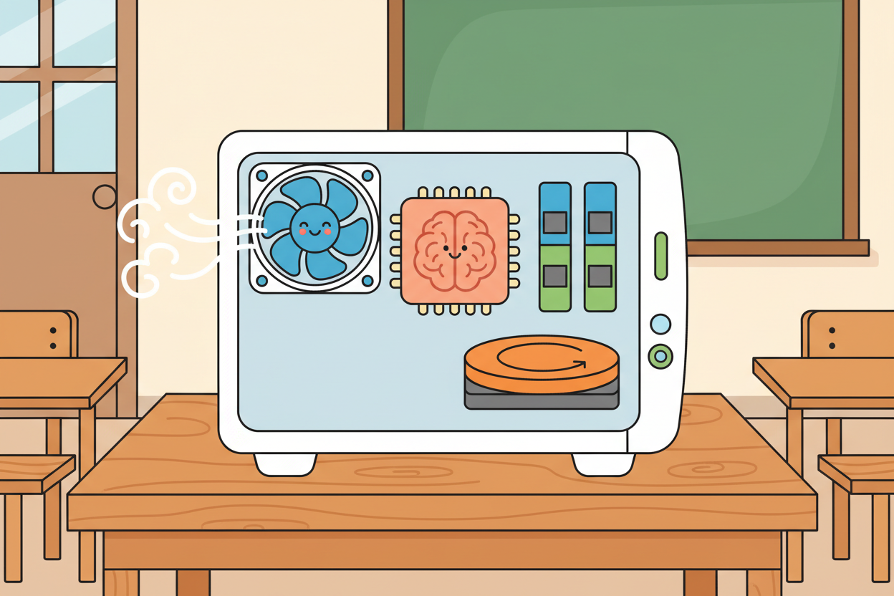
Picture 1. Inside the system unit: the processor that thinks, the memory that remembers while working, and the storage that keeps things safe.
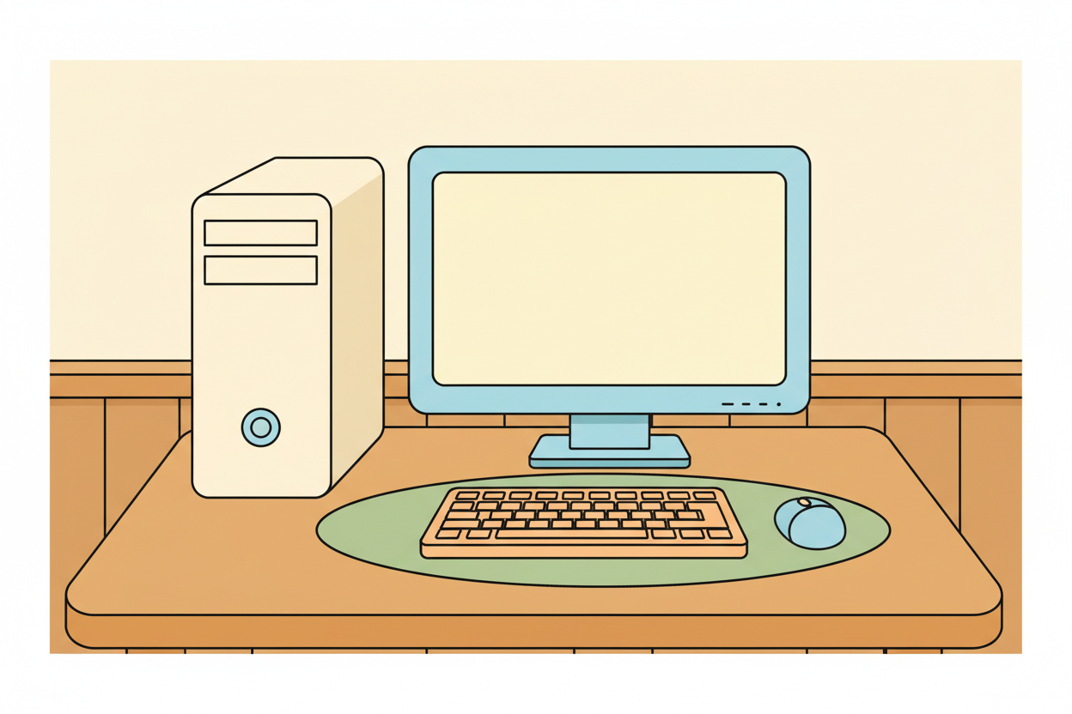
Picture 2. A complete set-up: the system unit standing beside the monitor, with the keyboard and mouse carrying instructions in.
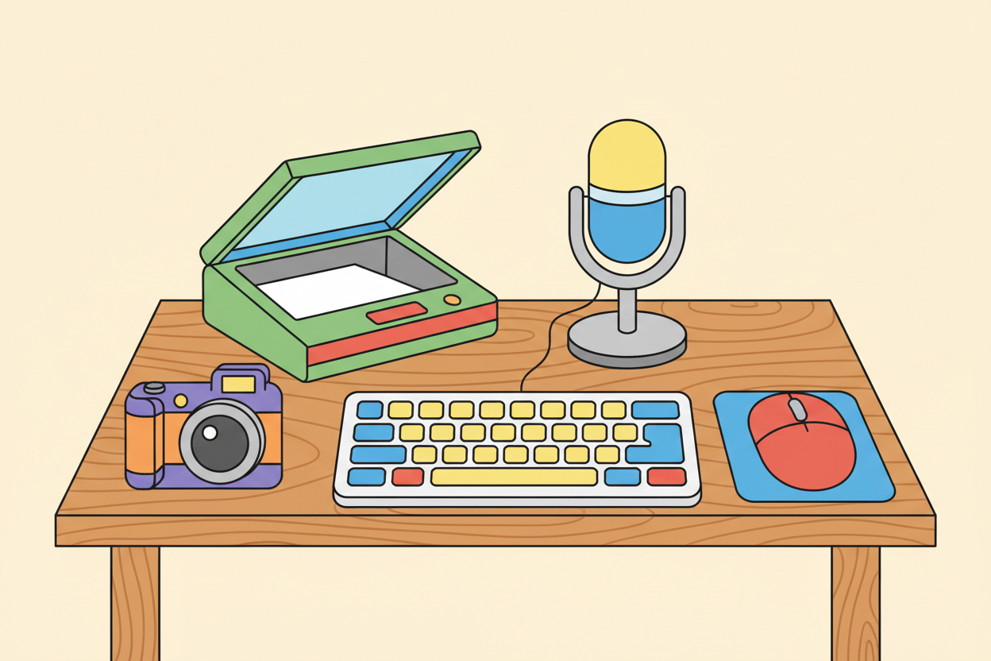
Picture 3. Input devices: keyboard, mouse, microphone, scanner and camera, all carrying our instructions into the computer.
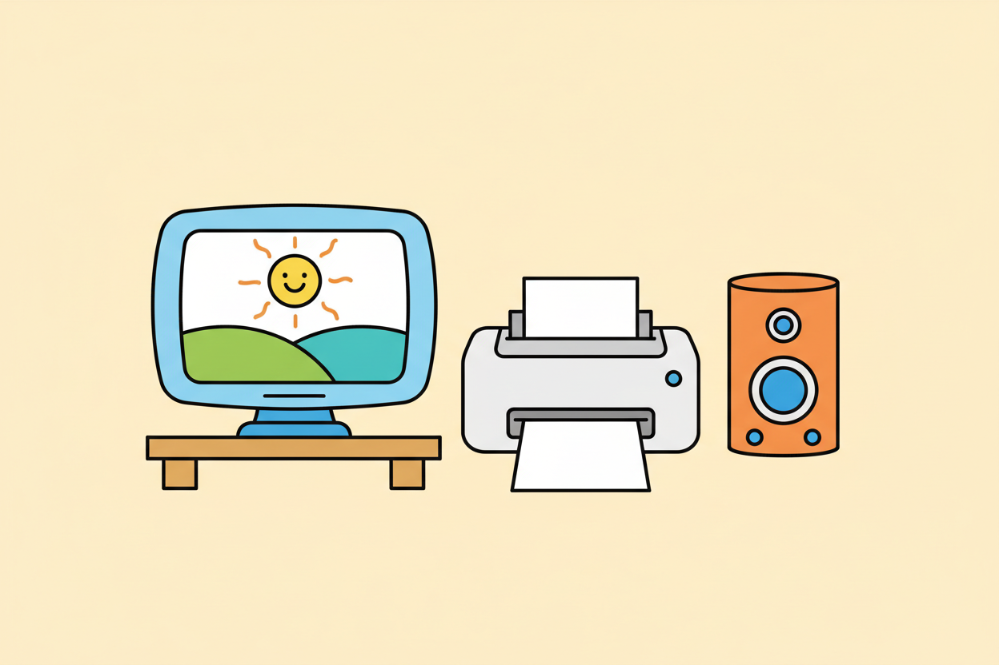
Picture 4. Output devices: the monitor shows, the printer prints and the speaker sounds. The computer answers back through them.

7. Period Two: Practise and Apply
- Sorting relay (15 minutes): each group receives a mixed pack of device cards and three labelled areas on the desk: goes in, comes out, goes both ways. Groups sort, then one member defends one choice with a reason.
- Whole-class check (10 minutes): the teacher holds up two or three contested cards, and the class votes with reasons. Correct the common mix-up: a touch screen is both, and a modem carries in and out.
- Recap and write (10 minutes): pupils copy the three headings with two examples under each, then complete the board diagram in their notes.

8. Assessment and Evidence
- Evidence to collect: each group's sorted card pack, photographed or counted by the teacher; each pupil's copied three-heading list.
Success looks like: pupils sort at least eight of the ten cards correctly and give a reason for at least one choice that names what the device carries, in or out.

9. Suggested Questions and Answer Guidance
1. What is the system unit? Answer: the main box of the computer that does the thinking and keeps the parts that process and store information.
2. Mention two parts found inside the system unit. Answer: any two of processor, memory, storage, power supply, cooling fan, motherboard.
3. What is a peripheral? Answer: any device connected around the system unit that carries information in or out, such as the keyboard, mouse, monitor or printer.
4. Give one device that is both input and output, with a reason. Answer: a touch screen, because you touch it to send instructions and it displays the answer.

10. Home Activity
Learners look for two devices at home, in the market or in a shop that either feed information into a machine or answer back from one, such as a phone keypad, a payment machine or a television. They draw one device and write beside it whether it takes information in, brings information out, or does both.

11. Inclusion
Learners who cannot write fluently yet may label the diagram with drawings or by pointing while the teacher writes. Learners with low vision sit closest to the chart and handle the real parts first. Every group mixes confident and growing readers, so card sorting never depends on one pupil's reading level.

12. Safety and Privacy
The teacher opens or demonstrates with equipment that is switched off and unplugged, and pupils never touch the inside of a machine or its power sockets. Cables are kept tidy on the floor so nobody trips. No pupil's name or photograph is attached to any device record the class keeps.

13. Teacher Reflection
After the lesson, note what worked, which parts confused the class, which pupils need follow-up, and one change for next time.
Reflection notes
__________________________________________________________________________________________

14. Curriculum Alignment and Document Status
This note expands the Rehoteq AI Education Curriculum, a proposed curriculum for school pilot, review and consultation; not an officially approved national syllabus. It does not replace the current NERDC curriculum or examination-board requirements, and schools remain responsible for checking current NERDC requirements and their own calendar before implementation.

Prepared by Rehoteq Technologies (rehoteq.com). First edition, November 2026.

