REHOTEQ
AI EDUCATION CURRICULUM
――――――――――――――――――――――――――――――

Comprehensive Teacher's Lesson Note
Smart and Ordinary Devices
Primary 1 · First Term · Week 2

Field | Detail
Subject | AI Education and Digital Skills
Academic session | 2026/2027
Duration | 2 periods (35 to 40 minutes each, subject to the school timetable)
Document type | Comprehensive Teacher's Lesson Note
Curriculum status | Proposed curriculum for school pilot, review and consultation
Prepared by | Rehoteq Technologies (rehoteq.com)
Edition | First edition, October 2026

PROPOSED CURRICULUM NOTICE: This lesson note expands the Rehoteq AI Education Curriculum's proposed Primary 1, First Term, Week 2 scheme of work. It is offered for school pilot, review and consultation. It is not represented as an officially approved national syllabus, and it does not replace the current NERDC curriculum or any examination-board requirement.

1. Introduction
Technology helps people perform tasks at home, in school, at work and in their communities. People use different devices to communicate, learn, tell time, listen to music, watch programmes and carry out other activities.
Some devices have electronic features that can respond to instructions, process information or connect to other devices. These are often called smart devices. Other devices perform simpler or more specific functions without those smart features.
In this lesson, pupils will identify examples of smart and ordinary devices, discuss what the devices do, and practise comparing them.
Important teaching note: The words "smart" and "ordinary" are simplified categories for young learners. They are not always strict technical opposites. For example, some watches show only the time, while smartwatches can also count steps or display notifications. A device is not automatically an artificial intelligence device just because it is electronic or connected to the internet.

2. Learning Objectives
By the end of the lesson, pupils should be able to:
1. Explain in simple words what a device is.
2. Identify at least three examples of smart devices.
3. Identify at least three examples of ordinary devices.
4. State one use of each device shown in class.
5. Compare two devices by describing what each one does.
6. Sort picture cards into suitable groups with teacher support.
7. Demonstrate safe and responsible behaviour around devices.

3. Key Vocabulary
Term | Meaning used in this lesson
Device | A tool or piece of equipment used to perform a task.
Smart device | An electronic device with features that can process information, respond to instructions or connect with other devices.
Ordinary device | A device that performs a simpler or more limited function and does not have the smart features being discussed.
Function | What an object or device does.
Compare | To look at two or more things and identify how they are alike or different.
Instruction | A direction telling someone or something what to do.

4. Teaching and Learning Materials
The teacher may use any available materials:
- Picture cards showing different devices.
- A chalkboard or whiteboard.
- Paper and pencils, crayons or coloured pencils.
- A basic watch or clock.
- A telephone or smartphone, if available.
- Pictures of a smartwatch, radio, television, computer and calculator.
- Printed worksheets or hand-drawn illustrations.
Low-resource option: No electronic device is required. The teacher can draw the objects on the board or use pictures cut from old newspapers, magazines or product packaging. Pupils must not be required to buy a device.

5. Sample Pictures
The illustrations below are original Rehoteq sample pictures for this lesson. Each carries a text caption, and important information does not depend on colour alone.
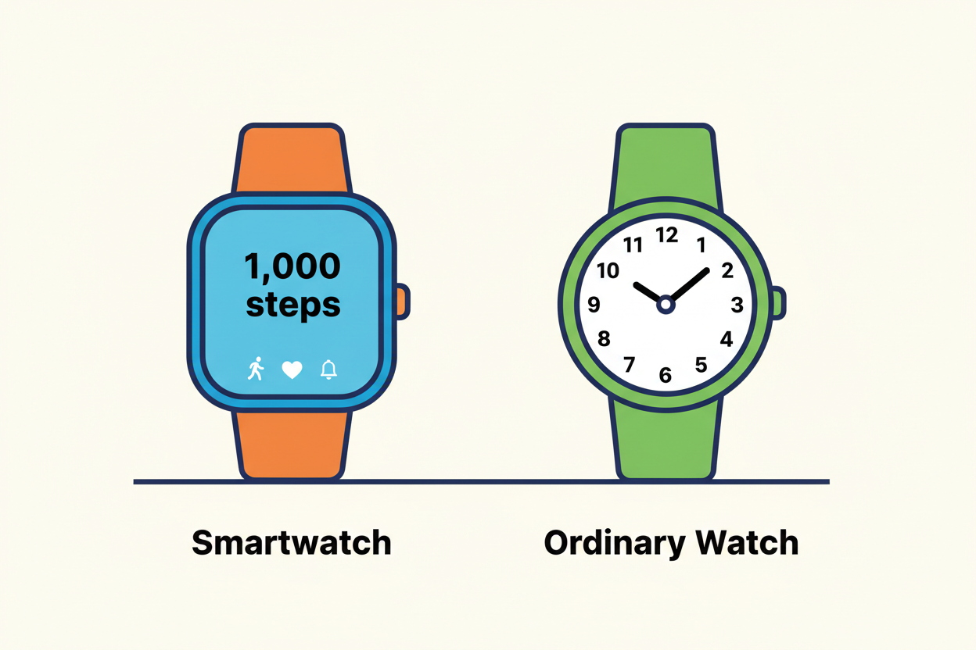
Picture 1. Smartwatch and ordinary watch. Both watches tell the time; the smartwatch also shows extra features such as a step count.
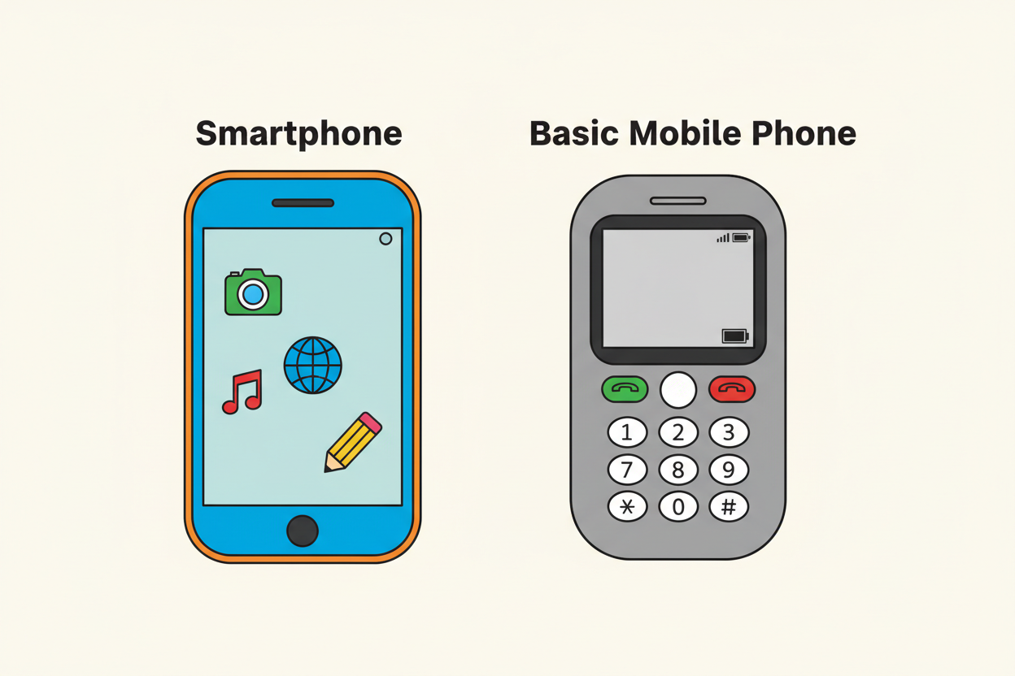
Picture 2. Smartphone and basic mobile phone. Both phones help people communicate; the smartphone also runs applications.
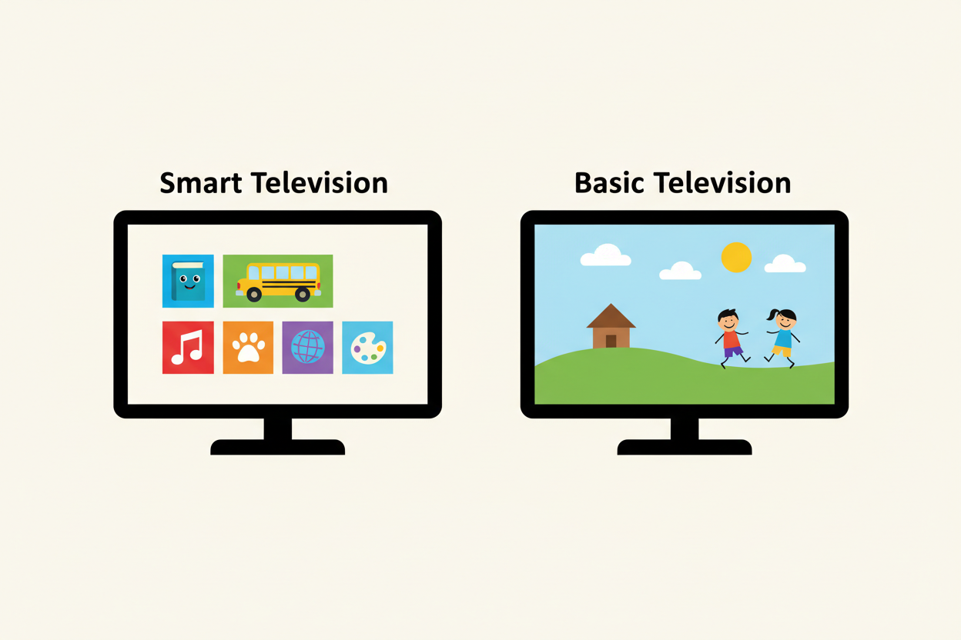
Picture 3. Smart television and basic television. The smart television can show a menu of programmes; the basic television shows one programme.
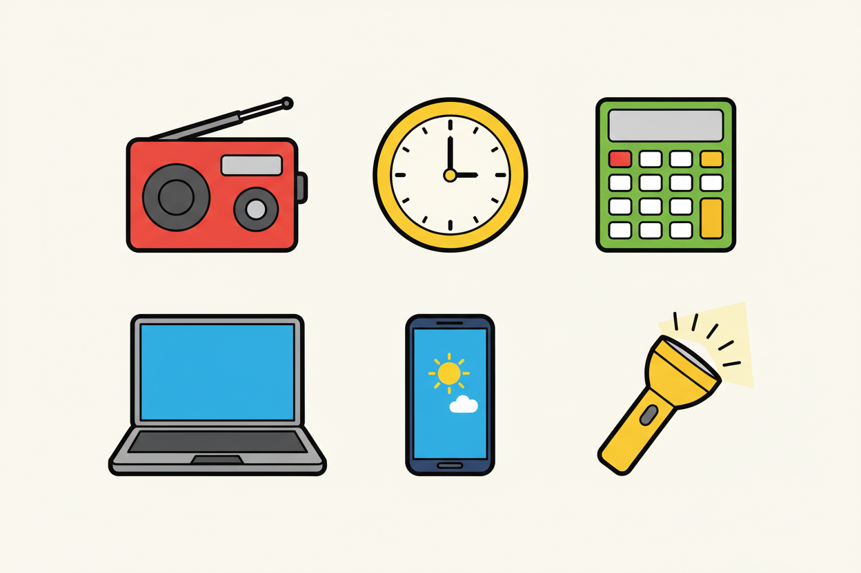
Picture 4. Everyday devices: radio, wall clock, calculator, laptop computer, smartphone and torchlight.
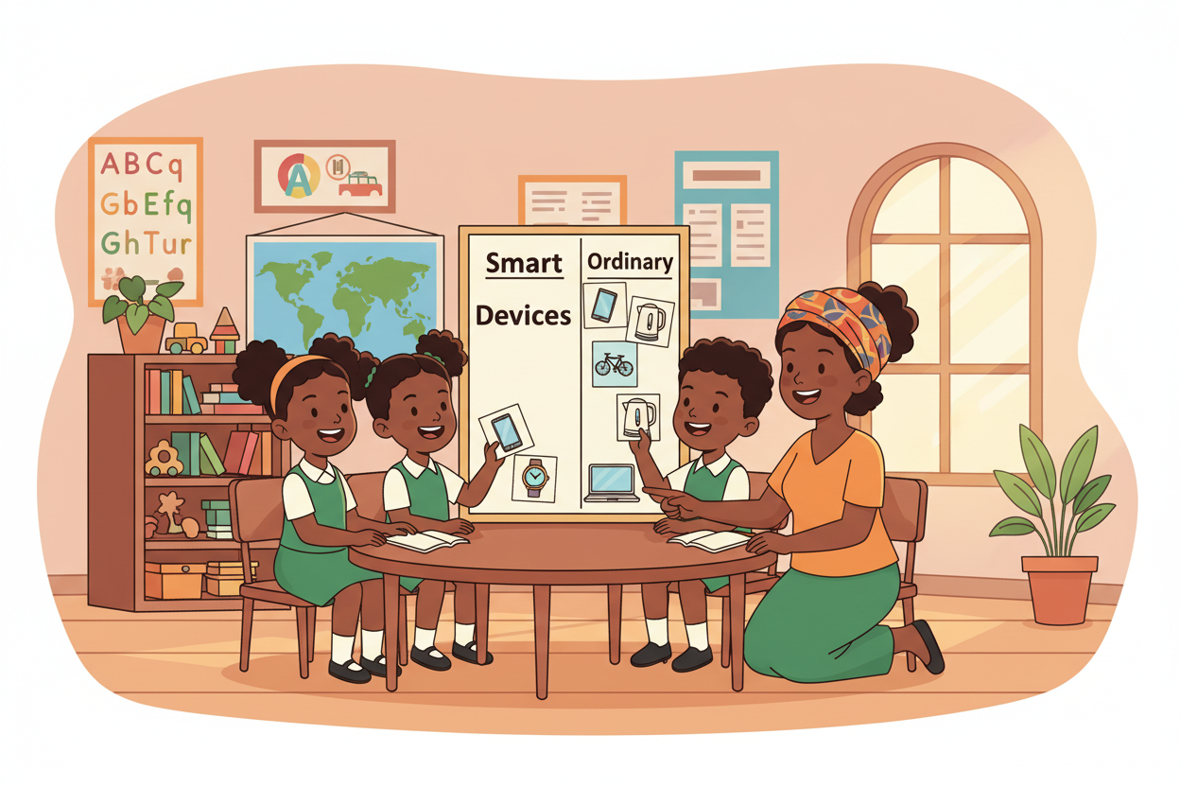
Picture 5. Classroom sorting activity: pupils place device picture cards into two groups, Smart Devices and Ordinary Devices.

6. Period One: Examples of Smart and Ordinary Devices
Duration: 35 to 40 minutes.

A. Introduction (5 minutes)
The teacher greets the pupils and asks:
1. Have you seen a phone before?
2. What do people use a clock for?
3. Have you seen a television or radio at home?
4. Which devices have you seen in your school or community?
Allow pupils to answer in their own words. Accept familiar examples from homes, shops, churches, mosques, markets and schools. Explain that people use devices to perform different tasks.

B. Teacher explanation (10 minutes)
A device is something people use to help them perform a task. Examples include a clock for telling time, a radio for listening to broadcasts, and a calculator for working with numbers.
Some electronic devices have additional features that make them smart devices. These features may include connecting to other devices, processing information or running different applications.
Examples of smart devices include:
- A smartphone.
- A smartwatch.
- A smart television.
- A tablet with smart functions.
Examples of ordinary devices for this lesson include:
- An ordinary wristwatch.
- A basic calculator.
- A simple torchlight.
- A basic radio.
Explain that the exact features matter. Not every phone, television or radio has the same capabilities. A basic electronic device is not necessarily a smart device.

C. Picture observation (5 minutes)
Display Picture 1 and Picture 2, or draw simple versions on the board. Ask pupils to point to the smartwatch, the ordinary watch, the smartphone and the basic mobile phone. Invite pupils to describe what they notice.
Expected observations:
- Both watches can tell time.
- A smartwatch may have additional features.
- Both types of phone can be used for communication, although their functions differ.
- Some devices have touchscreens, while others have physical buttons.

D. Guided classroom activity (10 minutes)
Activity: Name the Device
1. Display or draw one device at a time.
2. Ask pupils to name it.
3. Ask what the device helps people do.
4. Ask whether it is a smart device or an ordinary device in the examples taught.
5. Invite pupils to explain their choices in simple sentences.
Example dialogue:
Teacher: What is this? Pupils: A watch.
Teacher: What does it do? Pupils: It tells time.
Teacher: What extra features might a smartwatch have? Pupils: It may count steps or show messages.
Accept suitable answers and correct misunderstandings gently.

E. Oral recap (5 minutes)
- What is a device?
- Name one smart device.
- Name one ordinary device.
- What does a clock do?
- What extra feature can a smartwatch have?
Period One learning evidence: Each pupil should name at least one device and describe one function. Give additional picture prompts to pupils who need support.

7. Period Two: Comparing Devices and Their Uses
Duration: 35 to 40 minutes.

A. Revision (5 minutes)
Briefly revise the previous period. Display two pictures and ask pupils to identify each device. Remind pupils that devices can perform similar tasks while having different features.

B. Teacher explanation (8 minutes)
To compare devices means to look at two devices and say what is similar or different about them.
For example, an ordinary watch and a smartwatch can both tell time, but a smartwatch may also count steps or show notifications. A smartphone and a basic mobile phone can both help people communicate, though a smartphone usually has more applications and functions. A smart television may connect to internet services or run applications, while a basic television may have more limited functions.
The teacher should use only features that can be accurately shown in the selected examples.

C. Comparison table
Device | What it does | Additional or distinguishing feature
Ordinary watch | Tells time | Usually has limited functions
Smartwatch | Tells time | May count steps or show notifications
Basic mobile phone | Helps people communicate | May use physical buttons and have limited features
Smartphone | Helps people communicate | May run applications and connect to the internet
Basic television | Shows television programmes | Functions depend on the model
Smart television | Shows programmes | May run applications or use internet services
Simple torchlight | Provides light | Usually has a simple lighting function
Tablet | Displays learning materials and applications | May support touch input and internet connectivity
Teacher reminder: These are examples, not universal rules. Device models differ. Do not tell pupils that every smartphone, television or smartwatch has every listed feature.

D. Group activity: Sort the Picture Cards (10 minutes)
Materials: hand-drawn or printed device cards and two labelled areas on a desk or board.
1. Divide pupils into small groups.
2. Give each group a selection of device cards.
3. Ask pupils to identify the devices.
4. Let pupils place each card under "Smart Devices" or "Ordinary Devices", based on the examples and features discussed.
5. Ask each group to explain one choice.
Suggested cards: smartwatch, ordinary watch, smartphone, basic mobile phone, smart television, basic television, simple torchlight, basic calculator.
If a device is unfamiliar or its features are unclear, discuss it together rather than insisting on a classification without evidence.
Offline alternative: Draw the devices on the board and invite pupils to point to the appropriate group. Pupils can also draw the devices in their exercise books.

E. Practical activity: Which Device Would Help? (7 minutes)
Read each situation aloud. Ask pupils which device could help.
Situation | Possible answers
A person wants to know the time. | An ordinary watch, a clock or a smartwatch.
A teacher wants to display a learning video using a suitable internet-connected screen. | A smart television or another suitable connected device, depending on the available equipment.
A person wants to make a phone call. | A basic mobile phone or a smartphone.
A person needs light during a power outage. | A torchlight.
Emphasise that the best device depends on the task and the available features.

F. Lesson conclusion (5 minutes)
Ask pupils to complete these sentences orally:
- A device is something we use to ______.
- A smartwatch can tell ______.
- A smartphone can help people ______.
- We compare devices by looking at what they ______.
Conclude by explaining that technology includes many different tools. We should learn what each device does and use it safely.

8. Assessment
The teacher may use oral questions, a short written exercise or a practical sorting task.

Part A: Oral or written questions
1. What is a device?
2. Name two smart devices.
3. Name two ordinary devices from today's examples.
4. What does an ordinary watch do?
5. State one additional feature a smartwatch may have.
6. What can a smartphone help people do?
7. What does it mean to compare two devices?
8. Name one device that can provide light.

Part B: Match the device to its use
Device | Function
1. Watch | A. Provides light
2. Torchlight | B. Helps people communicate
3. Smartphone | C. Tells time
4. Television | D. Displays programmes

Part C: Practical task
Ask pupils to select two device pictures and explain one way they are alike or different.

Answer guide
Part A:
1. A tool or piece of equipment used to perform a task.
2. Examples: smartphone, smartwatch or smart television.
3. Examples: ordinary watch, simple torchlight or basic calculator.
4. It tells time.
5. It may count steps or show notifications.
6. It can help people communicate and perform other tasks through applications.
7. It means looking at two devices to identify similarities or differences.
8. A torchlight.
Part B: 1-C, 2-A, 3-B, 4-D.
Part C: Accept any reasonable comparison supported by the pictures and the lesson.

Suggested assessment record
For each pupil, mark whether the learner can:
- Identify devices.
- Describe a device's function.
- Recognise the examples taught as smart or ordinary.
- Compare two devices.
- Participate safely and respectfully.
Use the school's approved assessment policy. Provide oral responses or picture-based answers where writing is still difficult.

9. Homework
Task: Draw and Name Two Devices
In the exercise book, pupils should draw one smart device and one ordinary device, then write or dictate the name of each device and state one thing it does.
Example: Smartwatch, tells time and may count steps. Ordinary watch, tells time.
Important: Pupils do not need to own these devices. They may draw from classroom pictures, objects they have seen, or illustrations supplied by the teacher.

Optional family discussion: with a parent or trusted adult, identify one device used at home and discuss what it helps the family do. Do not ask pupils to share private information or photographs online.

10. Differentiation and Inclusion

For pupils who need more support
- Use large, clear pictures.
- Teach two device examples at a time.
- Allow pointing, matching or oral answers.
- Pair pupils for supported activities.

For pupils ready for an extra challenge
- Ask them to compare three devices.
- Ask them to explain why two devices can perform a similar task in different ways.
- Invite them to draw a new device and explain the problem it could help solve.

For pupils with visual, hearing or motor difficulties
- Provide verbal descriptions of pictures.
- Use tactile or large-format cards where possible.
- Allow a partner or teacher to assist with handling materials.
- Accept spoken answers or alternative ways of participating.

11. Safety, Privacy and Responsible Use
Teach pupils the following simple rules:
1. Ask a teacher or trusted adult before using an unfamiliar device.
2. Do not touch exposed wires, damaged plugs or electrical equipment with wet hands.
3. Do not use another person's phone, tablet or computer without permission.
4. Do not share personal information, passwords, photographs or private messages.
5. Do not connect devices to the internet without appropriate adult guidance.
6. Treat classroom equipment carefully and share it fairly.
7. Remember that electronic devices do not always give correct or suitable results; adults can help us check information.
No pupil should be required to bring an expensive device to school.

12. Teacher Preparation Checklist
Before the lesson, the teacher should:
☐ Read the lesson objectives and vocabulary.
☐ Prepare or draw pictures of the selected devices.
☐ Check that device labels are clear and accurate.
☐ Prepare sorting cards or board headings.
☐ Plan an offline alternative.
☐ Ensure pupils can participate without owning devices.
☐ Review the assessment questions and answers.
☐ Prepare an accessible way for all pupils to participate.
☐ Remind pupils about safety, permission and privacy.

13. Lesson Evaluation
After teaching, the teacher should complete the following:
Number of pupils present: ________________________________________
Number of pupils who met the objectives: ________________________________________
Objectives that need revision:
__________________________________________________________________________________________
Activities pupils found most helpful:
__________________________________________________________________________________________
Difficulties encountered:
__________________________________________________________________________________________
Support or follow-up required:
__________________________________________________________________________________________
Teacher's name / signature: ________________________________________
Date: ________________________________________

14. Curriculum Alignment and Document Status
This lesson note is based on the Rehoteq AI Education Curriculum's proposed Primary 1, First Term, Week 2 scheme of work.
The weekly scheme specifies:
- Period 1: Examples of smart devices and ordinary devices.
- Period 2: Compare devices and discuss what each helps people do.
- Assessment: Oral or written check, practical task or short exit ticket.
This document expands those points into a suggested teaching plan. Teachers may adapt timing and activities to suit their school's timetable, available materials and pupils' learning needs.
Status: Proposed Rehoteq curriculum for school pilot, review and consultation. It is not represented as an officially approved national syllabus. Before adoption, schools should check the current official NERDC curriculum, their own calendar and any examination-board requirements.

Copyright and attribution: © 2026 Rehoteq Technologies. Teachers and schools may download, print and use this lesson note freely for non-commercial educational purposes, with attribution to Rehoteq Technologies (rehoteq.com). The sample pictures in Section 5 are original Rehoteq illustrations created for this lesson and may be reused only with the same attribution.

